Task6:

Lineal correlation is not observed from 18:25 (19 minute from the start of the test) (task3)

Lineal correlation is not observed from 9:55 (12-13 minute from the start of the test) (task6)

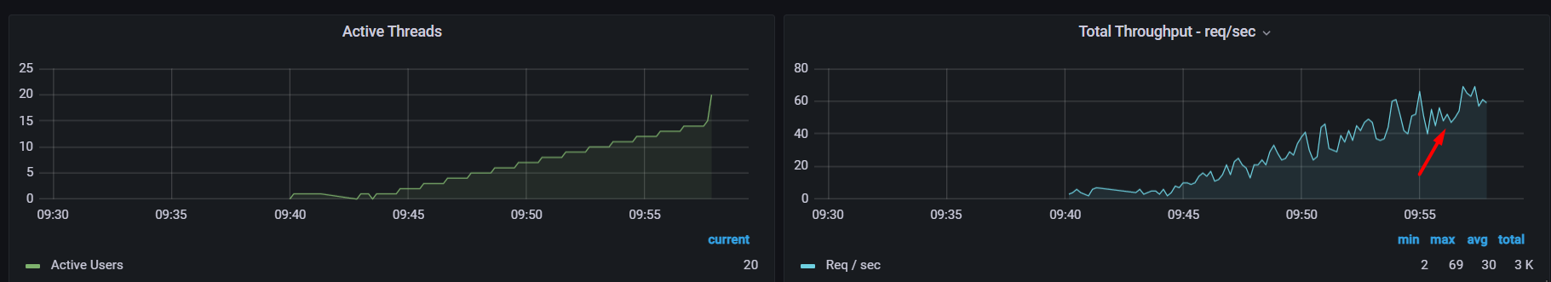

CPU on local machine (task3)

CPU on local machine (task6)

CPU on virtual machine

CPU starts to grow from 18:25(19 minute from start of the test)

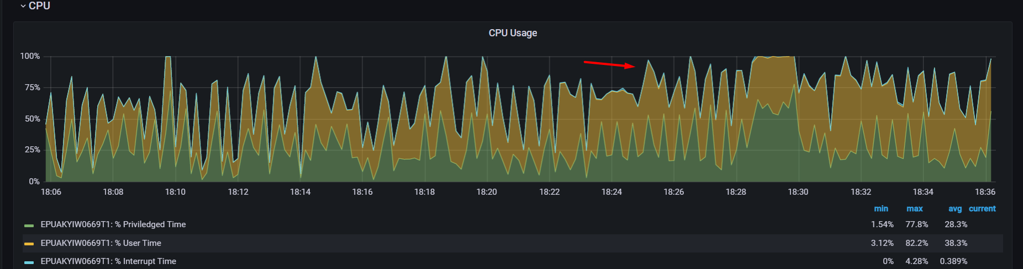

Saturation point is reached at 19 minutes with 20 users (threads) (task3)

Saturation point is reached at 12 minutes with 13 users (threads)(task6)

