SLIM (Smart Lipidomics Interactive Manager) User Manual ver. 0.1.1

## Author

Masaomi Hatakeyama

Functional Genomics Center Zurich,

University/ETH Zurich,

http://www.fgcz.ch/

Winterthurerstrasse 190, 8057 Zurich, Switzerland

Last Updated: 23th July 2015

## Contents

1. Installation … 1
2. Basic functions … 3
   1. Import Lipids, Compounds, Qunatities … 3
   2. Table view … 5
   3. Filtering and Exporting … 6
3. Set up passenger on MacOSX … 11

# 1. Installation

The installation procedure is described as follows:

1. Install Ruby >= 2.0
2. Download the archive file
3. Install libraries
4. Initialize database
5. Run

More detail in each step is explained from the next section.

# 1.1. Install Ruby

Please check if Ruby interpreter is installed in your system and its version by typing the following command in the terminal:

$ ruby -v

It should be fine if you can see the version number and it is over 2.0. However, you have to install Ruby interpreter by downloading the latest package from [www.ruby-lang.org](http://www.ruby-lang.org/) if the command above says, command not found, or the version number is less than 2.0. Please install Ruby by following the installation instruction, https://www.ruby-lang.org/en/documentation/installation/

# 1.2. Download the archive file

Please download the archive from the following link:

http://fgcz-slim-demo.uzh.ch/slim-v0.1.0_20150720.tgz

After the downloading of the archive file above, extract it by typing the following command:

$ tar zxvf slim-v0.1.0_20150720.tgz

It should work to extract it by just double-clicking the file, if you use MacOS X or Windows.

# 1.3. Install libraries

After changing the working directory in the extracted directory, namely slim-v0.1.0_20150720, the following command automatically installs all necessary libraries for the system:

$ bundle install --path vendor/bundle

This may take some depending on your system.

# 1.4. Initialize database

Before the system starts, the initialization of the database is needed.

$ bundle exec rake db:migrate RAILS_ENV=production

# 1.5. Run

SLIM server can run by the following commands:

$ export SECRET_KEY_BASE=`bundle exec rake secret`

$ bundle exec rails server -e production

if you run the server in background, -d option is available.

$ bundle exec rails server -e production -d

# 1.7. Check if it is running

Please access the server through a web-browser by typing the following URL in the address bar:

http://localhost:3000

It succeeds in installing if a pop-up window to ask ID and PASSWORD comes (Fig. 1). The tentative ID and PASSWORD are 'slim' and 'fat'.

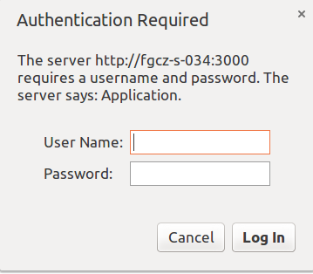

Fig. 1 Basic user authentification window

# 2. Basic functions

In this section, the following functions are explained.

1. How to import lipids, compounds, and quantities data
2. How to see the imported data
3. How to filter the compound data
   1. Absolute filtering
   2. Relative filtering
4. How to export filtered data

# 2.1 Import

Sample short data is available from

http://fgcz-slim-demo.uzh.ch/sample_data.tgz

Click either **Import lipids**, **Import Comound IDs**, or **Import Compound Quantities** (Fig. 2), and you can move on to file selection view (Fig. 3).

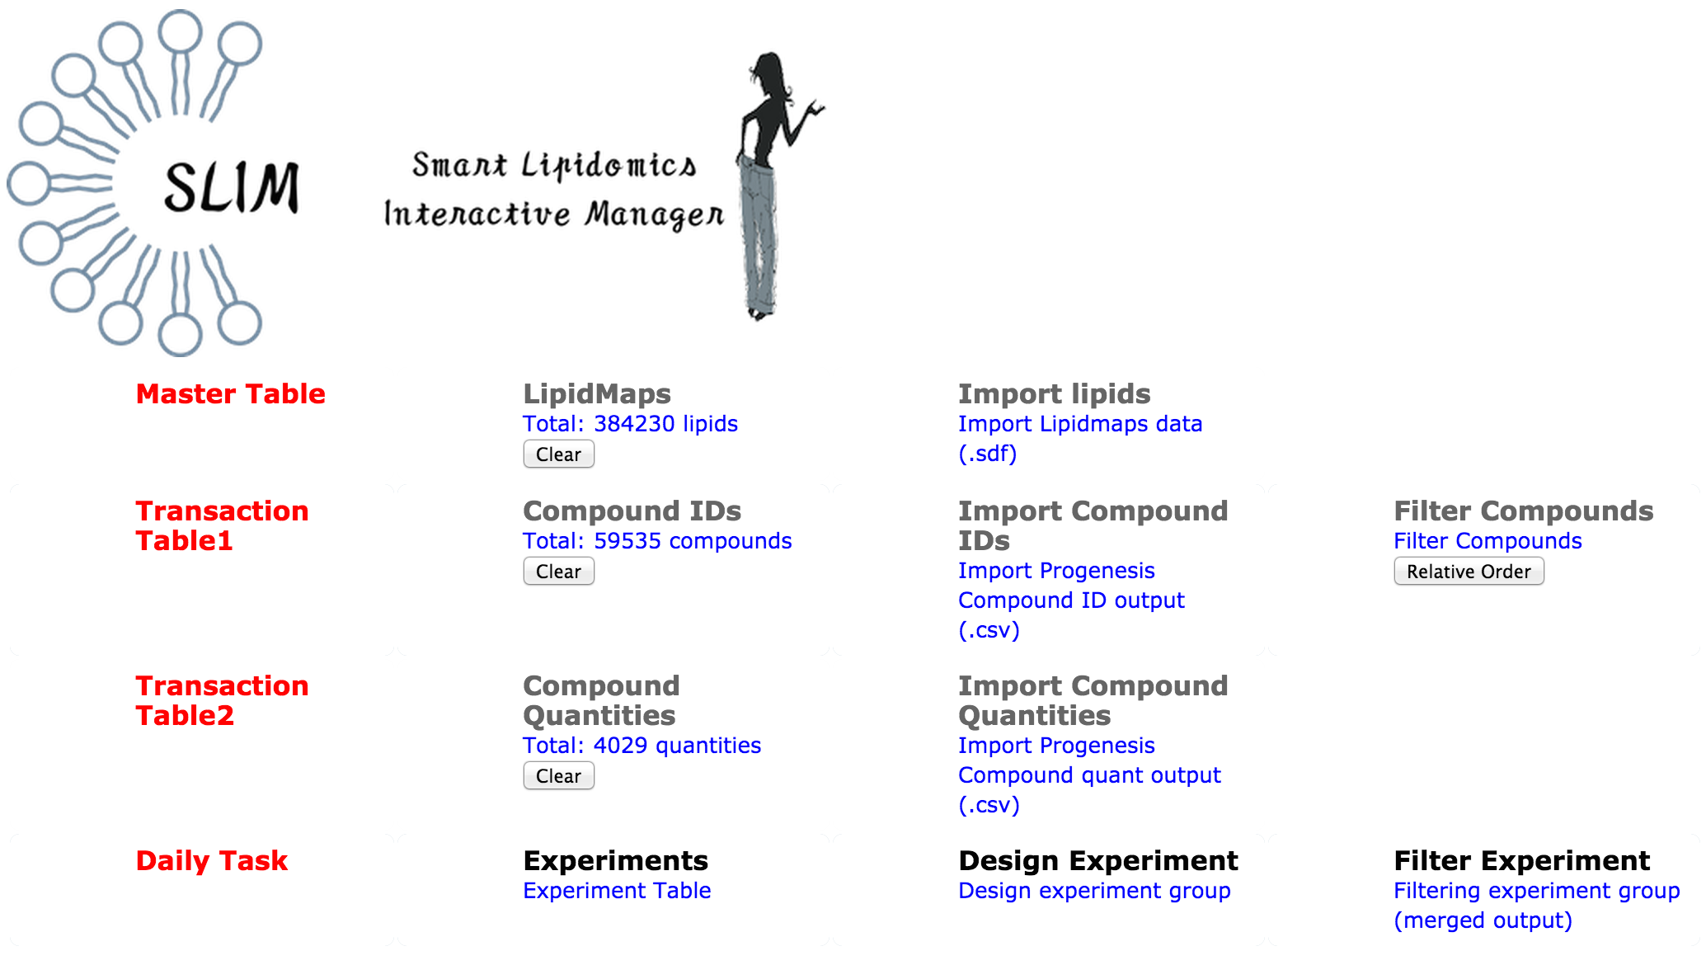

Fig. 2 Import in Top menu

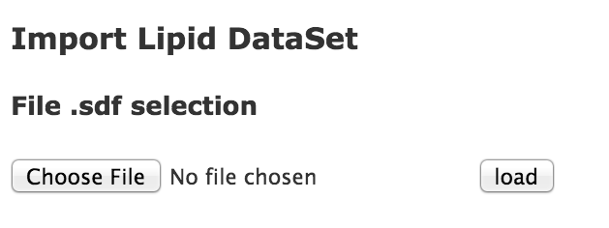

Fig. 3 File selection

If the importing succeeds, then the number of imported elements will be shown (Fig. 4) (it takes some time depending on the data size).

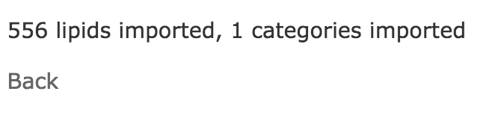

Fig. 4 Import report

Note that the importing order should be

1. LipidMap
2. Comound IDs
3. Compound Quantities

, because some table relations are created during the importing.

# 2.2 Table view

Click either **LipidMaps**, **Comound IDs**, or **Compound Quantities** (Fig. 5), and you can move on to a table view (Fig. 6).

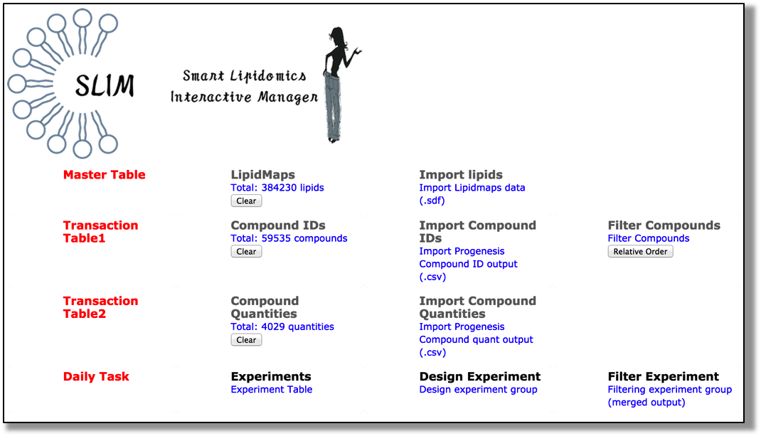

Fig. 5 Show table in Top menu

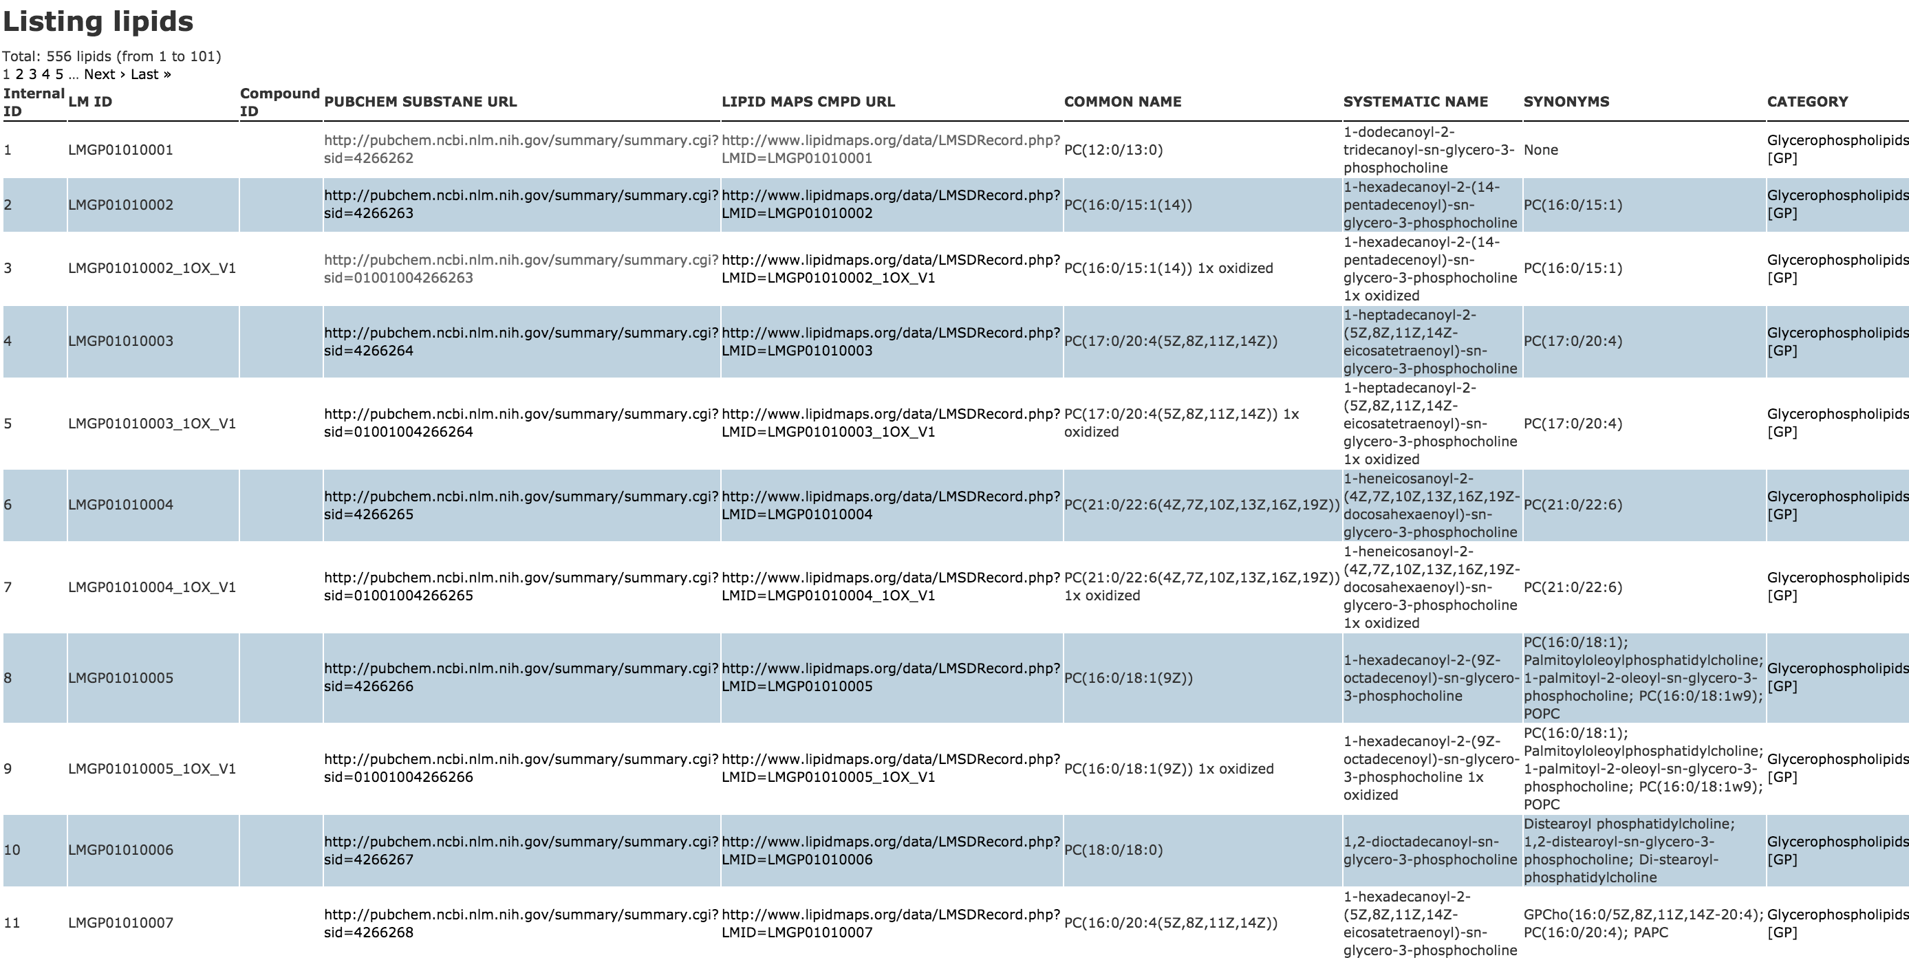

Fig. 6 Lipid table view

# 2.3 Filtering

There are two filtering functions:

1. Absolute filtering
2. Relative filtering

. The absolute filtering can do the filtering of compounds with absolute thresholds, e.g. Score Fragmentation score, isotope similarity, the number of adducts, and category. The relative filtering is to filter the compounds with the order of priority, e.g. score, fragmentation score, isotope similarity, and adducts size.

Click **Filter Compounds** (Fig. 7), and you can move on to the filtering setting view (Fig. 8).



Fig. 7 Filtering on top menu

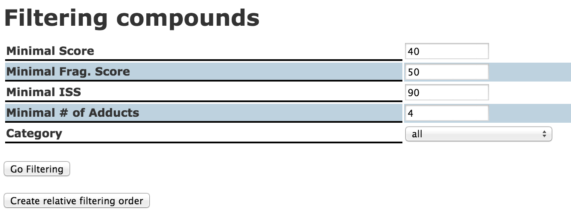

Fig. 8 Absolute filtering setting view

At the same time with showing absolute filtering setting view (Fig. 8), histograms are shown (Fig. 9). You can refer to these histograms for selecting a value for the absolute filtering.

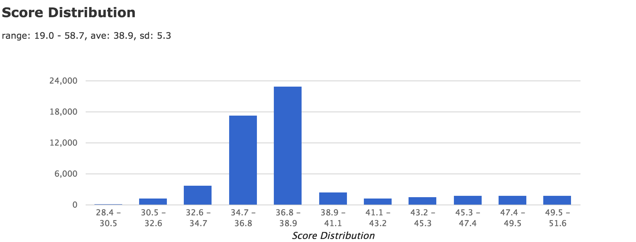

Fig. 9 Score dictribution

After you select the threshold values, click **Go Filtering**, and you can see the filtering result (Fig. 10). Then if you click **save as csv**, you can download the result as a csv file.

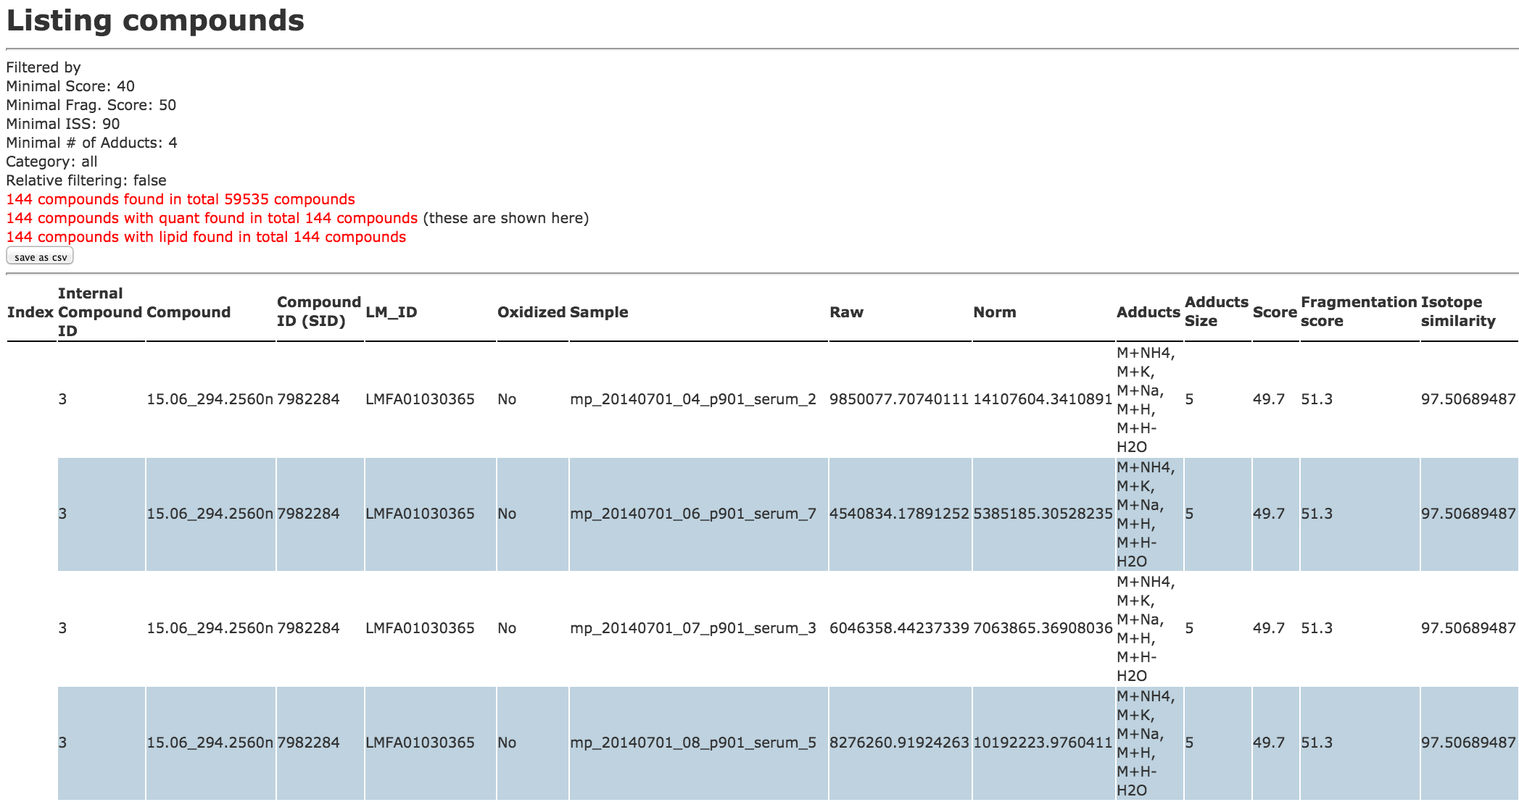

Fig. 10 An example of filtering result

If you want to filter the result further with the relative filtering, you can set the relative filtering order with clicking **Create relative filtering order** in the filtering view (Fig. 8).

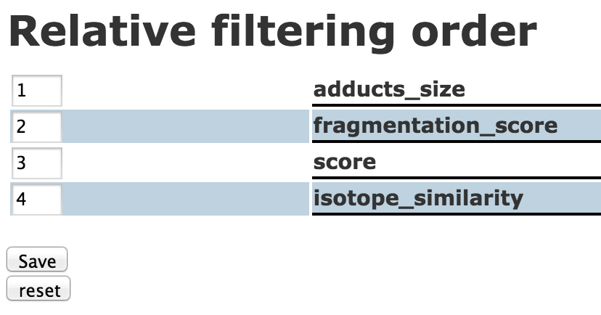

Fig. 11 Relative filtering order setting view

After setting the relative filtering order, the relative filtering order information will be shown in the filtering setting view (Fig. 12).

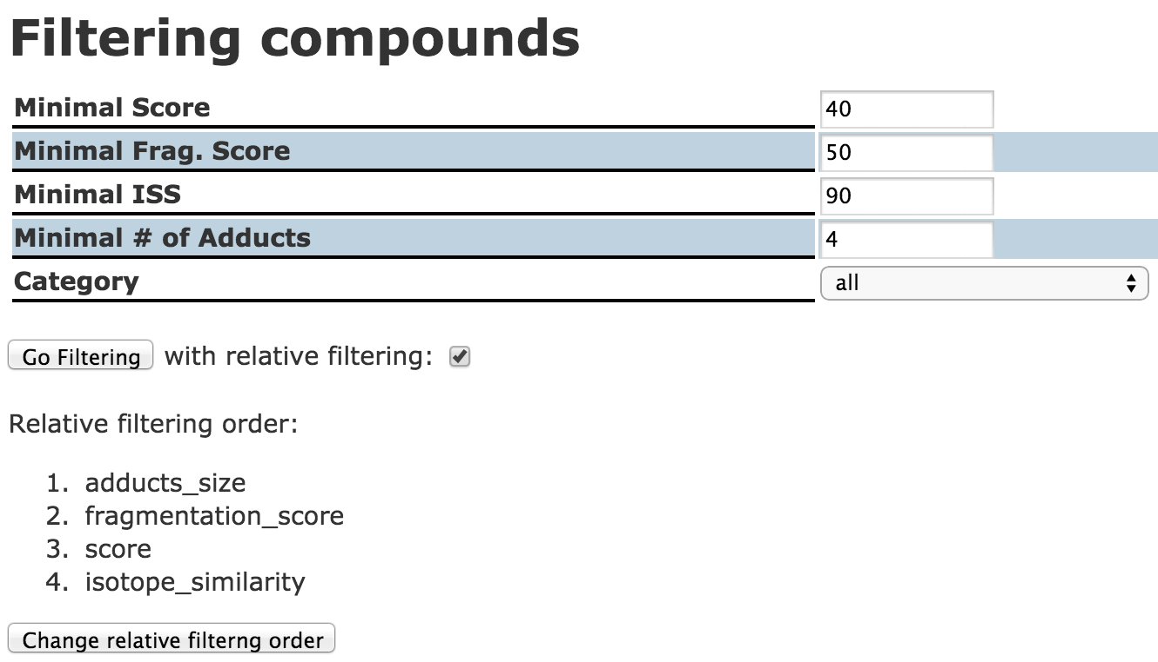

Fig. 12 Filtering setting view with relative filtering order

With the checking of relative filtering, **Go Filtering** executes the filtering with both absolute and relative filtering.

# 3. Set up passenger on MacOSX

In this section, the procedure how to set up passenger module in Apache is described. Passenger is a Ruby module binding with Apache WEB server software. It is much faster than WEBRick (Ruby WEB server) to run Ruby on Rails application. Usually Mac OS X has Apache software installed as a default. The installation and configuration of Apache is not described here. This document is written based on the installation test of using Ruby ver. 2.1.4 and Ruby on Rails ver. 4.2.1, and Passenger ver. 4.0.41 on MacOSX ver. 10.9.5 (Mavericks).

# 2.1 Install passenger gem

$ gem install passenger

# 2.2 Install passenger module

$ passenger-install-apache2-module

This command navigates you the installation of the passenger. The following log is the actual message in the test environment.

*This installer will guide you through the entire installation process. It*

*shouldn't take more than 3 minutes in total.*

*Here's what you can expect from the installation process:*

*1. The Apache 2 module will be installed for you.*

*2. You'll learn how to configure Apache.*

*3. You'll learn how to deploy a Ruby on Rails application.*

*Don't worry if anything goes wrong. This installer will advise you on how to*

*solve any problems.*

...

*Almost there!*

*Please edit your Apache configuration file, and add these lines:*

LoadModule passenger_module /Users/masa/.rbenv/versions/2.1.4/lib/ruby/gems/2.1.0/gems/passenger-5.0.14/buildout/apache2/mod_passenger.so

<IfModule mod_passenger.c>

PassengerRoot /Users/masa/.rbenv/versions/2.1.4/lib/ruby/gems/2.1.0/gems/passenger-5.0.14

PassengerDefaultRuby /Users/masa/.rbenv/versions/2.1.4/bin/ruby

</IfModule>

*After you restart Apache, you are ready to deploy any number of web*

*applications on Apache, with a minimum amount of configuration!*

*Deploying a web application: an example*

*Suppose you have a web application in /somewhere. Add a virtual host to your*

*Apache configuration file and set its DocumentRoot to /somewhere/public:*

<VirtualHost *:80>

ServerName www.yourhost.com

# !!! Be sure to point DocumentRoot to 'public'!

DocumentRoot /somewhere/public

<Directory /somewhere/public>

# This relaxes Apache security settings.

AllowOverride all

# MultiViews must be turned off.

Options -MultiViews

#Require all granted

</Directory>

</VirtualHost>

Actually please follow the message on your console, because the message above is not for your environment but for the test environment that I have tested.

In the test environment, the following two files are edited.

*/etc/apache2/other/passenger.conf*

LoadModule passenger_module /Users/masa/.rbenv/versions/2.1.4/lib/ruby/gems/2.1.0/gems/passenger-5.0.14/buildout/apache2/mod_passenger.so

<IfModule mod_passenger.c>

PassengerRoot /Users/masa/.rbenv/versions/2.1.4/lib/ruby/gems/2.1.0/gems/passenger-5.0.14

PassengerDefaultRuby /Users/masa/.rbenv/versions/2.1.4/bin/ruby

</IfModule>

/etc/apache2/extra/httpd-vhosts.conf

RailsEnv production

<VirtualHost *:9999>

ServerName localhost.rails

# !!! Be sure to point DocumentRoot to 'public'!

DocumentRoot /Users/masa/slim-v0.1.0_20150720/public

<Directory /Users/masa/slim-v0.1.0_20150720/public>

AllowOverride all

Options -MultiViews

Allow from all

</Directory>

</VirtualHost>

Listen 9999

The important parts are

* DocumentRoot path
* <Directory> tag

These are not to the Rails project directory but to the public directory of the Rails project directory. After these settings, you need start Apache.

$ sudo apachectl start

If it is already started,

$ sudo apachectl restart

then you can access the server with the following URL:

http://localhost:9999

Please note that there are a few things to be careful before running passenger as follows:

1. The permissions of all the directories to the Rails project should be accessible for anonymous user, namely the permission should be masked as 755.
2. Generate SECRET_KEY_BASE by the following command

$ bundle exec rake secret

1. And save the actual code in the production section of config/secrets.yml as follows:

production:

secret_key_base: xxxxxxxxxxxxxxxxxxxxxxxxxxxxxxxxxxxxxx

1. The running status of passenger can be checked by the following command and an example of test case is shown below:

$ passenger-status

Version : 5.0.14

Date : 2015-07-23 11:43:22 +0200

Instance: lscSr3Ac (Apache/2.2.29 (Unix) DAV/2 Phusion_Passenger/5.0.14)

----------- General information -----------

Max pool size : 6

App groups : 1

Processes : 1

Requests in top-level queue : 0

----------- Application groups -----------

/Users/masa/slim-v0.1.0_20150720 (production):

App root: /Users/masa/slim-v0.1.0_20150720

Requests in queue: 0

* PID: 22451 Sessions: 0 Processed: 0 Uptime: 31m 36s

CPU: 0% Memory : 5M Last used: 31m 36s ago