Crisis

# Objective

The objective of Crisis is to satisfy 20 resource demands within the time limit to complete the game. This is done by producing the correct resources when told to by the app.

# Setup

This game requires a smartphone running Android, with the Crisis app installed.

1. Shuffle the draw deck and place it face down anywhere in reach of all players. Deal out 5 cards to each player. Leave space for a discard pile nearby.
2. Place the phone, with the app running, in the centre of the table where it can be seen by all players.
3. Press play on the app when you are ready.

# Rules of Play

During play, the app will ask for the players to provide a particular amount of a certain resource (A, B or C). One player must contribute this resource and place it in the discard pile to continue.

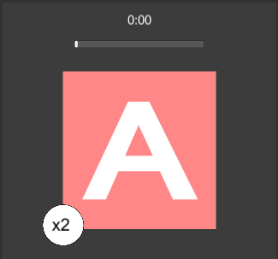

The resource required to satisfy the demand

The amount of said resource required

Only one player may commit the resources. If no players can satisfy the demand, one of two things can happen:

* Players may trade 3 cards of any combination of resources with another player. Players whom have already traded cannot trade with the same person until the next demand.
* Alternatively, players may press the “don’t have it” button, discard their hands and draw back up to five, at the cost of a time penalty.

After resources have been committed, the player who committed them draws back up to five. If the draw pile is not large enough to draw back up, shuffle the discard pile back into the draw pile, and draw as normal.

Play continues until all demands have been satisfied, or the timer runs out.