The Bureau

# Objective

A new president and his cabinet have been elected to run the country, and you have been tasked with staffing the Bureau of Information. Your job is to see that the correct documents get to the correct people.

# Setup

This game requires a smartphone running Android, with the Bureau app installed.

1. Shuffle the draw deck and place it face down anywhere in reach of all players. Deal out 5 cards to each player. Leave space for a discard pile nearby.
2. Place the phone, with the app running, in the centre of the table where it can be seen by all players.
3. Press play on the app when you are ready.

# Rules of Play

During play, your PDA will ask for you to provide an amount of a certain report (red, yellow or blue). One player must contribute these reports and place it in the discard pile to continue.

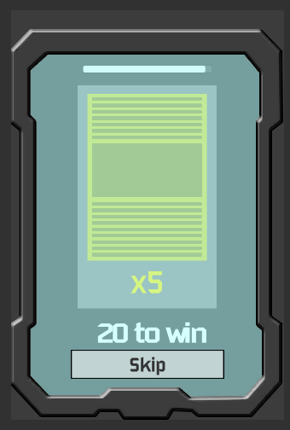

Skip the demand at the cost of a time penalty

How many demands to satisfy until winning

The amount of reports required

Time left

The report type being requested

Only one player may commit the reports. If no players can satisfy the demand, one of two things can happen:

* Players may trade 3 reports of any combination with another player. Players whom have already traded cannot trade with the same person until the next demand.
* Alternatively, players may press the “skip” button, discard their hands and draw back up to five, at the cost of a time penalty.

After reports have been committed, the player who committed them draws back up to five. If the draw pile is not large enough to draw back up, shuffle the discard pile back into the draw pile, and draw as normal.

Play continues until all demands have been satisfied, or the timer runs out.