

**Lime microsystems suite**

***- Compilation guide -***

|  |  |
| --- | --- |
| Document version: | 1.00 |
| Document revision: | 00 |
| Last modified: | 12/4/2014 3:07:00 PM |
|  |  |

**Contents**

1. Introduction 4
2. Installation and compilation of wxWidgets library 5

2.1 wxWidgets installation 5

1. EZ-USB FX3 SDK 7

3.1 EZ-USB FX3 SDK installation 7

1. FFTW 8

4.1 FFTW installation 8

1. lms-suite compilation 9

5.1 lms-suite compilation description 9

**Revision History**

**Version v01r01**

*Started: 12 Sep, 2014*

*Finished: 12 Sep, 2014*

Initial version

**Version v02r01**

*Started: 4 Dec, 2014*

*Finished: 4 Dec, 2014*

Switched to CMake build system

Introduction

The scope of this document is compilation of the lms-suite software on Windows OS.

Lms-suite uses wxWidgets, EZ-USB FX3 SDK and FFTW3 libraries, each of these libraries set-up is discussed first. Then detailed procedure of lms-suite compilation is provided.

Software required to compile lms-suite:

* CMake 2.8(or greater)
* Visual Studio 2013
* wxWidgets 3.0.0(or greater)
* EZ-USB FX3 SDK
* FFTW 3.3.4

Installation and compilation of wxWidgets library

Installation and compilation of wxWidgets library is covered in this chapter.

* 1. wxWidgets installation

Step by step instruction how to install, prepare and compile wxWidgets library is provided bellow:

1. Download wxWidgets source code or Installer from <http://wxwidgets.org/downloads/>
2. Install or extract wxWidgets 3.0.2 source code to the c:\wxWidgets-3.0.2\
3. Open C:\wxWidgets-3.0.2\build\msw\wx_vc12.sln Visual Studio 2013 solution
4. Select Release build as shown in Figure 1.

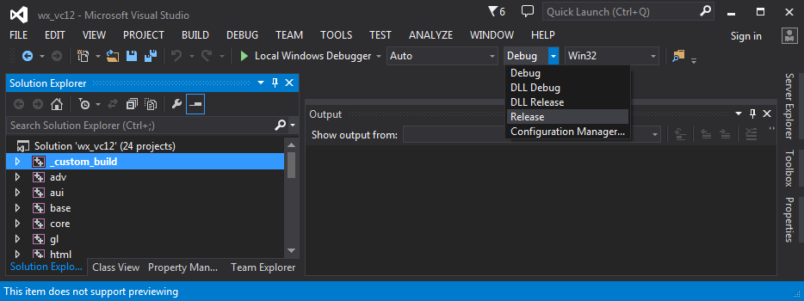

Figure 1 Selecting build target

1. Compile wxWidgets library by clicking PROJECT->BUILD SOLUTION as show in Figure 2

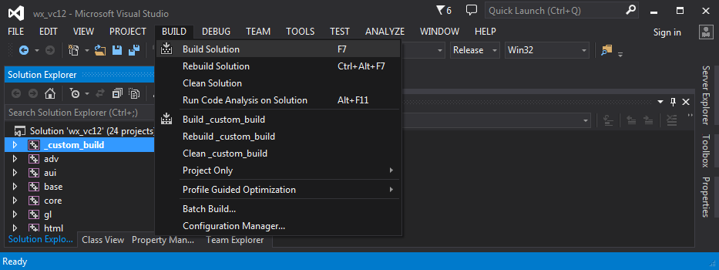

Figure 2 Compiling wxWidgets library

1. Wait for the compilation process to complete
2. After compilation there should be created wxWidgets libraries in C:\wxWidgets-3.0.2\lib\vc_lib directory

EZ-USB FX3 SDK

Setup of EZ-USB FX3 SDK is discussed in this chapter.

* 1. EZ-USB FX3 SDK installation

1. Download EZ-USB FX3 SDK for Windows from <http://www.cypress.com/?rID=57990>
2. Install it into C:\Cypress\EZ-USB FX3 SDK directory

FFTW

Setup of FFTW library is discussed in this chapter.

* 1. FFTW installation

1. Download precompiled DLLs (fftw-3.3.4-dll32.zip) for Windows from <http://www.fftw.org/install/windows.html>
2. Extract archive into C:\fftw-3.3.4-dll32 directory.

lms-suite compilation

Compilation instructions of lms-suite software is discussed in this chapter.

* 1. lms-suite compilation description

Lms-suite uses CMake system to setup build projects for your environment. First you need to install CMake system, you can download it from <http://www.cmake.org/download/>. To configure lms-suite project CMake-gui will be used in the instructions.

1. Place lms-suite folder into C:\lms-suite directory
2. Run cmake-gui
3. Browse source to where lms-suite source code is located. (e.g. C:/lms-suite/lms-suite/src)
4. Browse Build to where you want to place created binaries (e.g. C:/lms-suite/lms-suite/build)
5. Click Congifure button
6. In popup menu select Use default native compilers as shown in Figure 3

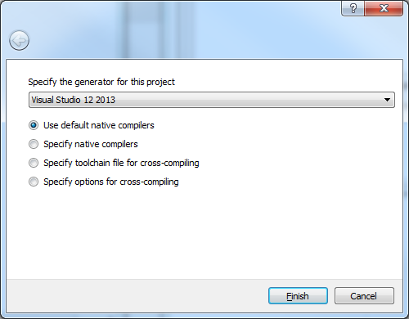

Figure 3 CMake project generator

1. Error dialog will popup informing that configuration process may be invalid and CMake window will show error of not found libraries as shown in Figure 4

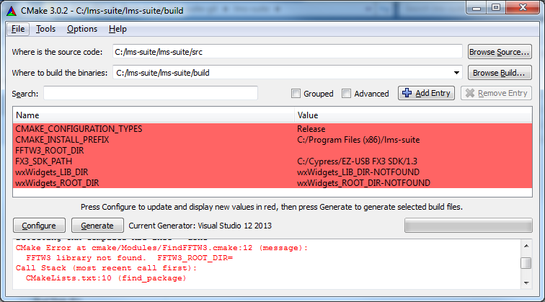

Figure 4 CMake not found libraries

1. Set FFTW3_ROOT_DIR value to directory where you placed FFTW library (e.g. C:\fftw-3.3.4-dll32)
2. Set wxWidgets_ROOT_DIR value to directory where you placed wxWidgets library (e.g C:\wxWidgets-3.0.2)
3. Click Configure
4. Click Generate, this will create Visual Studio project inside your selected build directory
5. Open created project C:\lms-suite\lms-suite\build\lms-suite.sln
6. In Visual Studio menu select BUILD->Build Solution
7. Wait for compilation process to complete
8. Compiled binaries will be places inside build directory in Release folder
9. Execute lms-suite.exe, lms-suite needs to have libfftw3f-3.dll file in the same directory