“想书”——分享你的生活

需求分析文档

日期 | 修改 | 描述
2022年3月31日 | 1.0 | 顺序图初始版本
2022年4月5日 | 1.1 | 去掉UI界面，增加了Netizen类

CRC卡
Netizens can scan other netizens’ jottings and comment on the contents of the jottings to communicate with other netizens. In addition, netizen can also publish their own ideas in the form of jottings for other netizens to scan and comment.

Netizen
Responsibilities | Collaborations
Provide netizen information.  Add a new jotting.  Add a new comment.z  Receive a new message. | Jotting constructs new object.  Comment constructs new object.  Message provides message details.

Jotting
Responsibilities | Collaborations
Provide jotting information.  Provide list of comments.  Add a new comment.  Construct jottings. | Comment provides comment details.  Comment constructs new object.

Comment
Responsibilities | Collaborations
Provide comment details.  Construct comments. | Message constructs new object.

Message
Responsibilities | Collaborations
Provide message details.
Construct messages.

顺序图——浏览笔记
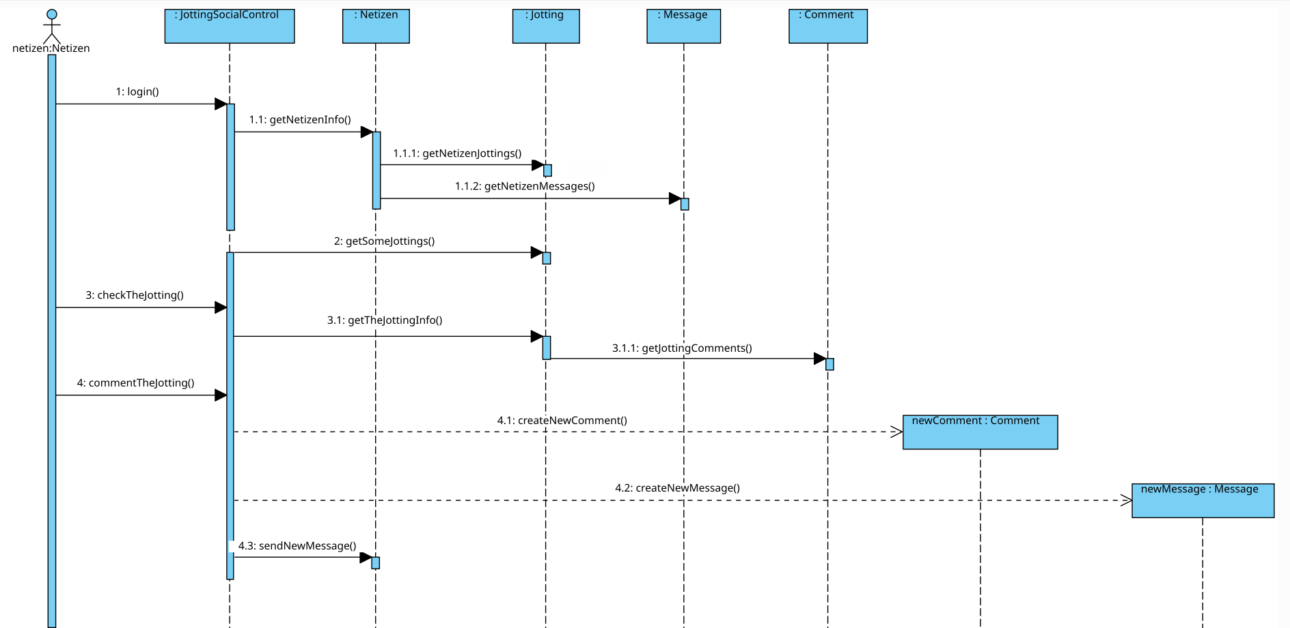

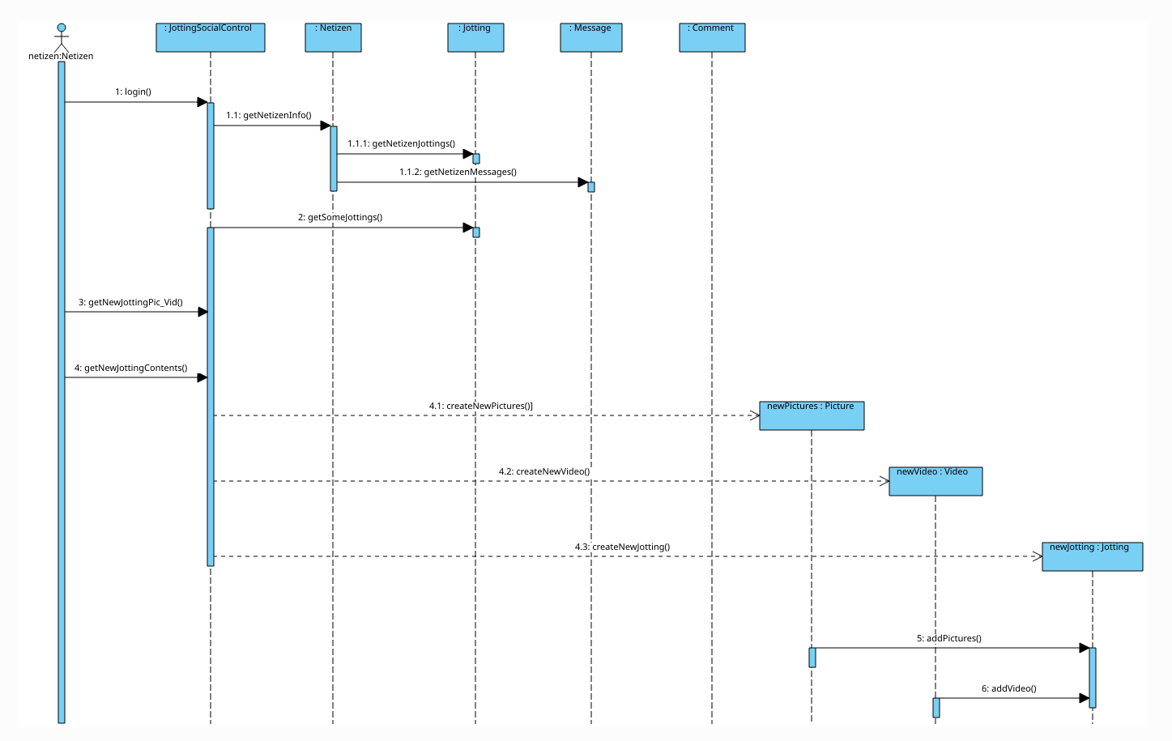
顺序图——发布笔记

