Goal
The aim of this exercise is to explore Probability Distributions and Bayesian Networks. The data-set in use is data of U.S. universities obtained from :
X1 (CS ranking score) = <http://grad-schools.usnews.rankingsandreviews.com/best-graduate-schools/>
X2 (research Overload) = Portion of research grants obtained from each university’s website
X3 (Admin base salary) = http://chronicle.com/factfile/ec-2015/#id=table_public_2014
X4 (Out of state tuition) = http://colleges.usnews.rankingsandreviews.com/best-colleges/rankings/
X5 (Number of CS grads in Fall 2015) = Mostly from each college’s website
It is a multivariate data-set with four variables and a fifth with some missing values. The missing values are provided separately in UniversityData.xls.
We will use Bayesian network tp determine some interesting conditional probabilities.

Introduction
Using​ ​Python​ ​and​ ​libraries​ ​like​ ​pandas,​ ​numpy,​ ​scipy,​ ​scikit-learn​ ​to​ ​process​ ​the​ ​given
dataset​ ​we​ ​could​ ​glean​ ​metrics​ ​like​ ​the​ ​mean,​ ​variance,​ ​standard​ ​deviation​ ​of​ ​variables.
We​ ​also​ ​analyze​ ​the​ ​significance​ ​of​ ​parameters​ ​like​ ​correlation,​ ​covariance,​ ​etc.
Also​ ​by​ ​calculating​ ​the​ ​log​ ​likelihood​ ​we​ ​can​ ​estimate​ ​the​ ​goodness​ ​of​ ​fit​ ​of​ ​the​ ​joint
probability​ ​density​ ​of​ ​the​ ​four​ ​variables​ ​we​ ​are​ ​concerned​ ​with.

Results
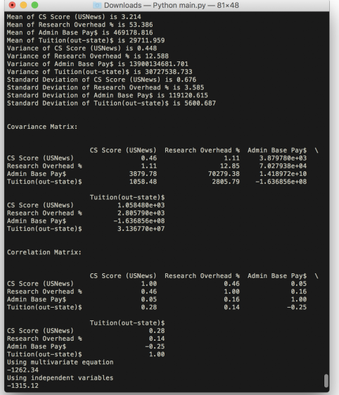

Results​ ​of​ ​the​ ​script

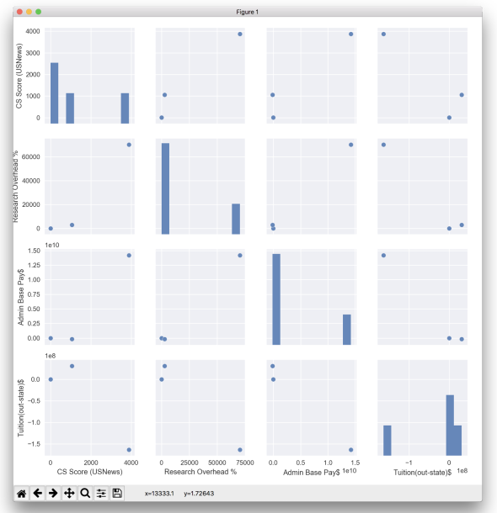
Seaborn​ ​visualization​ ​of​ ​Covariance​ ​Matrix

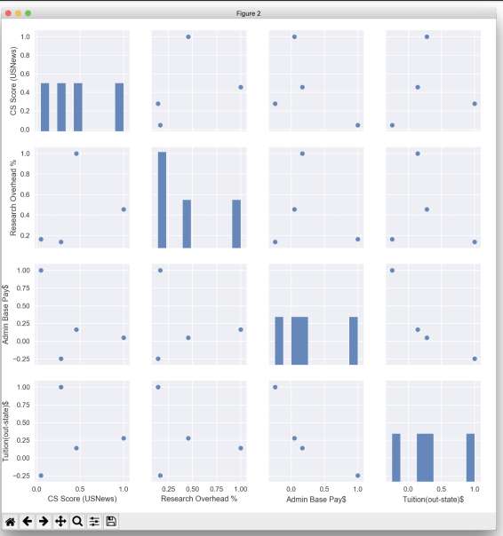
Pairwise​ ​Plot​ ​of​ ​Correlation​ ​Matrix

Interpretation
1. The​ ​obtained​ mean​ ​ ​value​ ​of​ ​CS​ ​score​ ​signify​ ​that​ ​the​ ​Universities​ ​scoring​ ​greater
than​ ​3.3​ ​can​ ​be​ ​safely​ ​categorized​ ​as​ ​good​ ​universities​ ​for​ ​CS​ ​course.
2. Similarly,​ ​universities​ ​with​ ​research​ ​overhead​ ​%​ ​greater​ ​than​ ​the​ ​ mean​ ​ ​value​ ​of​ ​53
can​ ​be​ ​regarded​ ​as​ ​research​ ​oriented​ ​universities.​ ​Also,​ ​the​ ​tuition​ ​of​ ​universities
lower​ ​than​ ​$29,711​ ​are​ ​affordable.​ ​Students​ ​can​ ​benefit​ ​with​ ​such​ ​vital​ ​information,
so​ ​as​ ​to​ ​decide​ ​which​ ​universities​ ​to​ ​choose​ ​during​ ​their​ ​university​ ​application process.
3. Variance​ ​ ​helps​ ​student​ ​gauge​ ​the​ ​impact​ ​of​ ​various​ ​criteria​ ​while​ ​looking​ ​for​ ​a
suitable​ ​university.​ ​As​ ​the​ ​low​ ​variation​ ​in​ ​CS​ ​ranking​ ​and​ ​research​ ​overhead
coupled​ ​with​ ​much​ ​greater​ ​variance​ ​in​ ​tuition​ ​suggest​ ​that​ ​the​ ​student​ ​must​ ​aim​ ​for
a​ ​university​ ​that​ ​provides​ ​education​ ​at​ ​lower​ ​tuitions​ ​as​ ​most​ ​of​ ​the​ ​most​ ​of​ ​the
universities​ ​are​ ​abreast​ ​in​ ​rest​ ​of​ ​the​ ​criteria.
4. Standard​ ​deviation​ ​ ​on​ ​the​ ​other​ ​hand​ ​would​ ​help​ ​an​ ​admin​ ​choose​ ​which
university​ ​would​ ​pay​ ​him​ ​the​ ​best.​ ​Universities​ ​tend​ ​to​ ​show​ ​a​ ​great​ ​deviation​ ​from
the​ ​mean​ ​payment,​ ​thus​ ​smartly​ ​choosing​ ​the​ ​university​ ​would​ ​yield​ ​the​ ​best
payment.
5. We​ ​can​ ​observe​ ​a​ ​high​ correlation​ ​ ​between​ ​the​ ​values​ ​of​ ​CS​ ​Score​ ​and​ ​Research
overhead​ ​indicating​ ​that​ ​universities​ ​with​ ​ ​high​ ​CS​ ​score​ ​tend​ ​to​ ​high​ ​research spendings.
6. Covariance​ ​matrix​ ​ ​shows​ ​us​ ​that​ ​the​ ​universities​ ​that​ ​invest​ ​heavily​ ​on​ ​research
tend​ ​to​ ​have​ ​higher​ ​admin​ ​base​ ​pay​ ​variations.​ ​Thus,​ ​someone​ ​seeking​ ​employment
at​ ​such​ ​university​ ​must​ ​consider​ ​this​ ​deductions.
7. Log-likelihood​ ​ ​ ​value,​ ​is​ ​used​ ​to​ ​evaluate​ ​goodness-of-fit​ ​for​ ​data​ ​models.​ ​In​ ​the
case​ ​of​ ​our​ ​dataset​ ​the​ ​negative​ ​value​ ​denotes​ ​that​ ​we​ ​have​ ​a​ ​large​ ​dataset.​ ​For
further​ ​use​ ​of​ ​the​ ​likelihood​ ​we​ ​must​ ​apply​ ​it​ ​to​ ​different​ ​representative​ ​functions
and​ ​the​ ​highest​ ​likelihood​ ​would​ ​signify​ ​best​ ​fit.

