Classifying New York Times articles

Three main sections:
Data Collection
Feature Extraction
Classfication

Data Collection
- New York Times articles are used as input Source and nytimesarticle API in Python is used for article extraction and BeautifulSoup is used for crawling the article urls collected
- A dynamic script “Part2/code/dataCollection/nyTimesArticleExtraction.py” is implemented which will collect new data and write the articles collection to “Part2/data/...” folders based on the category
- A total of 75 articles in each classes for training will be used. 30 for testing and 10 other articles from Chicago Tribune as Unknowndata to test the efficiency of our implementation
- Script is capable of taking multiple keywords and scraping multiple pages at once

Method to extract the content of an NYTimes url
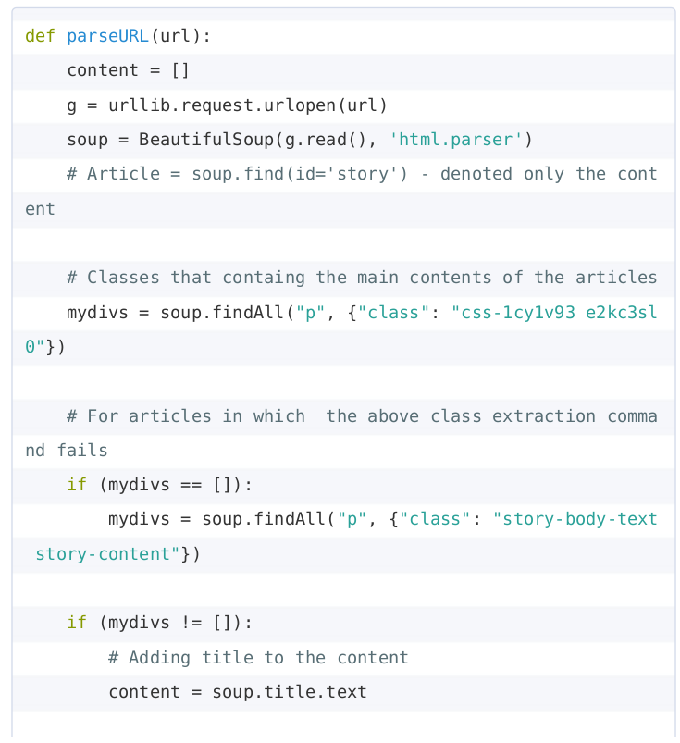
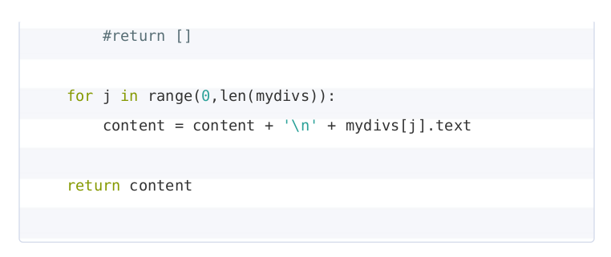

Method to collect articles from NYTimes and save them
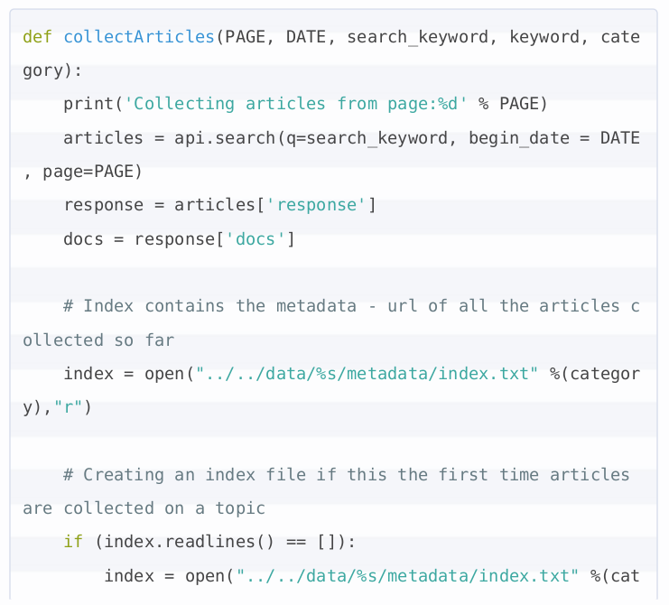

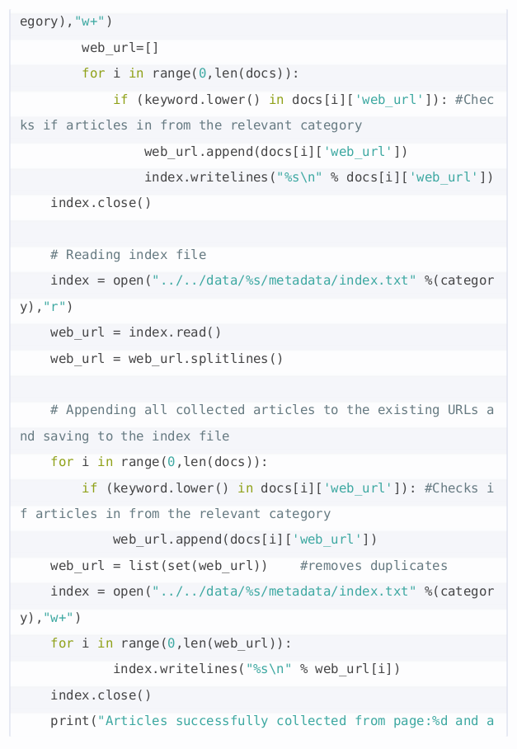
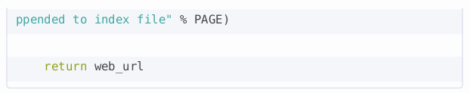

Feature Extraction
- Created script file “Part2/code/featureExtraction/featureExtraction.py” to extract top 20 features and create a feature matrix for training, testing and unknown data-sets separately
- Data is cleaned before extracting features and stop words are removed from the articles
- The Feature Extraction script when compiled, creates a Feature Matrix in “SVM” format which is used to train classifiers featureMatrixTrainingdata.txt → used for training classfier modes featureMatrixTestinggdata.txt, featureMatrixUnknowndata.txt → used for evaluating the models

Method to extract top 20 features of a class

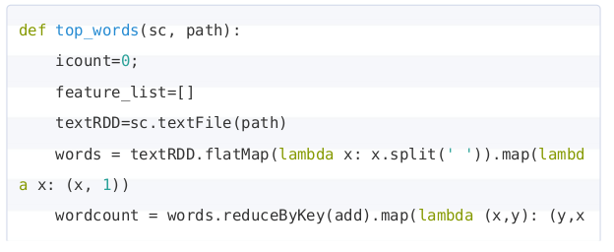
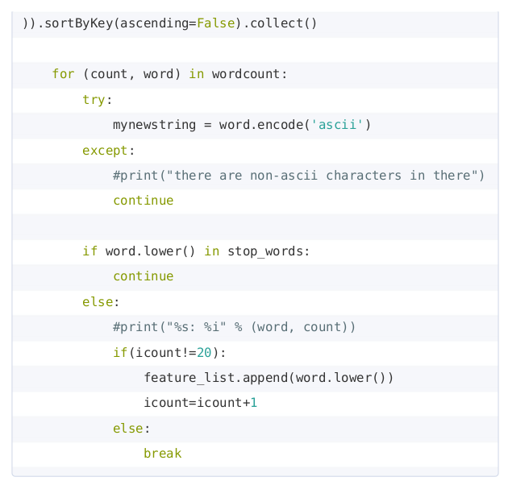

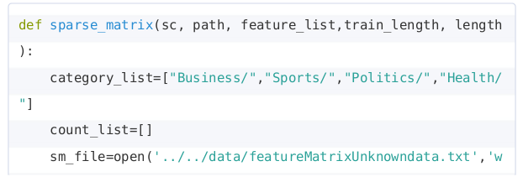
Method to create and write feature matrix for a dataset

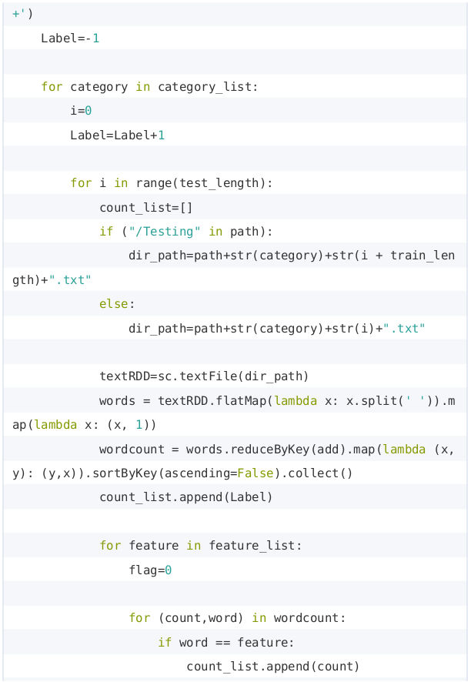

Building Classifiers
- Built a Naive Bayes and Neural Network Classifier (“Part2/code/mlclassifiers/*.py”
- Each of these classifers takes in the feature matrix from training data - extracted in the previous step and trains a classification model
- The model is then tested using the Test and Unknown feature Matrix

Naive Bayes Classifier
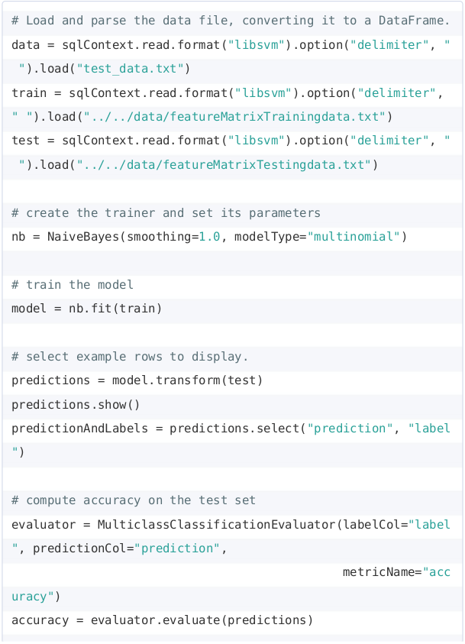

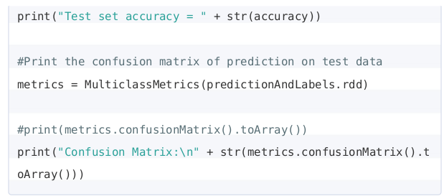

Results
Test set accuracy = 94.16%

Confusion Matrix:
[27 - 0 - 2 - 1]
[0 - 30 - 0 - 0]
[2 - 0 - 28 - 0]
[1 - 0 - 1 – 28]

Unknown dataset accuracy = 80.00%

Confusion Matrix:
[[ 3 - 0 - 0 - 2]
[ 0 - 4 - 1 - 0]
[ 0 - 0 - 4 - 1]
[ 0 - 0 - 0 – 5]]

Neural Network Classifier
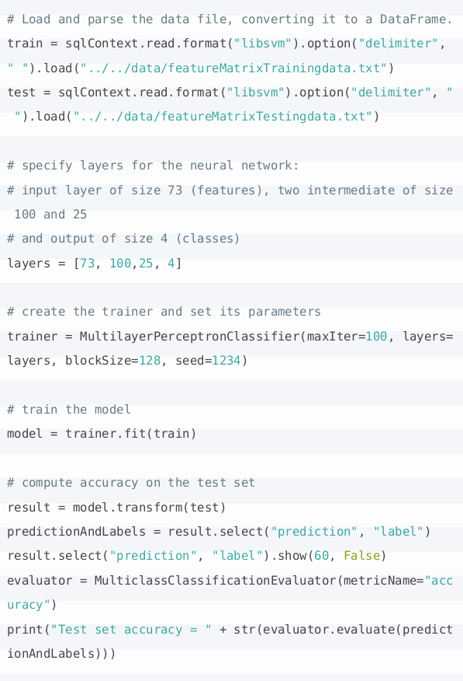

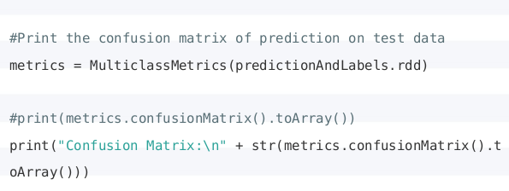

Results
Test set accuracy = 90.00%

Confusion Matrix:
[[ 27 - 0 - 2 - 1]
[ 1 - 28 - 1 - 0]
[ 3 - 0 - 26 - 1]
[ 1 - 0 - 2 - 27]]

Unknown set accuracy = 75.00%

Confusion Matrix:
[[ 3 - 0 - 0 - 2]
[ 1 - 4 - 0 - 0]
[ 1 - 0 - 4 - 0]
[ 0 - 1 - 0 - 4]]

