**Documentation**

**Part 1.**

**API Key**

Made an API Key from google map platform

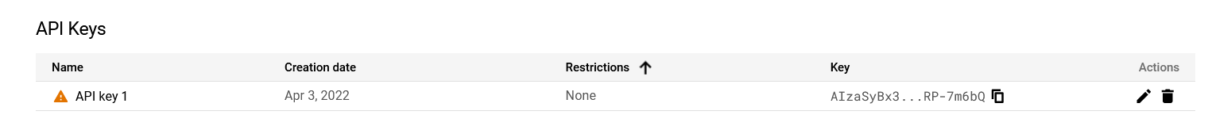



“com.google.maps.errors.RequestDeniedException: You must enable Billing on the Google Cloud Project at https://console.cloud.google.com/project/_/billing/enable Learn more at <https://developers.google.com/maps/gmp-get-started>”

**QR**

ZXing api

QR being made in the path but not displaying on a html page

**Part 2**

**Strengths**

Trying my hardest but getting to a bit when I get stuck cant find a way around it.

**Weaknesses**

Not giving myself enough time to put in the work.

**Part 3**