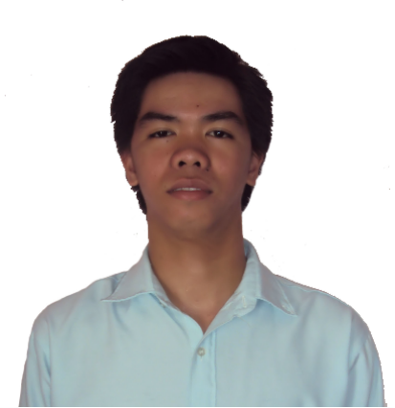
RAMOS, ROBERT R.
Chang Ombe, Dar Es Salaam,
Tanzania
Contact #: +255778042117
Email Add. robert_ramos20@ymail.com

WORKING EXPERIENCE:
DRI CO INC.
Contractor of Globe Telecoms
Telecoms Engineer
March 7, 2012 – January 8, 2013

Duties and Responsibilities:
-Locating Client location in Google Earth and also Location of BTS link up given by Globe Telecoms.
-Do actual survey of line of sight location (LOS) between Client and BTS for Microwave installation that gives internet connection to the client.
-Proposed Antenna Pole location and Server rack location in Client side.
-Proposed and captured photos of cable way from server rack up to antenna location.
-Proposed Antenna Mounting Bracket location (AMB) and Transmission rack in BTS side.
-Proposed and captured photos of cable way from AMB to Transmission rack.
-Filled up a Site Data Form that will give details and content of all the equipment inside the Cabin of the tower.
-Do a power point presentation that shows complete details in actual survey.
-Designing Poles and Bracket using Google Sketch up that will need for the installation of microwave antenna.
-Prepare and buy materials needed for installation of microwave antenna in client and BTS side.
-Coordinate to Client and Globe Telecoms and secure all the necessary permits and requirements before the deployment of installation team.
-Coordinate and guide installation team, and give them a time line about the installation of microwave.
-When the installation is done, I prepare the BOQ (Bills of Quantity) all
Company’s expenses are covered by this.
-I send the BOQ and Installation Report to Globe Telecoms, after the project is done and for billing purpose

Bayan Telecommunicationare
Plant Operations Department
Dispatch Engineer
September 15, 2010 – June 30, 2011

Duties and Responsibilities:
-Monitor the SO( Service Order) number, using the IBM ICMS software whether it is in the proper stage for Dispatch and also follow the proper staging.
-Dispatch the SO number both for Telephone and DSL to the Designated contractor.
-Staging the RSO (Return Service Order) to its right stage, this are the SO number that the contractor unable to install due to different reasons.
-Fault Ticket Closeout – staging to Closeout stage the ticket number if the contractor finish the repair to telephone. The contractor send a file for our reference for closeout.
-Answering the email send by the contractor and by the Encoder with regards to the Dispatch and RSO.

ABS – CBN Broadcasting Corporation
Broadcast Quality Management, Technical Operating Division
Intern
May 28, 2009 – October 2, 2009

Duties and Responsibilities:
-Monitoring the Audio and Video Discrepancies happened in On Air Program and log it in our Daily Discrepancy log sheet.
-We are deploying in different department to monitor if the department are following the standard procedure of calibrating the Color bars.
-Monitoring the Video tapes and materials feeds coming from different provinces and remotes area if they are containing Audio and Video Discrepancies and knowing the cause why it is happen.
-Making weekly reports of all the Discrepancies we monitor and sending it to our head for verification and questioning.

SKILLS:
Microsoft Office ( Word, Excel and Power Point)
Microsoft Visio
Google Sketch Up

EDUCATIONAL BACKGROUND:

TERTIARY: Bachelor of Science in Electronics and Communication Engineering
Rizal Technological University
Boni ave. Mandaluyong city, Philippines
2005 – 2010

SECONDARY: Antipolo National High School
Antipolo city
` 2001 – 2005

ACHIEVEMENT:
Career Service Professional Examination
University of Rizal System
Morong, Rizal
October 17, 2010

SEMINAR ATTENDED:

Tele – Sales ICMS 5.1 Systems Training
Bayan Telecommunications Buliding, QC
September 17 -29, 2010, ROC

Basic Audio and Video for EFP Cameramen ( Back to Basic)
Basement Eng’g. Conf. Room,Main Bldg.
ABS – CBN Broadcasting Corporation
June 27, 2009

Digital TV
Rizal Technological University
September 17, 2008

Surface – Mounted Technology
Rizal Technological University
July 11, 2008

DESIGNED STUDY:
WireLess Technology – Microwave Communication System
June 2009 – October 2009

Wired Technology – Telephony
June 2009 – October 2009

Broadcasting – Cable Television System
June 2010 – October 2010

Communication System Technology – Virtual Private Network (VPN)
June 2010 – October 2010

ORGANIZATION AFFILIATION:

College of Electronics and Communications Engineering Society (ECES)
Rizal Technological University
Boni Avenue, Mandaluyong City

Institute of Electronic Engineers in the Philippines (IECEP) – member

PERSONAL DATA:
Age: 23
Date of Birth: May 22, 1989
Place of Birth: Antipolo City
Citizenship: Filipino
Civil Status: Single
Gender: Male
Religion: Roman Catholic
Height: 5’6
Weight: 120 lbs.

CHARACTER REFERENCE:
Engr. Gerald Gumba
Fiber Optic Cable Department
Global Destiny
+639392972648

Ms. Edlyn Dorado
Supervisor / Team Leader
Plant Operations Department
Bayan Telecommunication
09397736606

Mr. Ceasar Carrillo
Operation Manager
DRI CO INC.
09175799006

I hereby swear that the above information are true and correct to the best of my knowledge.
ROBERT R. RAMOS

