From the Masaki Peninsula
From Chole Road, turn onto Kimweri Road.
Follow Kimweri Road past the Irish Pub and then take a right turn at the signs for “Imaging Plus” & “Access Africa”. It’s a tarmac road that turns into a dirt road. Follow this road past the Msasani fish market and the big baobab tree. After the baobab, the road curves hard to the left. After the hard left curve, take the second dirt road on the right. This is across from a school with a broken cement wall.
Follow this road all the way through Msasani Village until the very end. At the T junction, take a right turn, and then an immediate left turn. This is our street; the house is the second gate on the right side, just after the gate with the sign for Unilever Tea Company. It’s a big white wall, big white metal gate, plot number 6.
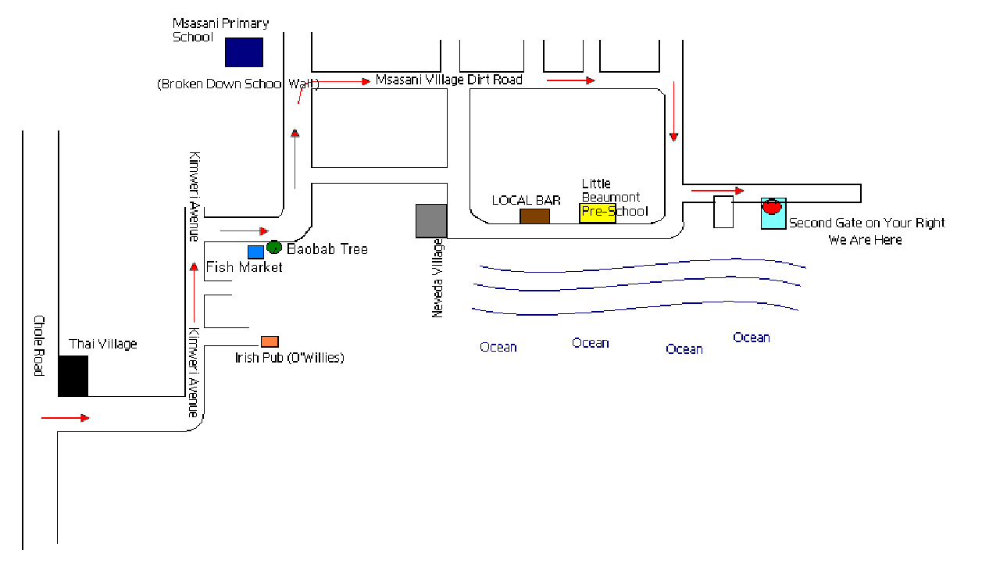

From Ali Hassan Mwinyi
Heading out of the City on Ali Hassan Mwinyi, take a right onto Kawawa/Old Bagamoyo towards Shoppers Plaza and Markham Plaza. Pass Shoppers Plaza on your left and Markahm Plaza on your right. Just after the Tanesco building and directly across from the Engen petrol station and Barclays Bank, take a right turn onto the dirt road. Then take the first left turn onto a narrow dirt road. Then, take the 2nd left turn onto another dirt road - this our street. (If you reach the beach front, you passed our street). The house is the second gate on the right side, just after the gate with the sign for Unilever Tea Company. It’s a big white wall, big white metal gate, plot number 6.

From Mikocheni
Take Old Bagamoyo towards Shoppers Plaza and Markham Plaza. Across from the Barclays Bank and the Engen petrol station, and just before the Tanesco building, take a left turn onto the dirt road. Then take the first left turn onto a narrow dirt road. Then, take the 2nd left turn onto another dirt road - this our street. (If you reach the beach front, you passed our street). The house is the second gate on the right side, just after the gate with the sign for Unilever Tea Company. It’s a big white wall, big white metal gate, plot number 6.

