**Problem Description**

Base on the transition probabilities of states and the emission probabilities to create an HMM. Then use HMM to give the most likely explanation of the state given the observation.

Files

My project contains four python files, including app.py, CustomerHMM.py, utlis.py, and State.py. Besides, there are a report document and a folder that contains different test input files.

How to run the script

1. Use python3 to run app.py.

2. If you want to test other input files, you can replace 'hmm_customer_1586733275338.txt' with other input files.

Output

Table 1 shows the Transition probabilities of states.

***Table 1*** Transition probabilities of states

|  |  |  |  |  |  |  |
| --- | --- | --- | --- | --- | --- | --- |
| State | Zero | Aware | Considering | Experiencing | Ready | Lost |
| Zero | 0.6 | 0.4 | 0.0 | 0.0 | 0.0 | 0.0 |
| Aware | 0.0 | 0.49 | 0.3 | 0.0 | 0.01 | 0.2 |
| Considering | 0.0 | 0.0 | 0.48 | 0.2 | 0.02 | 0.3 |
| Experiencing | 0.0 | 0.0 | 0.0 | 0.4 | 0.3 | 0.3 |
| Ready | 0.0 | 0.0 | 0.0 | 0.0 | 0.8 | 0.2 |
| Lost | 0.0 | 0.0 | 0.0 | 0.0 | 0.0 | 1.0 |

Table 2 shows the Emission probabilities.

***Table 2*** Emission probabilities

|  |  |  |  |  |  |  |  |
| --- | --- | --- | --- | --- | --- | --- | --- |
| stage | Demo | Video | Testimonial | Pricing | Blog | Payment | not click |
| Zero | 0.1 | 0.01 | 0.05 | 0.3 | 0.5 | 0.0 | 0.30 |
| Aware | 0.1 | 0.01 | 0.15 | 0.3 | 0.4 | 0.0 | 0.32 |
| Considering | 0.2 | 0.3 | 0.05 | 0.4 | 0.4 | 0.0 | 0.19 |
| Experiencing | 0.4 | 0.6 | 0.05 | 0.3 | 0.4 | 0.0 | 0.10 |
| Ready | 0.05 | 0.75 | 0.35 | 0.2 | 0.4 | 0.0 | 0.07 |
| Lost | 0.01 | 0.01 | 0.03 | 0.05 | 0.2 | 0.0 | 0.72 |
| Satisfied | 0.4 | 0.4 | 0.01 | 0.05 | 0.5 | 1.0 | 0.0 |

There are seven states, including Zero, Aware, Considering, Experiencing, Ready, Lost, and Satisfied. In Table 1, I only display six states because we don’t need to infer the Satisfied state. If a user clicks the payment link, this state must be the Satisfied state. At here, the Satisfied state is merely included here for completeness of the journey.

The initial probabilities of my code show as following:

P(Zero) = 1.0

P(Aware) = P (Considering) = P(Experiencing) = P(Ready) = P(Lost) =0

My code will print the most likely sequence of states, which is the most likely explanation of the state given the observations. Figure 1 shows the result of my code.

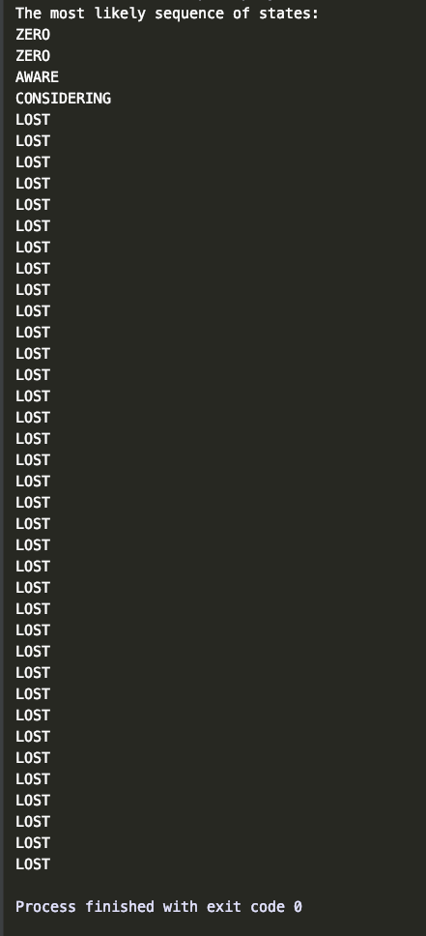

Figure 1