Database Systems (Jukic)
Chapter 3 Relational Database Modeling

3.1 Multiple Choice Questions

1) Tuple is a synonym for
A) Column
B) Field
C) Row
D) Table
Answer: C
Diff: 1 Page Ref: 57

2) Relation is a synonym for
A) Column
B) Field
C) Row
D) Table
Answer: D
Diff: 1 Page Ref: 57

3) Which of the following is NOT true? In a relational database:
A) Two tables can be a part of the same database
B) Two tables can have the same number of columns
C) Two tables can have the same number of rows
D) Two tables can have the same names
Answer: D
Diff: 2 Page Ref: 57-58

4) Which of the following is NOT true? In a relational table:
A) Two columns can have the same values
B) All column names are different
C) Two rows can have the same values
D) All values in a column are from the same domain
Answer: C
Diff: 2 Page Ref: 57-58

5) Which of the following statements regarding the table below is true?
ColumnA | ColumnB | ColumnC

A) Every value in Column A is unique
B) Every value in Column B is unique
C) Every combination of values in Column A and Column B within the same row is unique
D) All of the above
Answer: C
Diff: 2 Page Ref: 61
6) If a 1:M relationship is optional on the 1 side and mandatory on the M side, which of the following is true?
A) The resulting foreign key can have null (empty) values
B) The resulting foreign key cannot have null (empty) values
C) The resulting foreign key must have null (empty) values
D) No foreign key is created as a result of mapping such a relationship
Answer: A
Diff: 3 Page Ref: 64-65

7) If a 1:M relationship is optional on both sides, which of the following is true?
A) The resulting foreign key can have null (empty) values
B) The resulting foreign key cannot have null (empty) values
C) The resulting foreign key must have null (empty) values
D) No foreign key is created as a result of mapping such a relationship
Answer: A
Diff: 2 Page Ref: 64-65

8) If a 1:M relationship is mandatory on the 1 side and optional on the M side, which of the following is true?
A) The resulting foreign key can have null (empty) values
B) The resulting foreign key cannot have null (empty) values
C) The resulting foreign key must have null (empty) values
D) No foreign key is created as a result of mapping such a relationship
Answer: B
Diff: 3 Page Ref: 64-65

9) If a 1:M relationship is mandatory on both sides, which of the following is true?
A) The resulting foreign key can have null (empty) values
B) The resulting foreign key cannot have null (empty) values
C) The resulting foreign key must have null (empty) values
D) No foreign key is created as a result of mapping such a relationship
Answer: B
Diff: 3 Page Ref: 64-65

10) If a 1:M relationship is mandatory on the M side and optional on the 1 side, and if the table resulting from the 1 side has 3 records, then the table resulting from the M side cannot have less than ________ records.
A) 0
B) 1
C) 2
D) 3
Answer: D
Diff: 2 Page Ref: 64-65
11) If a 1:M relationship is optional on the M side and mandatory on the 1 side, and if the table resulting from the 1 side has 3 records, then the table resulting from the M side CANNOT have less than ________ records.
A) 0
B) 1
C) 2
D) 3
Answer: A
Diff: 3 Page Ref: 64-65

12) If a 1:M relationship is optional on both sides, and if the table resulting from the 1 side has 3 records, then the table resulting from the M side CANNOT have less than ________ records.
A) 0
B) 1
C) 2
D) 3
Answer: A
Diff: 3 Page Ref: 64-65

13) If a 1:M relationship is mandatory on both sides, and if the table resulting from the 1 side has 3 records, then the table resulting from the M side CANNOT have less than ________ records.
A) 0
B) 1
C) 2
D) 3
Answer: D
Diff: 3 Page Ref: 64-65

14) Which of the following is NOT true? Mapping an M:N relationship that has no attributes will result in:
A) A new relation
B) Two foreign keys
C) A composite primary key
D) A foreign key in both of the relations mapped from the involved entities
Answer: D
Diff: 1 Page Ref: 66-68

15) If an M:N relationship is optional on both sides, and if both relations resulting from the entities involved in the relationship each have 3 records, then the resulting bridge relation cannot have less than ________ records.
A) 0
B) 1
C) 3
D) 9
Answer: A
Diff: 3 Page Ref: 66-68
16) If an M:N relationship is mandatory on both sides, and if both relations resulting from the entities involved in the relationship each have 3 records, then the resulting bridge relation cannot have less than ________ records.
A) 0
B) 1
C) 3
D) 9
Answer: C
Diff: 3 Page Ref: 66-68

17) If an M:N relationship is mandatory on one side and optional on the other side, and if both relations resulting from the entities involved in the relationship each have 3 records, then the resulting bridge relation cannot have less than ________ records.
A) 0
B) 1
C) 3
D) 9
Answer: C
Diff: 3 Page Ref: 66-68

18) If an entity has three unique attributes, how many primary keys will its mapped relation have?
A) 0
B) 1
C) 2
D) 3
Answer: B
Diff: 1 Page Ref: 71-72

19) An entity with two multivalued attributes will be mapped as how many relations?
A) 1
B) 2
C) 3
D) 4
Answer: C
Diff: 2 Page Ref: 72-73

20) An ER diagram that contains two entities involved in two separate M:N relationships will be mapped as how many relations?
A) 1
B) 2
C) 3
D) 4
Answer: D
Diff: 2 Page Ref: 76
21) A relation resulting from a weak entity has a non-composite primary key when the identifying relationship is:
A) Optional on both sides
B) 1:1
C) 1:M
D) M:N
Answer: B
Diff: 3 Page Ref: 77-78

22) Autonumber data type option:
A) Automatically converts the existing data type into a number type
B) Assigns a number to each of the used data types
C) Enables automatic generation of consecutive numeric data values in a column
D) Enables automatic counting of columns in a table
Answer: C
Diff: 2 Page Ref: 84-85

23) How many columns will a relation resulting from mapping the Entity X have?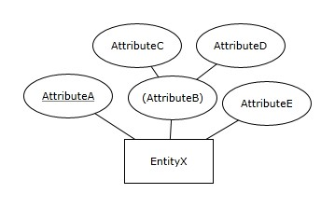
A) 2
B) 3
C) 4
D) 5
Answer: C
Diff: 2 Page Ref: 60-61
24) How many columns will a relation resulting from mapping the Entity Y have?
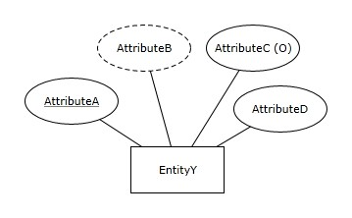
A) 2
B) 3
C) 4
D) 5
Answer: B
Diff: 2 Page Ref: 73

ABC RETAILER
Observe the ER diagram for the ABC Retailer: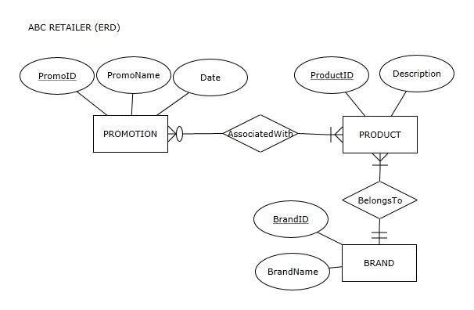
This ER diagram will be used for the following questions citing ABC Retailer ER Diagram.

25) How many tables will the relational schema mapped from the ABC Retailer ER diagram have?
A) 2
B) 3
C) 4
D) 5
Answer: C
Diff: 2 Page Ref: 59-70

26) How many columns will the relation PROMOTION have in the relational schema mapped from the ABC Retailer ER diagram?
A) 2
B) 3
C) 4
D) 5
Answer: B
Diff: 2 Page Ref: 59-70
27) How many columns will the relation PRODUCT have in the relational schema mapped from the ABC Retailer ER diagram?
A) 2
B) 3
C) 4
D) 5
Answer: B
Diff: 2 Page Ref: 59-70

28) How many columns will the relation BRAND have in the relational schema mapped from the ABC Retailer ER diagram?
A) 2
B) 3
C) 4
D) 5
Answer: A
Diff: 2 Page Ref: 59-70

29) How many foreign keys will the relational schema mapped from the ABC Retailer ER diagram have?
A) 0
B) 1
C) 2
D) 3
Answer: D
Diff: 2 Page Ref: 59-70

30) How many optional columns will the relational schema mapped from the ABC Retailer ER diagram have?
A) 0
B) 1
C) 2
D) 3
Answer: A
Diff: 3 Page Ref: 59-70
CENTRAL SCHOOL LIBRARY
Observe the ER diagram for the CENTRAL SCHOOL LIBRARY
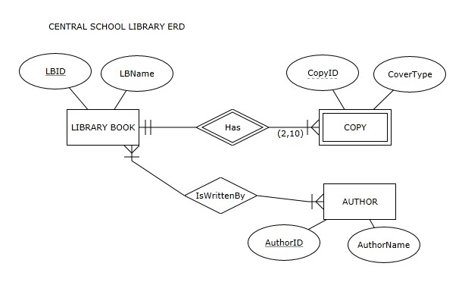
This ER diagram will be used for the following questions citing Central School Library ER Diagram.

31) How many tables will the relational schema mapped from the Central School Library ER diagram have?
A) 2
B) 3
C) 4
D) 5
Answer: C
Diff: 2 Page Ref: 59-80

32) How many bridge tables will the relational schema mapped from the Central School Library ER diagram have?
A) 0
B) 1
C) 2
D) 3
Answer: B
Diff: 2 Page Ref: 59-80
33) How many columns will the relation LIBRARY BOOK have in the relational schema mapped from the Central School Library ER diagram?
A) 2
B) 3
C) 4
D) 5
Answer: A
Diff: 2 Page Ref: 59-80

34) How many columns will the relation COPY have in the relational schema mapped from the Central School Library ER diagram?
A) 2
B) 3
C) 4
D) 5
Answer: B
Diff: 2 Page Ref: 59-80

35) How many columns will the relation AUTHOR have in the relational schema mapped from the Central School Library ER diagram?
A) 2
B) 3
C) 4
D) 5
Answer: A
Diff: 2 Page Ref: 59-80

36) How many tables in the relational schema mapped from the Central School Library ER diagram will have composite primary keys?
A) 0
B) 1
C) 2
D) 3
Answer: C
Diff: 3 Page Ref: 59-80

37) How many foreign keys will the relational schema mapped from the Central School Library ER diagram have?
A) 0
B) 1
C) 2
D) 3
Answer: D
Diff: 2 Page Ref: 59-70
38) How many foreign keys in the relational schema mapped from the Central School Library ER diagram serve as a component of a primary key?
A) 0
B) 1
C) 2
D) 3
Answer: D
Diff: 3 Page Ref: 59-70

39) How many optional columns will the relational schema mapped from the Central School Library ER diagram have?
A) 0
B) 1
C) 2
D) 3
Answer: A
Diff: 2 Page Ref: 59-70

40) What is the minimal number of records that can be entered in the database whose relational schema is mapped from the Central School Library ER diagram?
A) 1
B) 4
C) 5
D) 12
Answer: C
Diff: 3 Page Ref: 59-70
EAGLERUN TRUCKING DISPATCHER
Observe the ER diagram for the Eaglerun Trucking Dispatcher: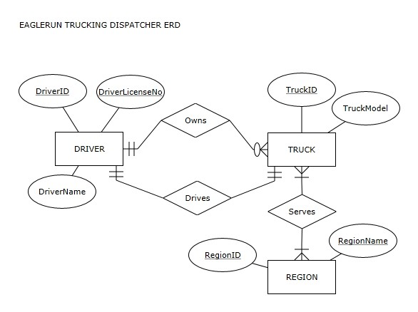
This ER diagram will be used for the following questions citing Eaglerun Trucking Dispatcher ER Diagram.

41) How many tables will the relational schema mapped from the Eaglerun Trucking Dispatcher ER diagram have?
A) 2
B) 3
C) 4
D) 5
Answer: C
Diff: 2 Page Ref: 59-80

42) How many bridge tables will the relational schema mapped from the Eaglerun Trucking Dispatcher ER diagram have?
A) 0
B) 1
C) 2
D) 3
Answer: B
Diff: 2 Page Ref: 59-72
43) How many columns will the relation DRIVER have in the relational schema mapped from the Eaglerun Trucking Dispatcher ER diagram?
A) 0 or 1
B) 1 or 2
C) 2 or 3
D) 3 or 4
Answer: D
Diff: 2 Page Ref: 59-72

44) How many columns will the relation TRUCK have in the relational schema mapped from the Eaglerun Trucking Dispatcher ER diagram?
A) 0 or 1
B) 1 or 2
C) 2 or 3
D) 3 or 4
Answer: D
Diff: 2 Page Ref: 59-72

45) How many columns will the relation REGION have in the relational schema mapped from the Eaglerun Trucking Dispatcher ER diagram?
A) 2
B) 3
C) 4
D) 5
Answer: A
Diff: 2 Page Ref: 59-72

46) How many foreign keys will the relational schema mapped from the Eaglerun Trucking Dispatcher ER diagram have?
A) 1
B) 2
C) 3
D) 4
Answer: D
Diff: 2 Page Ref: 59-72

47) How many foreign keys in the relational schema mapped from the Eaglerun Trucking Dispatcher ER diagram serve as a component of a primary key?
A) 0
B) 1
C) 2
D) 3
Answer: C
Diff: 3 Page Ref: 59-72
48) How many tables in the relational schema mapped from the Eaglerun Trucking Dispatcher ER diagram will have composite primary keys?
A) 0
B) 1
C) 2
D) 3
Answer: B
Diff: 3 Page Ref: 59-72

49) How many unique non-primary key columns will the relational schema mapped from the Eaglerun Trucking Dispatcher ER diagram have?
A) 0
B) 1
C) 2
D) 3
Answer: C
Diff: 2 Page Ref: 59-72

50) What is the minimal number of records that can be entered in the database whose relational schema is mapped from the Eaglerun Trucking Dispatcher ER diagram?
A) 1
B) 4
C) 5
D) 12
Answer: B
Diff: 3 Page Ref: 59-72

3.2 True/False Questions

1) A relational schema is a visual depiction of the relational database model.
Answer: TRUE
Diff: 1 Page Ref: 57

2) Two columns of a relational table can have the same names.
Answer: FALSE
Diff: 1 Page Ref: 57-58

3) Two columns of a relational table can have the same values.
Answer: TRUE
Diff: 2 Page Ref: 57-58

4) Two columns of two different tables in the same relational database can have the same names.
Answer: TRUE
Diff: 2 Page Ref: 57-58

5) Within one relation, two rows can be identical.
Answer: FALSE
Diff: 1 Page Ref: 57-58
6) A row of a relation can have in its column two values from the column's domain.
Answer: FALSE
Diff: 1 Page Ref: 57-58

7) If one of two identical relational tables has the first row moved to the last place, those two relational tables are no longer identical.
Answer: FALSE
Diff: 2 Page Ref: 57-58

8) If one of two identical relational tables has the last column row moved to the first place, those two relational tables are no longer identical.
Answer: FALSE
Diff: 2 Page Ref: 57-58

9) An optional attribute of an entity is not mapped as a column of a relation.
Answer: FALSE
Diff: 2 Page Ref: 62

10) A foreign key column must have the same name as the primary key column it refers to.
Answer: FALSE
Diff: 2 Page Ref: 66

11) A bridge relation is a result of mapping an M:N relationship.
Answer: TRUE
Diff: 1 Page Ref: 66

12) When an entity has multiple unique attributes, each one of them is mapped as a primary key of the resulting relation.
Answer: FALSE
Diff: 1 Page Ref: 71-72

13) An entity and its 1:1 unary relationship are mapped as one relation.
Answer: TRUE
Diff: 2 Page Ref: 74-76

14) An entity and its 1:M unary relationship are mapped as one relation.
Answer: TRUE
Diff: 2 Page Ref: 74-76

15) An entity and its M:N unary relationship are mapped as one relation.
Answer: FALSE
Diff: 2 Page Ref: 74-76

16) The relation resulting from mapping a weak entity (with a 1:M identifying relationship) has a composite primary key that is composed of the partial identifier and a foreign key corresponding to the primary key of the owner entity.
Answer: TRUE
Diff: 2 Page Ref: 77
17) Each weak entity has one owner entity.
Answer: FALSE
Diff: 1 Page Ref: 77

18) For each employee middle initial is optional is an example of an implicit database constraint.
Answer: FALSE
Diff: 1 Page Ref: 78-83

19) A restriction specifying that no salary entered in the salary column can be higher than $300,000 is an example of a business rule.
Answer: TRUE
Diff: 1 Page Ref: 81-82

20) Every attribute appears only once in an ER diagram
Answer: TRUE
Diff: 2 Page Ref: 86

GENERIC ERD
Observe the GENERIC ER Diagram below:
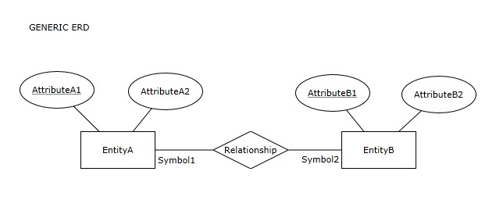
This ER diagram will be used for the following questions citing Generic ER Diagram.

21) If in the GENERIC ERD the Symbol 1 is >| and the Symbol2 is ||, then the number of relations in the relational schema resulting from mapping the GENERIC ERD is 2.
Answer: TRUE
Diff: 2 Page Ref: 59-70

22) If in the GENERIC ERD the Symbol 1 is >| and the Symbol2 is ||, then the number of columns in the relational schema resulting from mapping the GENERIC ERD is 5.
Answer: TRUE
Diff: 2 Page Ref: 59-70

23) If in the GENERIC ERD the Symbol 1 is >| and the Symbol2 is ||, then the number of optional columns in the relational schema resulting from mapping the GENERIC ERD is 0.
Answer: TRUE
Diff: 2 Page Ref: 59-70
24) If in the GENERIC ERD the Symbol 1 is >| and the Symbol2 is 0|, then the number of relations in the relational schema resulting from mapping the GENERIC ERD is 2.
Answer: TRUE
Diff: 2 Page Ref: 59-70

25) If in the GENERIC ERD the Symbol 1 is >| and the Symbol2 is 0|, then the number of columns in the relational schema resulting from mapping the GENERIC ERD is 5.
Answer: TRUE
Diff: 2 Page Ref: 59-70

26) If in the GENERIC ERD the Symbol 1 is >| and the Symbol2 is 0|, then the number of optional columns in the relational schema resulting from mapping the GENERIC ERD is 0.
Answer: FALSE
Diff: 2 Page Ref: 59-70

27) If in the GENERIC ERD the Symbol 1 is >| and the Symbol2 is 0<, then the number of relations in the relational schema resulting from mapping the GENERIC ERD is 2.
Answer: FALSE
Diff: 2 Page Ref: 59-70

28) If in the GENERIC ERD the Symbol 1 is >| and the Symbol2 is 0<, then the number of columns in the relational schema resulting from mapping the GENERIC ERD is 5.
Answer: FALSE
Diff: 2 Page Ref: 59-70

29) If in the GENERIC ERD the Symbol 1 is >| and the Symbol2 is 0<, then the number of optional columns in the relational schema resulting from mapping the GENERIC ERD is 0.
Answer: TRUE
Diff: 2 Page Ref: 59-70
ZYX COMPANY
Observe the ER diagram for the ZYX COMPANY:
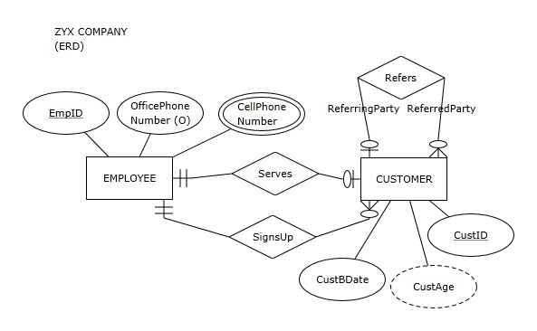
This ER diagram will be used for the following questions citing ZYX Company ER Diagram.

30) During mapping of the ZYX Company ERD into a relational schema, attribute EmpID from the ZYX Company ER diagram will be mapped as a column of the relation EMPLOYEE.
Answer: TRUE
Diff: 1 Page Ref: 59-76

31) During mapping of the ZYX Company ERD into a relational schema, attribute OfficePhoneNumber from the ZYX Company ER diagram will be mapped as a column of the relation EMPLOYEE.
Answer: TRUE
Diff: 2 Page Ref: 59-76

32) During mapping of the ZYX Company ERD into a relational schema, attribute CellPhoneNumber from the ZYX Company ER diagram will be mapped as a column of the relation EMPLOYEE.
Answer: FALSE
Diff: 2 Page Ref: 59-76

33) During mapping of the ZYX Company ERD into a relational schema, attribute CustID from the ZYX Company ER diagram will be mapped as a column of the relation CUSTOMER.
Answer: TRUE
Diff: 1 Page Ref: 59-76
34) Attribute CustBDate from the ZYX Company ER diagram will be mapped as a column of the relation CUSTOMER.
Answer: TRUE
Diff: 2 Page Ref: 59-76

35) Attribute CustAge from the ZYX Company ER diagram will be mapped as a column of the relation CUSTOMER.
Answer: FALSE
Diff: 2 Page Ref: 59-76

36) As a result of mapping the ZYX Company ERD into a relational schema, primary key of the relation EMPLOYEE will be referred to by a foreign key in the relation CUSTOMER.
Answer: TRUE
Diff: 2 Page Ref: 59-76

37) As a result of mapping the ZYX Company ERD into a relational schema, primary key of the relation CUSTOMER will be referred to by a foreign key in the relation CUSTOMER.
Answer: TRUE
Diff: 2 Page Ref: 59-76

38) As a result of mapping the ZYX Company ERD, the resulting relational schema will have a total of two relations.
Answer: FALSE
Diff: 3 Page Ref: 59-76

39) As a result of mapping the ZYX Company ERD, the resulting relational schema will have a total of four foreign keys.
Answer: TRUE
Diff: 2 Page Ref: 59-76

40) As a result of mapping the ZYX Company ERD, the resulting relational schema will have zero bridge tables.
Answer: TRUE
Diff: 2 Page Ref: 59-76

3.3 Essay Questions

1) What is a relational database a collection of?
Answer: A relational database is a collection of related relations within which each relation has a unique name.
Diff: 1 Page Ref: 57

2) What is a primary key?
Answer: Primary key is a column (or a set of columns) whose value is unique for each row. Primary keys cannot have null values. If there are multiple columns (or sets of columns) that have unique values in each row, one of them is designated as a primary key. Each relation must have a primary key.
Diff: 1 Page Ref: 59
3) How is a composite attribute of an entity mapped into a relation?
Answer: If an entity contains composite attributes, each component of the composite attribute is mapped as a column of a relation, while the composite attribute itself does not appear in the mapped relation.
Diff: 2 Page Ref: 60

4) Give a definition of entity integrity constraint.
Answer: In a relational table, no primary key column can have null (empty) values.
Diff: 1 Page Ref: 62

5) What is a foreign key?
Answer: A foreign key is a column in a relation that refers to a primary key column in another (referred) relation.
Diff: 1 Page Ref: 63

6) What is the difference between mapping a 1:M and a 1:1 relationship?
Answer: When a 1:M relationship is mapped, the foreign key must appear in the relation mapped from the M side. When a 1:1 relationship is mapped, the designer chooses in which of the tables the foreign key will appear.
Diff: 2 Page Ref: 68

7) Give a definition of referential integrity constraint.
Answer: In each row of a relation containing a foreign key, the value of the foreign key either matches one of the values in the primary key column of the referred relation, or the value of the foreign key is null (empty).
Diff: 2 Page Ref: 69

8) What is the difference between an implicit and user-defined database constraint?
Answer: Implicit constraints are rules that every relational database must satisfy in order to be valid. User-defined constraints are added by the database designer and they are specific for each database.
Diff: 2 Page Ref: 78-82

9) What is a business rule?
Answer: A business rule is a user-defined constraint that specifies restrictions on resulting databases that are not a part of the standard notation for creating ER diagrams.
Diff: 2 Page Ref: 81

10) Use an example to illustrate how M:N relationships and associative entities are mapped in the same way.
Answer: Figure 3.69
Diff: 2 Page Ref: 83

