brew

Autogenerated data summary from dataMaid

2019-03-02 18:44:51

# Data report overview

The dataset examined has the following dimensions:

|  |  |
| --- | --- |
| Feature | Result |
| Number of observations | 2410 |
| Number of variables | 10 |

### Checks performed

The following variable checks were performed, depending on the data type of each variable:

|  |  |  |  |  |  |  |  |  |
| --- | --- | --- | --- | --- | --- | --- | --- | --- |
|  | character | factor | labelled | haven labelled | numeric | integer | logical | Date |
| Identify miscoded missing values | × | × | × | × | × | × |  | × |
| Identify prefixed and suffixed whitespace | × | × | × | × |  |  |  |  |
| Identify levels with < 6 obs. | × | × | × | × |  |  |  |  |
| Identify case issues | × | × | × | × |  |  |  |  |
| Identify misclassified numeric or integer variables | × | × | × | × |  |  |  |  |
| Identify outliers |  |  |  |  | × | × |  | × |

Please note that all numerical values in the following have been rounded to 2 decimals.

# Summary table

|  |  |  |  |  |
| --- | --- | --- | --- | --- |
|  | Variable class | # unique values | Missing observations | Any problems? |
| Brewery | character | 551 | 0.00 % | × |
| Beer | character | 2305 | 0.00 % | × |
| Style | character | 100 | 0.00 % | × |
| ABV | numeric | 75 | 2.57 % | × |
| IBU | numeric | 108 | 41.70 % |  |
| Ounces | numeric | 7 | 0.00 % | × |
| City | character | 384 | 0.00 % | × |
| State | character | 51 | 0.00 % | × |
| Beer_ID | integer | 2410 | 0.00 % |  |
| Brewery_id | integer | 558 | 0.00 % |  |

# Variable list

## Brewery

|  |  |
| --- | --- |
| Feature | Result |
| Variable type | character |
| Number of missing obs. | 0 (0 %) |
| Number of unique values | 551 |
| Mode | “Brewery Vivant” |

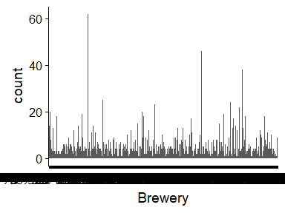

* The following values appear with prefixed or suffixed white space: "Four Fathers Brewing ", "Mountain Town Brewing Company ", "NorthGate Brewing ".
* Note that the following levels have at most five observations: "10 Barrel Brewing Company", "2 Towns Ciderhouse", "3 Daughters Brewing", "7 Seas Brewing Company", "7venth Sun", "Abita Brewing Company", "AC Golden Brewing Company", "Against The Grain Brewery", "Airways Brewing Company", "Alameda Brewing" (418 additional values omitted).
* Note that there might be case problems with the following levels: "Against the Grain Brewery", "Against The Grain Brewery".

## Beer

|  |  |
| --- | --- |
| Feature | Result |
| Variable type | character |
| Number of missing obs. | 0 (0 %) |
| Number of unique values | 2305 |
| Mode | “Nonstop Hef Hop” |

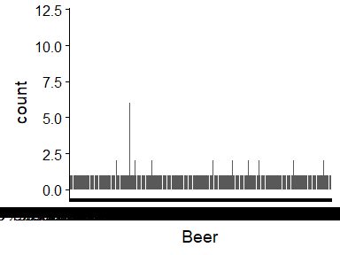

* The following values appear with prefixed or suffixed white space: "14? ESB ", "32?/50? K?lsch ", "Alter Ego ", "Aurora ", "Bunker Hill Blueberry Ale ", "Lewbricator Wheat Dopplebock ", "Nordskye ", "Port Barrel Wee Mac ", "Texicali ", "White Rabbit ".
* Note that the following levels have at most five observations: "#001 Golden Amber Lager", "#002 American I.P.A.", "#003 Brown & Robust Porter", "#004 Session I.P.A.", "#9", "077XX", "10 Degrees of Separation", "10 Ton", "113 IPA", "11th Hour IPA" (2292 additional values omitted).

## Style

|  |  |
| --- | --- |
| Feature | Result |
| Variable type | character |
| Number of missing obs. | 0 (0 %) |
| Number of unique values | 100 |
| Mode | “American IPA” |

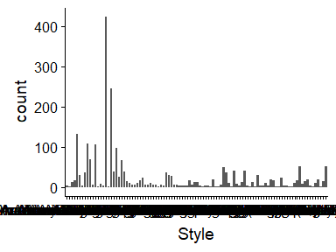

* The following suspected missing value codes enter as regular values: "".
* Note that the following levels have at most five observations: "", "Abbey Single Ale", "American Barleywine", "American Double / Imperial Pilsner", "American India Pale Lager", "American Malt Liquor", "Braggot", "Chile Beer", "Dubbel", "Dunkelweizen" (26 additional values omitted).

## ABV

|  |  |
| --- | --- |
| Feature | Result |
| Variable type | numeric |
| Number of missing obs. | 62 (2.57 %) |
| Number of unique values | 74 |
| Median | 0.06 |
| 1st and 3rd quartiles | 0.05; 0.07 |
| Min. and max. | 0; 0.13 |

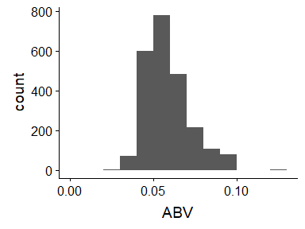

* Note that the following possible outlier values were detected: "0", "0.03", "0.03", "0.03", "0.03", "0.04", "0.04", "0.04", "0.04", "0.04" (3 additional values omitted).

## IBU

|  |  |
| --- | --- |
| Feature | Result |
| Variable type | numeric |
| Number of missing obs. | 1005 (41.7 %) |
| Number of unique values | 107 |
| Median | 35 |
| 1st and 3rd quartiles | 21; 64 |
| Min. and max. | 4; 138 |

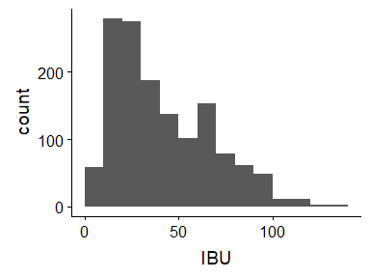

## Ounces

|  |  |
| --- | --- |
| Feature | Result |
| Variable type | numeric |
| Number of missing obs. | 0 (0 %) |
| Number of unique values | 7 |
| Median | 12 |
| 1st and 3rd quartiles | 12; 16 |
| Min. and max. | 8.4; 32 |

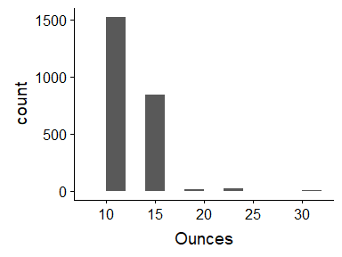

* Note that the following possible outlier values were detected: "8.4".

## City

|  |  |
| --- | --- |
| Feature | Result |
| Variable type | character |
| Number of missing obs. | 0 (0 %) |
| Number of unique values | 384 |
| Mode | “Grand Rapids” |

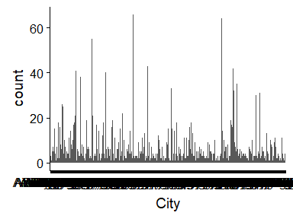

* Note that the following levels have at most five observations: "Abingdon", "Abita Springs", "Ada", "Afton", "Airway Heights", "Alpine", "Angola", "Ann Arbor", "Arrington", "Ashburn" (252 additional values omitted).

## State

|  |  |
| --- | --- |
| Feature | Result |
| Variable type | character |
| Number of missing obs. | 0 (0 %) |
| Number of unique values | 51 |
| Mode | " CO" |

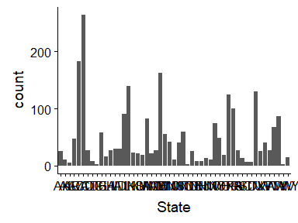

* The following values appear with prefixed or suffixed white space: " AK", " AL", " AR", " AZ", " CA", " CO", " CT", " DC", " DE", " FL" (41 additional values omitted).
* Note that the following levels have at most five observations: " AR", " DE", " ND", " WV".

## Beer_ID

|  |  |
| --- | --- |
| Feature | Result |
| Variable type | integer |
| Number of missing obs. | 0 (0 %) |
| Number of unique values | 2410 |
| Median | 1453.5 |
| 1st and 3rd quartiles | 808.25; 2075.75 |
| Min. and max. | 1; 2692 |

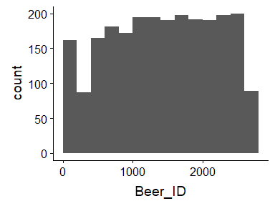

## Brewery_id

|  |  |
| --- | --- |
| Feature | Result |
| Variable type | integer |
| Number of missing obs. | 0 (0 %) |
| Number of unique values | 558 |
| Median | 206 |
| 1st and 3rd quartiles | 94; 367 |
| Min. and max. | 1; 558 |

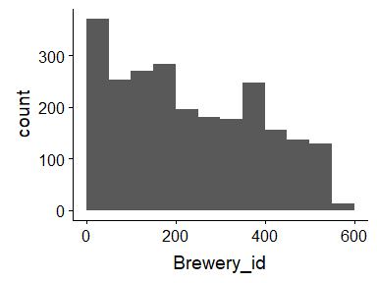

Report generation information:

* Created by Could not determine from system (username: linda).
* Report creation time: Sat Mar 02 2019 18:44:53
* Report was run from directory: C:/Users/linda/Documents/DDS
* dataMaid v1.2.0 [Pkg: 2018-10-03 from CRAN (R 3.5.2)]
* R version 3.5.1 (2018-07-02).
* Platform: x86_64-w64-mingw32/x64 (64-bit)(Windows >= 8 x64 (build 9200)).
* Function call: makeDataReport(data = brew, replace = TRUE)