mapdata

Autogenerated data summary from dataMaid

2019-03-02 18:45:06

# Data report overview

The dataset examined has the following dimensions:

|  |  |
| --- | --- |
| Feature | Result |
| Number of observations | 52 |
| Number of variables | 19 |

### Checks performed

The following variable checks were performed, depending on the data type of each variable:

|  |  |  |  |  |  |  |  |  |
| --- | --- | --- | --- | --- | --- | --- | --- | --- |
|  | character | factor | labelled | haven labelled | numeric | integer | logical | Date |
| Identify miscoded missing values | × | × | × | × | × | × |  | × |
| Identify prefixed and suffixed whitespace | × | × | × | × |  |  |  |  |
| Identify levels with < 6 obs. | × | × | × | × |  |  |  |  |
| Identify case issues | × | × | × | × |  |  |  |  |
| Identify misclassified numeric or integer variables | × | × | × | × |  |  |  |  |
| Identify outliers |  |  |  |  | × | × |  | × |

Please note that all numerical values in the following have been rounded to 2 decimals.

# Summary table

|  |  |  |  |  |
| --- | --- | --- | --- | --- |
|  | Variable class | # unique values | Missing observations | Any problems? |
| hc-group | character | 2 | 0.00 % | × |
| hc-middle-x | numeric | 33 | 1.92 % | × |
| hc-middle-y | numeric | 30 | 1.92 % | × |
| hc-key | character | 52 | 1.92 % | × |
| hc-a2 | character | 52 | 1.92 % | × |
| labelrank | character | 3 | 1.92 % | × |
| hasc | character | 52 | 1.92 % | × |
| woe-id | character | 52 | 1.92 % | × |
| state-fips | character | 52 | 1.92 % | × |
| fips | character | 52 | 1.92 % | × |
| postal-code | character | 52 | 1.92 % | × |
| name | character | 52 | 1.92 % | × |
| country | character | 2 | 1.92 % | × |
| region | character | 5 | 1.92 % |  |
| longitude | character | 52 | 1.92 % | × |
| woe-name | character | 52 | 1.92 % | × |
| latitude | character | 52 | 1.92 % | × |
| woe-label | character | 52 | 1.92 % | × |
| type | character | 3 | 1.92 % | × |

# Variable list

## hc-group

|  |  |
| --- | --- |
| Feature | Result |
| Variable type | character |
| Number of missing obs. | 0 (0 %) |
| Number of unique values | 2 |
| Mode | “admin1” |

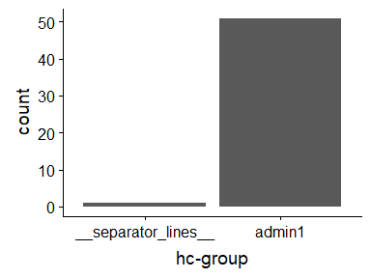

* Note that the following levels have at most five observations: "**separator_lines**".

## hc-middle-x

|  |  |
| --- | --- |
| Feature | Result |
| Variable type | numeric |
| Number of missing obs. | 1 (1.92 %) |
| Number of unique values | 32 |
| Median | 0.51 |
| 1st and 3rd quartiles | 0.44; 0.56 |
| Min. and max. | 0.3; 0.91 |

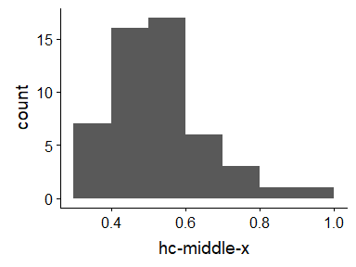

* Note that the following possible outlier values were detected: "0.3", "0.87", "0.91".

## hc-middle-y

|  |  |
| --- | --- |
| Feature | Result |
| Variable type | numeric |
| Number of missing obs. | 1 (1.92 %) |
| Number of unique values | 29 |
| Median | 0.5 |
| 1st and 3rd quartiles | 0.45; 0.54 |
| Min. and max. | 0.14; 0.79 |

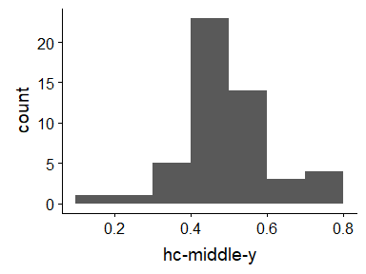

* Note that the following possible outlier values were detected: "0.14", "0.27", "0.67", "0.75", "0.77", "0.78", "0.79".

## hc-key

* The variable is a key (distinct values for each observation).

## hc-a2

* The variable is a key (distinct values for each observation).

## labelrank

|  |  |
| --- | --- |
| Feature | Result |
| Variable type | character |
| Number of missing obs. | 1 (1.92 %) |
| Number of unique values | 2 |
| Mode | “0” |

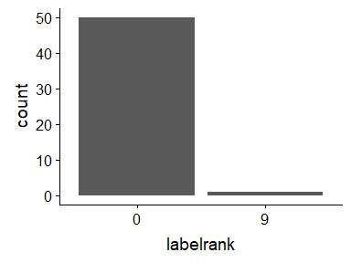

* The following suspected missing value codes enter as regular values: "9".
* Note that the following levels have at most five observations: "9".

## hasc

* The variable is a key (distinct values for each observation).

## woe-id

* The variable is a key (distinct values for each observation).

## state-fips

* The variable is a key (distinct values for each observation).

## fips

* The variable is a key (distinct values for each observation).

## postal-code

* The variable is a key (distinct values for each observation).

## name

* The variable is a key (distinct values for each observation).

## country

* The variable only takes one (non-missing) value: "United States of America". The variable contains 1.92 % missing observations.

## region

|  |  |
| --- | --- |
| Feature | Result |
| Variable type | character |
| Number of missing obs. | 1 (1.92 %) |
| Number of unique values | 4 |
| Mode | “South” |

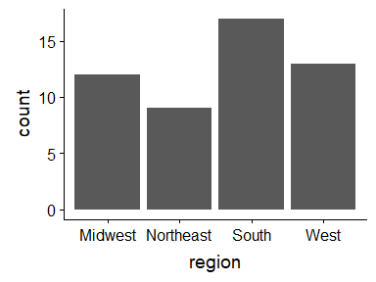

## longitude

* The variable is a key (distinct values for each observation).

## woe-name

* The variable is a key (distinct values for each observation).

## latitude

* The variable is a key (distinct values for each observation).

## woe-label

* The variable is a key (distinct values for each observation).

## type

|  |  |
| --- | --- |
| Feature | Result |
| Variable type | character |
| Number of missing obs. | 1 (1.92 %) |
| Number of unique values | 2 |
| Mode | “State” |

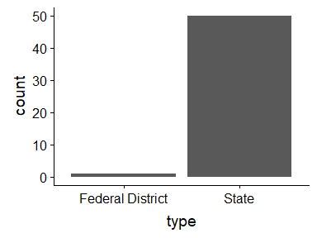

* Note that the following levels have at most five observations: "Federal District".

Report generation information:

* Created by Could not determine from system (username: linda).
* Report creation time: Sat Mar 02 2019 18:45:08
* Report was run from directory: C:/Users/linda/Documents/DDS
* dataMaid v1.2.0 [Pkg: 2018-10-03 from CRAN (R 3.5.2)]
* R version 3.5.1 (2018-07-02).
* Platform: x86_64-w64-mingw32/x64 (64-bit)(Windows >= 8 x64 (build 9200)).
* Function call: makeDataReport(data = mapdata, replace = TRUE)