statesum

Autogenerated data summary from dataMaid

2019-03-02 18:45:16

# Data report overview

The dataset examined has the following dimensions:

|  |  |
| --- | --- |
| Feature | Result |
| Number of observations | 51 |
| Number of variables | 11 |

### Checks performed

The following variable checks were performed, depending on the data type of each variable:

|  |  |  |  |  |  |  |  |  |
| --- | --- | --- | --- | --- | --- | --- | --- | --- |
|  | character | factor | labelled | haven labelled | numeric | integer | logical | Date |
| Identify miscoded missing values | × | × | × | × | × | × |  | × |
| Identify prefixed and suffixed whitespace | × | × | × | × |  |  |  |  |
| Identify levels with < 6 obs. | × | × | × | × |  |  |  |  |
| Identify case issues | × | × | × | × |  |  |  |  |
| Identify misclassified numeric or integer variables | × | × | × | × |  |  |  |  |
| Identify outliers |  |  |  |  | × | × |  | × |

Please note that all numerical values in the following have been rounded to 2 decimals.

# Summary table

|  |  |  |  |  |
| --- | --- | --- | --- | --- |
|  | Variable class | # unique values | Missing observations | Any problems? |
| State | character | 51 | 0.00 % | × |
| MedianABV | numeric | 17 | 0.00 % | × |
| MedianIBU | numeric | 35 | 1.96 % | × |
| Breweries | numeric | 25 | 0.00 % |  |
| DifferentTypes | character | 51 | 0.00 % | × |
| DifferentStyles | integer | 1 | 100.00 % | × |
| BreweriesPerCapita | numeric | 32 | 0.00 % | × |
| EconomicImpactMil | numeric | 51 | 0.00 % |  |
| EconomicImpactRank | numeric | 51 | 0.00 % |  |
| BarrelsPerYear | numeric | 51 | 0.00 % |  |
| GallonsPerAdult | numeric | 35 | 0.00 % | × |

# Variable list

## State

* The variable is a key (distinct values for each observation).

## MedianABV

|  |  |
| --- | --- |
| Feature | Result |
| Variable type | numeric |
| Number of missing obs. | 0 (0 %) |
| Number of unique values | 17 |
| Median | 0.06 |
| 1st and 3rd quartiles | 0.06; 0.06 |
| Min. and max. | 0.04; 0.06 |

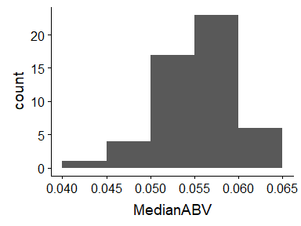

* Note that the following possible outlier values were detected: "0.04", "0.05", "0.05".

## MedianIBU

|  |  |
| --- | --- |
| Feature | Result |
| Variable type | numeric |
| Number of missing obs. | 1 (1.96 %) |
| Number of unique values | 34 |
| Median | 35 |
| 1st and 3rd quartiles | 30; 42.75 |
| Min. and max. | 19; 61 |

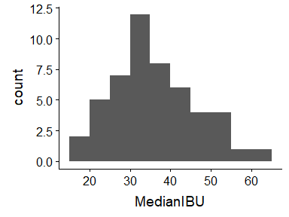

* Note that the following possible outlier values were detected: "19", "20", "20.5", "21".

## Breweries

|  |  |
| --- | --- |
| Feature | Result |
| Variable type | numeric |
| Number of missing obs. | 0 (0 %) |
| Number of unique values | 25 |
| Median | 7 |
| 1st and 3rd quartiles | 3.5; 16 |
| Min. and max. | 1; 47 |

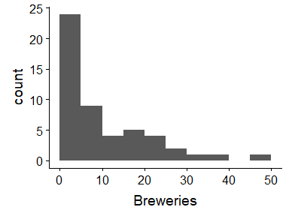

## DifferentTypes

* The variable is a key (distinct values for each observation).

## DifferentStyles

* The variable only takes one value: "NA".

## BreweriesPerCapita

|  |  |
| --- | --- |
| Feature | Result |
| Variable type | numeric |
| Number of missing obs. | 0 (0 %) |
| Number of unique values | 32 |
| Median | 2.2 |
| 1st and 3rd quartiles | 1.65; 3.8 |
| Min. and max. | 0.6; 11.5 |

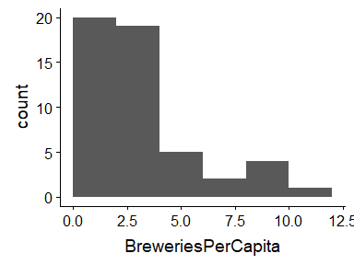

* Note that the following possible outlier values were detected: "0.6", "0.9", "1".

## EconomicImpactMil

|  |  |
| --- | --- |
| Feature | Result |
| Variable type | numeric |
| Number of missing obs. | 0 (0 %) |
| Number of unique values | 51 |
| Median | 718 |
| 1st and 3rd quartiles | 359.5; 1913 |
| Min. and max. | 152; 7345 |

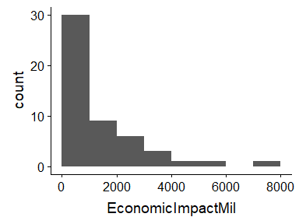

## EconomicImpactRank

|  |  |
| --- | --- |
| Feature | Result |
| Variable type | numeric |
| Number of missing obs. | 0 (0 %) |
| Number of unique values | 51 |
| Median | 26 |
| 1st and 3rd quartiles | 13.5; 38.5 |
| Min. and max. | 1; 51 |

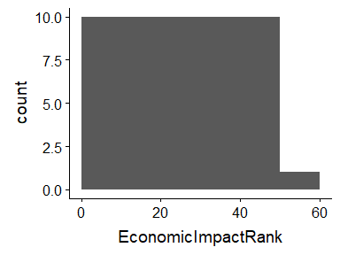

## BarrelsPerYear

|  |  |
| --- | --- |
| Feature | Result |
| Variable type | numeric |
| Number of missing obs. | 0 (0 %) |
| Number of unique values | 51 |
| Median | 206529 |
| 1st and 3rd quartiles | 67091; 547788.5 |
| Min. and max. | 12848; 3724010 |

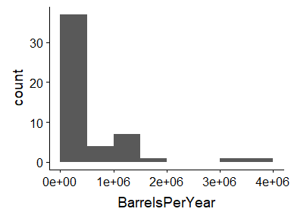

## GallonsPerAdult

|  |  |
| --- | --- |
| Feature | Result |
| Variable type | numeric |
| Number of missing obs. | 0 (0 %) |
| Number of unique values | 35 |
| Median | 2 |
| 1st and 3rd quartiles | 1.05; 3.6 |
| Min. and max. | 0.3; 18.9 |

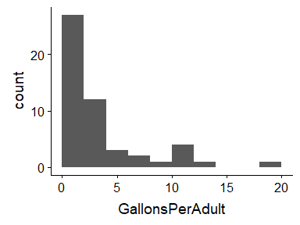

* Note that the following possible outlier values were detected: "0.3", "0.4", "0.5", "0.6".

Report generation information:

* Created by Could not determine from system (username: linda).
* Report creation time: Sat Mar 02 2019 18:45:18
* Report was run from directory: C:/Users/linda/Documents/DDS
* dataMaid v1.2.0 [Pkg: 2018-10-03 from CRAN (R 3.5.2)]
* R version 3.5.1 (2018-07-02).
* Platform: x86_64-w64-mingw32/x64 (64-bit)(Windows >= 8 x64 (build 9200)).
* Function call: makeDataReport(data = statesum, replace = TRUE)