top

Autogenerated data summary from dataMaid

2019-03-02 18:45:10

# Data report overview

The dataset examined has the following dimensions:

|  |  |
| --- | --- |
| Feature | Result |
| Number of observations | 2 |
| Number of variables | 4 |

### Checks performed

The following variable checks were performed, depending on the data type of each variable:

|  |  |  |  |  |  |  |  |  |
| --- | --- | --- | --- | --- | --- | --- | --- | --- |
|  | character | factor | labelled | haven labelled | numeric | integer | logical | Date |
| Identify miscoded missing values | × | × | × | × | × | × |  | × |
| Identify prefixed and suffixed whitespace | × | × | × | × |  |  |  |  |
| Identify levels with < 6 obs. | × | × | × | × |  |  |  |  |
| Identify case issues | × | × | × | × |  |  |  |  |
| Identify misclassified numeric or integer variables | × | × | × | × |  |  |  |  |
| Identify outliers |  |  |  |  | × | × |  | × |

Please note that all numerical values in the following have been rounded to 2 decimals.

# Summary table

|  |  |  |  |  |
| --- | --- | --- | --- | --- |
|  | Variable class | # unique values | Missing observations | Any problems? |
| State | character | 2 | 0.00 % | × |
| Beer | character | 2 | 0.00 % | × |
| ABV | numeric | 2 | 0.00 % | × |
| IBU | character | 2 | 0.00 % | × |

# Variable list

## State

* The variable is a key (distinct values for each observation).

## Beer

* The variable is a key (distinct values for each observation).

## ABV

* Note that this variable is treated as a factor variable below, as it only takes a few unique values.

|  |  |
| --- | --- |
| Feature | Result |
| Variable type | numeric |
| Number of missing obs. | 0 (0 %) |
| Number of unique values | 2 |
| Mode | “0.082” |
| Reference category | 0.082 |

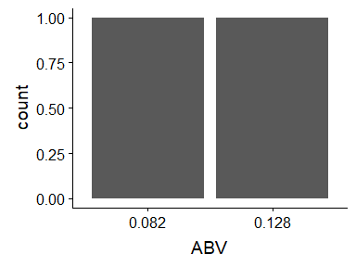

* Note that the following levels have at most five observations: "0.082", "0.128".

## IBU

* The variable is a key (distinct values for each observation).

Report generation information:

* Created by Could not determine from system (username: linda).
* Report creation time: Sat Mar 02 2019 18:45:11
* Report was run from directory: C:/Users/linda/Documents/DDS
* dataMaid v1.2.0 [Pkg: 2018-10-03 from CRAN (R 3.5.2)]
* R version 3.5.1 (2018-07-02).
* Platform: x86_64-w64-mingw32/x64 (64-bit)(Windows >= 8 x64 (build 9200)).
* Function call: makeDataReport(data = top, replace = TRUE)