**Liberator IPT Release Rev 3 SW Native Conversion**

**Design Notes 5/24/13**

# Rev 3 Updates

Conversion error with trigger spring fixed

Hammer pin added

Conversion Notes

# .380 barrel (threaded) - Status : Complete

* Case Rim Fillet broken in import. Readded in SW model but only on one corner

## Geometry Check

### Inventor Mass Properties

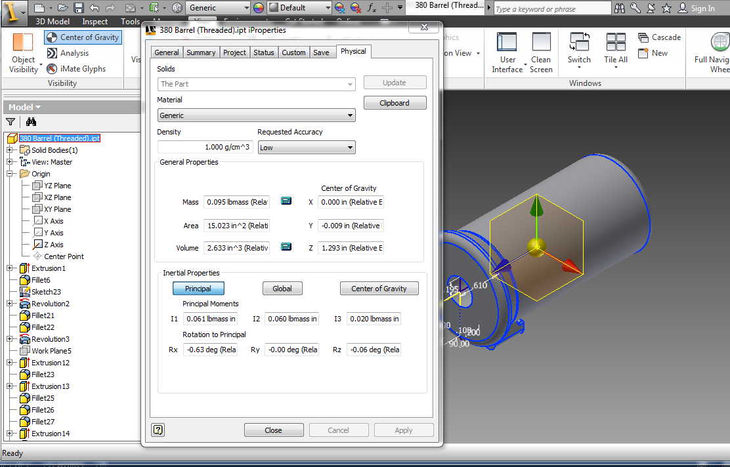

### Solidworks Mass Properties

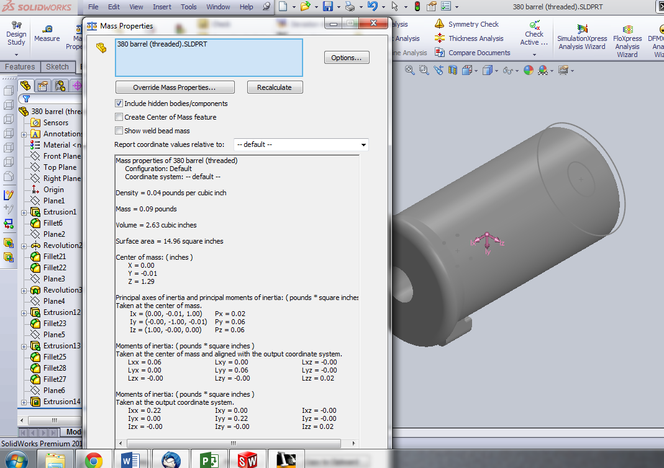

# Bottom Cover - Status : Complete

* Simple Part, No check needed

## Geometry Check

### Inventor Mass Properties

### Solidworks Mass Properties

# Firing Pin Bushing - Status : Complete

* Simple Part, No check needed

## Geometry Check

### Inventor Mass Properties

### Solidworks Mass Properties

# Frame - Status : Complete

2 Inch fillet and .125 fillet broken. Remodeled completely for Solidworks

Trigger cutout two way extrusion missing during import. Fixed in SW model

Barrel Lock

Mass properties still not close enough. Revisit and verify

## Geometry Check

### Inventor Mass Properties

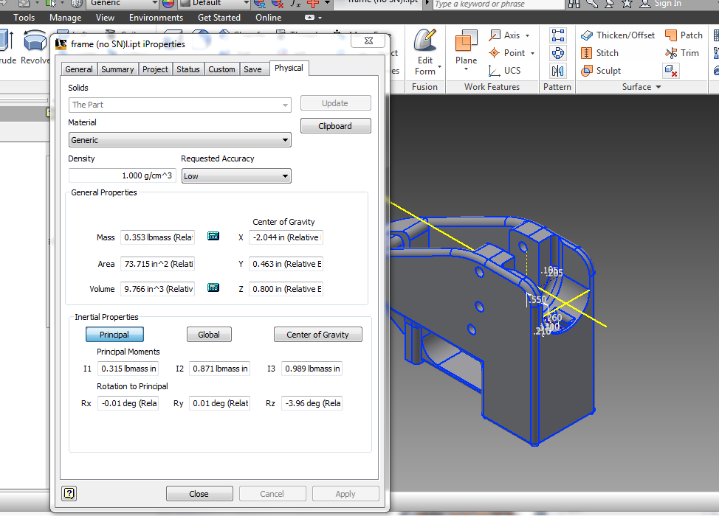

### Solidworks Mass Properties

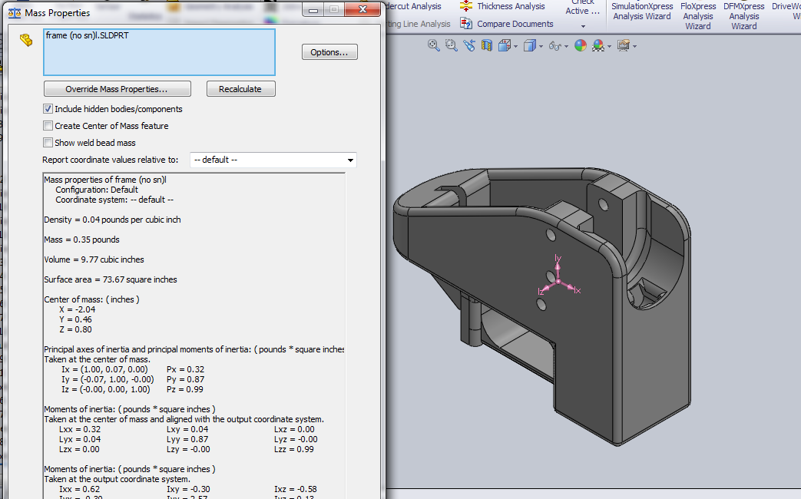

# Frame Pin - Status : Complete

* Simple Part, No check needed

## Geometry Check

### Inventor Mass Properties

# Grip Pin - Status : Complete

* Changed length from 1.60 in to .875 in

## Geometry Check

### Inventor Mass Properties

### Solidworks Mass Properties

# Grip - Status : Complete

* Import miserably failed. Complete remodel from scratch

## Geometry Check

### Inventor Mass Properties

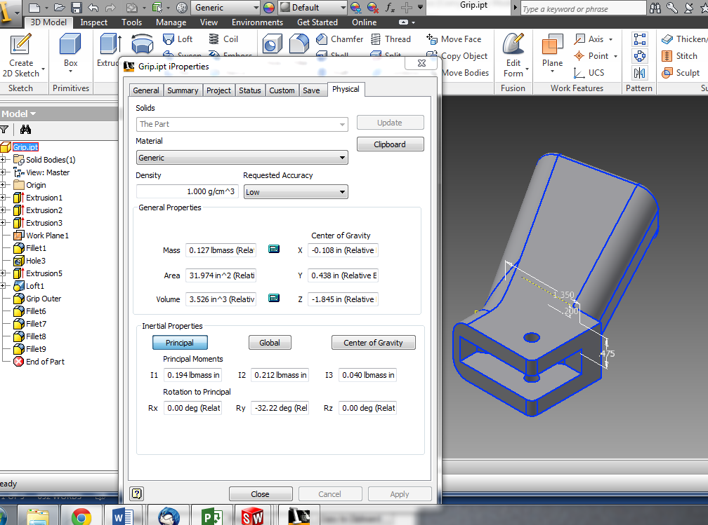

### Solidworks Mass Properties

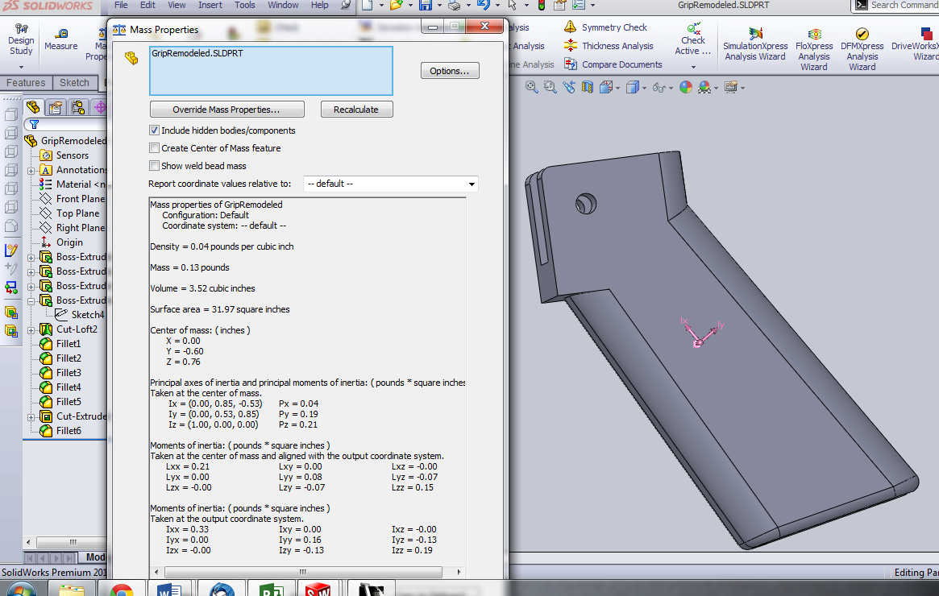

# Hammer Body - Status : Complete

* Hammer Hole Missing, Remodeled
* Some extrusions broken, Remodeled
* Mass properties check out
* Check hammer hole position

## Geometry Check

### Inventor Mass Properties

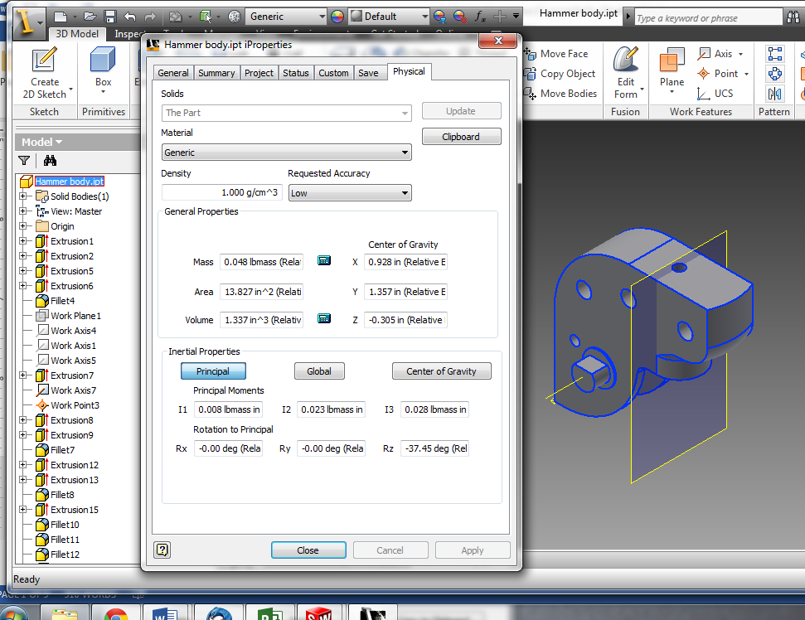

### Solidworks Mass Properties

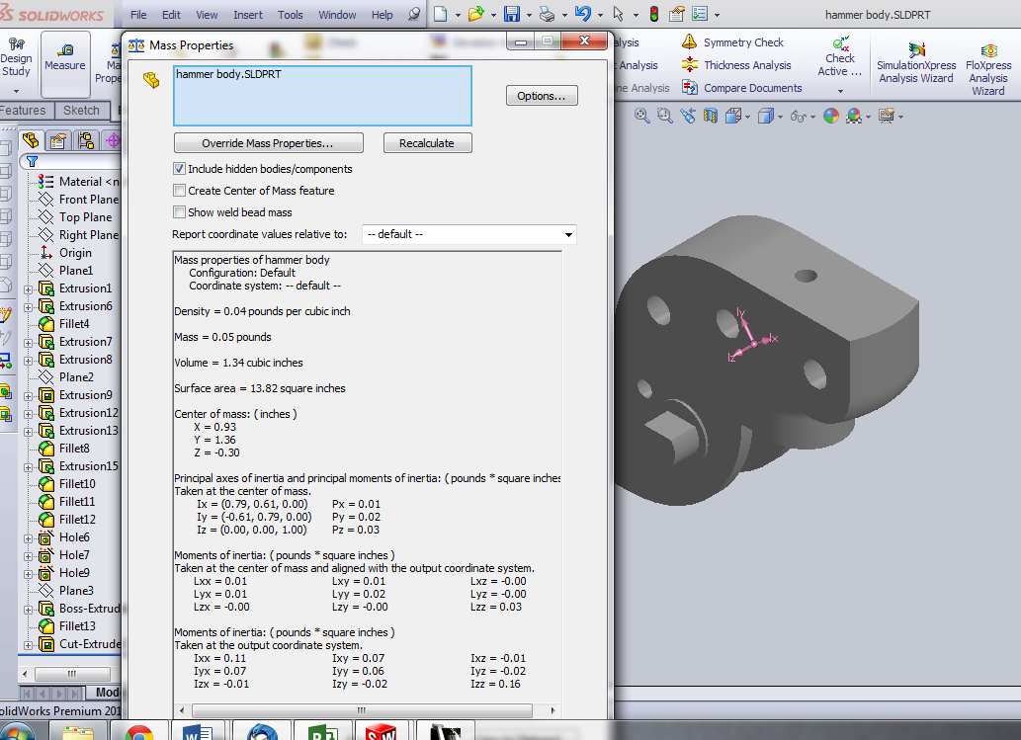

# Spring - Status : Complete

* Complete remodel
* Based on DWG generated from Inventor

## Geometry Check

### Inventor Mass Properties

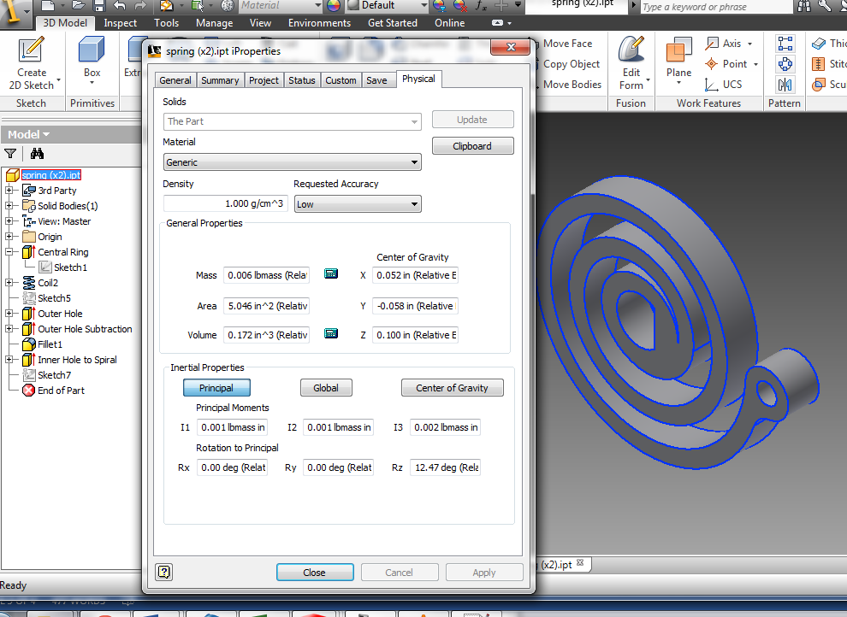

### Solidworks Mass Properties

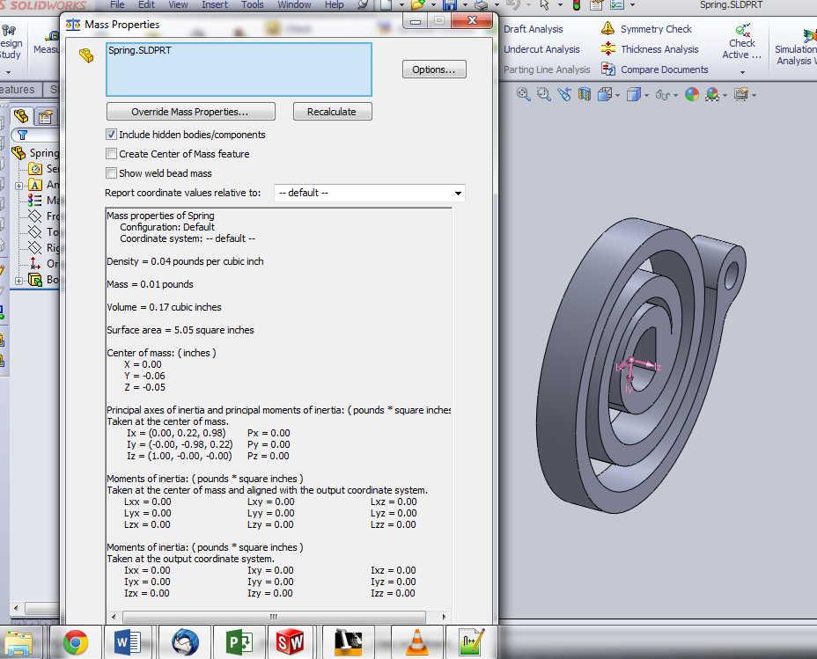

# Spring Connecting Rod Bushing - Status : Complete

* Simple Part, No check needed

## Geometry Check

### Inventor Mass Properties

### Solidworks Mass Properties

# Trigger Spring - Status : Complete

* Clean Import

## Geometry Check

### Inventor Mass Properties

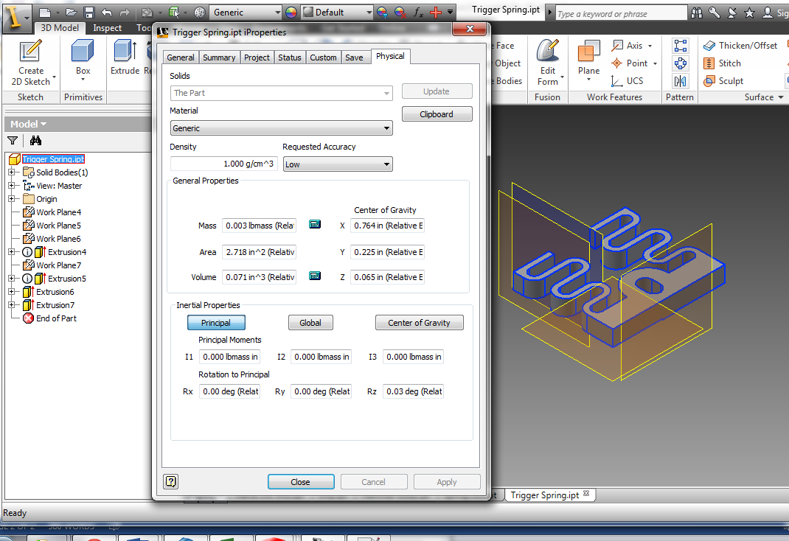

### Solidworks Mass Properties Spring Connecting Rod Bushing Status : Complete

* Simple Part, No check needed

## Geometry Check

### Inventor Mass Properties

### Solidworks Mass Properties

# Trigger - Status : Complete

* Fillets Broken on import

## Geometry Check

### Inventor Mass Properties

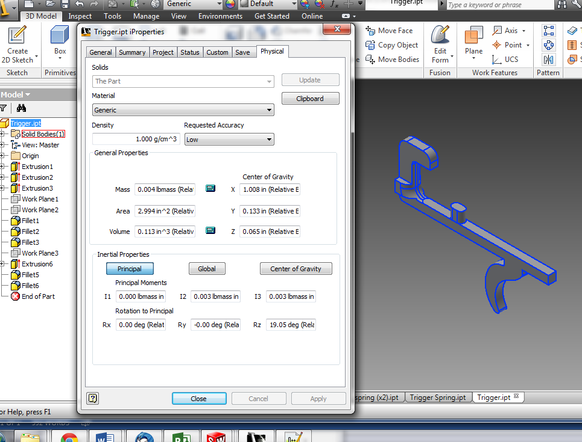

### Solidworks Mass Properties

