**Baikadamova Danel IT-2004**

**3. Write an SQL statement to extract from the driver table the first and last name into one column using the aliases for that column (5 points).**

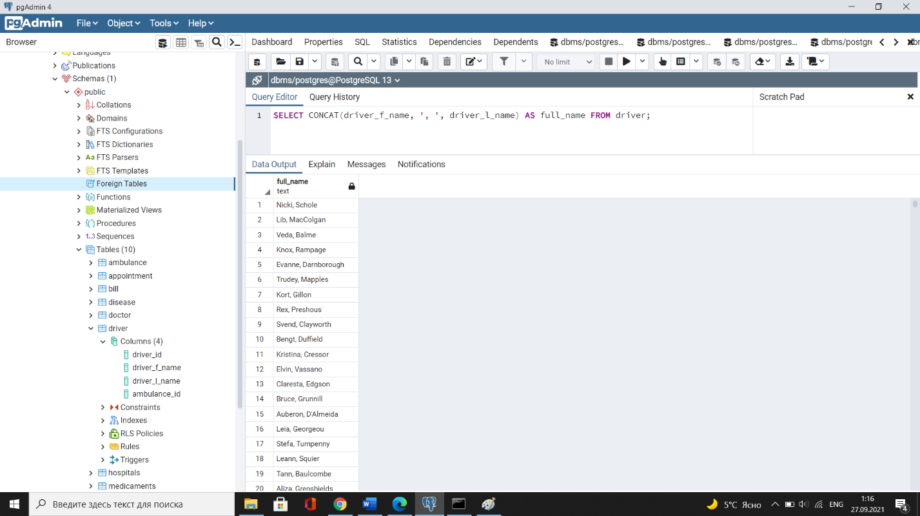

**4. Write a query to select first fifteen records from a Patient table (5 points).**

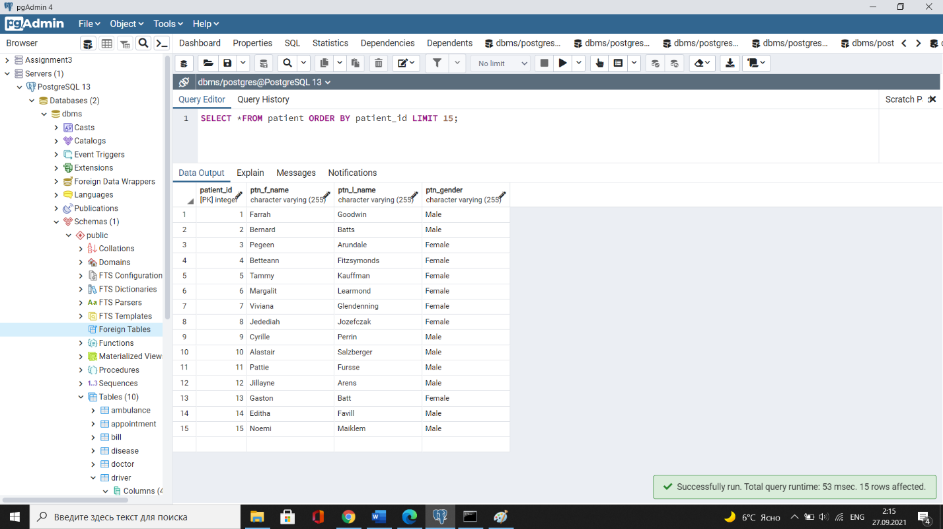

**5. Write a SQL statement to get all data from the Patient table in descending order by their first name. You should use aliases for presented columns (5 points).**

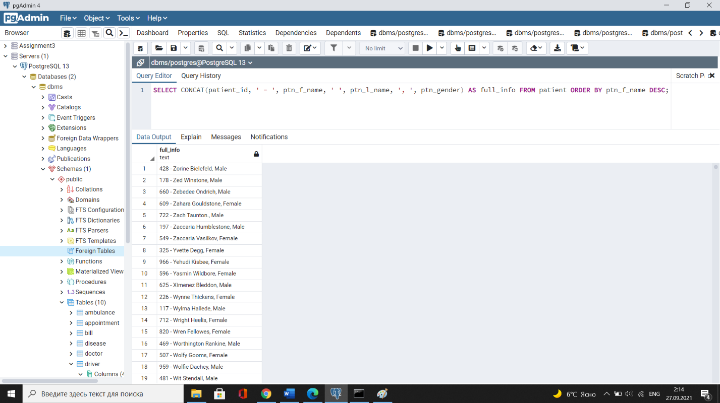

**6. Write a single query to display first and last name and date of birth for all doctors who were born between 1980 and 1985 (5 points).**

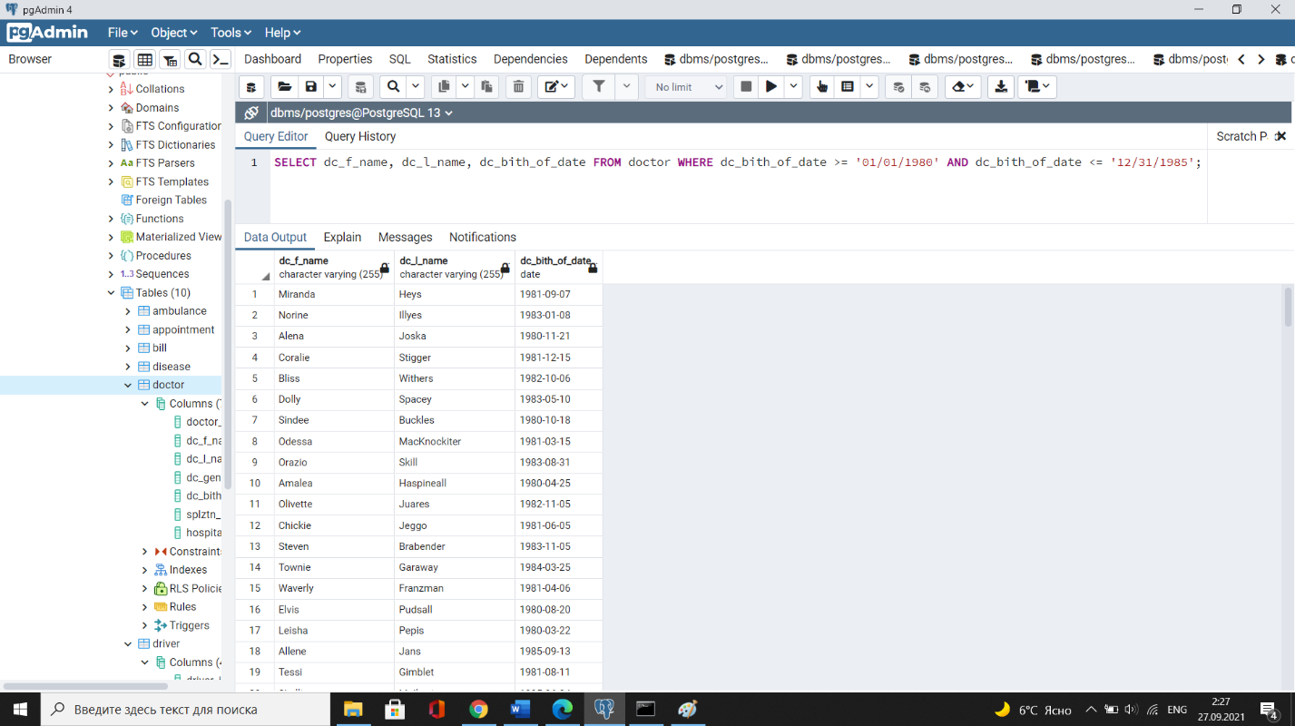

**7. Write a SQL statement to modify hospital status in a Hospitals table for hospitals, located in Beizhang (5 points).**

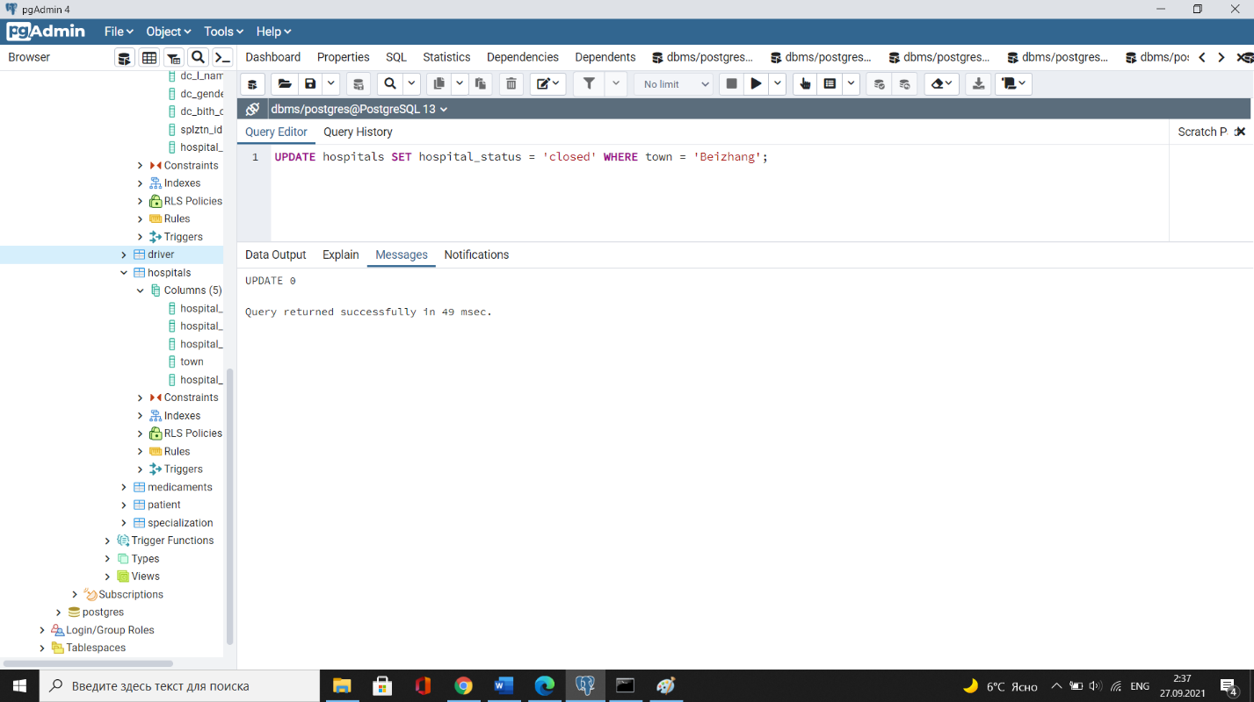

**8. Write a SQL statement to get the number of town available in the Hospitals table (5 points).**

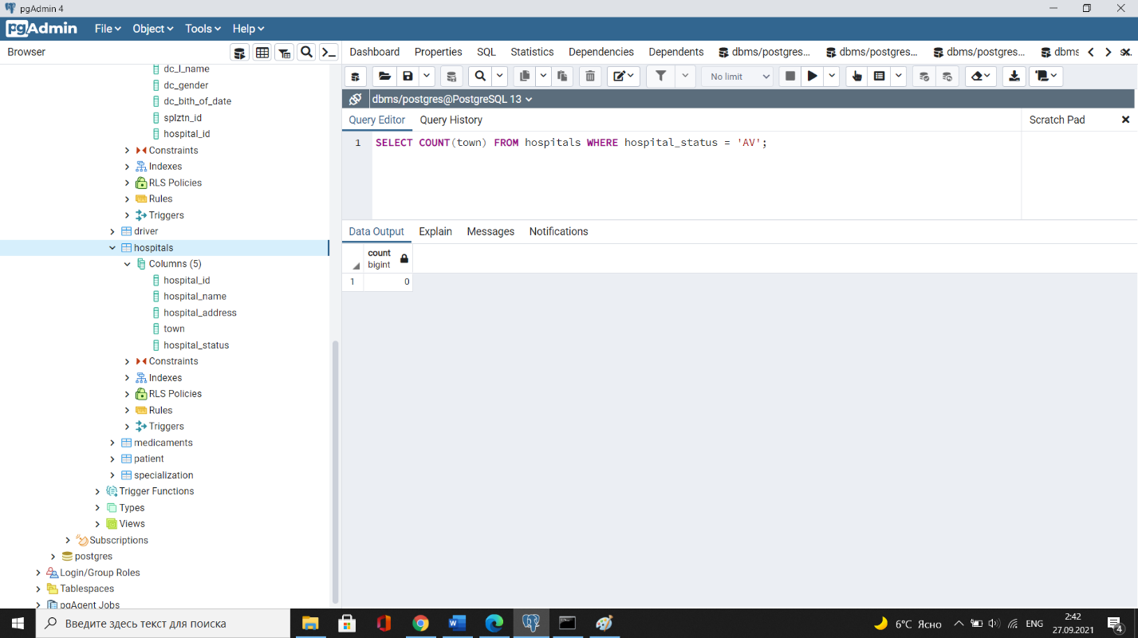

**9. Write a SQL statement to get the total price for all appointments (5 points).**

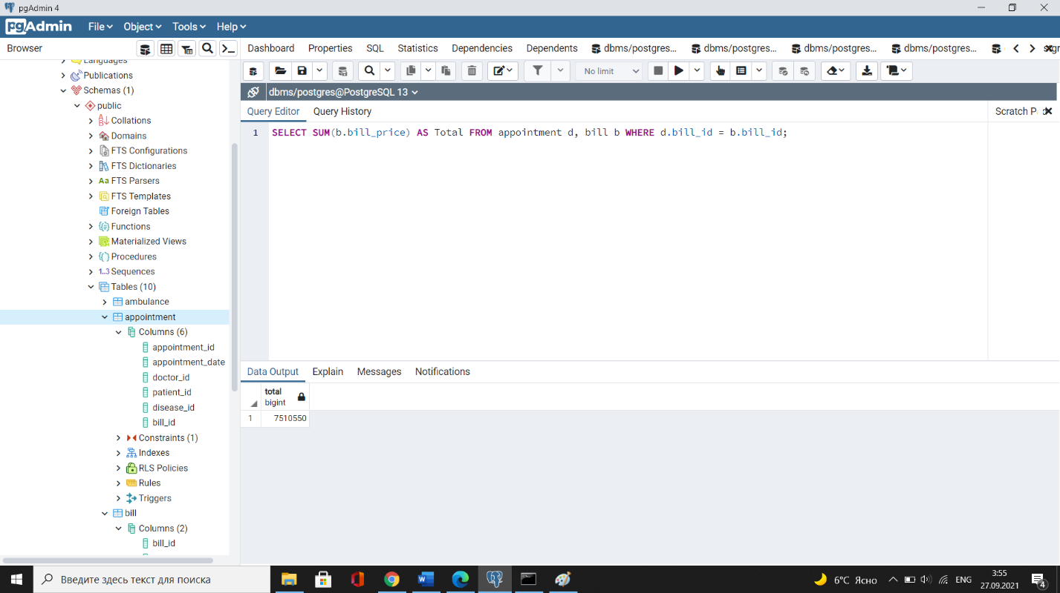

**10. Write a query to get the maximum price for bills with “Flu” disease (5 points).**

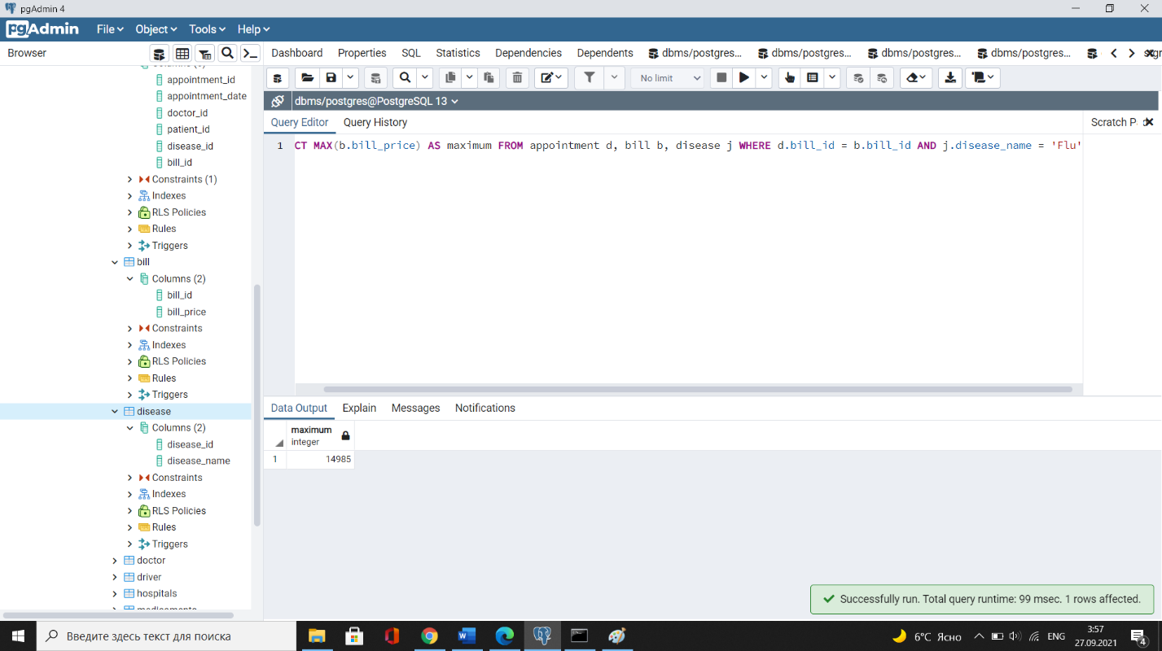

**11. Write a query to get the bills’ minimum price for patient Corine Doherty (5 points).**

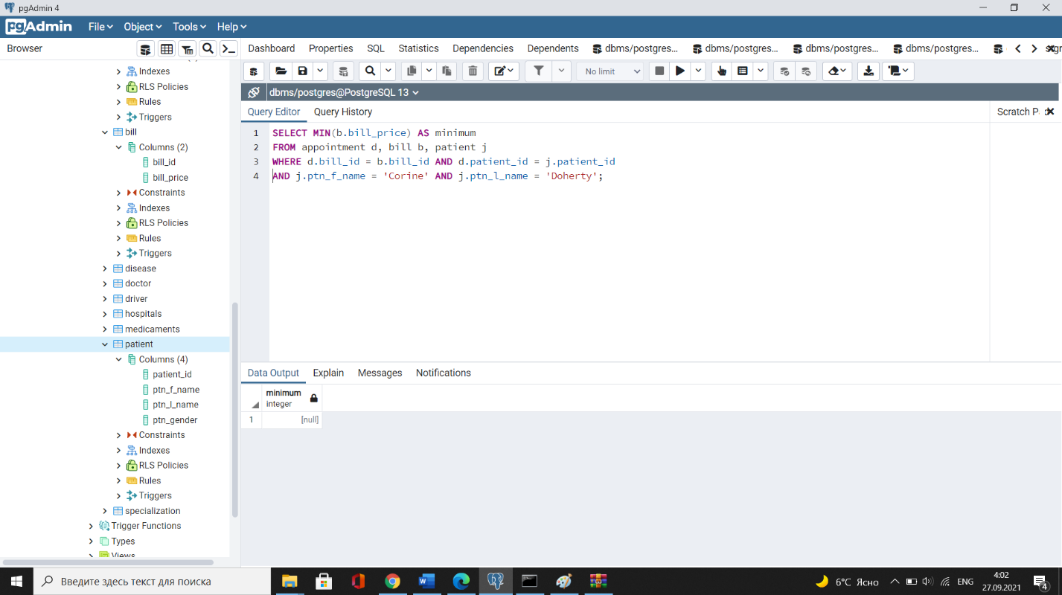

**12. Write a query to get the average price for doctors with specialization_id = 18 (5 points).**

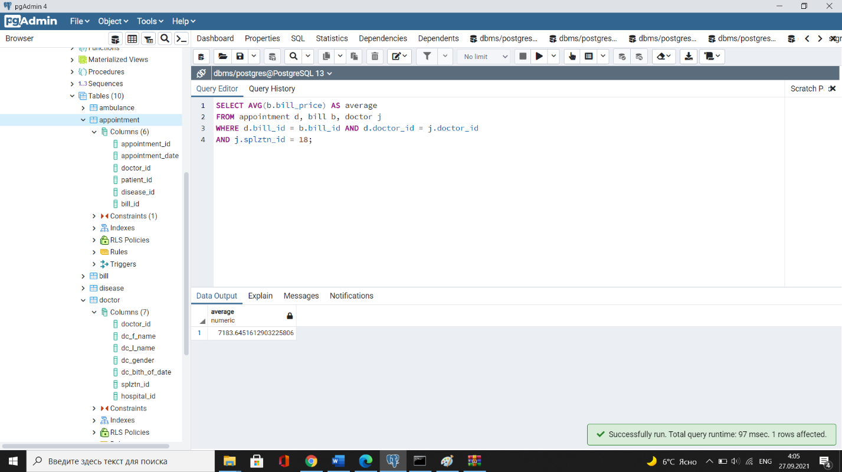

**13. Write a SQL statement to get data from hospitals table excluding the duplicates values from the "town" column (5 points).**

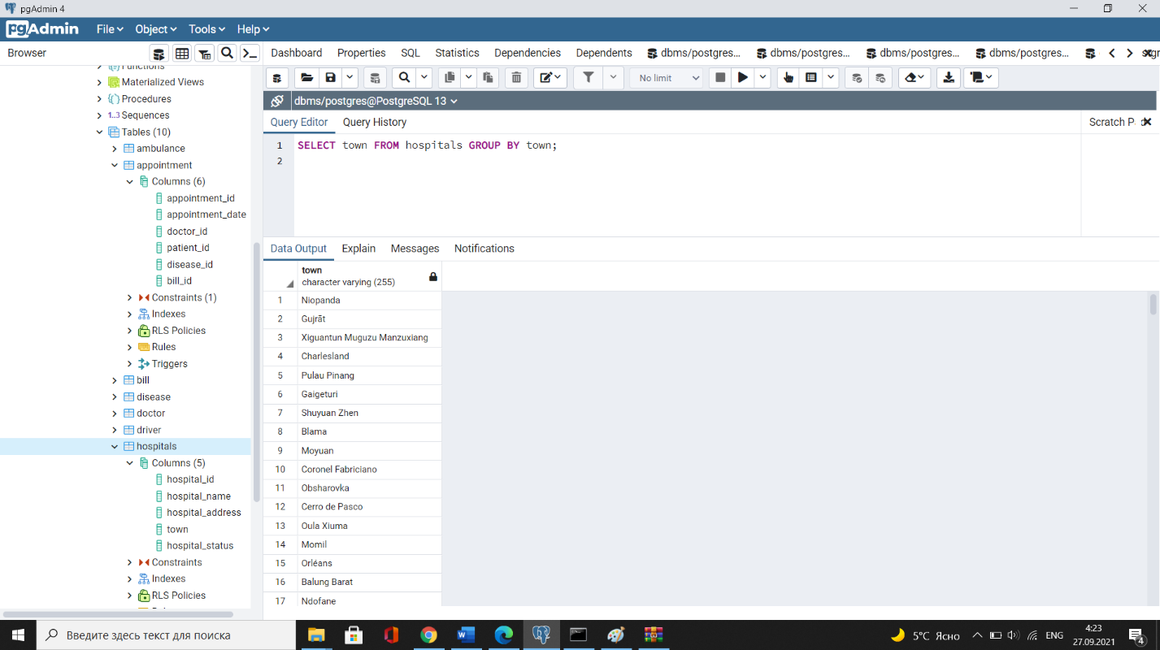

**14. Write a SQL query to get the number of doctors working for each specialization_id (5 points).**

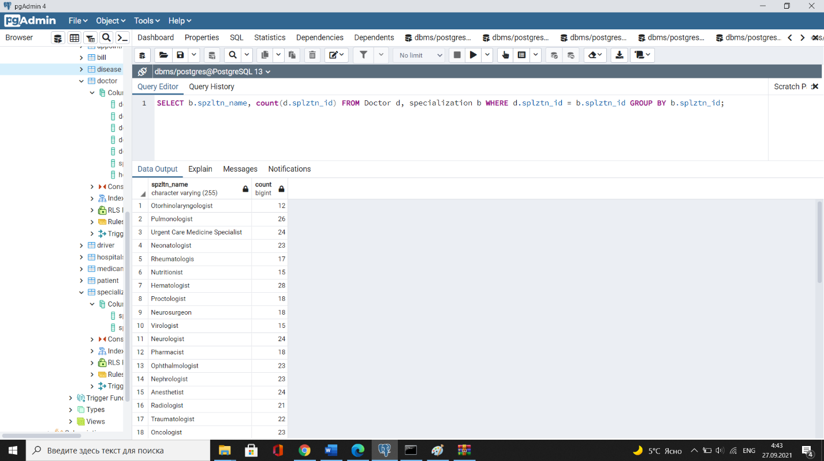

**15. Write a query to display the age of doctors, if the age is less than 35, display the age group as young, from 35 to 60 as middle, from 60 as old (5 points).**

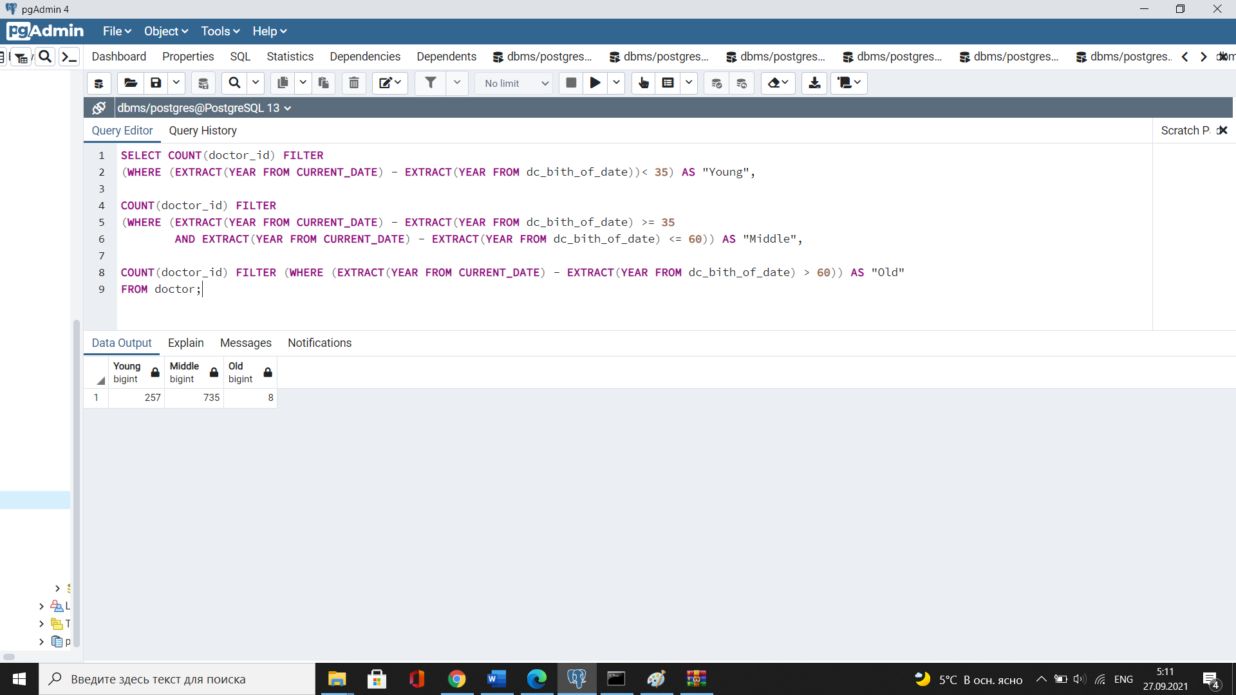

**16. Write a query to get the first and last name of the patients who has the letter 'n' as the fifth character and 'l' in the first name (5 points).**

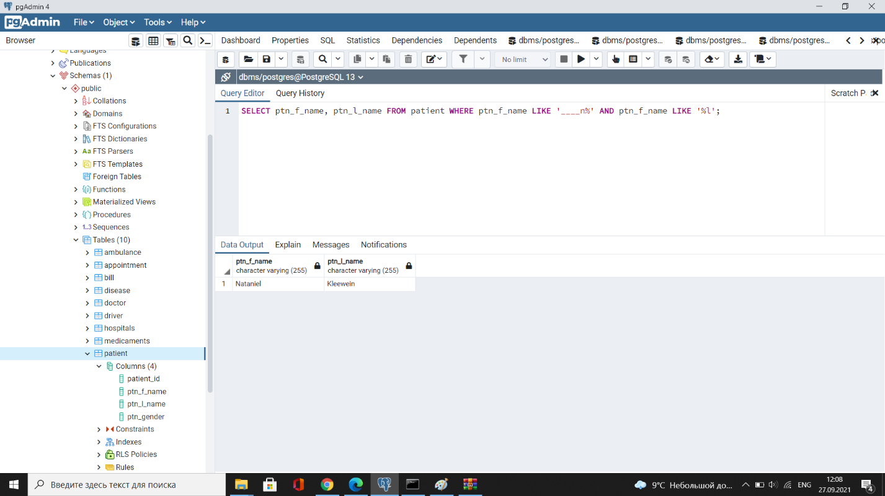

**17. Write a query to display the last name of doctors whose name contain exactly seven characters (5 points).**

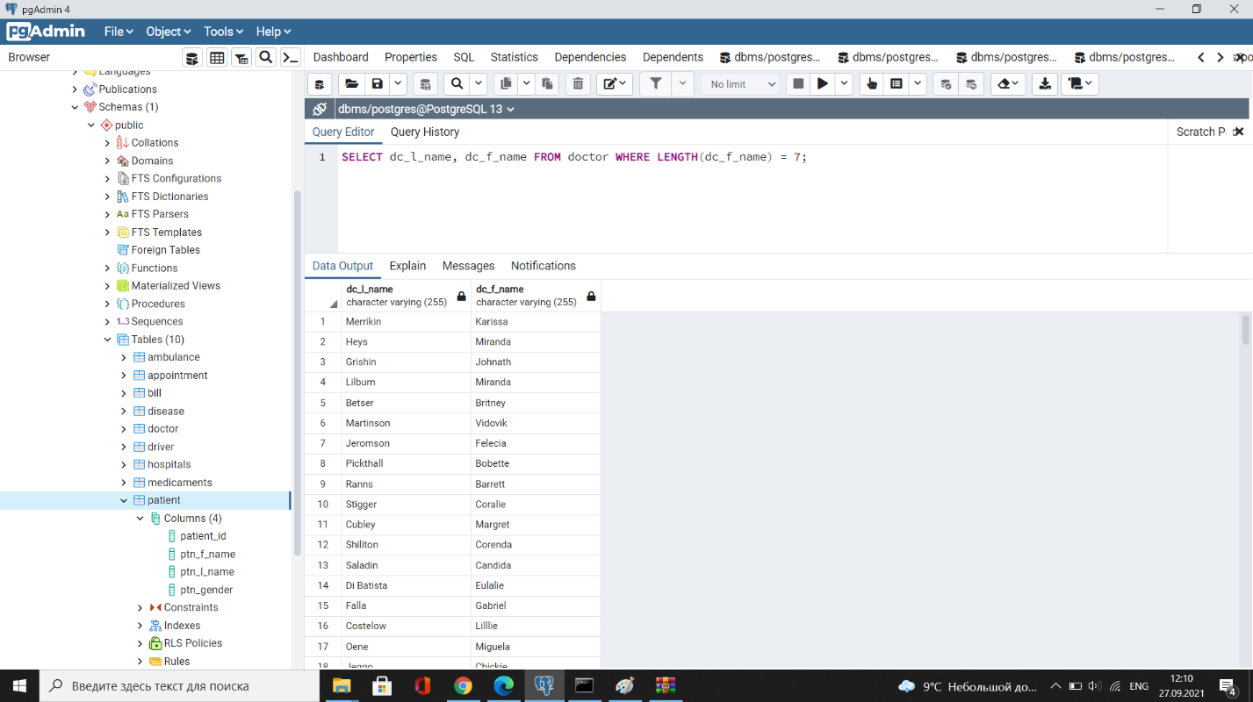

**18. Write a query to get the difference between the highest and lowest bill’s price (5 points).**

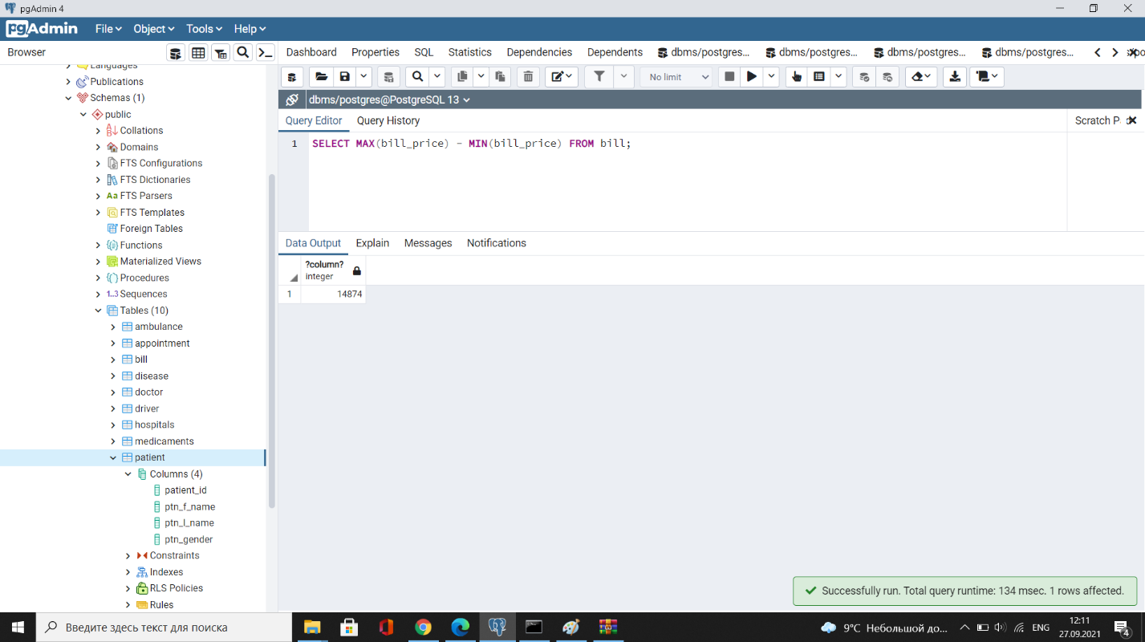

**19. Write a query to get number of medicaments available for each hospital in descending order from hospital_medicaments table (5 points).**

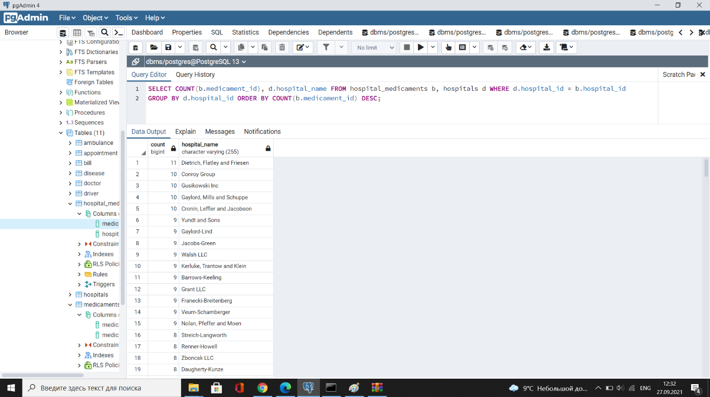

**20. Write a single query to display the first and last name of patient whose bill price is higher than 13000 (5 points).**

