Baikadamova Danel IT-2004

1. **Write a SQL query to count the number of patients who booked an appointment after 2nd of October, 2018 (5 points).**

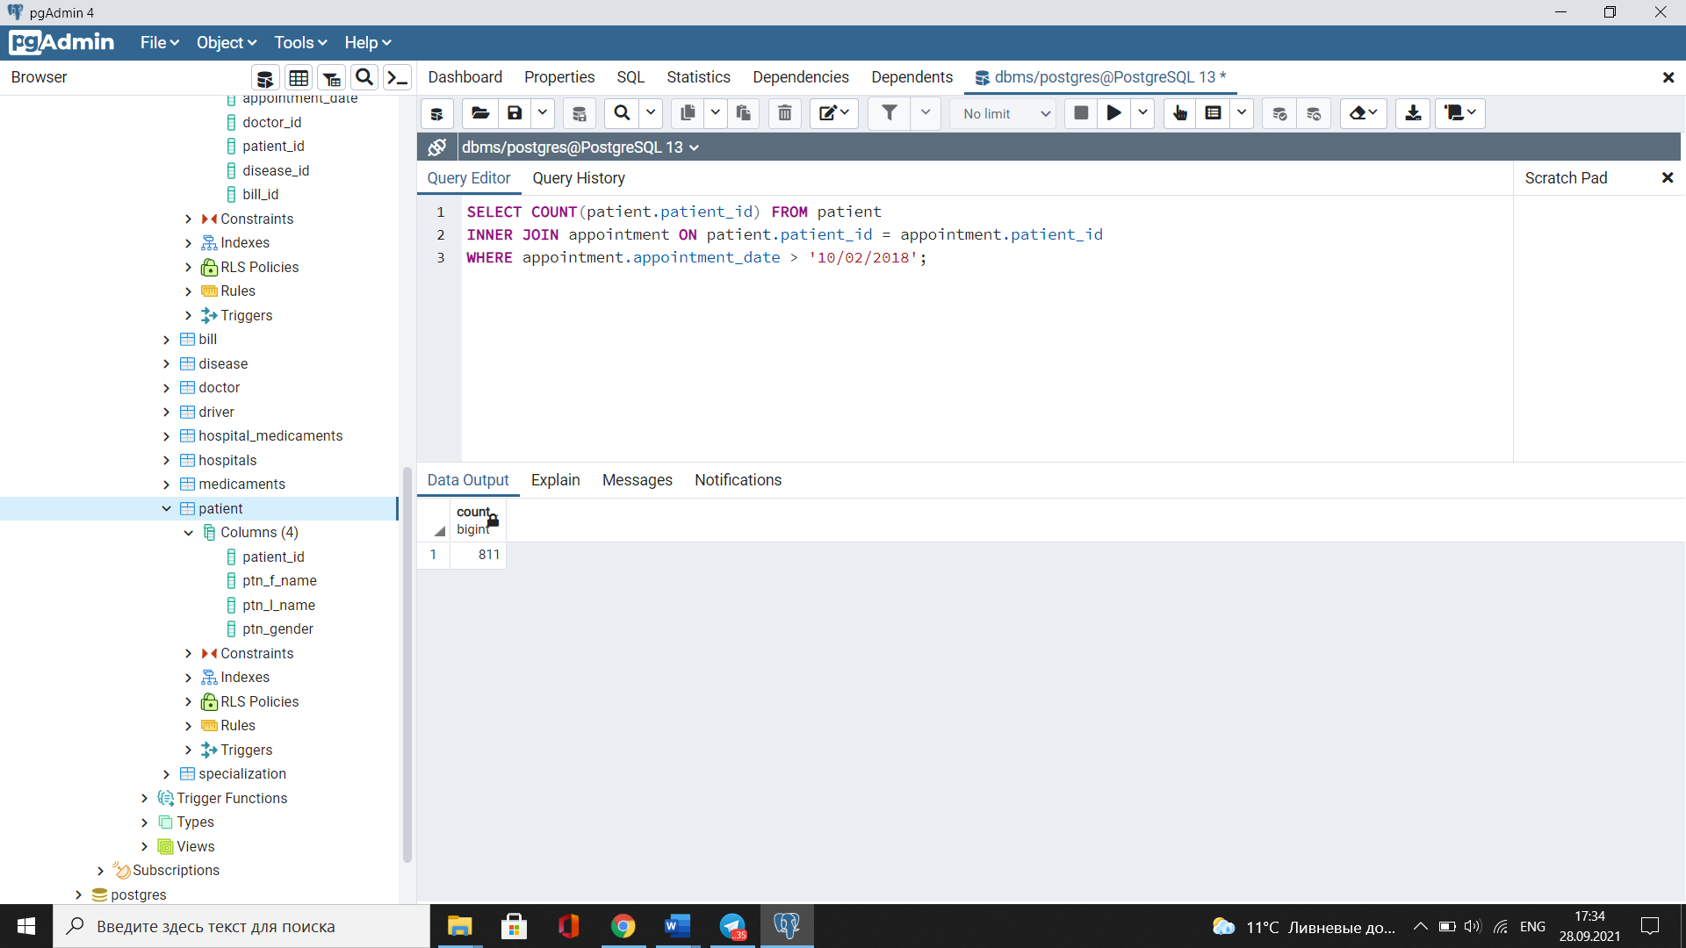

1. **Write an SQL statement to find the doctors that work in less than two hospitals (5 points).**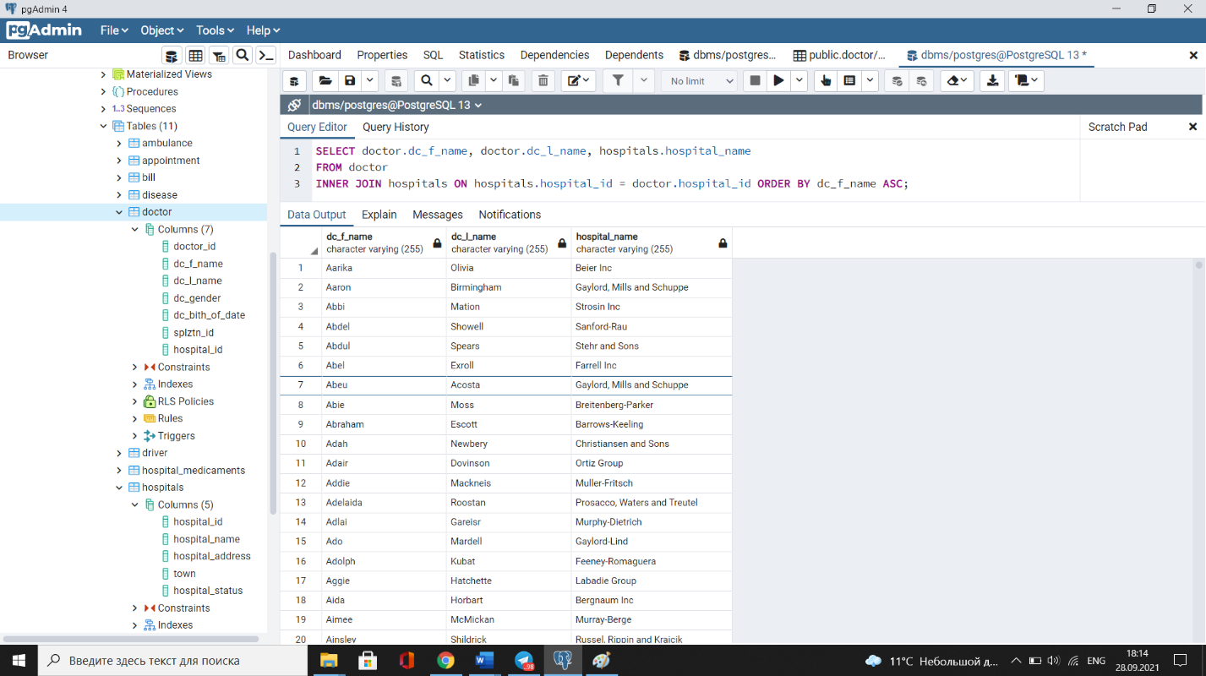
2. **Write a SQL query to find the patients with their doctors by whom they got their treatment (10 points).**

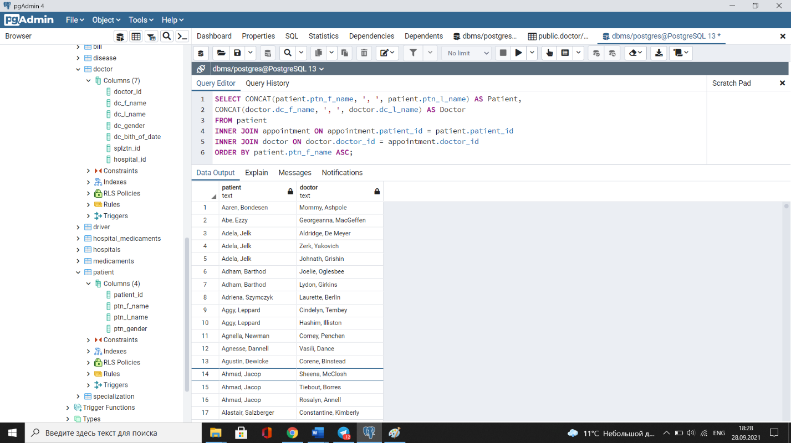

1. **Write a SQL query to count number of unique patients who got an appointment (5 points).**

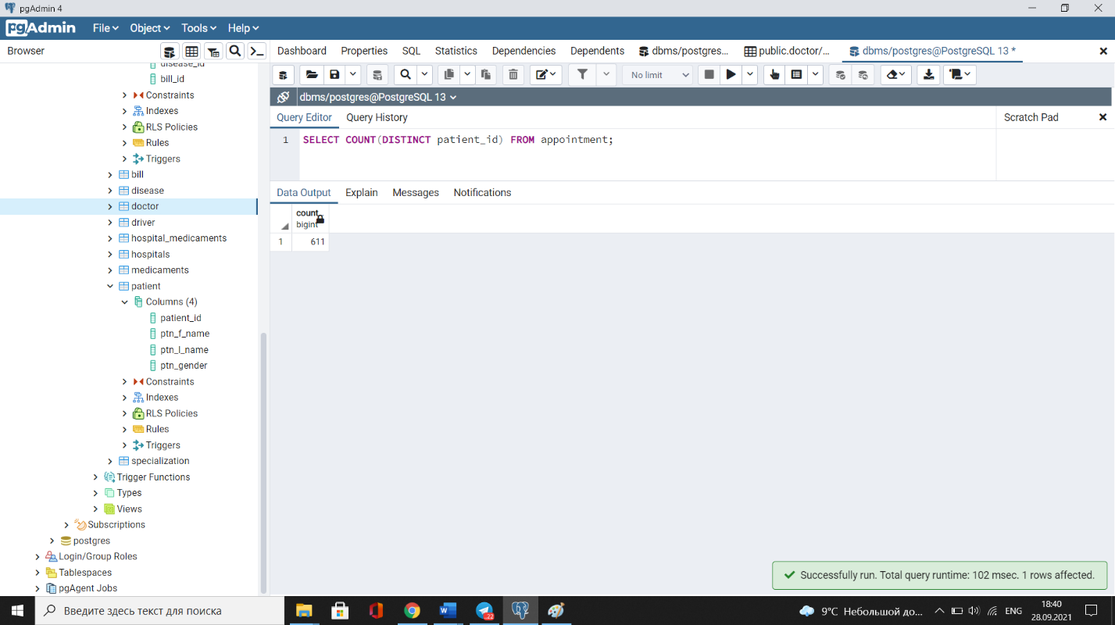

1. **Write a SQL query to find those patients who taken the appointment on the “2008-04-09” (5 points).**

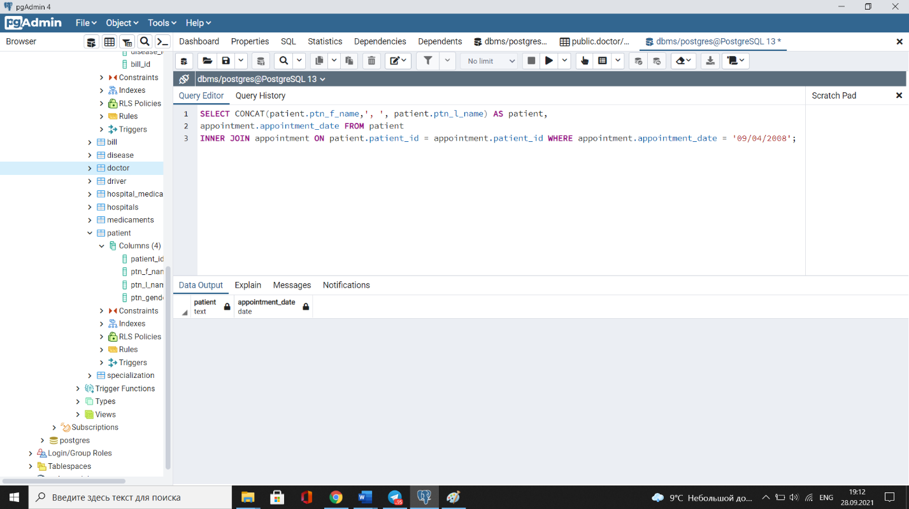

1. **Write a SQL query to find the appointment that have the largest bill paid by patient (5 points).**

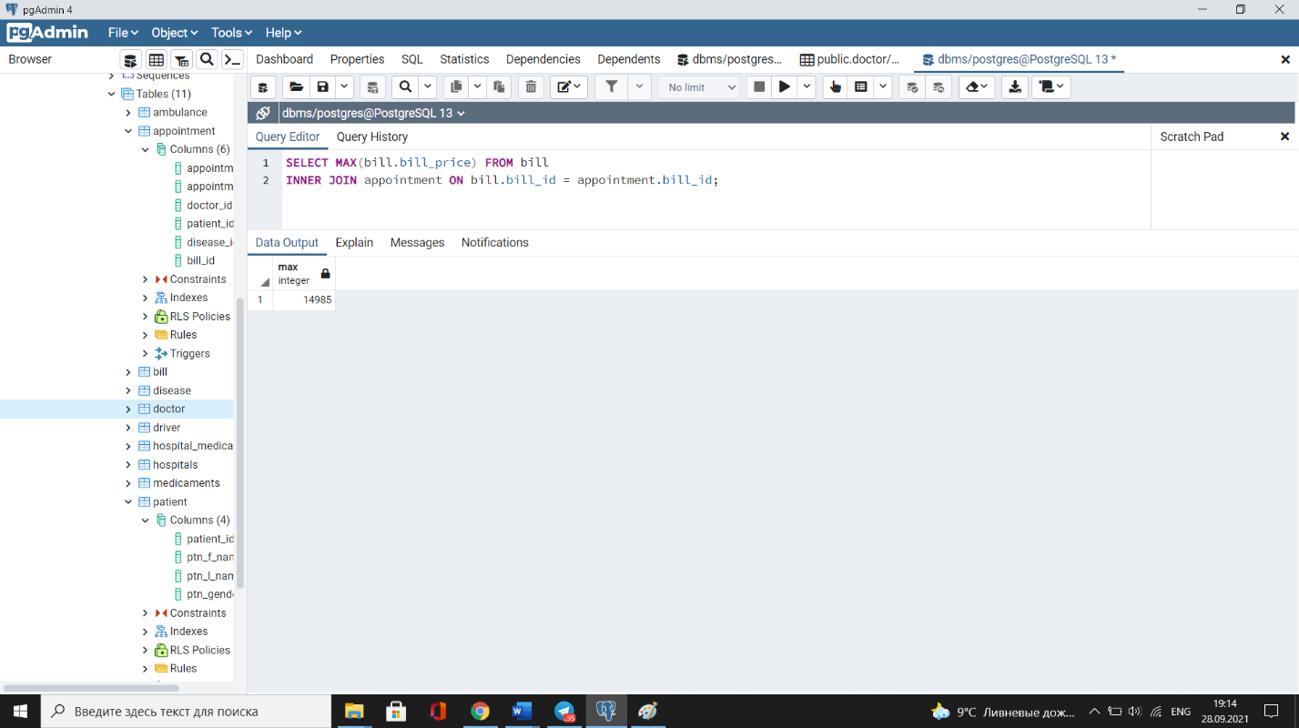

1. **Write a SQL query to find the doctor f_name and doctor l_name working in each hospital (5 points).**

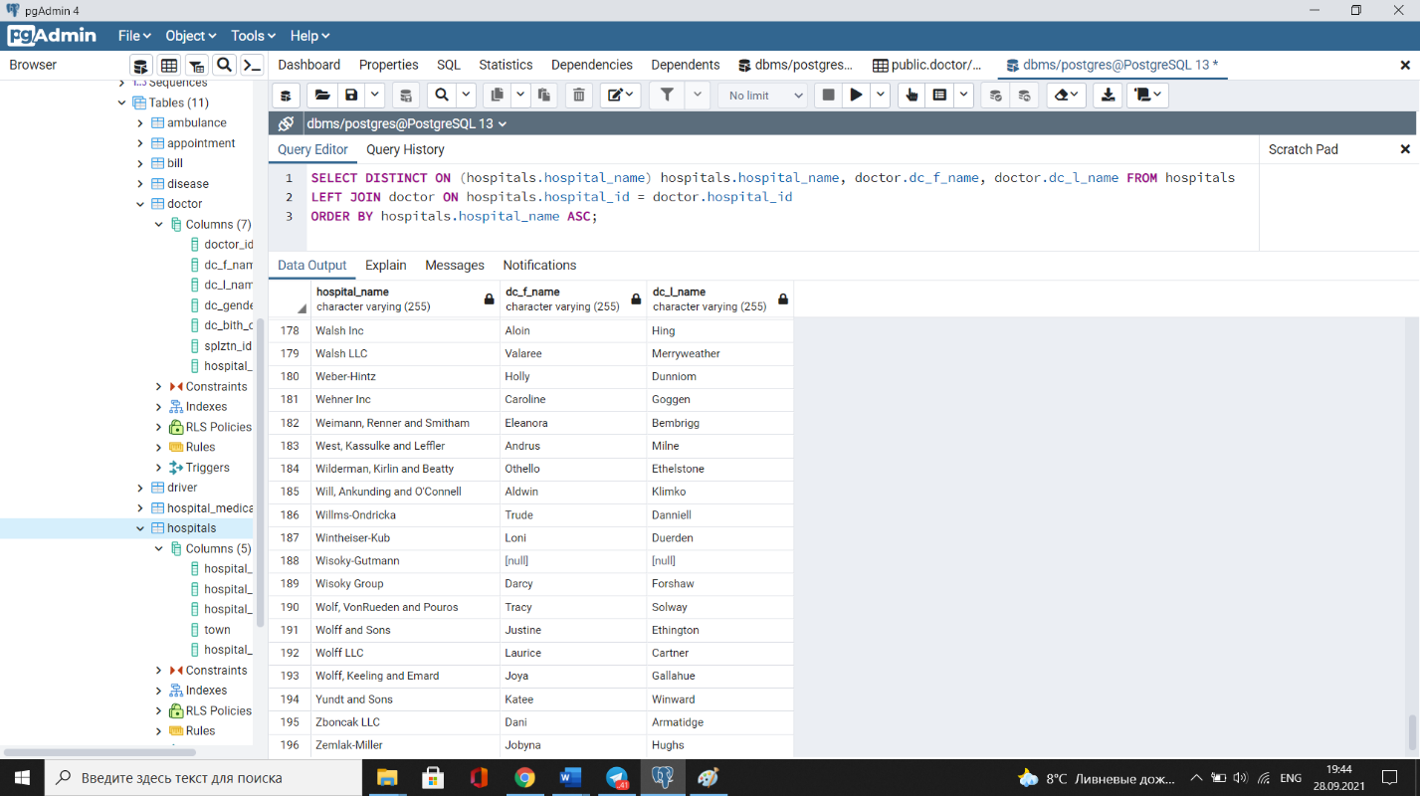

1. **Write a SQL query to find all doctors who treat “COVID-19” (10 points).**

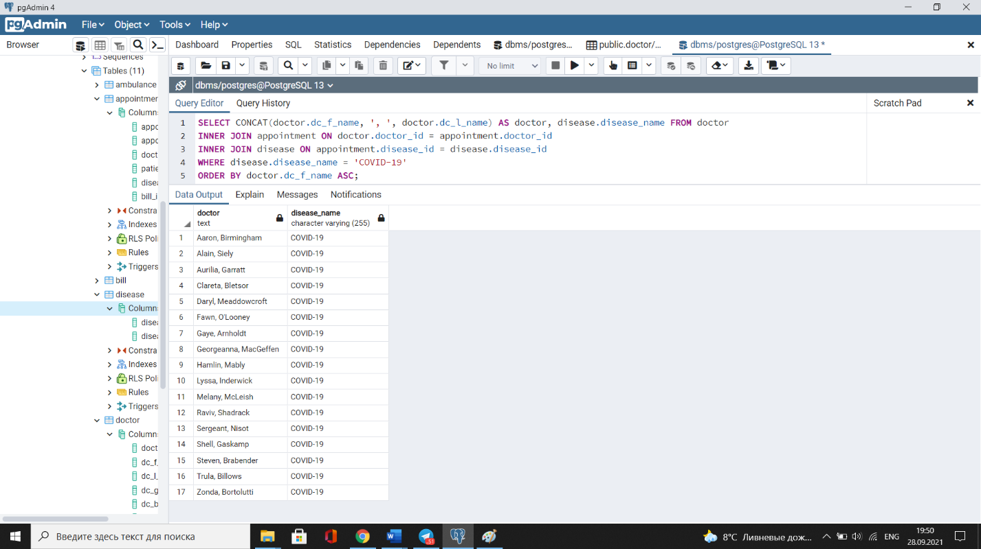

1. **Write a SQL query to find all doctors who doesn’t have an appointment on date “2018-06-25” (5 points).**

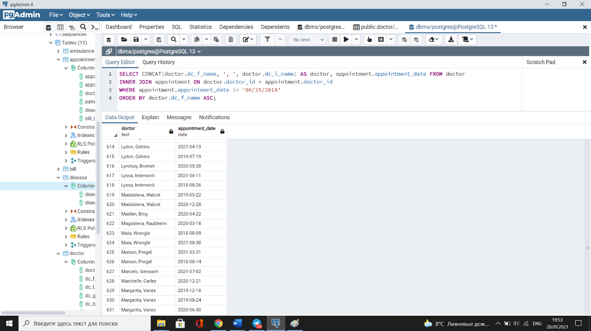

1. **Write a SQL query to find the driver f_name driver l_name working in each ambulance (5 points).**

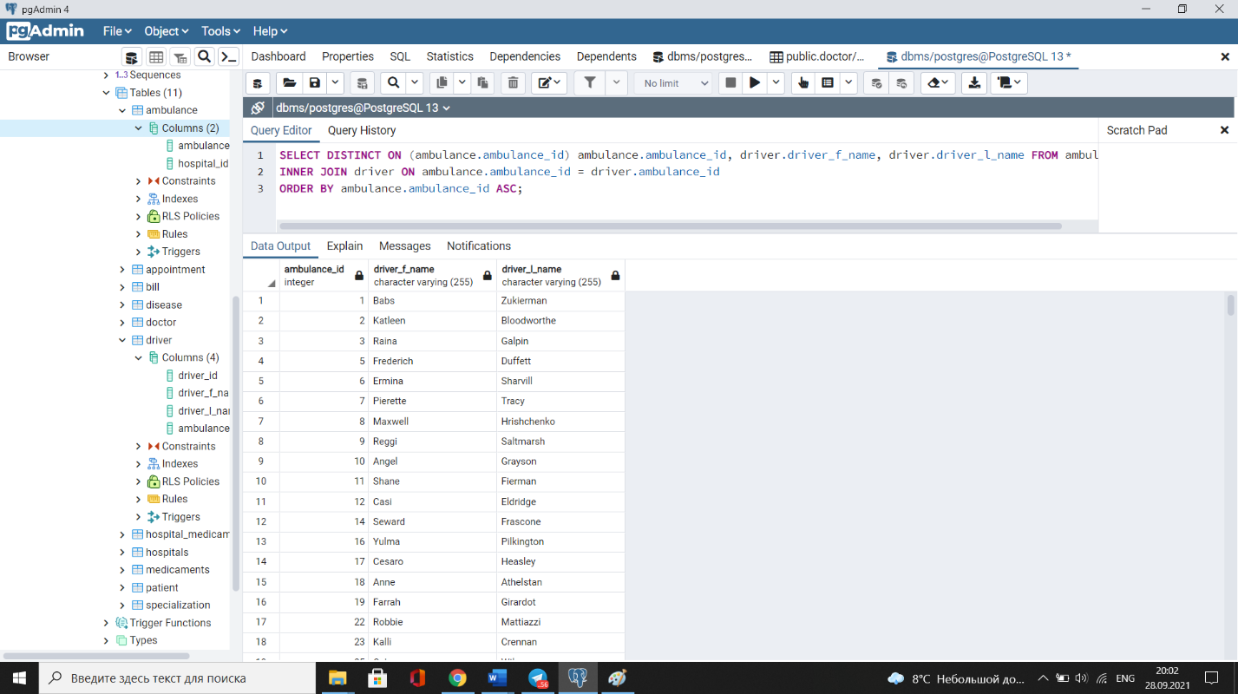

1. **Write a SQL query to find the addresses of the hospitals which have in stock medicaments as “Toradol” and “Leukeran” (10 points).**

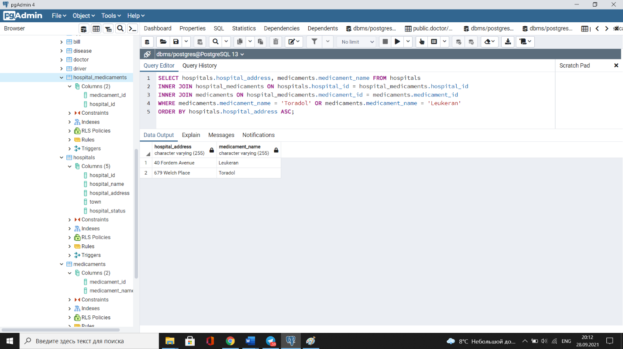

1. **Write a SQL query using Self Join. Change the database if needed (10 points).**

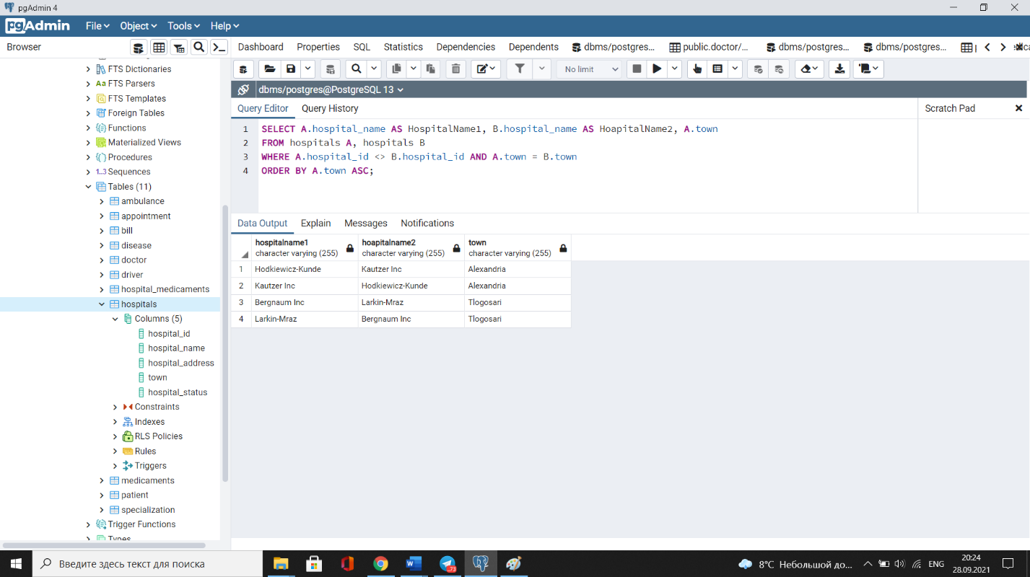

1. **Write a SQL query using Сross Join. Change the database if needed (10 points).**

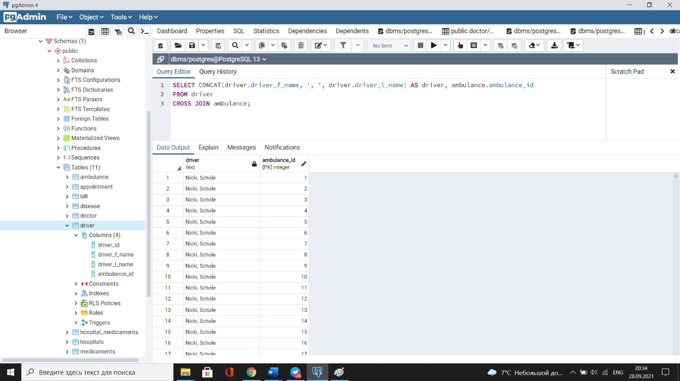

1. **Write a SQL query using Natural Join. Change the database if needed (10 points).**

