Baikadamova Danel IT-2004

1. **Write a query to get the average bill_price for all bill_id above 970. (5 points)**

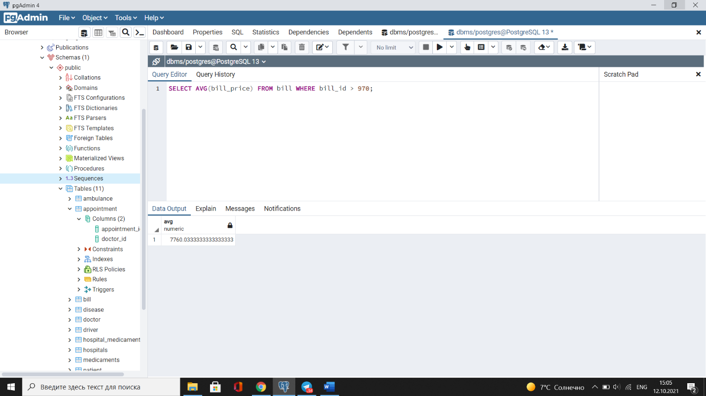

1. **Write a query to calculate the average salary of male doctors whose Doctor id less then 35. (5 points)**

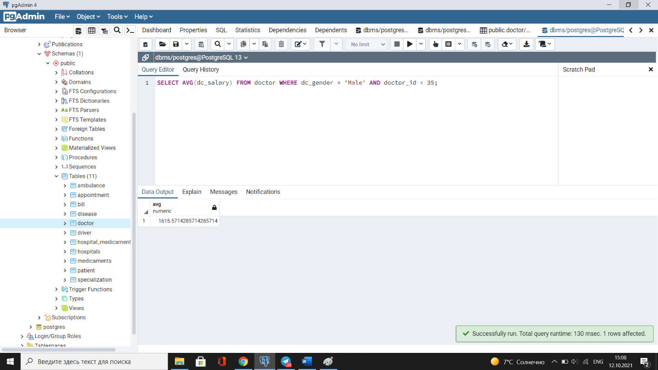

1. **Write a query to find the first name, last name of doctors and salaries of the doctors who have a higher salary than the doctor whose last name is ‘Wyldish’. (5 points)**

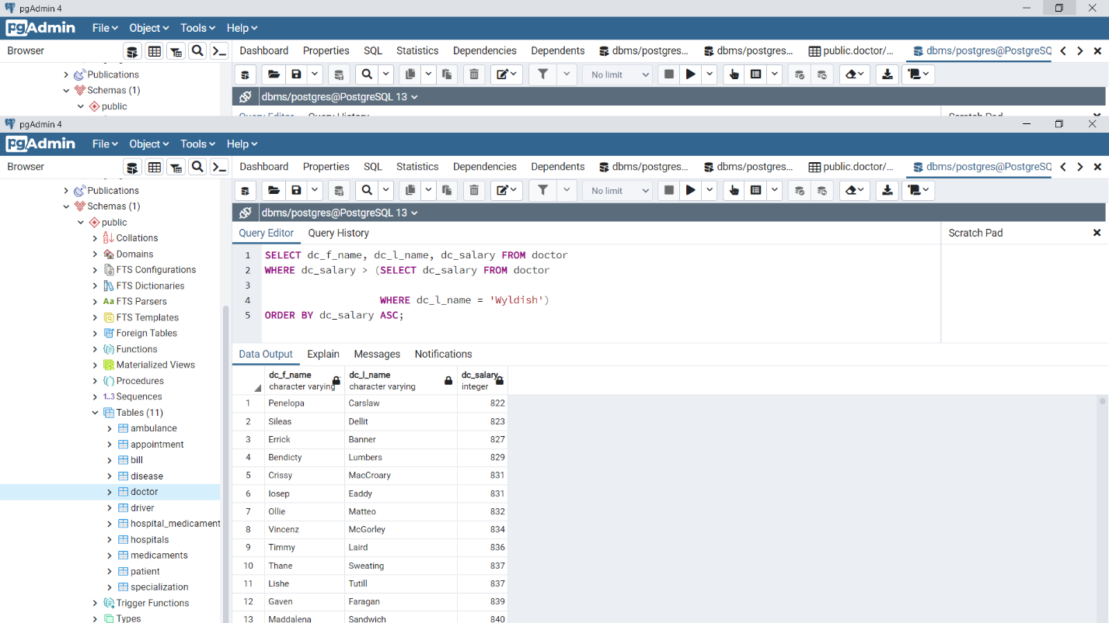

1. **Write a SQL subquery to find the first name and last name of all doctors who works as Neurologist. (5 points)**

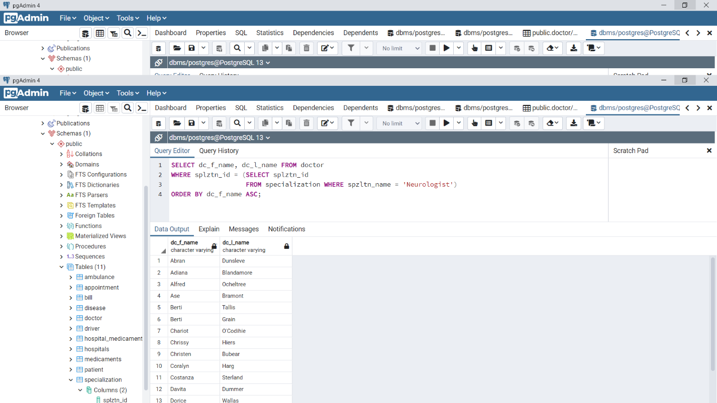

1. **Write a SQL subquery to find the first name, last name and salary, which is greater than the average salary of the doctors. (5 points)**

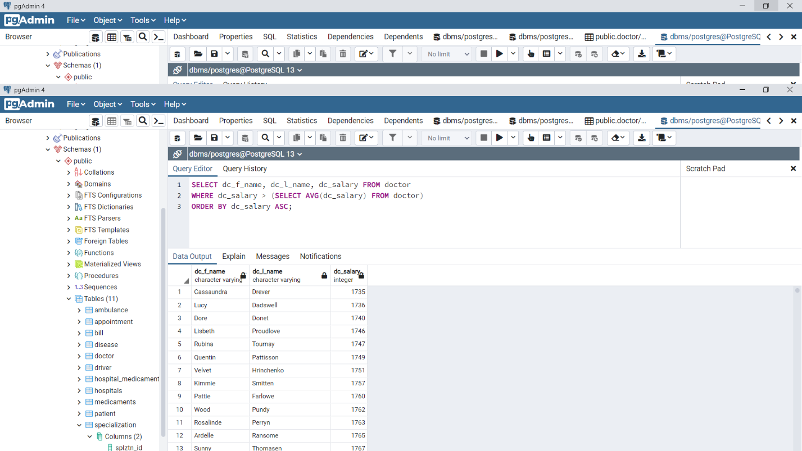

1. **Write a SQL subquery to find the first name of doctors, last name of doctors and salary of doctors, which is equal to the minimum salary for this specialization, he/she is working on. (5 points)**

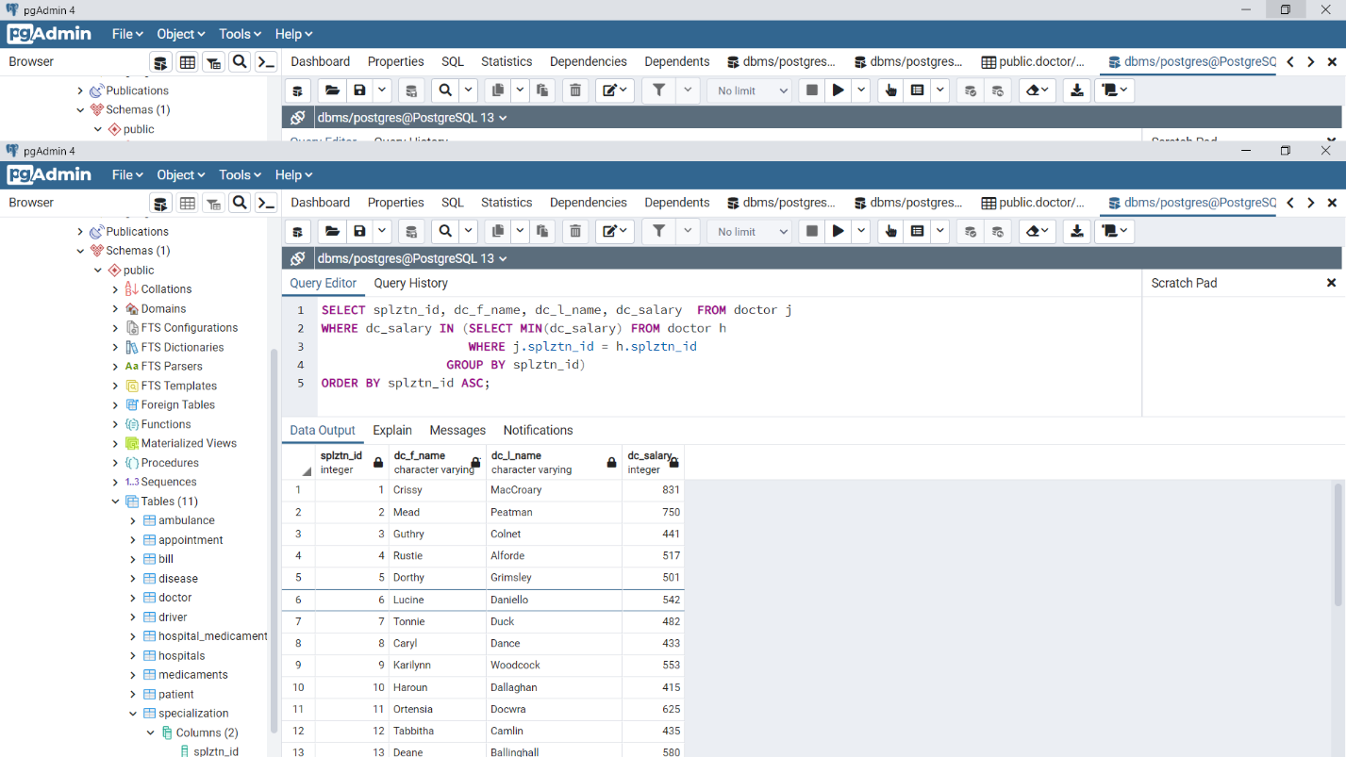

1. **Write a SQL subquery to find all the information of the doctors who draws the same salary as the minimum salary for all specializations. (10 points)**

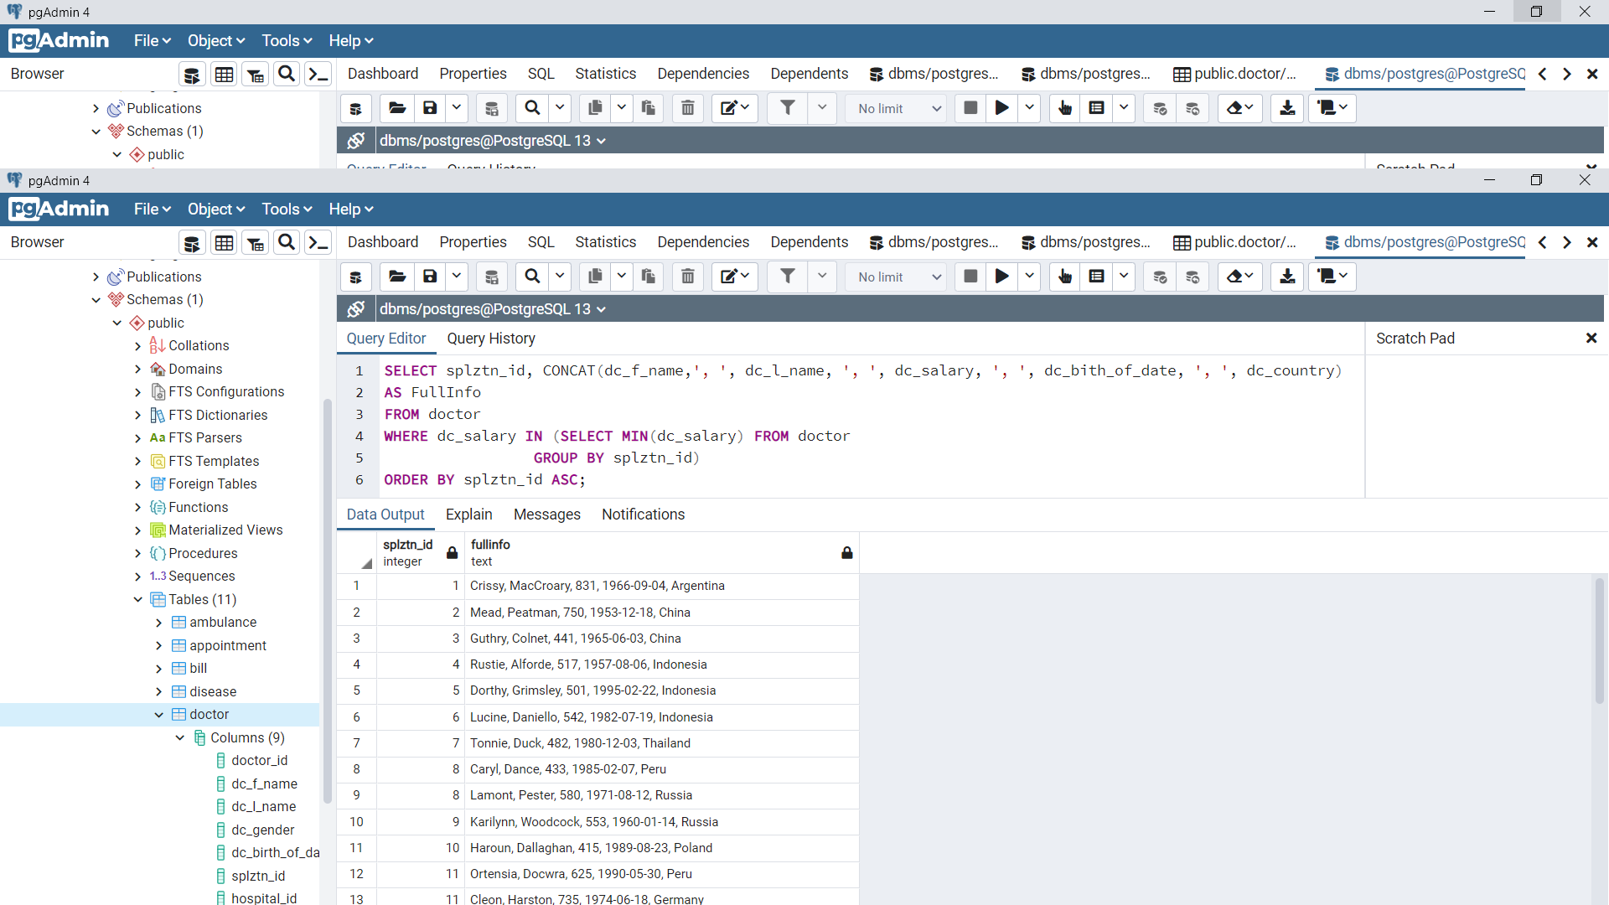

1. **Write a query to get three minimum salaries of doctors. (10 points)**

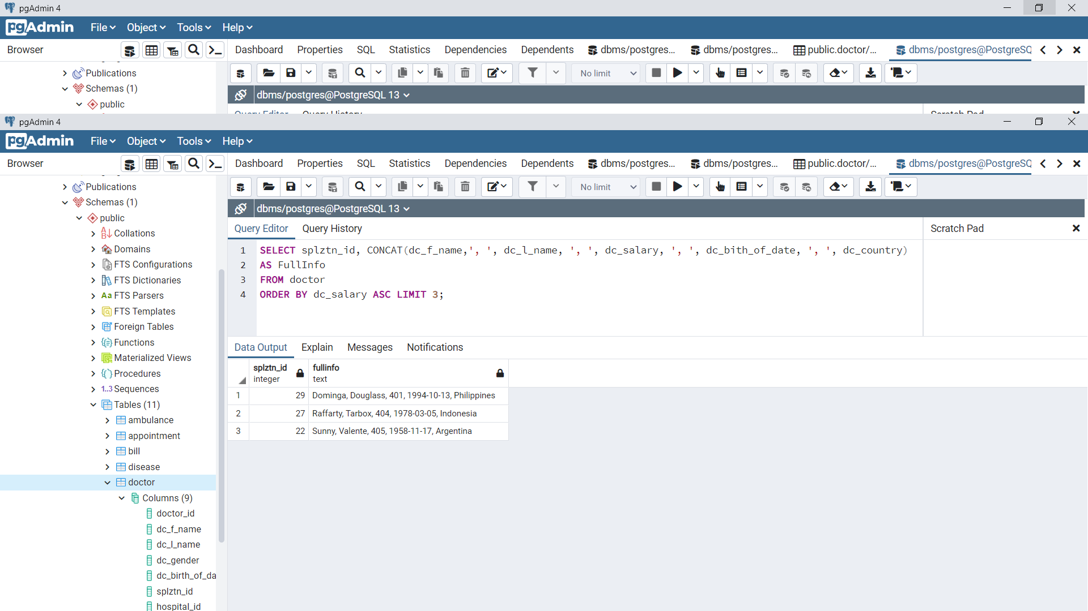

1. **Write a query that returns the first name, salary, gender of doctors, along with the average salaries of each gender. Use the window function. (10 points)**

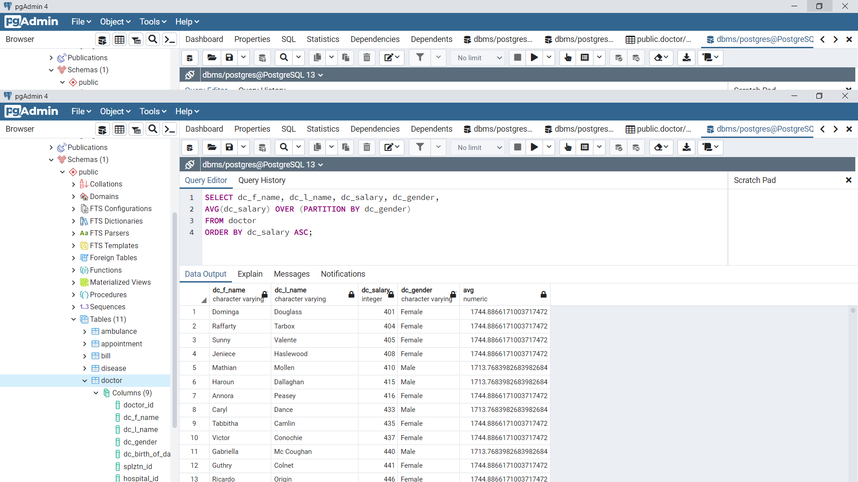

1. **Write a query that filters and finds only the top paid doctor in each hospital id. Use the window function. (10 points)**

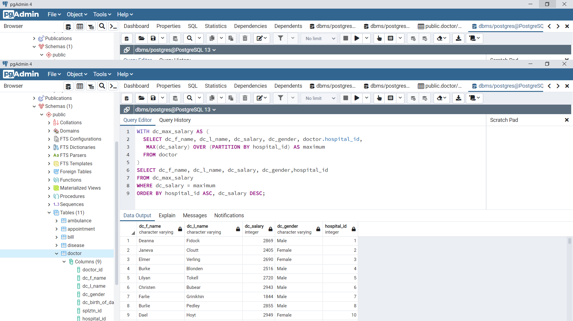

1. **Write a SQL query using ROW_NUMBER window function. (10 points)**

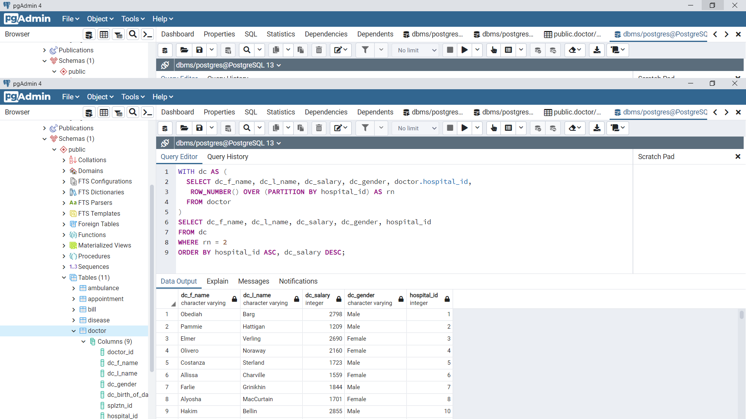

1. **Write a SQL query using DENSE_RANK window function. (10 points)**

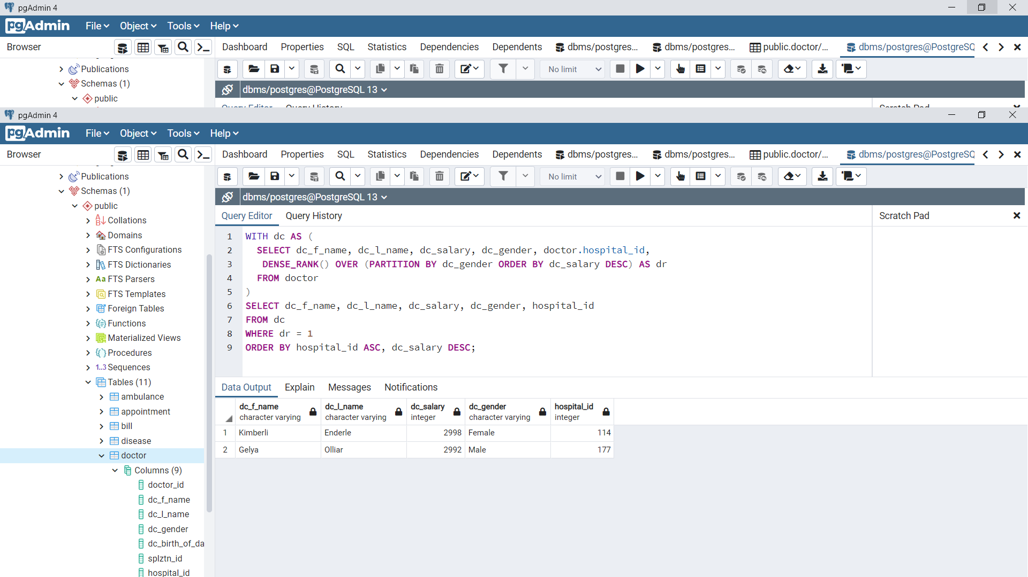

1. **Write a SQL query using FIRST_VALUE window function. (10 points)**

