**Baikadamova Danel IT-2004**

1. **Write a SQL query that displays the amount of male and female doctors per each country and the number of doctors by gender. The total number of doctors for each country should be displayed as the first line for the group. (5 points)**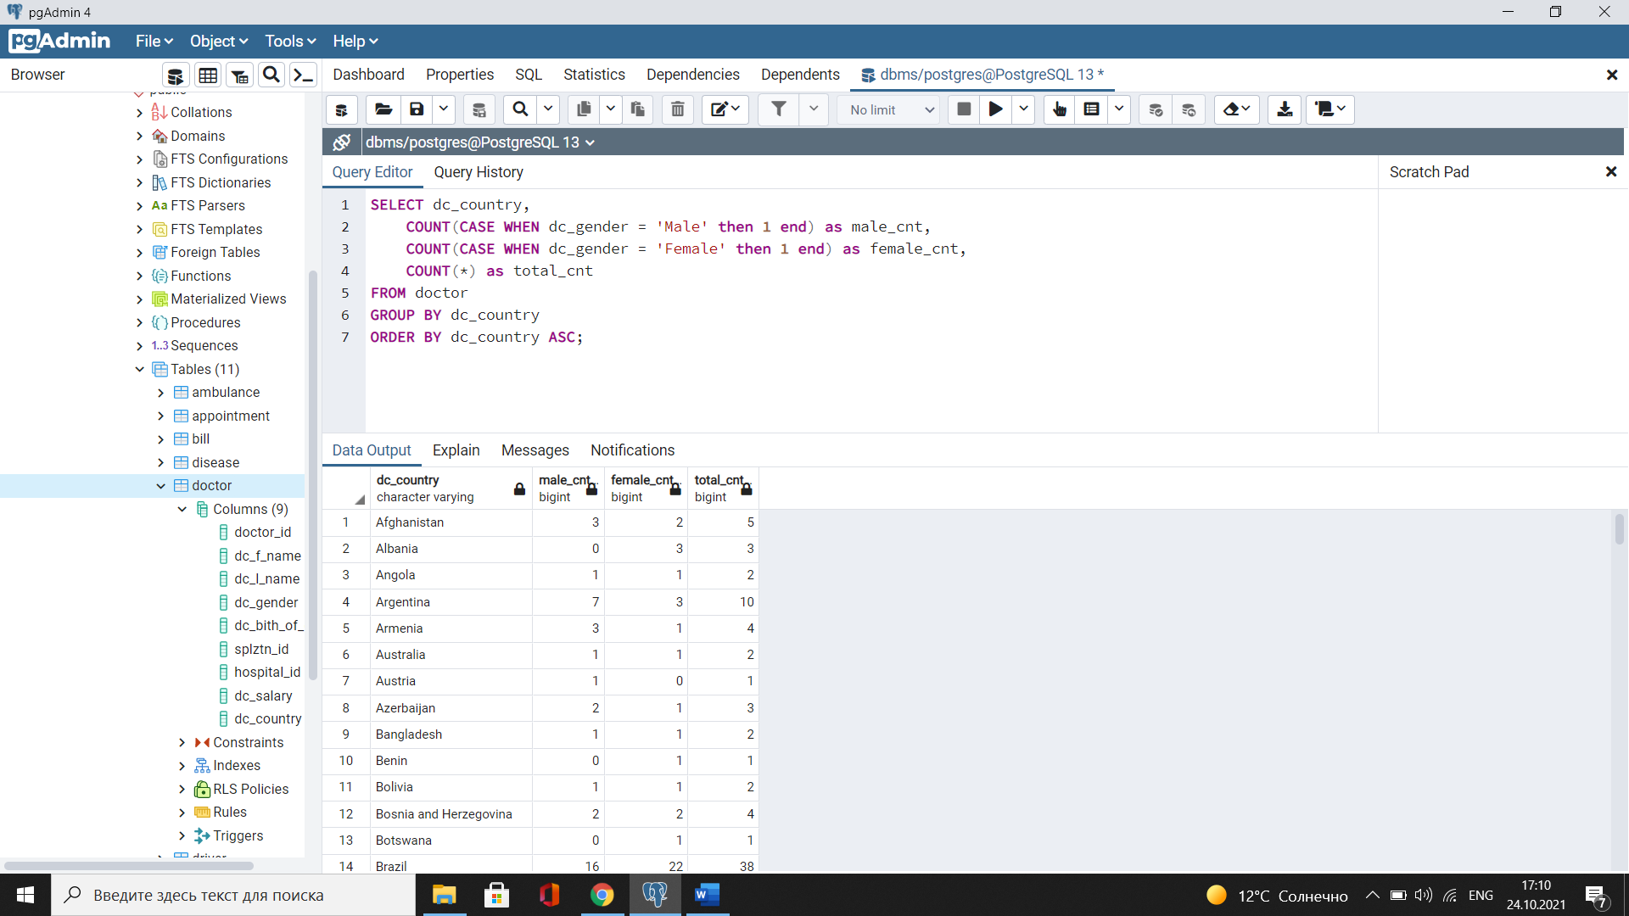
2. **Write a SQL query that displays how many female and male doctors treat each disease, and how many patients refer to these doctors?(5 points)**

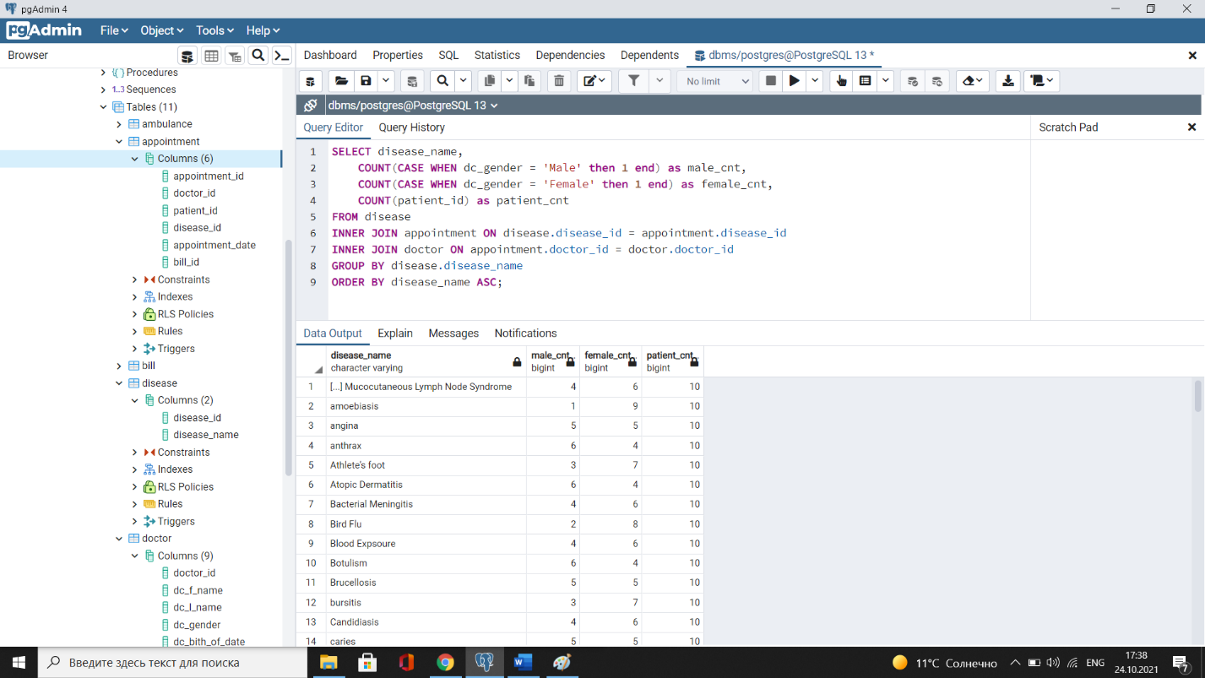

1. **Write a SQL query to find the number of drivers for each ambulance and the number of ambulances for each hospital? (5 points)**

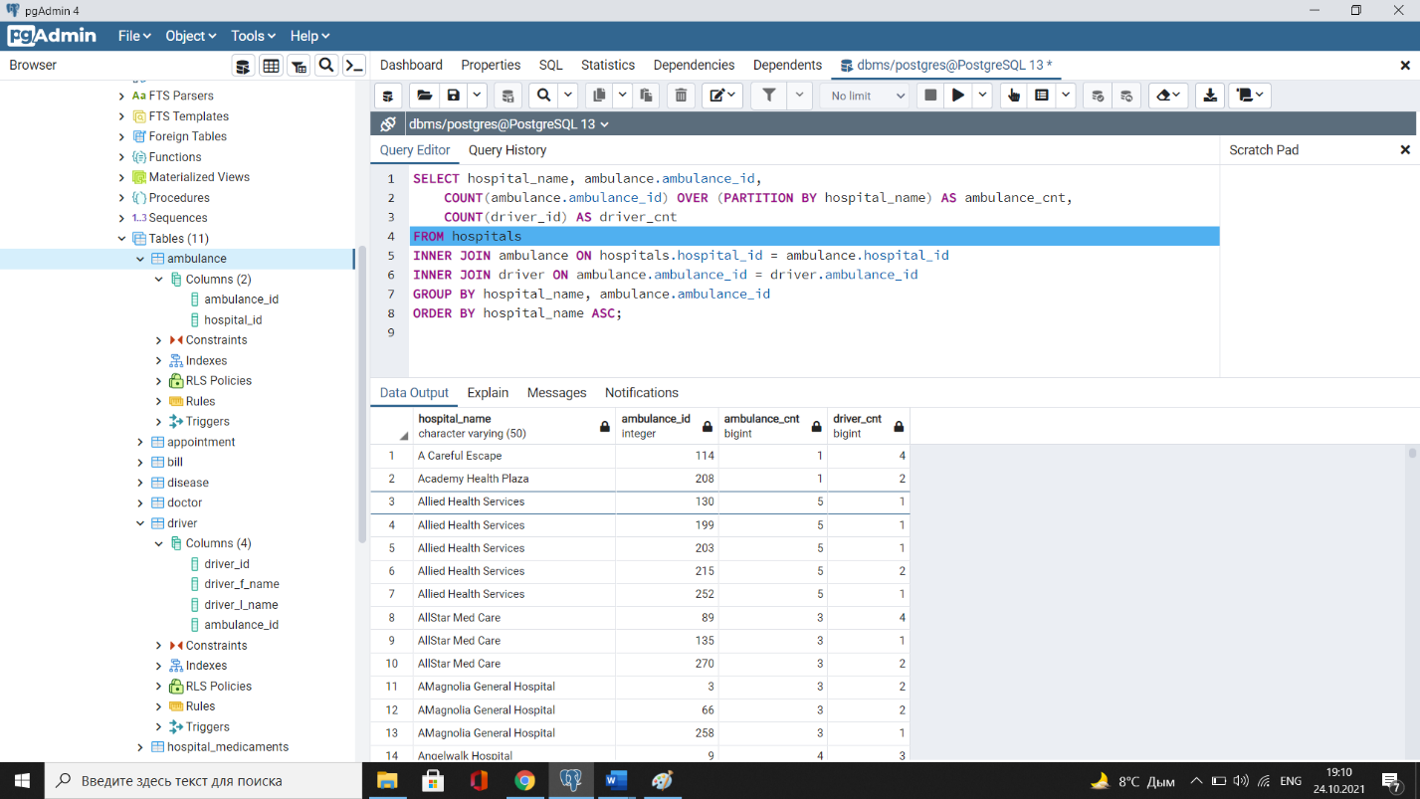

1. **Write a SQL query to find how many hospitals belong to each hospital status and how many doctors work in each of those hospitals? The total number of doctors for each hospital status should be displayed as the first line for the group. (10 points)**

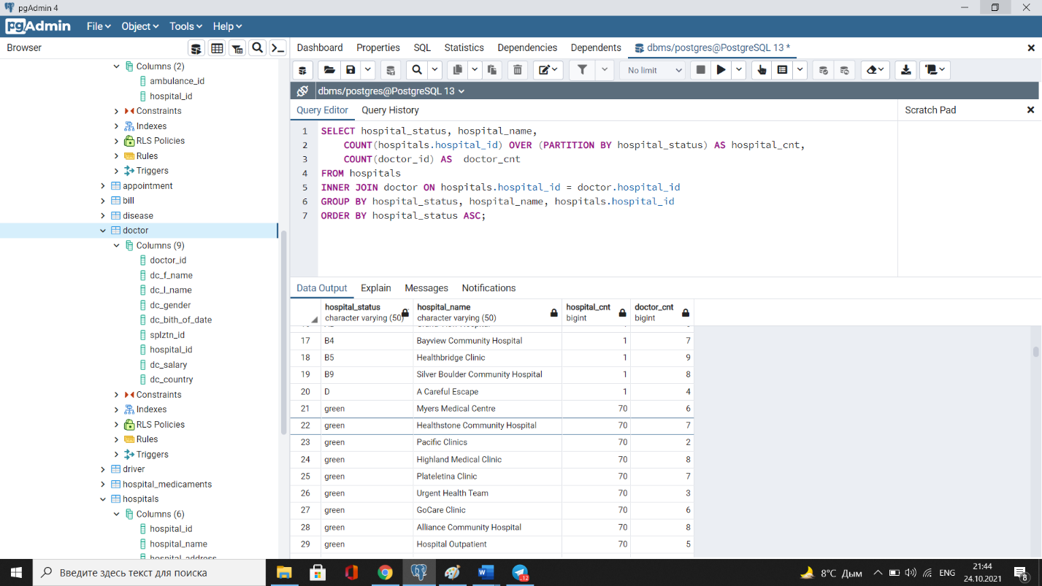

1. **Create an unique index for the ptnt_phone of the Patient table. Check if the index was created or not. Insert into the table a new patient with data(insert into Patient (patient_id, ptn_f_name, ptn_l_name, ptn_gender, ptnt_birth_date, ptnt_phone, ptnt_country, ptnt_address) values (1212, 'Mikkela', 'Anderson', 'Female', '1985-03-05', '850-163-2365', 'Angola', '567 Nottingham place'). Explain in your own words what is going on in the output? (10 point)**

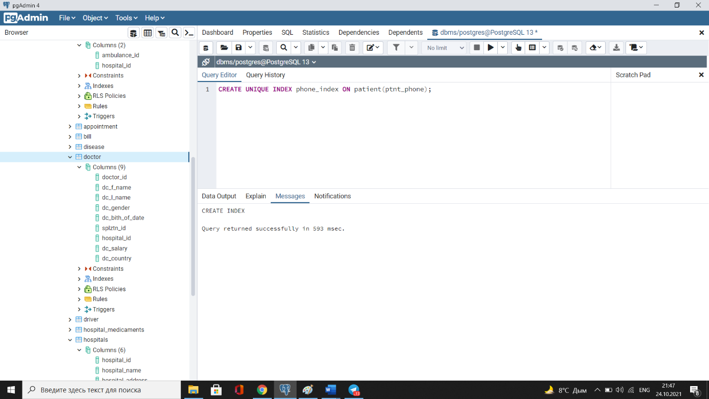

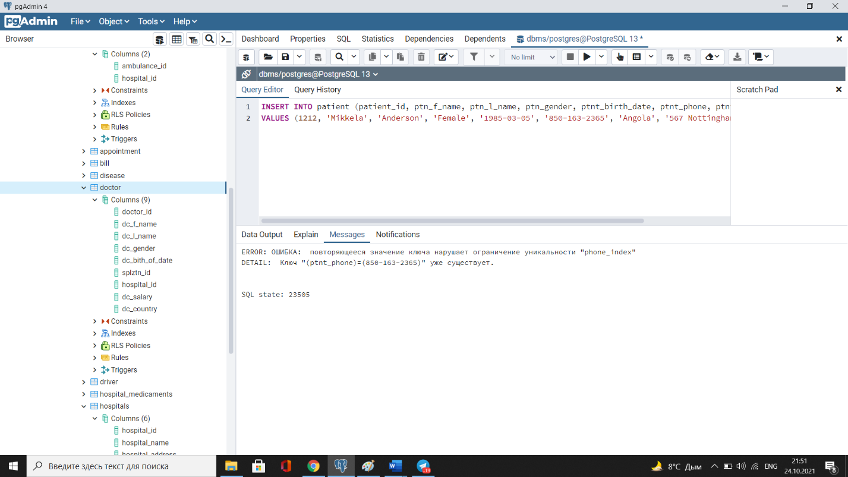

Not working cause of unique constraint, we can not have duplicate.

1. **Create an index for the Doctor table. Use for that first name, last name, date of birth and country. Then, write a SQL query to find a doctor who lives in China and was born in 1979 and check if the query uses indexes or not.(10 points) -2 screenshots**
2. **Write a SQL query to list indexes for tables Doctor and Patient. After delete the created indexes. (5 points) - 2 screenshots**
3. **Create a view in which you can display the full name and country of origin of patients who were treated by doctors from Brazil. (5 points)**
4. **Create a view in which you can display the full name and id of all doctors who treat diseases starting with the letter “M”.(5 points)**
5. **Create a view that links to the Hospital database tables and contains the doctor's identification number and last name, while displaying only doctors working in Colombian hospitals and doctors whose salaries are less than 1200$ . (5 points)**
6. **Update any of the created views by adding new information in the view table. (5 points)**
7. **Write a SQL query using UNION. Change the database if needed. (10 points)**
8. **Write a SQL query using INTERSECT. Change the database if needed. (10points)**
9. **Write a SQL query using EXEPT. Change the database if needed.(10 points)**