**Baikadamova Danel IT-2004**

1. **Create a block that shows the first_name and last_name of all patients. (5 points)**

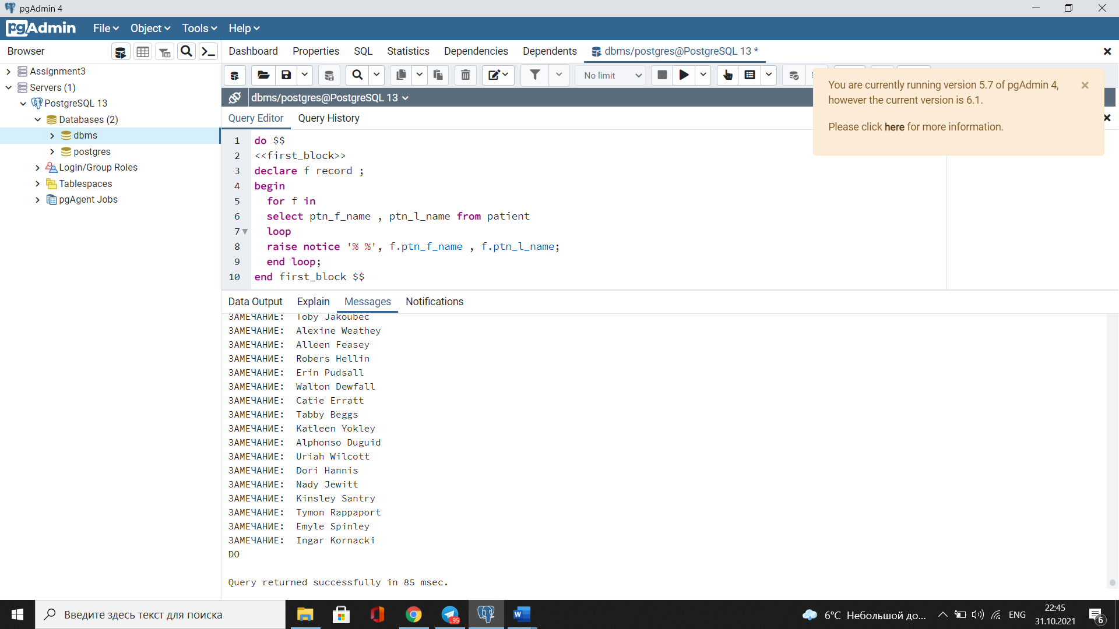

1. **Create a block that shows the average salary of all doctors. (5 points)**

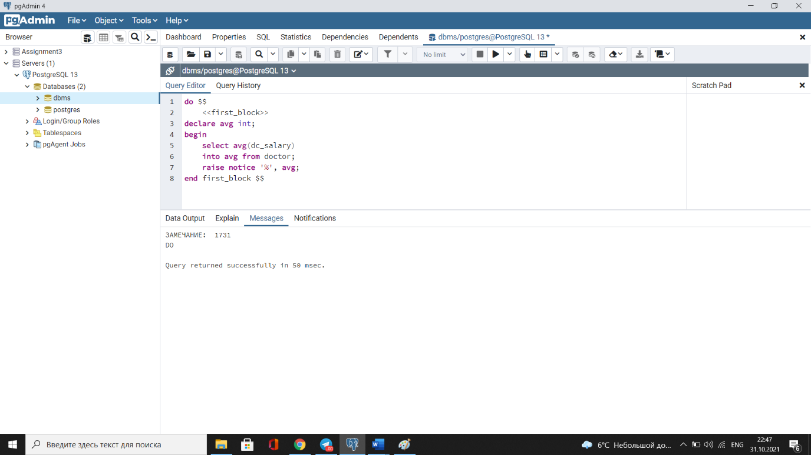

1. **Create a block that finds all doctors whose salary is less than 500$. (5 points)**

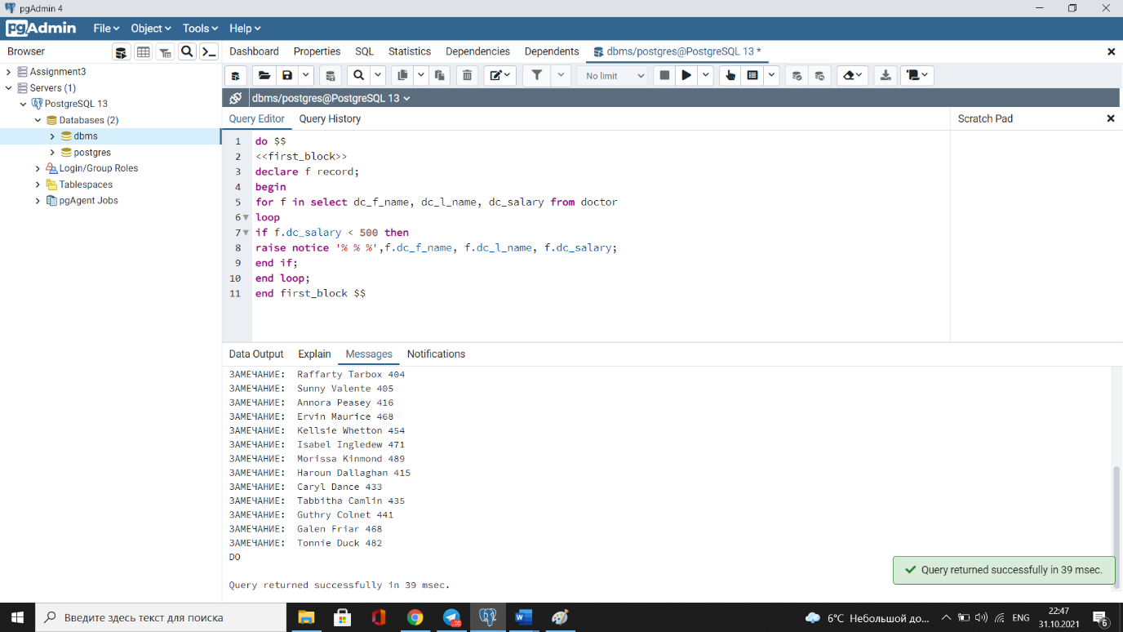

1. **Create a block that finds all phone number of patients except the number that starts from number 3 (use continue statement with for loop). (5 points)**

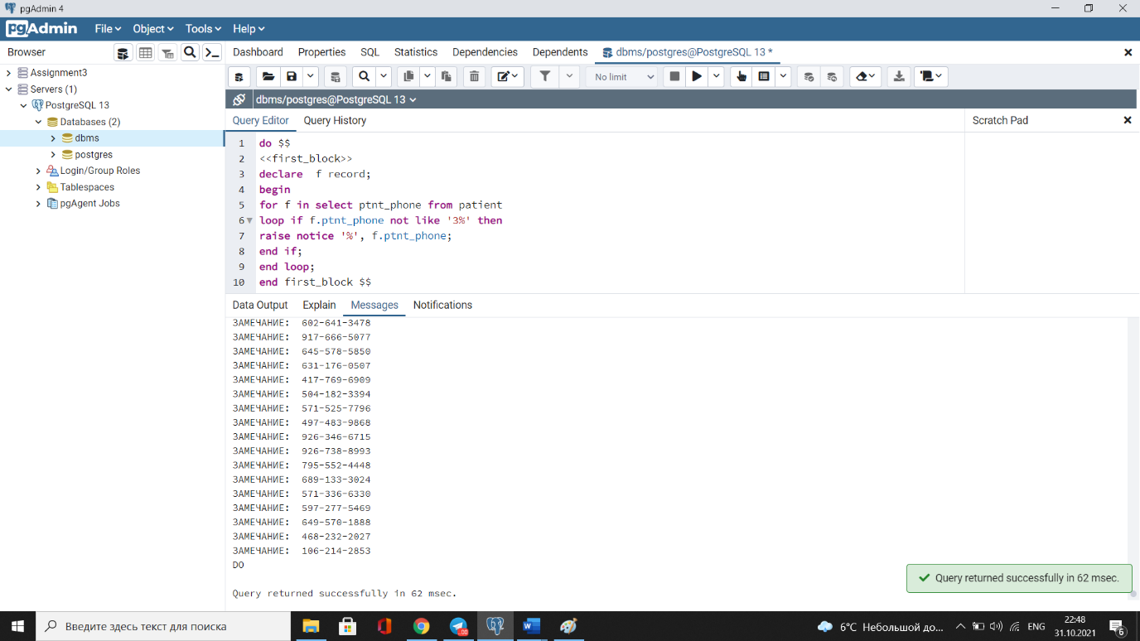

1. **Create a block that finds all doctors whose salary is less than the average salary. (5 points)**

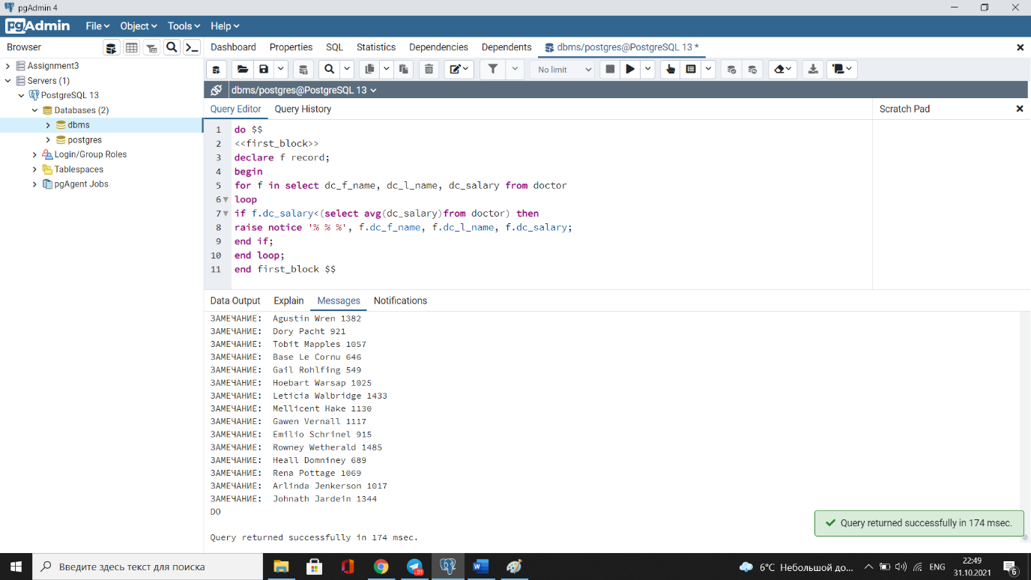

1. **Create a function that finds ten highly paid doctors. (5 points)**

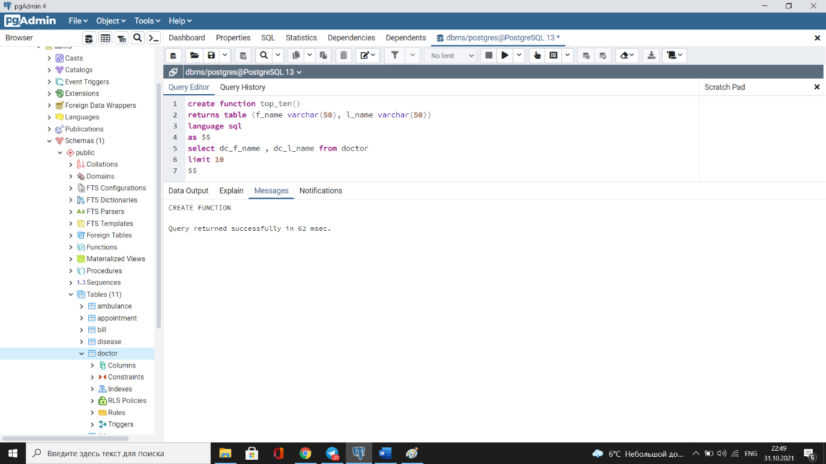

1. **Create a function that takes one parameter - a pattern of the name of the disease and show who is sick with this disease. (5 points)**

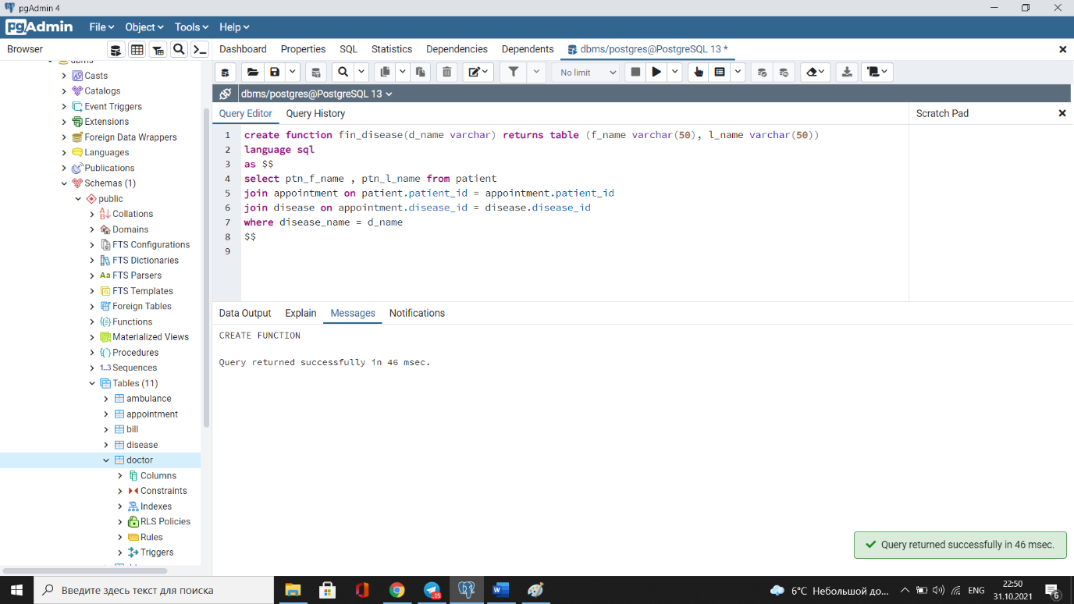

1. **Create a function that contains three parameters: the first and second parameter is the age range of the doctor, and the third is the name of the specialization. Call the function with the appropriate argument values and display the results, otherwise raise an exception. (5 points)**

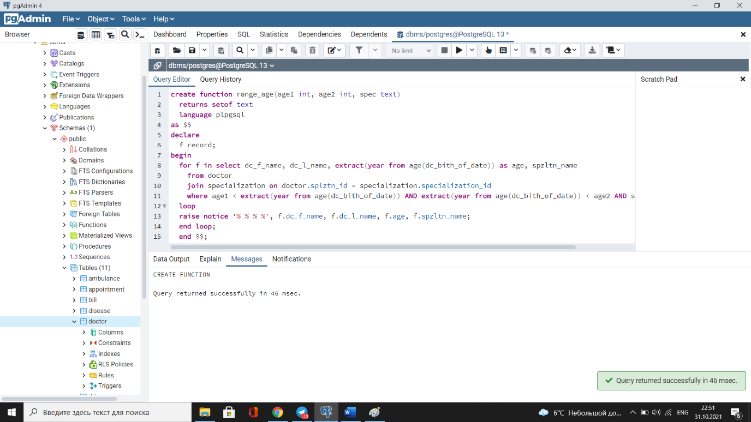

1. **Create a function that contains two parameters, the first parameter is the start point of the drivers’ id, and the second parameter is the endpoint. Loop through and show the ids of drivers with first_name and last_name. (10 points)**

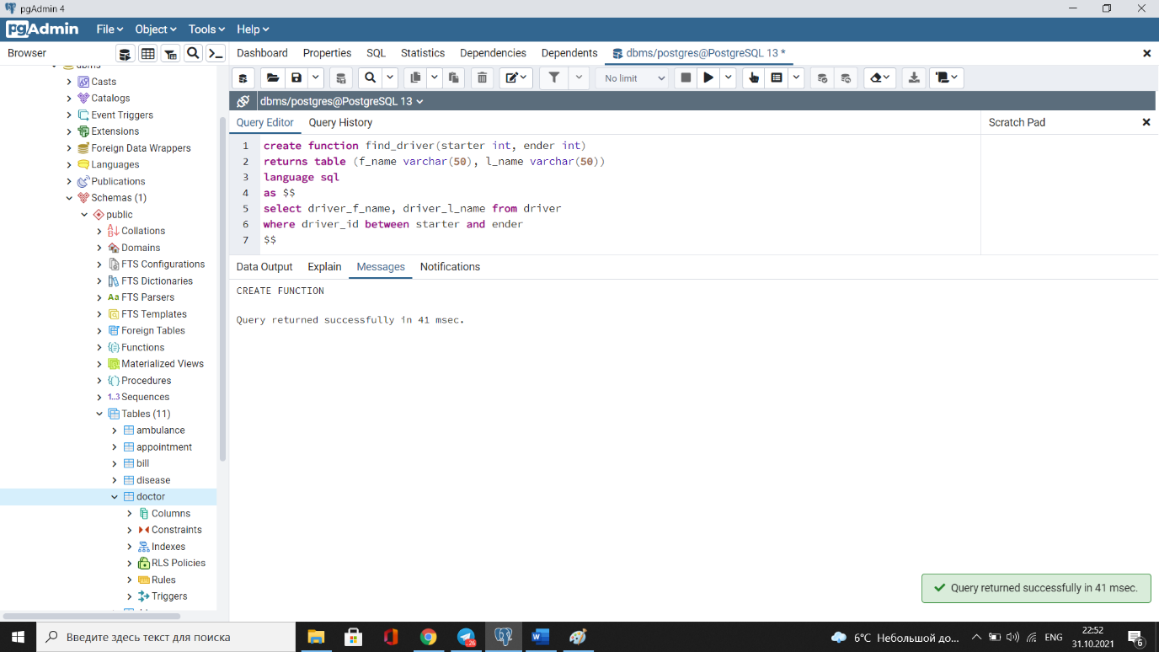

1. **Create and call a procedure that takes one argument as the name of a disease and then displays the average age for that disease. Use exception for the name of disease.(10 points)**

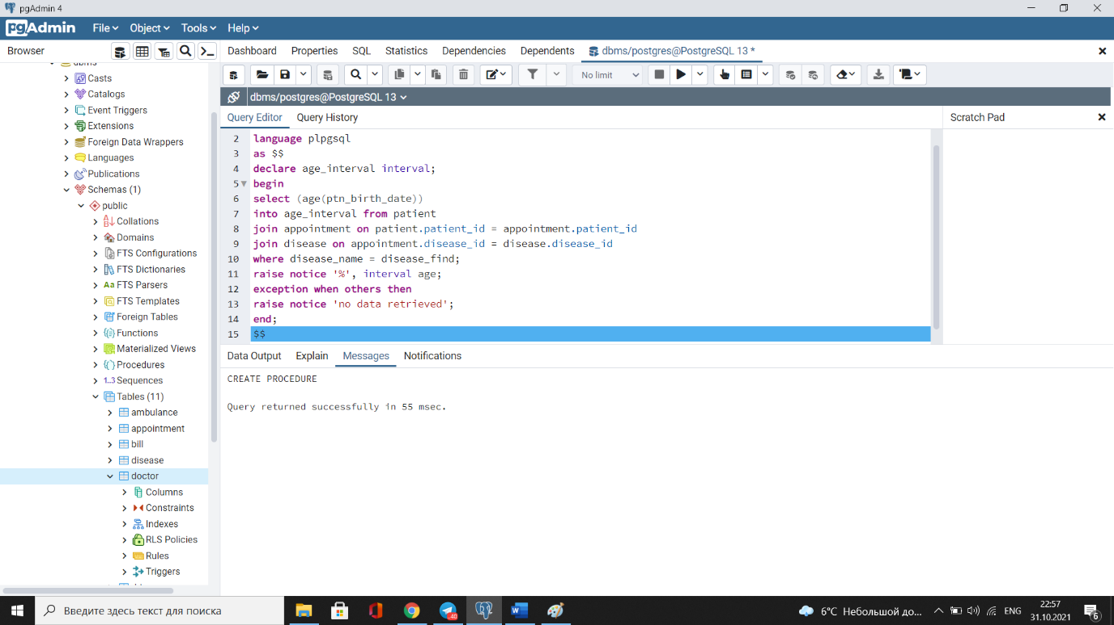

1. **Create and call a procedure that raises the salary of doctors by 10% whose salary is less than 500. (10 points)**

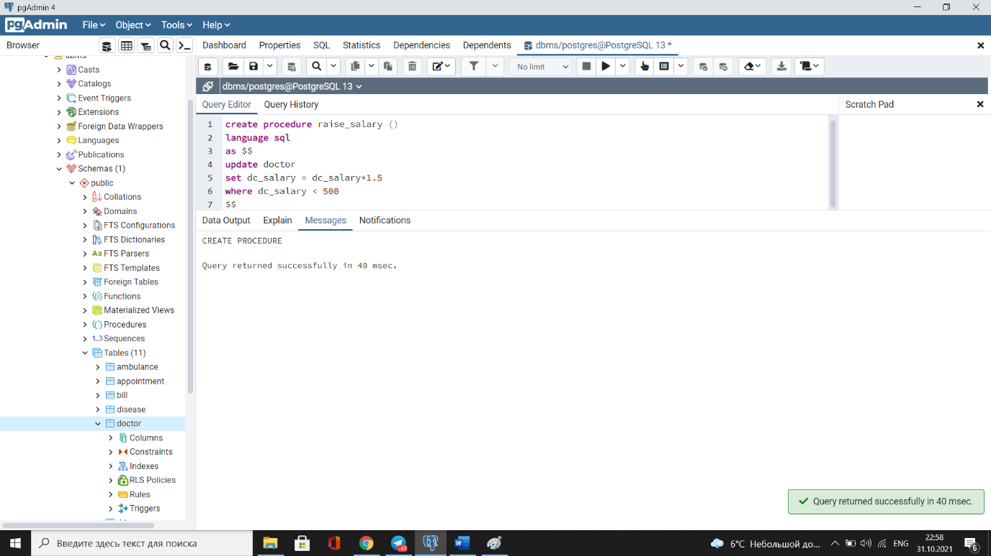

1. **Create and call a procedure that finds the top three highly paid doctors for each year of appointment table. (10 points)**

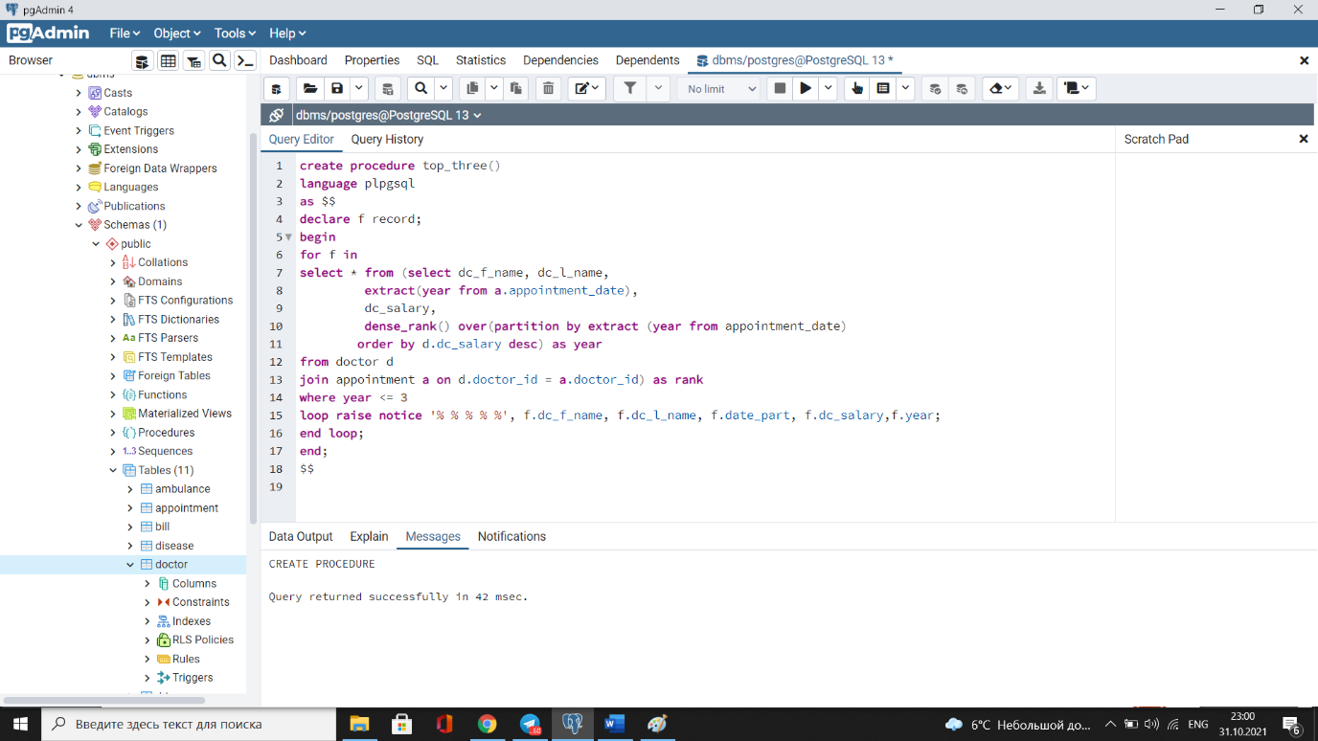

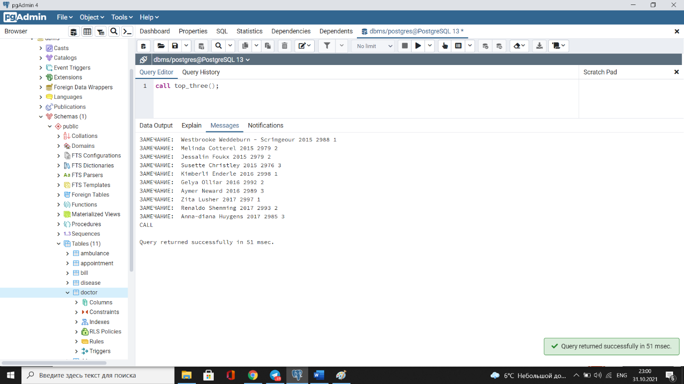

1. **Create and call a procedure that finds most popular specialization name by maximum bill price. (10 points)**

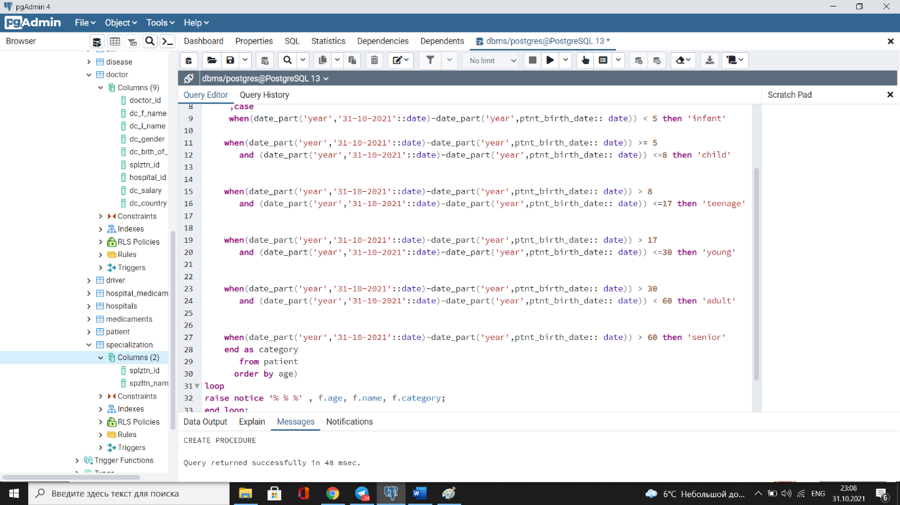

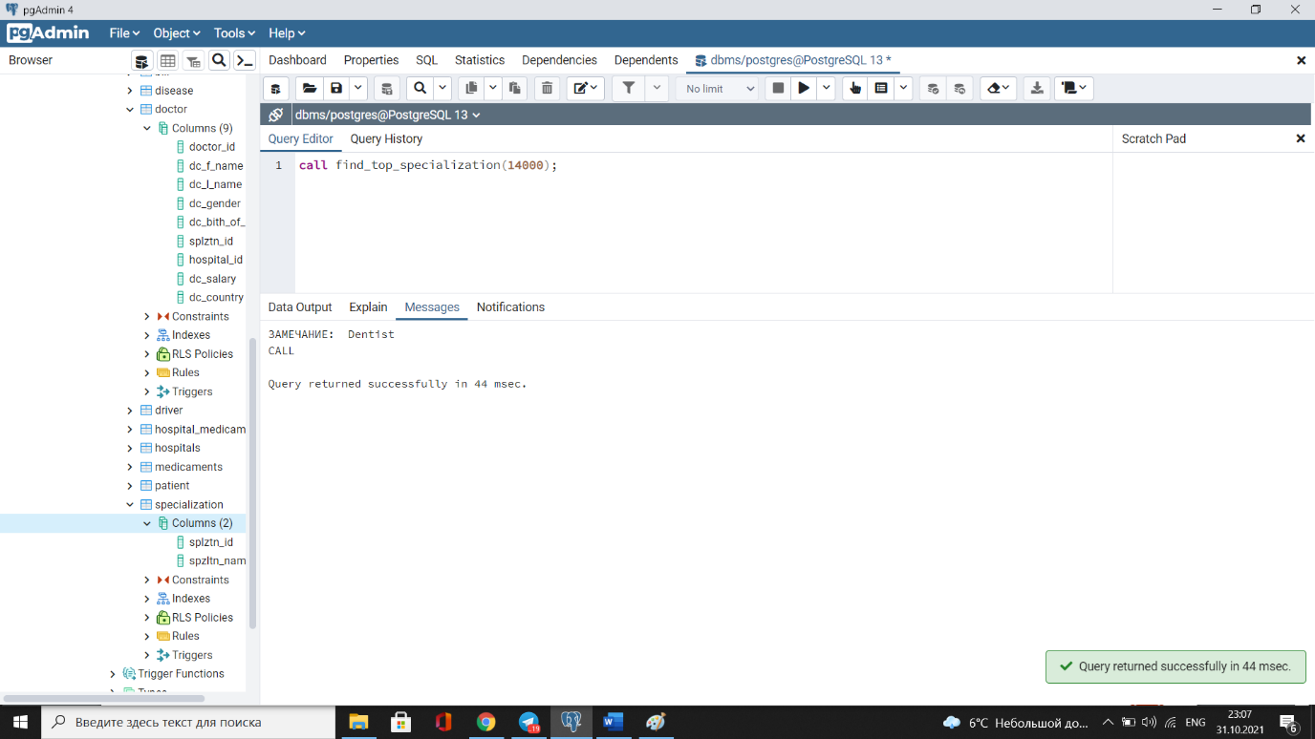

1. **Create and call a procedure that divides the age of patients into the following classification age range: (10 points)**

* **child : 5-8**
* **teenage: 9-17**
* **young: 18-30**
* **adult: 31-60**
* **senior: greater than 60**



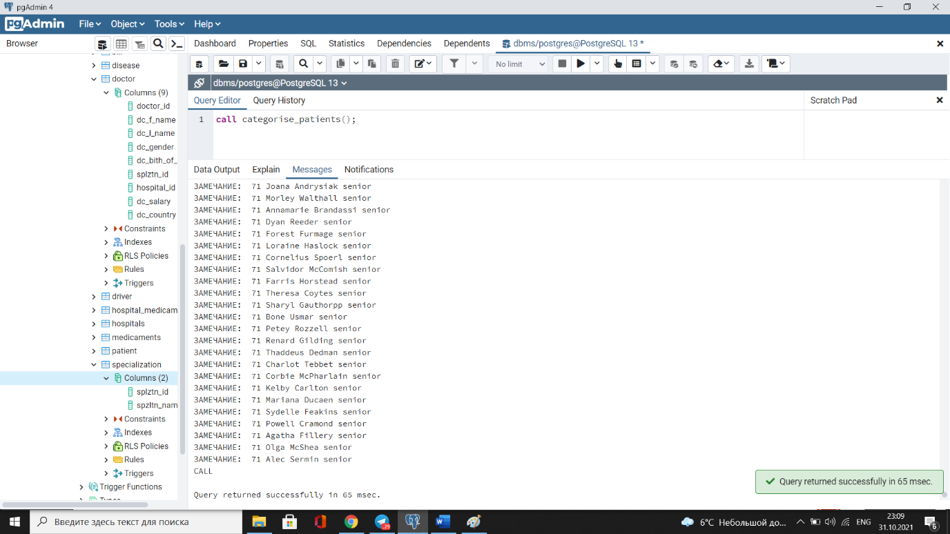

1. **Drop any 2 functions and procedures.**

