**Task1. Write a procedure that will raise doctors salaries. Ask user to enter doctor_id. If his country is Italy and specialization is Neurologist, then raise salary by 10%. Otherwise rollback. (10 points)**

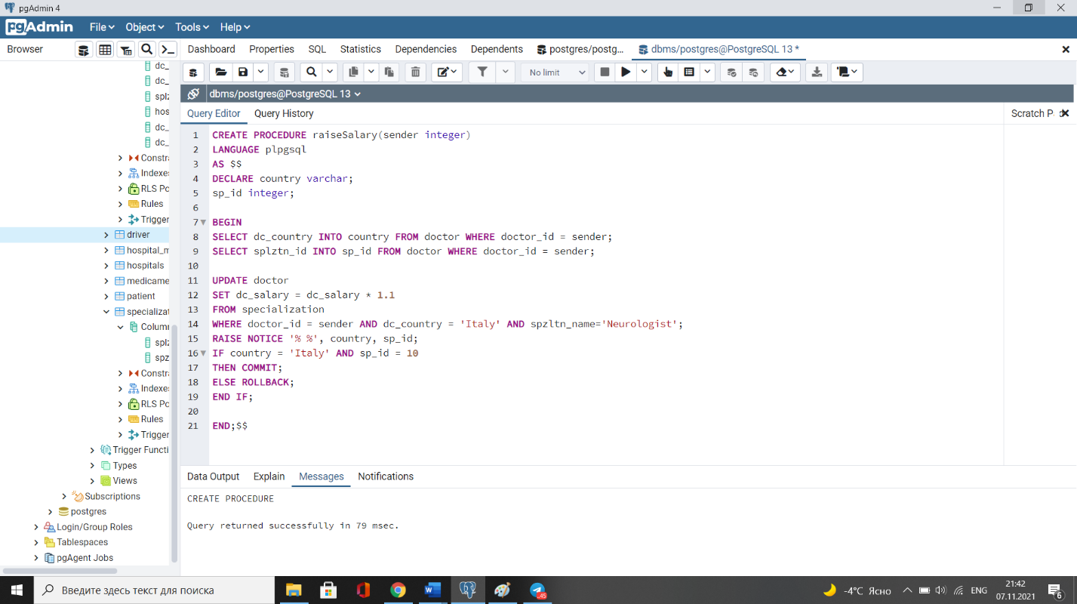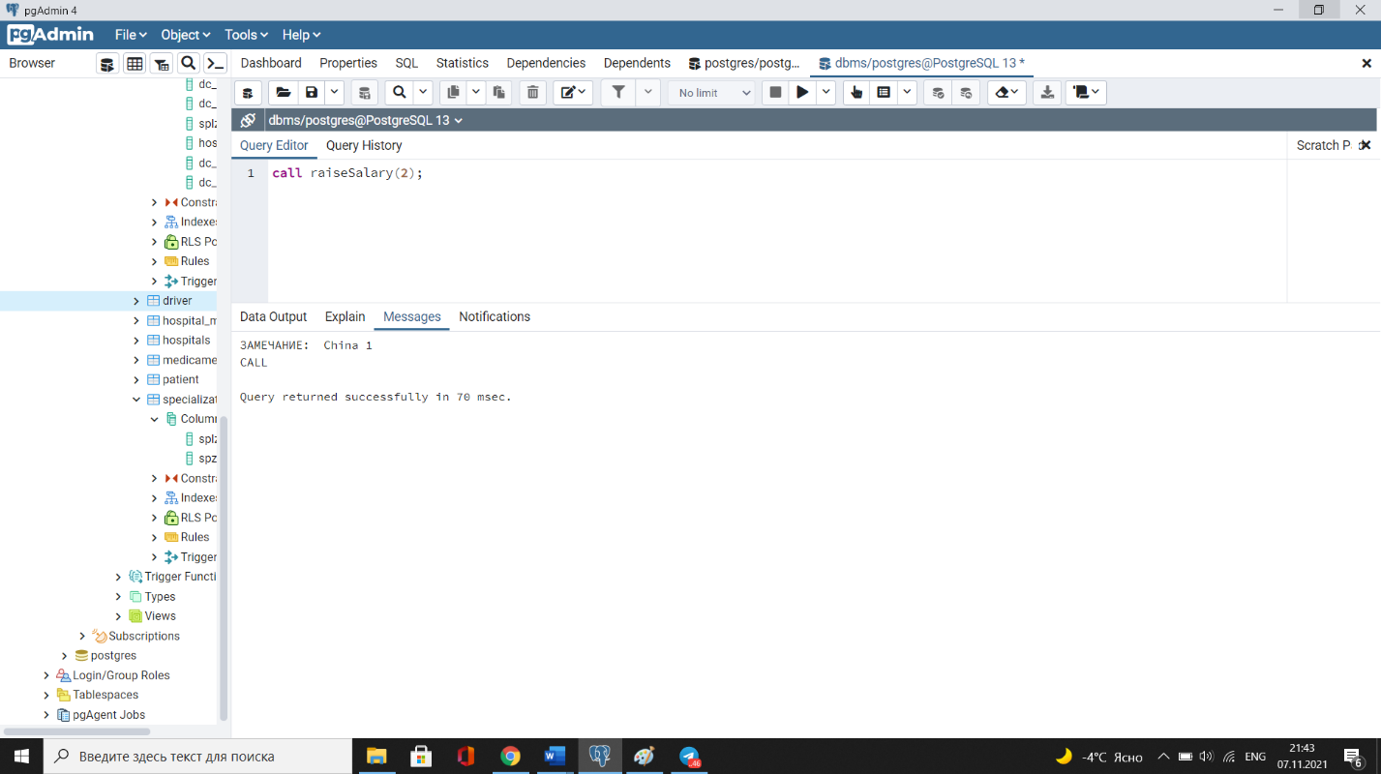

**Task2. Create a procedure to find a doctor with minimum salary and delete this doctor from Hospital db. Commit if succeeded. Rollback otherwise. (10 points)**

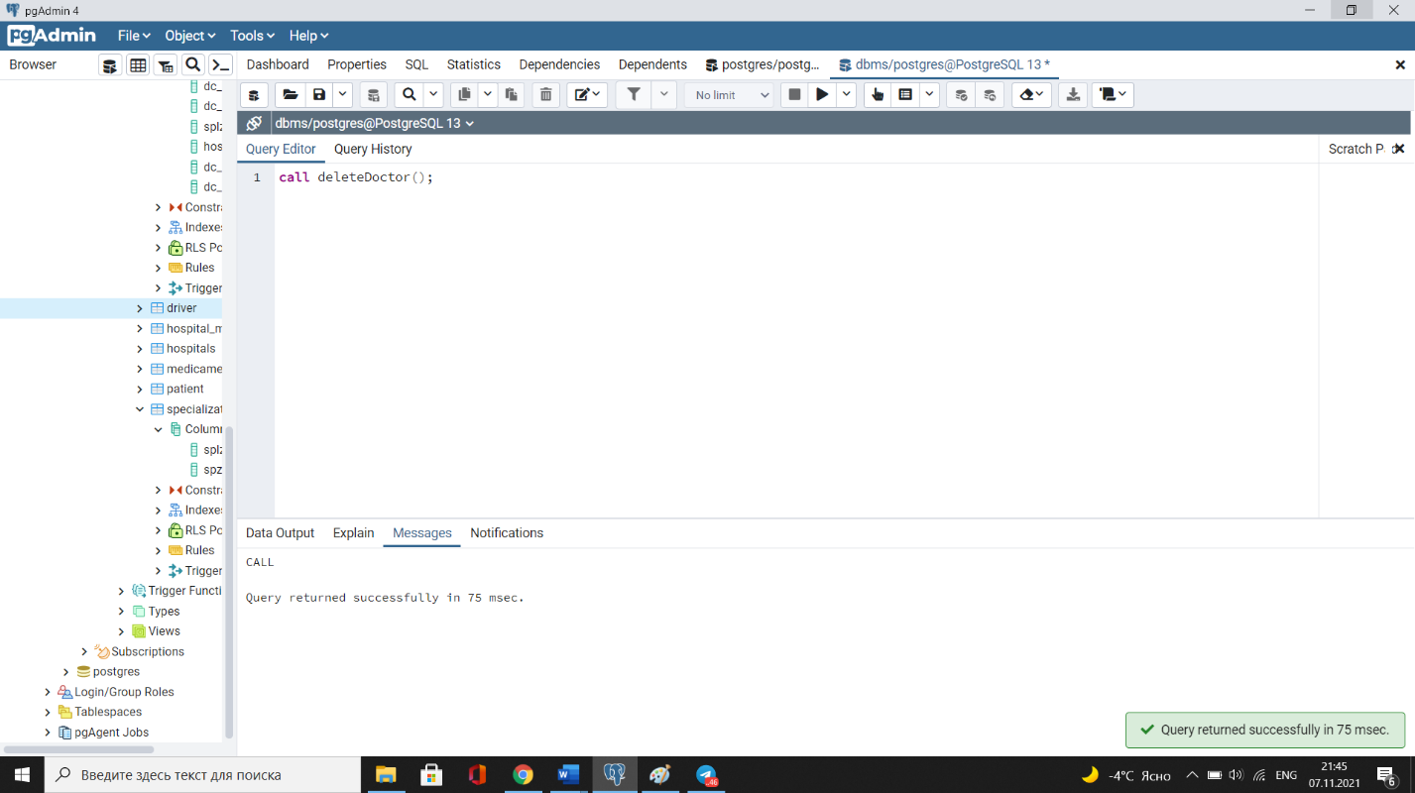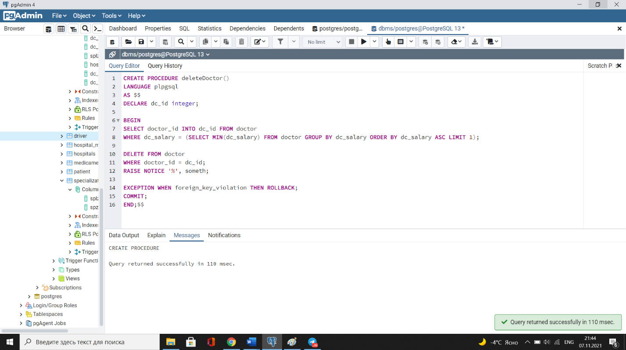

**Task 3. Create a procedure for giving 20% discount for services of doctor with id 150. (10 points)**

**Task4. Create a procedure for changing ambulance id to 1 for those drivers who drive ambulance with id 110. Commit if succeeded. Rollback otherwise. (10 points)**

**Task 5. Create a procedure to insert a new medicament into Medicaments table. The procedure should take medicament_name as input parameter and check if the medicament exists in the table. You should add a the medicament if not. Rollback otherwise. (10 points)**

**Task6. Create a procedure for checking hospital status. It should take a parameter for inserting hospital country. If the country is 'China', change hospital status to green. Rollback otherwise. (10 points)**

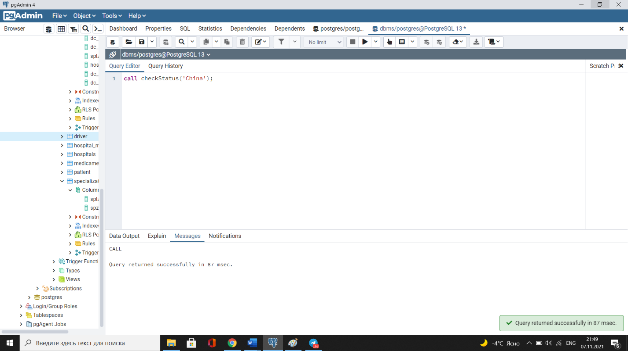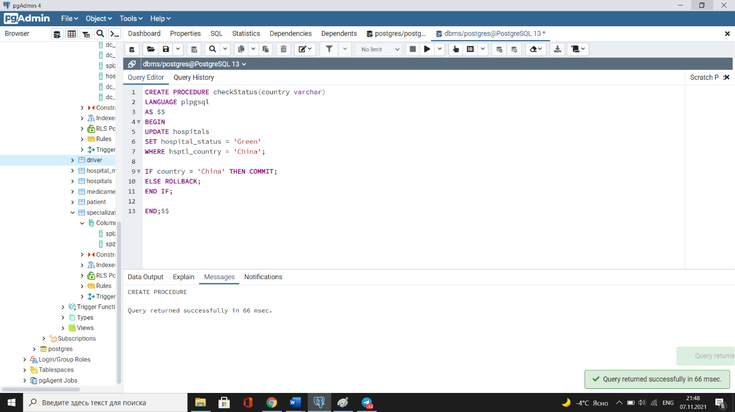

**Task7. Create a procedure for deleting first 50 medicaments from Medicaments table. (10 points)**

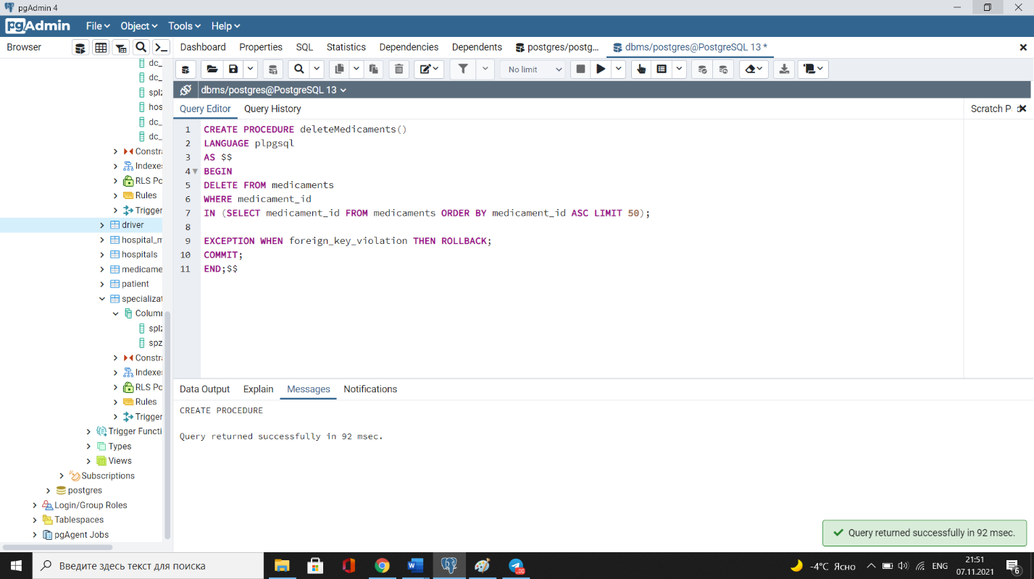

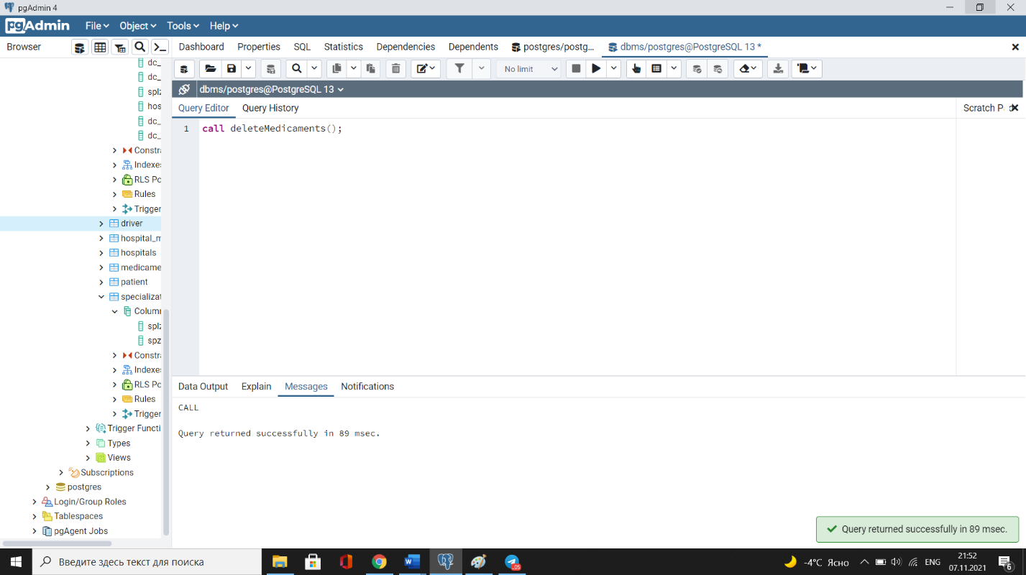

**Task8. Create a procedure for raising salary by 5% for female doctors from Iran. (10 points)**

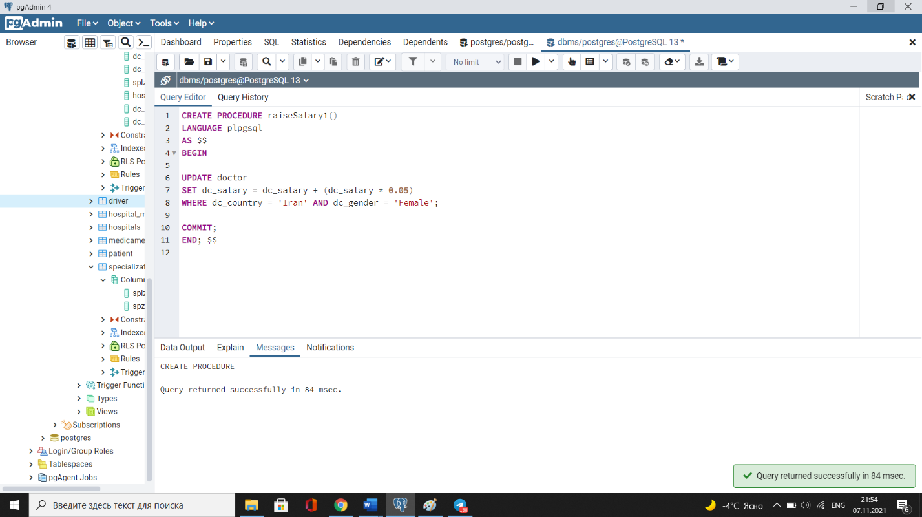

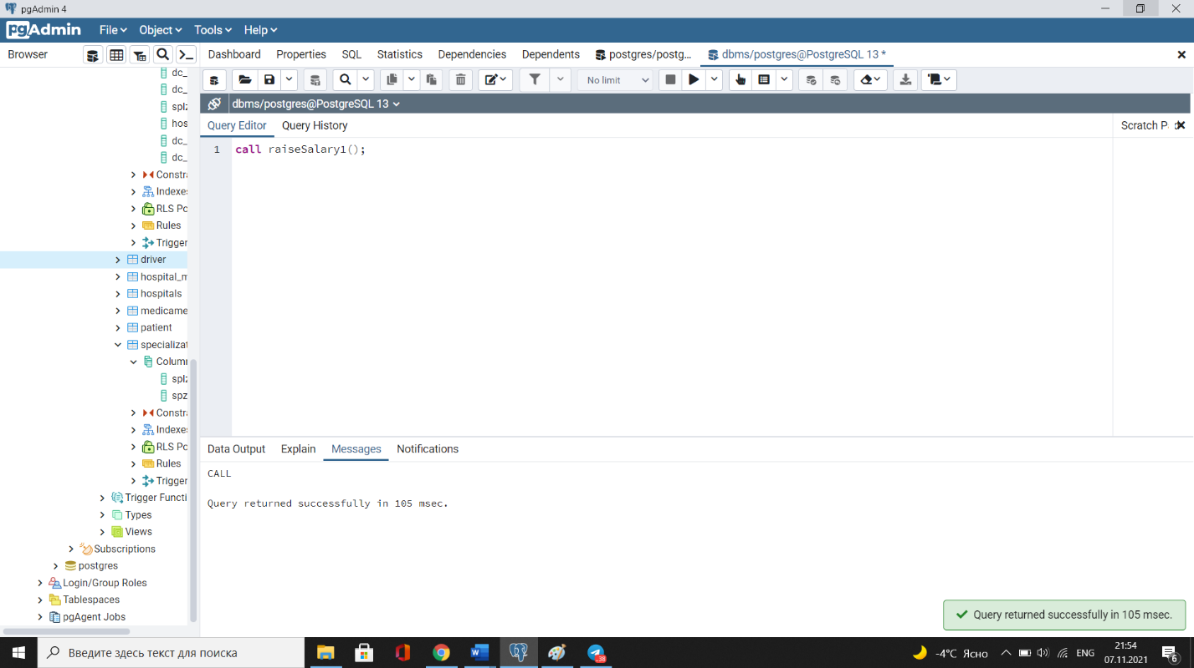

**Task9. Create a procedure for adding an appointment to Appointment table. It should check whether inserted values are valid or not (valid means they exist in relevant tables : doctor_id in doctors table, patient_id in patient table, etc.). If yes - insert. Rollback otherwise. (20 points)**

