The following is how get github.

-First make a github account and send the user name to the owner before moving forward. The following steps will not work until you are added to the repository.

-Go to the following link for github:

http://git-scm.com/download/mac

http://git-scm.com/download/win

-The following picture shows the settings that should be selected for installing:

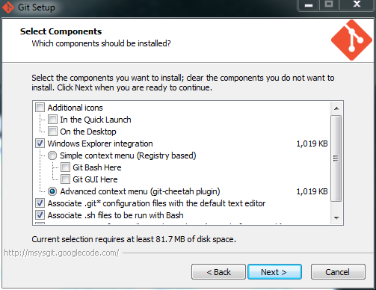

-Then go to one of the following links for the GUI:

mac.github.com

windows.github.com

-Once in the GUI is setup, clone the repository by selecting the plus at the top left as seen in the picture below. Then select ETHOS.

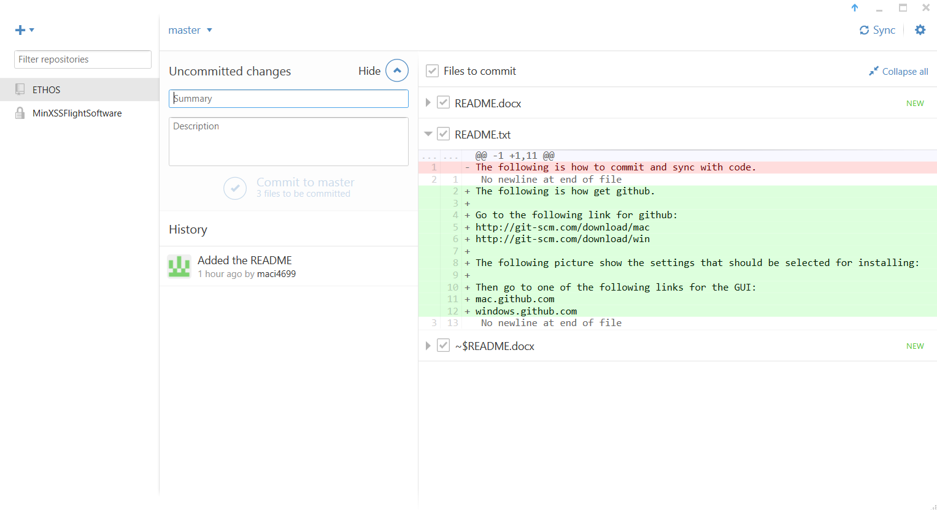

-To commit, the changes will appear in the middle column above with the changes on the right. To sync to other changes click on the sync button at the upper right corner. Let me know if anyone else has any questions.