**Documentation**

**iPolyglot**

To

**University College of Technology Sarawak.**

No. 1, Jalan Universiti

96000 Sibu

Sarawak

Malaysia

**Signatories**

|  |  |
| --- | --- |
| **Prepared By : Lim Kha Shing**  **Affiliation : -** | **Date :** |
| **Accepted By : Dr. Bakri Madon**  **Affiliation : University College of Technology Sarawak** | **Date :** |

**Point of Contacts**

|  |
| --- |
| **Lim Kha Shing**  **Contact No. : +6016-5935703**  **E-mail Address : kslim5703@gmail.com** |
| **University College of Technology Sarawak**  **Name : Dr. Bakri Madon**  **Designation : Dean & Associate Professor**  **E-mail Address :** [**drbakri@ucts.edu.my**](mailto:drbakri@ucts.edu.my) |

Revision History

|  |  |  |  |
| --- | --- | --- | --- |
| **Date** | **Version** | **Description** | **Author** |
| 14 / 3 / 2020 | 1.0 | Document Creation | Lim Kha Shing |
|  |  |  |  |
|  |  |  |  |
|  |  |  |  |
|  |  |  |  |

**Table of Contents**

**System Architecture** 5

**Flowchart** 6

**Algolia** 7

Pricing 7

Al-Quran Records 8

# **System Architecture**

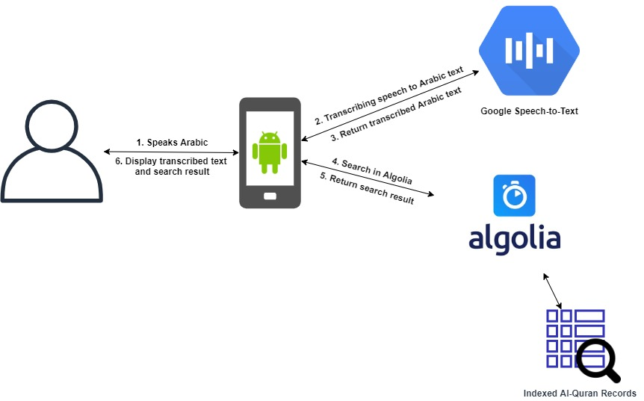

# **Flowchart**

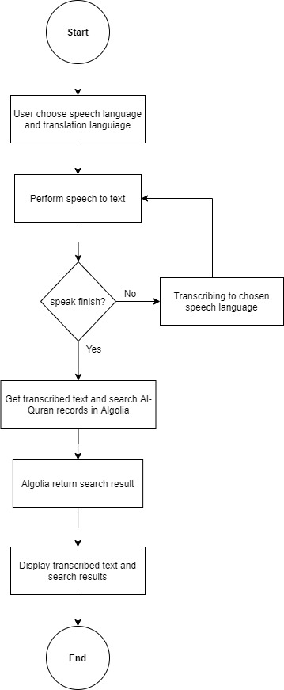

# **Algolia**

## Pricing

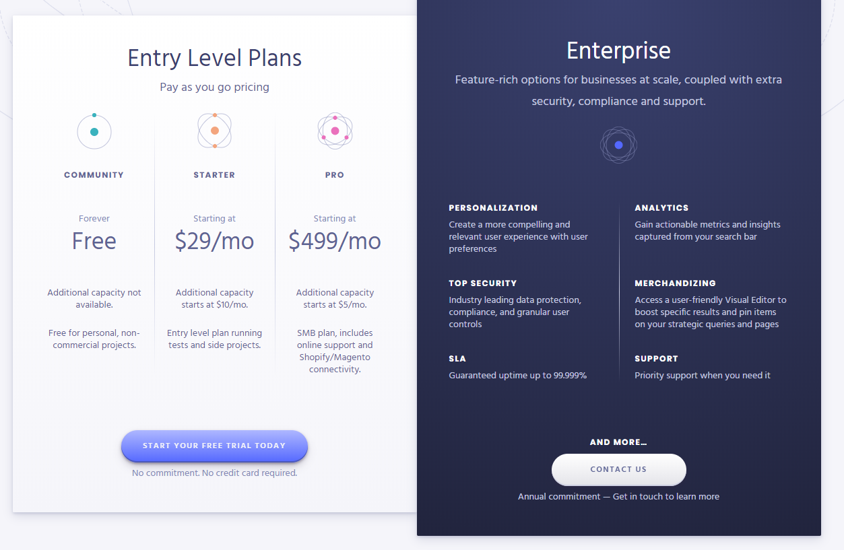

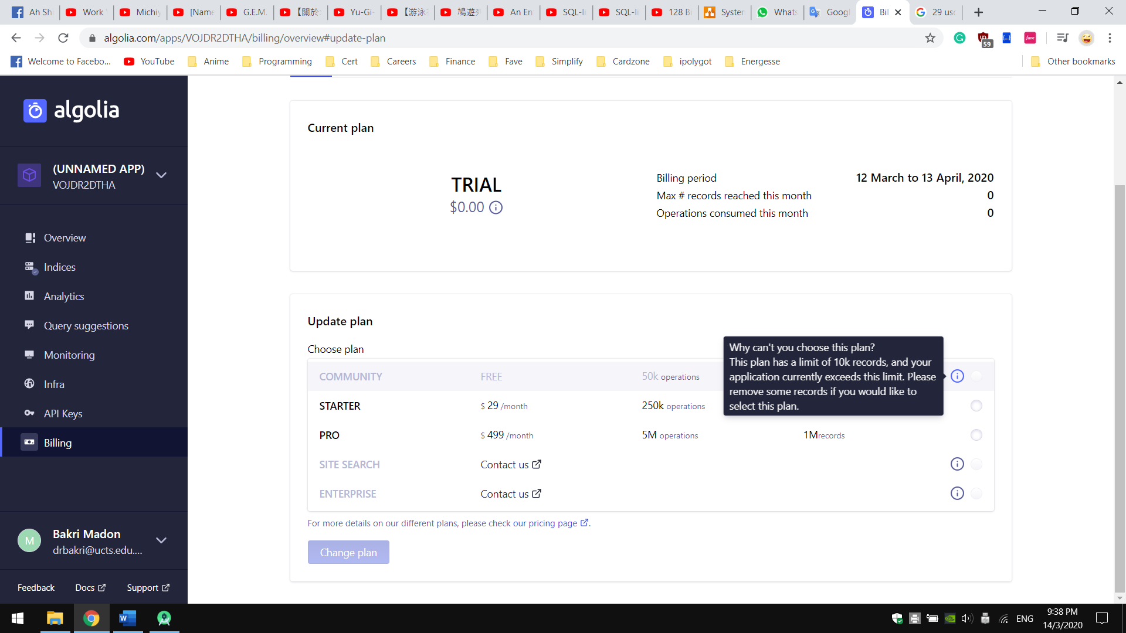Algolia, a Search Provider offered powerful search capability along with analytics tools. It has 4 Plans, Free, Starter, Pro and Enterprise. However, due to our Al-Quran data has exceeded 10,000 records, we need to be at least on Starter Plan in order to continue using Algolia.

Starter Plan cost 29 USD per month (Around 123.90 Malaysia Ringgit as in March 2020). For more information, please visit <https://www.algolia.com/pricing/>

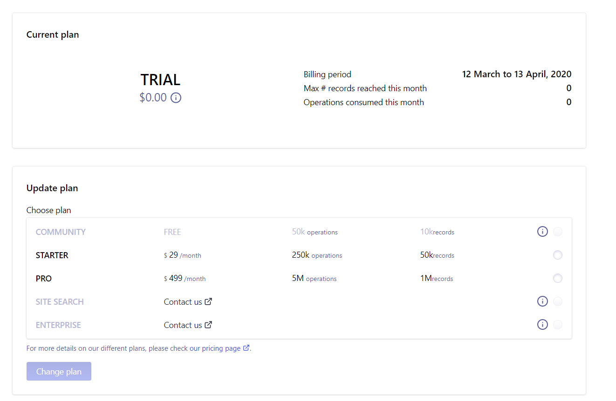

## Al-Quran Records

There are two main indices when developing and testing the iPolyglot application. One is development indices, naming *dev_al_quran*, and another for production - *al_quran*. Any development work will be done on dev_al_quran, and after development and testing, making sure it works as expected, then the configuration and data of dev_al_quran indice will be replicate to production *al_quran*

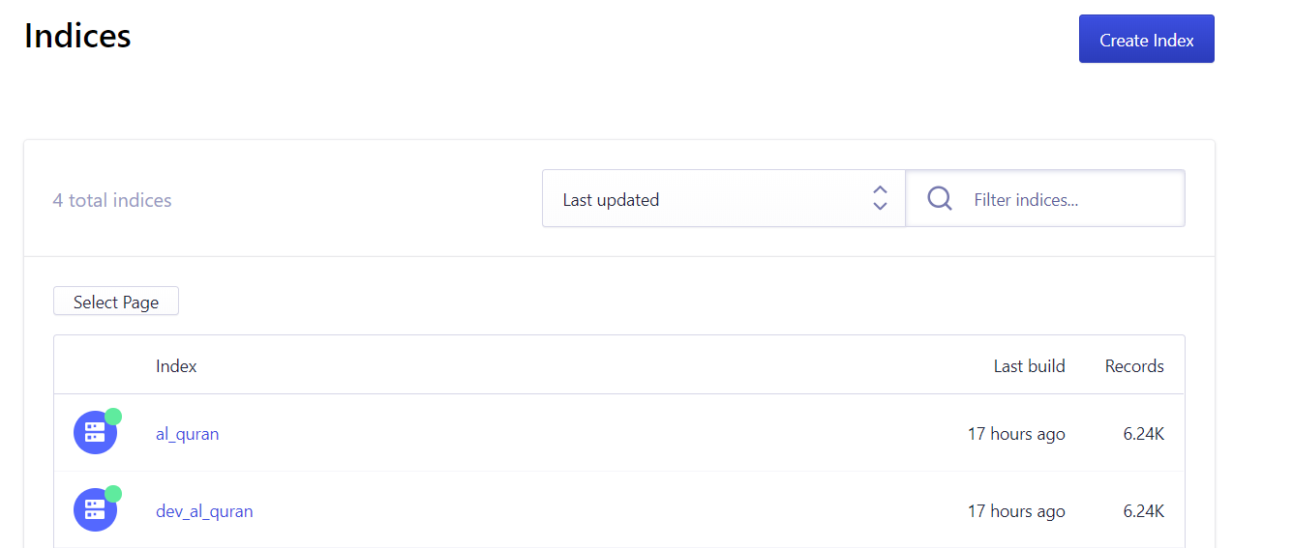

Each verse in Al-Quran is structured as individual record in Algolia. Each record contains the current number chapter, current number of verses, the meaning in Arabic text and the translation. Any search operation that run by Algolia through its client or API will return all the information that stored on the records. All the information and search result is sorted by the chapter number following the verse number. Here is the sample of Al-Quran records in Algolia.

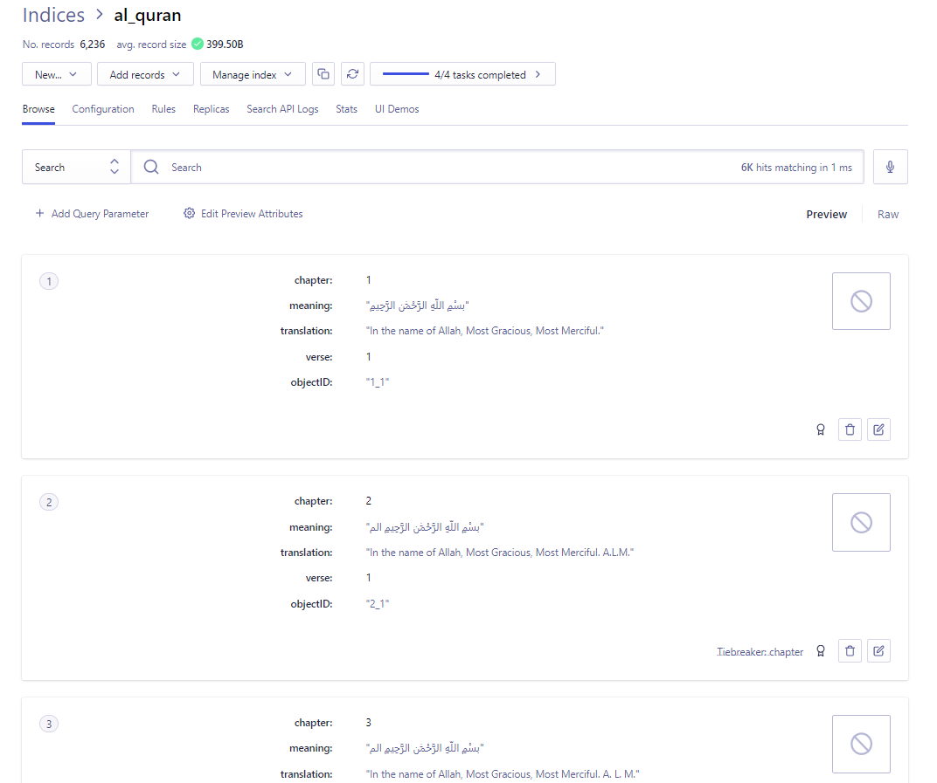

You can use the email and password below for accessing Algolia and configure the search operation on it.

**Email**: [drbakri@ucts.edu.my](mailto:drbakri@ucts.edu.my)

**Password**: ucts2020