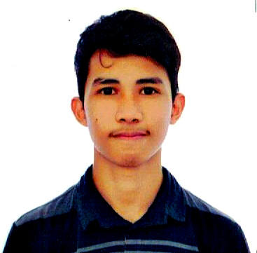

**Limmanuel B. Lopez**

Home Address: 0240 Sentinela Rd, Pulong Yantok, Angat, Bulacan

City Address: 295 N. Domingo St., Brgy. Ermitano, San Juan City

Email Address: limmanuellopez@gmail.com

Cellphone No.: 09226415435

**Objectives**

To be part of your company wherein I could develop my working capacities, skills and business efficiencies as well as to enhance my interpersonal relationship and build my self-esteem.

**Personal Information**

Date : June 19, 1997  
Place of Birth : Bansud, Oriental Mindoro

Gender : Male

Status : Single

Height : 5 ft. 3 in.

Weight : 48 kg.

Religion : Roman Catholic

**Experience**

**April 2016 - June 2016** : Technical Support Intern

Asia Premier One Source Inc.

**Skills** **Hardware:**

Hardware Installation

Computer Networking

Computer Troubleshooting

**Software:**

Computer Literate (Proficient in using MS Word, MS Excel, MS PowerPoint, MS Visio)

Knowledgeable in several programming language (C++, Java, Assembly)

Software installation (i.e. Operating System and Applications)

Software Troubleshooting

CAD Operator

**Educational Background**

**College:** Polytechnic University of the Philippines  
Bachelor of Science in Computer Engineering  
S.Y 2013-Present

**High School:** Golden Values Academy  
Year Graduated: 2013

**Elementary:** Osias M. Esteban Elementary School  
Year Graduated: 2009

**Affiliations**

Association of Concerned Computer Engineering Students for Service (ACCESS)

College of Engineering Managers of Information Technology (CEMIT)

Institute of Computer Engineers of the Philippines (ICpEP)

**Seminars Attended**

Computer Research and Engineering Symposium (CoRES) – 2014 / 2015 / 2016  
Polytechnic University of the Philippines, Manila  
Organized by: ACCESS Organization & 4th Year CpE Students

Sofware Freedom Day “*Free Open Source Software (FOSS)*” Seminar – 2016  
Polytechnic University of the Philippines, Manila  
Organized by: CEMIT Organization

ICpEP General Assembly – 2016  
Asia Pacific College, Makati  
Organized by: ICpEP

CpEYesta General Assembly – 2013  
Sienna College of Taytay  
Organized by: ICpEP

**Character Reference**

Dr. Remedios Ado  
Director, Institute of NSTP & ETEEAP  
Computer Engineer / Professor  
Polytechnic University of the Philippines  
+639985342518

Engr. Rolito L. Mahaguay  
Computer Engineer/ Professor  
Polytechnic University of the Philippines  
+639256824614

Engr. Orlando Delfino Tubola  
Chief, Center for Engineering & Technology Research  
Polytechnic University of the Philippines  
+639989574755