Water Quality at site SW1 before and after grass waterway implementation.

Samantha K Oliver

September 15, 2017

## Site history

At site SW1, edge-of-field monitoring begain in 2012, and corn was produced from 2011-2015. On May 10, 2015, a grass waterway was installed on the field, and corn was planted that same year. In 2016 and 2017, alfalfa was planted. This analysis describes water quality before and after implementation of the grass waterway.

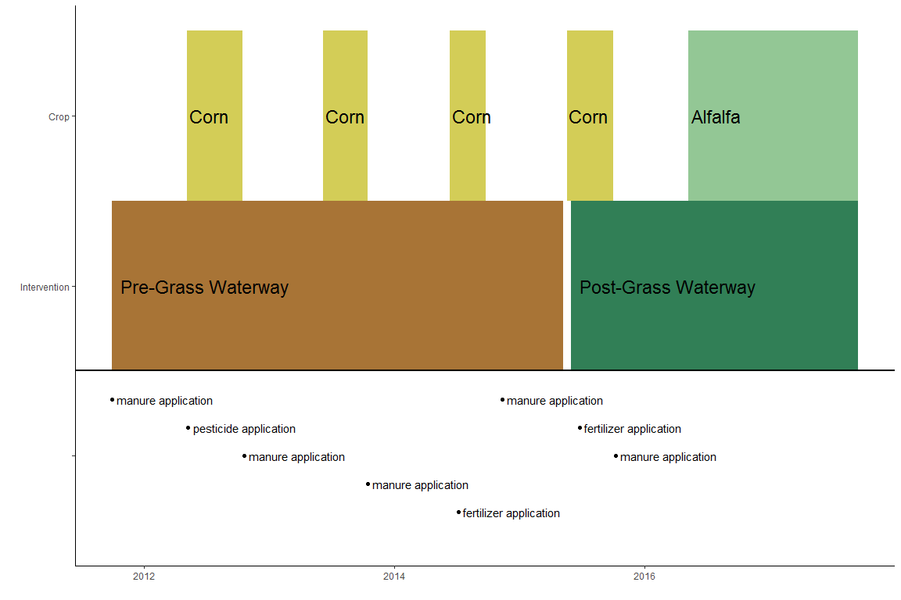

Timeline for site SW1.

Note that the echo = FALSE parameter was added to the code chunk to prevent printing of the R code that generated the plot.