**Memory Organization of a Computer System**

**Introduction:**

 Memory refers to the computer hardware integrated circuits that store information for immediate use in a computer it is synonymous with the term primary storage. Computer memory operates at a high speed, for example  (RAM), as a distinction from storage that provides slow-to-access information but offers higher capacities. If needed, contents of the computer memory can be transferred to secondary storage a very common way of doing this is through a memory management technique called virtual memory. An archaic synonym for memory is store.

Memory such as

* Main memory
* Secondary memory
* Cache memory

**Description:**

A memory unit is the collection of storage units or devices together. The memory unit stores the binary information in the form of bits. Generally, memory/storage is classified into 2 categories:

* **Volatile Memory**: This loses its data, when power is switched off.
* **Non-Volatile Memory**: This is a permanent storage and does not lose any data when power is switched off.

**Memory Hierarchy**

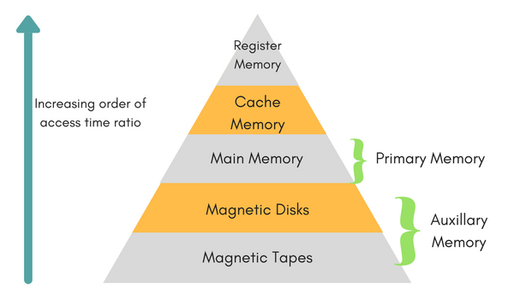

**Auxiliary Memory:** Devices that provide backup storage are called auxiliary memory.

**For example:** Magnetic disks and tapes are commonly used auxiliary devices. Other devices used as auxiliary memory are magnetic drums, magnetic bubble memory and optical disks.

**Main Memory:** The memory unit that communicates directly within the CPU, auxiliary memory and Cache memory, is called main memory. It is the central storage unit of the computer system. It is a large and fast memory used to store data during computer operations. Main memory is made up of **RAM** and **ROM**.

**RAM: Random Access Memory**

* **DRAM**: Dynamic RAM, is made of capacitors and transistors, and must be refreshed every 10~100 ms. It is slower and cheaper than SRAM.
* **SRAM**: Static RAM, has a six transistor circuit in each cell and retains data, until powered off.
* **NVRAM**: Non-Volatile RAM, retains its data, even when turned off. Example: Flash memory.
* **ROM: Read Only Memory**, is non-volatile and is more like a permanent storage for information. It also stores the bootstrap load program, to load and start the operating system when computer is turned on
* Programmable **Read**-**Only** **Memory** (PROM) This **type** of **ROM** can be re-programmed by using a special device called a PROM programmer. ...
* Erasable Programmable **Read**-**Only** **Memory** (EPROM) ...
* Electrically Erasable Programmable **Read**-**Only** **Memory** (EEPROM)

are some commonly used ROMs.

**Cache Memory:** Cache memory is a small amount of fast but expensive memory placed between the processor and main memory.

The performance of cache memory is measured in terms of a quantity called **hit ratio**. When the CPU refers to memory and finds the word in cache it is said to produce a **hit**. If the word is not found in cache, it is in main memory then it counts as a **miss**.

**Memory Access Methods:**

Each memory type, is a collection of numerous memory locations. To access data from any memory, first it must be located and then the data is read from the memory location. Following are the methods to access information from memory locations:

1. **Random Access**: Main memories are random access memories, in which each memory location has a unique address. Using this unique address any memory location can be reached in the same amount of time in any order.
2. **Sequential Access**: This methods allows memory access in a sequence or in order.
3. **Direct Access**: In this mode, information is stored in tracks, with each track having a separate read/write head.

**Conclusion:**

A computer system contains a variety of memory devices to store data and information for its operation. In general memory components of a computer system is divided into three categories.

* Internal Memory
* Main memory
* Secondary Memory