Part A • Grammar, Vocabulary and How to …
GRAMMAR
1 Choose the correct words to complete the sentences.
1 After she left the office, she went / was going for a coffee with her friend.
2 I walked / was walking down the road when I saw a wallet on the floor.
3 It had rained / was raining hard so we stayed at home.
4 I didn’t watch the film last night because I saw /
had seen it already.
5 When I arrived / had arrived at the station, the train was just departing.
6 Sasha heard / was hearing a noise upstairs so she went to see what it was.
7 My passport wasn’t stolen because I hid / had hidden it under the bed.
/7

2 Complete the sentences with the correct form of the verbs in brackets.
1 She hopes __________ (complete) her master’s degree in June.
2 The instructions were hard to follow, but we finally succeeded in __________ (build) the wardrobe.
3 She doesn’t care about __________ (do) regular exercise.
4 He put off __________ (take) the exam until he felt more confident.
5 After working for a bank, she went on __________ (work) for a large charity.
6 We grew up __________ (eat) fresh fruit and vegetables from my grandmother’s garden.
7 When I was coming home from work, I stopped __________ (have) a coffee with Todd.
8 Can you remember __________ (take) the rubbish out when you leave?
/8

3 Match the sentence beginnings (1–5) with the endings (a–e).
1 She’s got all their albums except ___
2 Hardly anyone was at the party, ___
3 The film wasn’t too bad except ___
4 We didn’t do anything on holiday apart ___
5 Peter doesn’t usually eat cakes, ___

a not even Tessa.
b but even he enjoyed them.
c for the latest one.
d from eating and sleeping.
e it was quite long.
/5
VOCABULARY
4 Complete the sentences with words for describing possessions.
1 Your new jacket looks really c _ _ l. It’s really fashionable.
2 This watch b _ _ _ _ _ _ d to my grandfather and he gave it to me for my 21st birthday.
3 The cover of the book is a bit d _ _ _ _ _ d because some water fell on it.
4 An art expert thinks the painting is g _ _ _ _ _ e and not a copy.
5 These earrings are quite old, but I don’t think they’re
w _ _ _ h a lot.
6 After my uncle died, I i _ _ _ _ _ _ _ d a little money.
7 Please look after my goldfish well. It’s very s _ _ _ _ _ l to me.
/7

5 Choose the correct words to complete the sentences.
1 He gave her a beautiful denim / diamond ring before they got married.
2 These boots are made of cotton / rubber so my feet don’t get wet.
3 We gave my parents a set of glass / silver knives and forks for their wedding anniversary.
4 The wood / glass for this table came from a forest in Scotland.
5 The necklace was expensive because it’s made of
gold / stone.
6 The gate outside our house is made of iron / plastic because it’s a strong metal.
/6

6 Complete the sentences with the words and phrases in the box.
a big fan of appreciate do without
give pleasure ideal not for me tastes
1 Those toys __________ to a lot of young children, who love playing with them.
2 The holiday apartment is __________ for families because it’s next to the beach.
3 Now I’m older, I __________ the smaller things in life, like having a coffee with my friends.
4 I can __________ a car so I’m not going to buy one.
5 My husband and I have different __________ so it was difficult to choose furniture we both liked.
6 She isn’t __________ jazz so she didn’t enjoy the concert.
7 This programme is __________. I hate reality TV shows like this.
/7
HOW TO …
7 Complete the sentences with the words and phrases in the box.
calling do you think go over hang up leave lock it up reach wonder if you’ll find
you would mind
1 Could you __________ your jacket? Don’t leave it lying around.
2 __________ you’ll be able to meet me after work?
3 Can you __________ the plan again because there are some things I don’t understand.
4 I __________ you could help me with the washing up.
5 Please __________ a message and I’ll get back to you later.
6 I’m __________ to make an appointment with the dentist.
7 If you leave your bike in the street, make sure you __________.
8 You can take my keys. __________ them on the kitchen table and you can give them to me later.
9 I wonder if __________ posting this letter for me.
10 This is Ivan. You can __________ me on 5367-17230.
/10

Total: /50
Part B • Listening, Reading and Writing
LISTENING
1 [Audio UT1.01] Listen to five speakers talking about possessions. Match the speakers (1–5) with the statements (A–E).
1 Chloe: ___
2 Jack: ___
3 Leah: ___
4 Harry: ___
5 Aimee: ___

A I bought it because of its simple style.
B I appreciate the material it’s made from.
C I’d wanted to get one for a long time.
D I didn’t have to pay much for it.
E I got it to replace something I’d lost.
/5

2 [Audio UT1.01] Listen again. Are the statements
True (T) or False (F)?
1 Chloe’s chair had been owned by someone else. T / F
2 Chloe hadn’t expected the chair to be comfortable. T / F
3 Jack had thought the watch was made of real gold. T / F
4 Jack has decided to stop wearing the watch. T / F
5 Leah had decided to buy the game before she went to the shop. T / F
6 Leah thinks her video game is made from good materials. T / F
7 Harry’s leather jacket was a present from someone.
T / F
8 Harry even wears his new jacket at home. T / F
9 Aimee’s wardrobe cost a lot of money. T / F
10 Aimee’s wardrobe was broken when she got it. T / F
/10

READING
3 Read a magazine article in which people describe their favourite rooms. Are the ideas from the article (1–6) Facts (F) or Opinions (O)?
1 Ken had inherited his house from his auntie. F / O
2 Ken’s house reflects his auntie’s love of being with people. F / O
3 The glass objects in Ken’s house were useless. F / O
4 Ken’s old sofa had been damaged. F / O
5 Vero’s bedroom is a special place for her. F / O
6 Vero’s personal space is important for her mental health. F / O
7 Vero’s furniture makes the room bright on winter days.
F / O
/7

My favourite room
Two readers tell us about their favourite rooms.
Ken
I live in an old house, which I inherited from my auntie a few years ago. I enjoyed spending time there when I was growing up because it was such a friendly place. She loved socialising and I think the house reflects that. That’s because there’s only one main room downstairs which contains a kitchen, dining area and living room. It’s like a big social space where family and friends could get together for afternoon teas and Sunday lunches. There were photographs of family occasions everywhere, as well as the little glass objects that she collected. I always thought they were useless, but they gave her a lot of pleasure!

For me, that room brings back happy memories, which is why I’ve kept it almost the same. The long wooden table, which can fit twelve people around it, has been there for years. We eat most of our family meals there, but it’s also ideal for dinner parties because of its size. The only thing I’ve changed is the sofa because the old one was damaged after years of use. The new one is huge and there’s enough space for five or six people to sit there comfortably. After dinner, we take our coffees over to the sofa, where we can carry on chatting.

Vero
After a busy day at work, it’s important to relax, which is why my favourite room is my bedroom. It’s not a particularly big room, but I love lying down in there and losing myself in my thoughts. In fact, it’s so special to me that I’ve even stopped my kids playing in there. I spend my life picking up clothes and toys in their bedrooms and I don’t want to do it in my own room! My husband thinks I’m being unfair, but I think having personal space is important for my mental health.

I’m a big fan of a certain Swedish furniture shop, and most of my bedroom furniture is from there. In my opinion, the white wardrobe and chest of drawers makes the room feel bright, even on dark winter days. Although they’re not made of genuine wood, I believe they still bring some style to the room. The thing that gives me most pleasure, though, is the big iron bed, which belonged to my mother. She wanted to sell it, but I persuaded her to give it to me. It’s my favourite possession and I appreciate its beautiful design and strength.
4 Read the article again. Are the statements True (T) or False (F)?
1 Ken’s house has three separate rooms downstairs. T / F
2 Ken’s auntie enjoyed having glass objects in her house. T / F
3 Ken’s favourite room has changed little since his auntie lived there. T / F
4 Ken usually continues talking at the table after dinner.
T / F
5 Vero sometimes lets her children play in her bedroom.
T / F
6 Vero often has to move things from the floor of her children’s bedroom. T / F
7 Vero’s bedroom furniture is made from real wood. T / F
8 Vero’s favourite piece of furniture is a metal bed. T / F
/8
WRITING
5 Complete the adverts for selling items online with the words in the box.
condition includes Indian new used
Electric Toaster
Brand ¹__________ toaster in perfect ²__________. Received as a gift this year, but never ³__________.
In original box with all instructions.
Price: £25
Location: Bristol, UK

Teapot
Genuine ⁴__________ teapot. Made from cast iron with beautiful design and wooden handle. ⁵__________ four teacups.
Price: £15
Location: Glasgow, Scotland
/5

6 Choose four of the items in the box and write online adverts for them in note form.
handbag jeans ring saucepans table typewriter violin
Write 100–140 words in total.
/15

Total: /50

Part C • Speaking
SPEAKING
1 Make questions and ask your partner.
1 What sports / playing / five years ago?
2 What / dream about / doing / in future?
3 Why / some people / struggle / learning a language?
4 How often / tidy up / bedroom?
5 What possessions / could / do without?
/5

2 Answer your partner’s questions.
/5

3 Describe the picture to your partner. What are the people thinking about?
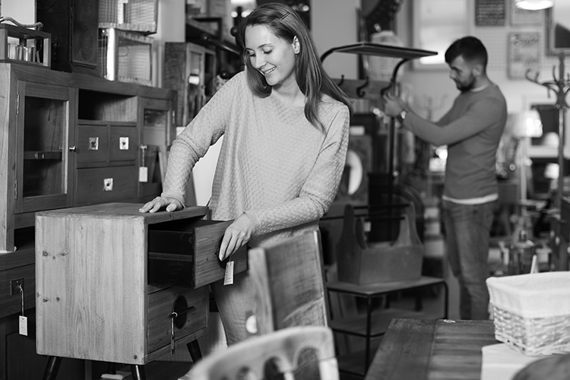
/10

Total: /20

