Part A • Grammar, Vocabulary and How to …
GRAMMAR
1 Choose the correct words to complete the sentences.
1 Before I went to bed, I turned off / was turning off the lights.
2 I saw you outside the cinema when I had driven /
was driving home from work.
3 We couldn’t hear anything because the children made / were making a lot of noise.
4 I read / had read the book already, but I was happy to read it again.
5 I was sitting in the garden when you called /
had called.
6 We noticed / were noticing a bright light in the sky, but we didn’t know what it was.
7 She stayed at home because she caught / had caught a cold.
/7

2 Complete the sentences with the correct form of the verbs in brackets.
1 They don’t like __________ (spend) their time in the house.
2 I need to concentrate on __________ (finish) this exercise.
3 She struggles with __________ (study) when her friends are playing outside.
4 I look forward to __________ (see) the next episode.
5 It was getting late, but they carried on __________ (talk).
6 I think Alba will grow up __________ (be) a scientist.
7 Let’s stop __________ (eat) our lunch when we finish this task.
8 I remember __________ (leave) my phone on the chair, but it’s gone now.
/8

3 Match the sentence beginnings (1–5) with the endings (a–e).
1 The restaurant was nice except ___
2 No one wanted to help me, ___
3 I’ve read all the books in the series apart ___
4 We’ve visited most European countries except ___
5 Marta usually prefers to stay at home, ___

a from the first one.
b not even my brother.
c but even she came to the party.
d for Spain and Portugal.
e the waiters were very slow.
/5

VOCABULARY
4 Complete the sentences with words for describing possessions.
1 There are lots of copies around, but this handbag is
g _ _ _ _ _ e.
2 My mother i _ _ _ _ _ _ _ d her house from her parents when they died.
3 I have had my dog for many years and he’s very
s _ _ _ _ _ l to me.
4 You look really c _ _ l with your new haircut. It’s very fashionable!
5 The armchair is a bit d _ _ _ _ _ d, but I’m going to repair it.
6 I think her necklace must be w _ _ _ h a lot of money.
7 This car b _ _ _ _ _ _ d to my brother before he gave it to me.
/7

5 Choose the correct words to complete the sentences.
1 I love my denim / steel jacket because it’s so comfortable.
2 The statue is made of cotton / stone so it’s very heavy.
3 We don’t use plastic / wood cups because they’re bad for the environment.
4 There was glass / iron all over the floor when the window broke.
5 I like to wear cotton / rubber clothes in summer so I don’t get too hot.
6 Ships are often made from diamond / steel because it’s a strong metal.
/6

6 Complete the sentences with the words and phrases in the box.
a big fan of appreciate do without dream
give pleasure not for me tastes
1 I use my roller skates every day and I couldn’t __________ them.
2 The town’s new flower garden will __________ to a lot of people.
3 He isn’t __________ nature documentaries so he never watches them.
4 I __________ the help you’re giving me. It means a lot to me.
5 My __________ house would have a swimming pool in the garden.
6 Some people like doing extreme sports, but they’re __________. I’d never do them.
7 Iona and I don’t have the same __________ in music. She likes blues, but I like electronic music.
/7
HOW TO …
7 Complete the sentences with the words and phrases in the box.
call me back do you think get back to
hang them up lock up take it out to see you’ll need you would mind would you
1 __________ ask your mother to call me back?
2 I’ve washed your clothes so you can __________ in the wardrobe.
3 __________ you could meet me on Saturday morning?
4 I left the rubbish bag by the back door. Could you __________?
5 __________ to unlock the drawer with this key before you can open it.
6 Can you __________ on this number when you get home?
7 I wonder if __________ looking after my cat this weekend.
8 Don’t forget to __________ the house when you go out.
9 I was ringing __________ if you want to go out tonight.
10 Leave a message and I’ll __________ you when I can.
/10

Total: /50
Part B • Listening, Reading and Writing
LISTENING
1 [Audio UT1.01] Listen to five speakers talking about possessions. Match the speakers (1–5) with the statements (A–E).
1 Chloe: ___
2 Jack: ___
3 Leah: ___
4 Harry: ___
5 Aimee: ___

A I appreciate the material it’s made from.
B I bought it because of its simple style.
C I got it to replace something I’d lost.
D I’d wanted to get one for a long time.
E I didn’t have to pay much for it.
/5

2 [Audio UT1.01] Listen again. Are the statements
True (T) or False (F)?
1 Chloe’s chair had been part of the furniture in a coffee shop. T / F
2 Chloe’s chair wasn’t as comfortable as she expected.
T / F
3 Jack doesn’t usually wear jewellery apart from a watch. T / F
4 Jack knew the watch was steel when he bought it. T / F
5 Leah isn’t normally interested in old video games. T / F
6 Leah thinks her game still works because it’s made of metal. T / F
7 Harry lost his old jacket when he was travelling. T / F
8 Harry had always wanted to have a denim jacket. T / F
9 Aimee couldn’t hang her clothes up before she got a wardrobe. T / F
10 Aimee’s wardrobe had never belonged to anyone else. T / F
/10

READING
3 Read a magazine article in which people describe their favourite rooms. Are the ideas from the article (1–6) Facts (F) or Opinions (O)?
1 Miquel took out the rubbish from the kitchen. F / O
2 Miquel’s kitchen is bright and airy. F / O
3 The advertisement in Miquel’s kitchen is special. F / O
4 The office Lucy worked in was minimalist. F / O
5 Lucy’s study is fashionable and interesting. F / O
6 There are too many books on Lucy’s shelves. F / O
7 The statue on Lucy’s desk gives her pleasure. F / O
/7

My favourite room
Two readers tell us about their favourite rooms.
Miquel
For me, the kitchen has always been the most important room in the house. When I was growing up, I spent a lot of time there, hanging out while my grandmother prepared meals on the big iron cooker. In between jobs, like taking out the rubbish or cutting vegetables, I learnt how to cook, and I found out all the local news from her. I still feel happiest in the kitchen, cooking my favourite dishes and listening to music, or chatting with my family. I’ve also got wonderful views across the fields so it’s great for relaxing after a day at work.

I’m not a big fan of modern styles so my kitchen is quite old-fashioned. It still has the original cupboards which are made of wood, although I painted them white. Now the kitchen feels bright and airy in my opinion. I’ve also decorated it with plants and other decorations and, on one wall, I’ve hung up a genuine advertisement for hot chocolate from the 1930s. It belonged to my dad so it’s quite special to me. I hope to get some more pictures like that because they definitely make the kitchen more interesting. I know my kitchen isn’t to everyone’s tastes, but it gives me a lot of pleasure!

Lucy
I’m a travel writer and I used to work in a minimalist office. It just had basic furniture and no decorations. It never felt like the right place for a travel writer to be working in. However, when I started working from home, I converted my spare bedroom into a study. It’s not very big so I’ve had to use the space carefully, but I think it’s pretty cool. It’s got everything I need to do my job, but it also reflects my love of travelling and finding out about other cultures.

I’ve got a big desk in there, which I couldn’t do without. That’s where my computer is, as well as piles of paper and books. Apart from my desk, I’ve got shelves along one wall where I keep my books. I know I’ve got too many and I should tidy them up a bit. However, I’ve put off doing it because I don’t want to throw any of them away. I’ve also got lots of decorations made from all sorts of things like leather and glass. My favourite is a small stone statue which I bought in Mexico. I keep it on my desk and it brings back memories of my travels. It gives me a lot of pleasure every time I look at it.
4 Read the article again. Are the statements True (T) or False (F)?
1 Miquel’s kitchen used to be more important to him. T / F
2 Miquel is able to see the countryside from his kitchen.
T / F
3 Miquel replaced the original kitchen cupboards with more modern ones. T / F
4 Miquel thinks everyone likes the style of his kitchen.
T / F
5 Lucy didn’t appreciate the office she worked in. T / F
6 Lucy has always used the room as a study. T / F
7 Lucy doesn’t think the desk in her study is necessary.
T / F
8 The statue on Lucy’s desk reminds her of places she’s visited. T / F
/8
WRITING
5 Complete the adverts for selling items online with the words in the box.
condition includes Italian new used
Garden Statue
¹__________ garden statue. Made from stone in the shape of a little boy. Approximately 1.5 metres tall. Good ²__________ with a little damage at the base.
Price: £75
Location: Cardiff, Wales

Television
Brand ³__________ television, never ⁴__________.
In original box with all instructions. ⁵__________ remote control and all necessary cables.
Price: £250
Location: Carrickfergus, Northern Ireland
/5

6 Choose four of the items in the box and write online adverts for them in note form.
handbag jeans ring saucepans table typewriter violin
Write 100–140 words in total.
/15

Total: /50

Part C • Speaking
SPEAKING
1 Make questions and ask your partner.
1 What / doing / 7 p.m. yesterday?
2 Which of your possessions / most special?
3 What music / grow up / listening to?
4 Who / usually / takes the rubbish out / your house?
5 Where / go / for / dream holiday?
/5

2 Answer your partner’s questions.
/5

3 Describe the picture to your partner. What are the people talking about?
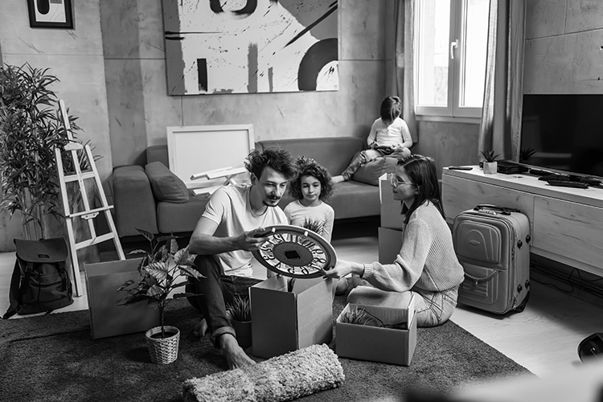
/10

Total: /20

