Part A • Grammar, Vocabulary and How to …
GRAMMAR

1 Circle the correct words.
0 After she left the office, she went / was going for a coffee with her friend.

1 I walked / was walking down the road when I saw a wallet on the floor.
2 It had rained / was raining hard so we stayed at home.
3 I didn’t watch the film last night because I saw / had seen it already.
4 When I arrived / had arrived at the station, the train was just departing.
5 Sasha heard / was hearing a noise upstairs so she went to see what it was.
6 My passport wasn’t stolen because I hid / had hidden it under the bed.
___ / 6

2 Circle the answer (A or B) that best completes each sentence.
0 She hopes ___ her master’s degree in June.
^{A} completing | ^{B} to complete

1 The instructions were hard to follow, but we finally succeeded
in ___ the wardrobe.
^{A} building | ^{B} to build

2 He put off ___ the exam until he felt more confident.
^{A} taking | ^{B} to take

3 After working for a bank, she went on ___ for a large charity.
^{A} working | ^{B} to work

4 When I was coming home from work, I stopped ___ a coffee with Todd.
^{A} having | ^{B} to have

5 Can you remember ___ the rubbish out when you leave?
^{A} taking | ^{B} to take
___ / 5

3 Match (1–4) with (A–E) to make sentences.
A not even Tessa.
B but even he enjoyed them.
C for the latest one.
D from eating and sleeping.
E it was quite long.

0 She’s got all their albums except _C_
1 Hardly anyone was at the party, ___
2 The film wasn’t too bad except ___
3 We didn’t do anything on holiday apart ___
4 Peter doesn’t usually eat cakes, ___

___ / 4

VOCABULARY

4 Complete the sentences with words for describing possessions.
0 This watch b e l o n g e d to my grandfather and he gave it to me for my
21st birthday.
1 The cover of the book is a bit d _ m _ _ _ d because some water fell on it.
2 An art expert thinks the painting is g _ n _ _ _ e and not a copy.
3 These earrings are quite old, but I don’t think they’re w _ _ t h a lot.
4 After my uncle died, I i _ _ e _ _ t _ d a little money.
___ / 4

5 Circle the correct words.

0 He gave her a beautiful denim / diamond ring before they got married.
1 These boots are made of cotton / rubber so my feet don’t get wet.
2 We gave my parents a set of glass / silver knives and forks for their wedding anniversary.
3 The wood / glass for this table came from a forest in Scotland.
4 The gate outside our house is made of iron / plastic because it’s a strong metal.
___ / 4

6 Complete the sentences with the words and phrases (A–F).
0 Those toys _D_ to a lot of young children, who love playing with them.
A a big fan of
B appreciate
C do without
D give pleasure
E ideal
F not for me
1 The holiday apartment is ___ for families because it’s next to the beach.
2 Now I’m older, I ___ the smaller things in life, like having a coffee with my friends.
3 I can ___ a car so I’m not going to buy one.
4 She isn’t ___ jazz so she didn’t enjoy the concert.
5 This programme is ___. I hate reality TV shows like this.

___ / 5

HOW TO …

7 Complete the sentences with the words and phrases (A–G).
0 _B_ you’ll be able to meet me after work?
A calling
B Do you think
C lock it up
D reach
E wonder if
F You’ll find
G you would mind
1 I ___ you could help me with the washing up.
2 I’m ___ to make an appointment with the dentist.
3 If you leave your bike in the street, make sure
you ___.
4 You can take my keys. ___ them on the kitchen table and you can give them to me later.
5 I wonder if ___ posting this letter for me.
6 This is Ivan. You can ___ me on 5367-17230.
___ / 12

TOTAL: ___ / 40
x 1.25 = ___ / 50

Part B • Listening, Reading and Writing
LISTENING

1 [Audio UT1.01] Listen to five people talking about possessions. Match the speakers (1–4) with the statements (A–E).
0 Chloe _C_
A I bought it because of its simple style.
B I appreciate the material it’s made from.
C I’d wanted to get one for a long time.
D I didn’t have to pay much for it.
E I got it to replace something I’d lost.
1 Jack ___
2 Leah ___
3 Harry ___
4 Aimee ___

___ / 4

2 [Audio UT1.01] Listen again. Are the statements True (T) or False (F)?
0 Chloe hadn’t expected the chair to be comfortable. _F_
1 Jack has decided to stop wearing the watch. ___
2 Leah had decided to buy the game before she went to the shop. ___
3 Harry’s leather jacket was a present from someone. ___
4 Aimee’s wardrobe was broken when she got it. ___
___ / 8

READING

3 Read the text in which people describe their favourite rooms. Are the ideas from the article (1–4) Facts (F) or Opinions (O)?
0 Ken had inherited his house from his auntie. _F_
1 The glass objects in Ken’s house were useless. ___
2 Ken’s old sofa had been damaged. ___
3 Vero’s personal space is important for her mental health. ___
4 Vero’s furniture makes the room bright on winter days. ___
___ / 4

My favourite room
Two readers tell us about their favourite rooms.

KEN
I live in an old house, which I inherited from my auntie. I enjoyed spending
time there when I was growing up. My auntie loved socialising and I
think the house reflects that. There’s only one main room downstairs which
contains a kitchen, dining area and living room. It’s like a big social
space where family and friends could get together for afternoon teas and
Sunday lunches. There were photographs of family occasions
everywhere, as well as the little glass objects that she collected. I always
thought they were useless, but they gave her a lot of pleasure!

For me, that room brings back happy memories, which is why I’ve kept it
almost the same. The long wooden table, which can fit twelve people
around it, has been there for years. We eat most of our family meals there,
but it’s also ideal for dinner parties because of its size. The only thing
I’ve changed is the sofa because the old one was damaged after years of
use. The new one is huge and there’s enough space for five or six
people to sit there comfortably. After dinner, we take our coffees over to the
sofa, where we can carry on chatting.

VERO
After a busy day at work, it’s important to relax, which is why my favourite
room is my bedroom. It’s not particularly big, but I love lying down in
there and losing myself in my thoughts. In fact, it’s so special to me that I’ve
even stopped my kids playing in there. I spend my life picking up
clothes and toys in their bedrooms and I don’t want to do it in my own room!
My husband thinks I’m being unfair, but I think having personal space
is important for my mental health.

Most of my bedroom furniture comes from a certain Swedish furniture
shop. In my opinion, the white wardrobe and chest of drawers makes the
room feel bright, even on dark winter days. Although they’re not made
of genuine wood, I believe they still bring some style to the room. The thing
that gives me most pleasure, though, is the big iron bed, which
belonged to my mother. It’s my favourite possession and I appreciate its
beautiful design and strength.

4 Read the text again. Are the statements True (T) or False (F)?
0 Ken’s house has three separate rooms downstairs. _F_

1 Ken’s favourite room has changed little since his auntie lived there. ___
2 Ken usually continues talking at the table after dinner. ___
3 Vero often has to move things from the floor of her children’s bedroom. ___
4 Vero’s favourite piece of furniture is a metal bed. ___
___ / 8

WRITING

5 Complete the adverts for selling items online with the words in the box.
Electric Toaster
Brand ⁰____new___ toaster in perfect ¹__________.
condition
Includes
Indian
new
used
Received as a gift this year, but never ²__________.
In original box with all instructions.
Price: £25
Location: Bristol, UK

Teapot
Genuine ³__________ teapot. Made from cast iron
with beautiful design and wooden handle.
⁴__________ four teacups.
Price: £15
Location: Glasgow, Scotland
___ / 4
6 Choose four of the items in the box. Write online adverts for them in note form.
handbag jeans ring saucepans typewriter violin
Write 100–140 words.
___ / 12

TOTAL: ___ / 40
x 1.25 = ___ / 50
Part C • Speaking
SPEAKING

1 Put the words in the correct order to make questions.
Ask your partner your questions.
0 What / you / playing / five / were / sports / years / ago?
____What sports were you playing five years ago?________

1 dream / you / doing / do / What / in the / about / future? ___________________________________________________
2 do / struggle with / people / learning / some / Why / a language?
___________________________________________________
3 tidy / How / you / often / do / your / up / bedroom? ___________________________________________________
4 you / What / could / do / possessions / without?
___________________________________________________
___ / 4

2 Answer your partner’s questions.
___ / 4
3 Describe the picture to your partner.
What are the people thinking about?
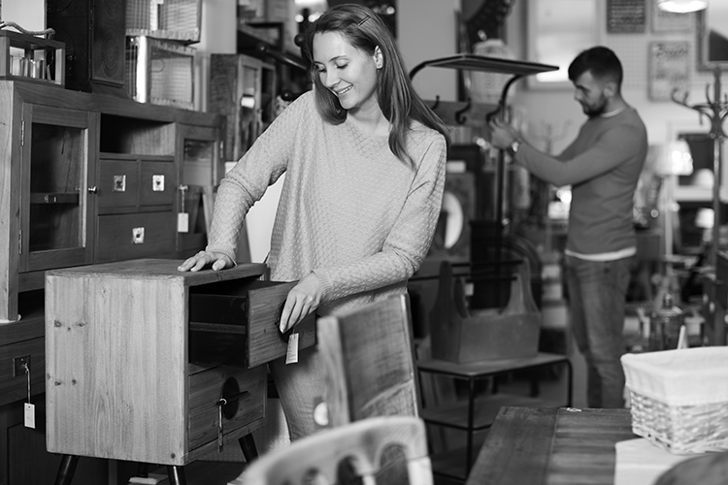
___ / 12

TOTAL: ___ / 20

