Part A • Grammar, Vocabulary and How to …
GRAMMAR
1 Complete the second version of the sentences using the words in brackets.
1 You should write your name on your jacket because you might lose it.
You should write your name on your jacket _______________ (in case) it.
2 They might offer us a nicer room, but we’re still not staying in this hotel.
We’re still not staying in this hotel _______________ (even if) us a nicer room.
3 You need to apologise for being rude to me or I’m not going to help you.
I’m not going to help you _______________ (unless) for being rude to me.
4 You should press this button to speak to the driver if there is an emergency.
_______________ (in case of), press this button to speak to the driver.
5 Don’t make Naim get up if he doesn’t want to.
Don’t make Naim get up _______________ (unless) to.
6 If you don’t work hard, you won’t pass the exam.
You won’t pass the exam _______________ (unless) hard.
7 We don’t have a car, but we wouldn’t have anywhere to park it anyway.
_______________ (even if) a car, we wouldn’t have anywhere to park it.
/7

2 Complete the sentences with the words and phrases in the box.
essential got need needs not allowed permitted supposed
1 I was __________ to collect Vincent from the airport, but I forgot.
2 You are__________ to drink water during the exam. If you decide to bring it, it must be in a clear, plastic bottle.
3 The salad __________ to be washed before we can eat it.
4 I’ve __________ to send this parcel to my sister.
5 It’s __________ to wear warm clothes when walking in the mountains because it gets very cold.
6 My grandmother is __________ to drive because she can’t see very well.
7 Our teacher says we __________ to read the rest of the chapter for homework.
/7

3 Choose the correct words to complete the sentences.
1 Would you prefer / rather to stay in or go out tonight?
2 I’d much rather / rather much eat sushi than pasta.
3 She’d rather not / not rather speak to Jill right now.
4 Given the choice, I go for / ’d go for the comedy rather than the drama.
5 Do / Would you prefer to get up late tomorrow morning?
6 Which would you rather be / go, a chef or an actor?
/6

VOCABULARY
4 Match the sentence beginnings (1–8) with the endings (a–h).
1 It’s important not to lose ___
2 He won’t be able to deal ___
3 I find it hard to keep ___
4 In order to avoid ___
5 I’m sure we’ll meet ___
6 When I’ve got ___
7 I’ve got to get a lot ___
8 We’ve fallen behind ___
a done before we go on holiday.
b schedule so we need to work faster.
c to a routine when I’m working from home.
d distractions, I always close the door.
e your concentration in this part of the game.
f this job out of the way, I’ll have more time.
g the deadline without any problems.
h with the challenge of managing a team.
/8

5 Complete the sentences with words related to work.
1 The workers felt e _ _ _ _ _ _ _ d because they had to work very long hours.
2 My b _ _ _ _ _ _ _ _ d is in education because I was a teacher for many years.
3 Do you think you could d _ _ _ with this customer for me?
4 He doesn’t have enough e _ _ _ _ _ _ _ _ e as a waiter for this job.
5 I’ve got a t _ _ _ _ _ _ _ y job. It’s only for a few weeks.
6 I won’t be able to h _ _ _ _ e working nights because I’ve got things to do during the day.
7 They treated me u _ _ _ _ _ _ y when they refused to pay me for the extra hours.
8 Briony is the person in c _ _ _ _ e of health and safety.
9 I need a l _ _ _ - t _ _ _ job and not just a job for a few months.
10 She was given several c _ _ _ _ _ s to improve her behaviour before they asked her to leave her job.
11 I’d like to o _ _ _ _ _ _ e a present for our boss’s birthday.
12 The company have offered me a p _ _ _ _ _ _ _ t contract so I can keep on working there.
/12
HOW TO …
6 Put the words in the correct order to make sentences and questions.
1 bring / to / What / you / would / company / the
___________________________________________?
2 school / Can / example / use / I / from / an
___________________________________________?
3 company / lot / offer / have / I / a / to / your
___________________________________________.
4 you / position / Why / this / interested / are / in
___________________________________________?
5 work / job / you / did / last / long / How / your / at
___________________________________________?
/5

7 Complete the sentences with the words in the box and the appropriate prefix (in, ir or un).
appropriate dependent enthusiastic popular regular
1 Rory has been very __________ about his job lately. He’s forever complaining about his salary.
2 He made a completely __________ comment about my clothes so I reported him to the boss.
3 Her attendance at work is quite __________ and she’s already missed two weeks this year.
4 The decision not to increase pay was very __________ with the staff.
5 You’ll need to be __________ because you’ll have to work from home.
/5

Total: /50
Part B • Listening, Reading and Writing
LISTENING
1 [Audio UT3.01] Listen to Katrina and Stuart discussing the advantages and disadvantages of work in the 21st century. Match the speakers Katrina (K), Stuart (S) or Both (B) with the statements (1–7).
1 I needed to take this job. K / S / B
2 I chose to accept this job. K / S / B
3 The hours I work are flexible. K / S / B
4 I had to leave my last job. K / S / B
5 I am not available for work in the mornings. K / S / B
6 I can’t complain about the money. K / S / B
7 I sometimes find it hard to do my job. K / S / B
/7

2 [Audio UT3.01] Listen again. Complete the notes with a word or short phrase.
1 Katrina does deliveries for restaurants, bookshops and _______________.
2 Katrina’s current job is more _______________ than her old job.
3 Katrina changes her _______________ if she has to study a lot.
4 Katrina thinks new delivery riders might spend longer _______________ than other riders.
5 Stuart looks after the children during the week because his wife is employed _______________.
6 Stuart used to receive less _______________ when he worked as a teacher.
7 Stuart says _______________ at home make his job more stressful.
8 Stuart has better _______________ when his children have gone out.
/8

READING
3 Read a blog post about being a roadie, who is someone who helps travelling performers. Match the paragraphs (1–5) with the headings (A–E).
A How did I become a roadie?
B What would I change about my job?
C What is my daily routine like?
D What’s the best thing about my job?
E What does my job involve?
/5

Blog: My life as a roadie
By Nathan Miller
Some readers have been asking me what it’s like being a roadie. In this blog post, I’m going to tell you so you can decide whether it’s the job for you.

1 ___
Some people think I just hang out with rock stars and go to parties. In reality, though, I rarely do that because I’m always busy. I’m responsible for setting up the equipment, like the musical instruments and speakers, and making sure it works. My job starts when we arrive at the venue and it finishes when we’ve packed everything away at the end. I have to deal with new challenges every day because each venue is different. We hardly ever relax because we’re always on the road.

2 ___
I’ve always been into rock music and I used to go to concerts in my hometown. My dream was to be a performer, but I wasn’t very musical so I knew that wouldn’t happen! However, I thought being a roadie would be the next-best option. I discussed it with a band manager who said there were opportunities if I was willing to work hard. It didn’t matter if I didn’t have a background in music. Of course, I agreed and the rest is history, as they say.

3 ___
There’s no fixed schedule, so I start working when we arrive at the venue. I have to take the equipment out of the trucks and set it up, which can take hours. When we’ve got that out of the way, I might take a break for a couple of hours. However, I’m supposed to stay at the venue in case there are any problems. My work begins again a few hours before the concert starts. I run around making sure everything works correctly. My day ends when the equipment is packed away again, which is usually pretty late.

4 ___
What I like most is being involved in something I love. Even though I don’t play in the band, I’m responsible for making sure the concert is a success. I’ve worked with some amazing bands and it makes me proud to see the fans enjoying the concerts. Apart from that, I also have the chance to travel all over the world. We’ve been travelling around Europe for the last three months, and we’re off to South America later in the year.

5 ___
The main disadvantage is that the future is uncertain as we only have temporary contracts. Some roadies complain because they think we’re being exploited. They think it’s unfair that we don’t have permanent contracts. Personally, I understand the need to be flexible because the future is never certain. At the same time, I might not feel the same way when I’m older and I’ve got more responsibilities. If I had a family to support, I’d probably prefer a more regular job with better conditions.

4 Read the blog post again. Choose the correct answer (A, B, C or D).
1 What does the writer say about roadies in the first paragraph?
A They spend their time hanging out with rock stars and going to parties.
B They are supposed to arrive at the venue before everyone else.
C They usually have the opportunity to relax while they are travelling.
D They have to manage difficult situations which change regularly.

2 When was the writer offered his first job as a roadie?
A when he was performing at a concert
B after speaking to someone in the industry
C while he was attending a rock concert
D after getting some experience in the industry

3 What does the writer normally do when he arrives at a venue?
A make sure everything works correctly
B look for problems in the venue
C get the equipment ready to be used
D take a break for a couple of hours

4 Why does the writer like being a roadie?
A He is necessary for the success of the concert.
B He sometimes has the chance to play in the band.
C He has been able to travel around South America.
D He is lucky enough to work with his favourite bands.

5 How does the writer feel about the future of his career?
A confident that he will get a permanent contract
B concerned about the short-term nature of the job
C certain that he will enjoy the job when he’s older
D pleased that the contract is only temporary
/10

WRITING
5 Correct the mistakes in the sentences.
1 I live in the country for two years.
___________________________________________
2 I look forward to meet you in the near future.
___________________________________________
3 I will wait to hear from you?
___________________________________________
4 I beleive I have the necessary skills.
___________________________________________
5 I am applying the job as a teaching assistant.
___________________________________________
/5

6 Read the job advert. Write a cover email for the job. Include important information about yourself and ask three questions about the job.
Tour Guide
Sunshine Tours Ltd.
Somerton

We organise tours around the UK for foreign tourists. We are looking for friendly, reliable, independent people with a background in tourism to join our team of tour guides.

You will be responsible for organising excursions and activities for small groups of tourists. You will also be required to stay at some beautiful locations around the UK.

Good level of English and another language is preferred.

Send your application to Victoria Kerr.

Write 100–140 words.
/15

Total: /50

Part C • Speaking
SPEAKING
1 Make questions and ask your partner.
1 How / avoid distractions / when / studying?
2 Have / ever / felt exploited / by / employer?
3 Is / better / have / permanent contract / for work?
4 Do / think / it / essential / learn / language / these days?
5 Do / prefer / work with / other people / or / by yourself?
/5

2 Answer your partner’s questions.
/5

3 Describe the picture to your partner. Why have the people chosen this job?
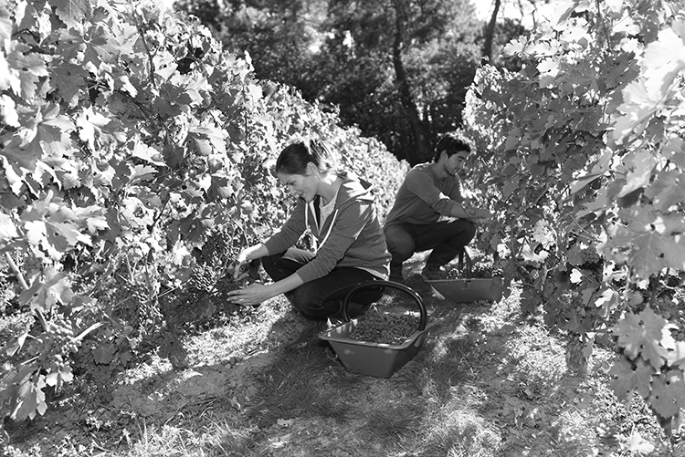
/10

Total: /20

