Part A • Grammar, Vocabulary and How to …
GRAMMAR
1 Choose the correct option (a, b or c) to complete the sentences.
1 They ___ stay at our house, but we don’t have space.
a were hoping b went to c were going to
2 He ___ open a café, but he didn’t find the right location.
a planning to b planned to c was planning
3 I ___ you tomorrow afternoon to see how you are.
a was calling b planning to call c was going to call
4 We ___ to check the weather forecast before we left.
a were waiting b are waiting c are going to wait
5 We ___ to hear from Seb yesterday, but no news yet.
a are expecting b were expecting c didn’t expect
6 She ___ to leave the book here, but she took it with her.
a meaning b meant c mean
7 The owners ___ sell the house before the winter.
a intended to b intending to c were intending
8 She thought ___ nice to bring you some flowers.
a it will be b it would be c would be
9 What ___ to tell me last night about Katie?
a are you going b you were going c were you going
10 I ___ to cancel the flight. It was an accident.
a meant b didn’t mean c wasn’t meaning
/10

2 Choose the correct words to complete the conversations.
1 A: Where does she / she does work now?
B: At the hairdressers on the High Street.
2 A: What you have / have you lost?
B: My phone. I thought it was on the table.
3 A: Could you tell me how long you spent /
did you spend on your homework?
B: About five hours.
4 A: Can I ask you what I should do / should I do with
this box?
B: Leave it over there, please.
5 A: Could you tell me where you play / do you play
tennis?
B: At the sports centre in town.
6 A: Can I ask / I can ask you how old you are?
B: I’m forty-five.
7 A: Do you know why he did stay / stayed at home?
A: I think he’s ill.
8 A: Wouldn’t / Didn’t you like to go for a walk?
B: No, thank you. I’m too tired.
9 A: Isn’t it / It is going to rain this afternoon?
B: I don’t think so.
10 A: Don’t you think / You don’t think we should say
goodbye?
B: No, they’re too busy.
/10
VOCABULARY
3 Complete the sentences with the words and phrases in the box.
come clean deceive doubt made up pretend scheme
1 I realised that she hadn’t told me the truth and she had tried to __________ me.
2 I __________ he’s telling the truth because he lies about everything.
3 I’m sure she __________ that story. I don’t believe a word.
4 I know you’re lying. Why don’t you __________ and tell me the truth?
5 Let’s __________ to be famous and see if anyone believes us.
6 They created a __________ to make money from old people by saying they were going to help them.
/6

4 Complete the sentences with adjectives to describe films.
1 I was looking forward to seeing the film, but I found it a bit d _ _ _ _ _ _ _ _ _ _ _ g in the end.
2 Some of the images in this film are s _ _ _ _ _ _ g and are not suitable for children.
3 The film is s _ _ w at the beginning, but it becomes more interesting later on.
4 This is a p _ _ _ _ _ _ l film which makes you think about the biggest problems in our society.
5 I took my family to see this film and it was very
e _ _ _ _ _ _ _ e. We liked it very much.
6 There is a d _ _ _ _ _ _ c scene at the beginning of the film which is very exciting.
/6

5 Choose the correct words to complete the sentences.
1 It can be hard to find a job in the film / film industry unless you have the right contacts.
2 I managed to find the star / soundtrack of the film in a local music shop, but it was only available on CD.
3 She’s going to read the film / script before she decides whether to accept the part or not.
4 The desert in the south of Morocco is a popular location / footage for films.
5 There was far too much television script / footage of the celebrities’ wedding.
6 They have asked a little-known Canadian actor to shoot / star in the film.
7 They plan to film / direct the main scenes in a studio.
8 The Hollywood producer / film-maker will be responsible for everything – scripts, filming and finance.
/8
HOW TO …
6 Choose the correct words to complete the conversations.
Conversation 1
A: Have you ¹heard / seen about the tiger that ²rescued / escaped from the zoo?
B: That ³looks / sounds scary. What happened?
A: ⁴Apparently / Appeared, it got into the city. Luckily, no one was hurt and they managed to catch it.
B: That’s a ⁵lucky / relief.

Conversation 2
A: Are you ⁶following / hearing the story about the family who were thrown out of their home?
B: No. What’s happened?
A: The story’s gone ⁷trending / viral on social media. It ⁸remembers / seems that a lot of people are upset about it.
B: Really? ⁹I believed / had no idea.
A: Yes, and some people have organised a ¹⁰march / strike through the town centre.
/10

Total: /50

Part B • Listening, Reading and Writing
LISTENING
1 [Audio UT4.01] Listen to a podcast in which Alistair and Sarah talk about a film they have seen. Match the speakers Alistair (A), Sarah (S) or Both (B) with the statements (1–5).
1 It’s not the first film with this type of story. A / S / B
2 The film is really about the way people react to climate change. A / S / B
3 The film should have a more direct message. A / S / B
4 The film-makers have made a clever film which reflects the problems we face. A / S / B
5 The film is unlikely to convince everyone about the problem of climate change. A / S / B
/5

2 [Audio UT4.01] Listen again. Choose the correct answer (A, B or C).
1 Alistair says that the film
A stars two of his favourite American actors.
B was available on social media for a while.
C is about people trying to save the world.

2 Sarah thinks the behaviour of some of the characters is
A upsetting.
B funny.
C inspiring.

3 Alistair says that newsreaders in the film
A help the scientists tell the truth.
B want their audience to be happy.
C decide to lie to their viewers.

4 Alistair thinks audiences might be confused about
A the message of the film.
B the ending of the film.
C the characters in the film.

5 Sarah thinks that climate change
A is a joke for most people.
B isn’t taken seriously enough.
C could have a positive effect.
/10

READING
3 Read the story about a hoax. Put the sentences (a–h) in the correct order (1–8) to complete a summary of the story.
___ a Hull decided to tell the truth about the Cardiff Giant.
___ b He organised for the giant to be hidden by a member of his family.
___ c The giant became a popular attraction which Hull and Newell made money from.
___ d George Hull wanted people to see that is not difficult to deceive other people.
___ e Some people began to realise that the giant wasn’t real.
___ f The giant was left in the ground for some time before it was found.
___ g He paid some people to make a giant out of stone.
___ h An entertainer made his own copy of the Cardiff Giant.
/8
The Cardiff Giant
In 1867, George Hull came up with a scheme to convince people that giants had once walked the earth. Hull was an American cigar maker who had had an argument with a group of people who believed that giants once existed. He intended to show them, and everyone else, how easily people could be deceived. His plan was to create a fake giant which had been turned into stone, and he was going to show it to the world.
Hull made careful plans and he started by buying a large piece of soft stone, which he transported to Chicago. Then he employed sculptors to create a three-metre giant man from the stone. He made the sculptors promise to keep it a secret. They thought it would be a good idea to use chemicals to make the giant look old, and Hull even made small holes in it to make the ‘skin’ look more natural. When the giant was finally ready, Hull arranged for it to be buried on the farm of his cousin, William Newell.
The giant remained underground for a year before Newell hired two men to dig a well in the same place. The two men had no idea about Hull and Newell’s scheme so they were amazed to discover the giant. The announcement of the discovery was made in local newspapers and people were soon rushing to the farm to see the giant. Newell, who was happy to live the lie, put up a tent to protect the giant, and charged visitors fifty cents to see the dramatic discovery. He shared the profits with Hull.
While many people were deceived by Hull’s hoax, others doubted that the Cardiff Giant was genuine. They argued that it was impossible for the giant to keep its features after a long time in the ground. Perhaps realising that the truth was going to come out, Hull sold his share of the giant for $30,000. The circus owner P.T. Barnum had been interested in buying the giant. However, when the owners refused to sell it to him, he created his own fake giant. Barnum told everyone that Hull’s giant was the fake and then charged people to see his ‘real’ giant!
Some people continued to believe the story of the Cardiff Giant until 1870 when the sculptors decided to come clean. Hull then also decided to break his silence and he spoke publicly about his dishonest scheme. When the truth came out, interest in the giant disappeared and its owners stopped displaying it. In 1947, the Cardiff Giant was eventually sold to the Farmers’ Museum in Cooperstown, New York, where it attracts visitors once again.

4 Read the story again. Are the statements True (T) or False (F)?
1 Hull wanted to show people that giants had really existed. T / F
2 Hull bought the stone for the Cardiff Giant in Chicago.
T / F
3 The sculptors agreed not to tell anyone about the giant. T / F
4 Newell was comfortable deceiving the giant’s visitors.
T / F
5 Hull sold his share of the giant after telling people the truth. T / F
6 Barnum had intended to buy the Cardiff Giant from its owners. T / F
7 Hull was the first person to tell the truth about the Cardiff Giant. T / F
/7

WRITING
5 Choose the correct words to complete the sentences.
1 The film was quite slow / slowly at the beginning, but it became more exciting later on.
2 The scenes with the dolphins swimming next to the boat are wonderful / wonderfully shot.
3 The film ends dramatic / dramatically with the police catching the art thieves.
4 This is a powerful / powerfully reminder of the problems many people face.
5 The director has dealt with the issue intelligent / intelligently.
/5

6 Read the announcement from a website and write a film review.
Films which changed our lives

Have you seen a film which changed your life? Write a review of the film, including background information, a description of what happens, and why the film changed your life.

We will publish the best reviews on our website.

Write 100–140 words.
/15

Total: /50

Part C • Speaking
SPEAKING
1 Make questions and ask your partner.
1 When / last time / made up / story?
2 Why / children / pretend / be adults?
3 Have / seen / disappointing programmes / recently?
4 Why / some people / decide / strike?
5 How important / soundtrack / in a film?
/5

2 Answer your partner’s questions.
/5

3 Describe the picture to your partner. What are the people filming?
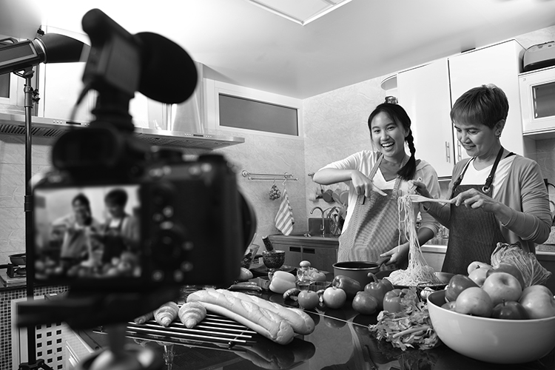
/10

Total: /20

