Part A • Grammar, Vocabulary and How to …
GRAMMAR

1 Circle the answer (A or B) that best completes each sentence.
0 They ___ stay at our house, but we don’t have space.
^{A} were hoping | ^{B} were going to
1 He ___ open a café, but he didn’t find the right location.
^{A} planned to | ^{B} was planning

2 We ___ to check the weather forecast before we left.
^{A} are going to wait | ^{B} were waiting

3 She ___ to leave the book here, but she took it with her.
^{A} meant | ^{B} meaning

4 She thought ___ nice to bring you some flowers.
^{A} it will be | ^{B} it would be

5 What ___ to tell me last night about Katie?
^{A} are you going | ^{B} were you going
___ / 5

2 Circle the correct words.
0 I didn’t / wouldn’t mean to cancel the flight. It was an accident.

1 A: Where does she / she does work now?
B: At the hairdressers on the High Street.
2 A: What you have / have you lost?
B: My phone. I thought it was on the table.
3 Could you tell me how long you spent / did you spend on your homework?
4 A: Can I ask you what I should do / should I do with this box?
B: Leave it over there, please.
5 Could you tell me where you play / do you play tennis?
6 Can I ask / I can ask you how old you are?
7 Do you know why he did stay / stayed at home?
8 A: Wouldn’t / Didn’t you like to go for a walk?
B: No, thank you. I’m too tired.
9 A: Isn’t it / It is going to rain this afternoon?
B: I don’t think so.
10 A: Don’t you think / You don’t think we should say goodbye?
B: No, they’re too busy.
___ / 10

VOCABULARY

3 Complete the sentences with the words and phrases (A–F).
0 I realised that she hadn’t told me the truth and she had tried to _B_ me.
A come clean
B deceive
C doubt
D made up
E pretend
F scheme
1 I ___ he’s telling the truth because he lies about everything.
2 I’m sure she ___ that story. I don’t believe a word.
3 I know you’re lying. Why don’t you ___ and tell me the truth?
4 Let’s ___ to be famous and see if anyone believes us.
5 They created a ___ to make money from old people by saying they were going to help them.
___ / 5

4 Complete the sentences with adjectives to describe films.
0 I was looking forward to seeing the film, but I found it a bit
d i s a p p o i n t i n g in the end.
1 Some images in this film are s _ o _ k _ _ g and are not suitable for children.
2 This is a p _ w _ _ f _ l film which makes you think about the biggest problems in our society.
3 I took my family to see this film and it was very e _ j _ _ _ b _ e. We liked it very much.
4 There is a d _ _ m _ t _ c scene at the beginning of the film which is very exciting.
___ / 4

5 Circle the correct words.
0 I managed to find the star / soundtrack of the film in a local music shop, but it was only available on CD.

1 She’s going to read the film / script before she decides whether to accept the part or not.
2 The desert in the south of Morocco is a popular location / footage for films.
3 There was far too much television script / footage of the celebrities’ wedding.
4 The Hollywood producer / film-maker will be responsible for everything – scripts, filming and finance.
___ / 4

HOW TO …

6 Circle the correct options.
Conversation 1:
A: Have you ⁰ heard / seen about the tiger that escaped from the zoo?
B: That ¹ looks / sounds scary. What happened?
A: ² Apparently / Appeared, it got into the city. Luckily, no one was hurt and they managed to catch it.
B: That’s a ³ lucky / relief.

Conversation 2:
A: Are you ⁴ following / hearing the story about the family who were thrown out of their home?
B: No. What’s happened?
A: The story’s gone ⁵ trending / viral on social media. It seems that a lot of people are upset about it.
B: Really? ⁶ I believed / had no idea.
A: Yes, and some people have organised a march through the town centre.
___ / 12

TOTAL: ___ / 40
x 1.25 = ___ / 50

Part B • Listening, Reading and Writing
LISTENING

1 [Audio UT4.01] Listen to a podcast in which Alistair and Sarah talk about a film they have seen. Match the speakers Alistair (A), Sarah (S) or Both (B) with the statements (1–4).
0 It’s not the first film with this type of story. _A_
1 The film is really about how people react to climate change. ___
2 The film should have a more direct message. ___
3 The film-makers have made a clever film about the problems we face. ___
4 The film is unlikely to convince everyone about climate change. ___
___ / 4

2 [Audio UT4.01] Listen again. Circle the correct answer, A or B.
0 Alistair says that the film
^{A} is about people trying to save the world. | ^{B} stars two of his favourite American actors.

1 Sarah thinks the behaviour of some of the characters is
^{A} upsetting. | ^{B} inspiring.

2 Alistair says that newsreaders in the film
^{A} want their audience to be happy. | ^{B} decide to lie to their viewers.

3 Alistair thinks audiences might be confused about
^{A} the ending of the film. | ^{B} the message of the film.

4 Sarah thinks that climate change
^{A} is a joke for most people. | ^{B} isn’t taken seriously enough.
___ / 8

READING

3 Read the story about a hoax. Put the sentences (A–G) in the order they are mentioned.
0 _C_
A Hull decided to tell the truth about the Cardiff Giant.
B He organised for the giant to be hidden by a family member.
C George Hull wanted people to see that it’s not difficult to deceive other people.
D Some people began to realise that the giant wasn’t real.
E The giant was left in the ground for some time before it was found.
F He paid some people to make a giant out of stone.
G An entertainer made his own copy of the Cardiff Giant.
1 ___
2 ___
3 ___
4 ___
5 ___
6 ___
___ / 6

The Cardiff Giant
In 1867, George Hull came up with a scheme to convince people that giants
had once walked the earth. He’d had an argument with a group of
people who believed that giants once existed and intended to show them,
and everyone else, how easily people could be deceived. His plan was
to create a fake giant which had been turned into stone.

Hull started by buying a large piece of soft stone, which he transported
to Chicago. Then he employed sculptors to create a three-metre giant man
from it, making the sculptors promise to keep it a secret. They used
chemicals to make the giant look old and made small holes in it to make the
‘skin’ look more natural. When finally ready, Hull arranged for the giant
to be buried on the farm of his cousin, William Newell.

The giant remained underground for a year before Newell hired two
men to dig a well in the same place. The two men had no idea about Hull
and Newell’s scheme so they were amazed to discover the giant. The
announcement of the discovery was made in local newspapers and people
were soon rushing to the farm to see it. Newell, who was happy to live
the lie, put up a tent to protect the giant. He charged visitors fifty cents to
see the dramatic discovery and shared the profits with Hull.

While many people were deceived by Hull’s hoax, others doubted that the
Cardiff Giant was genuine. Perhaps realising that the truth was going
to come out, Hull sold his share of the giant for $30,000.

The circus owner P.T. Barnum had wanted to buy the giant and when the owners refused to sell it to him, he created his own fake giant. Barnum then told everyone that Hull’s giant was the fake and charged people to see his ‘real’ giant!

Some people continued to believe the story of the Cardiff Giant until
1870 when the sculptors decided to come clean. Hull then also decided to
break his silence and spoke publicly about his dishonest scheme.
When the truth came out, interest in the giant disappeared and its owners
stopped displaying it. In 1947, the Cardiff Giant was eventually sold
to the Farmers’ Museum in Cooperstown, New York, where it attracts
visitors once again.

4 Read the text again. Are the statements True (T) or False (F)?
0 Hull wanted to show people that giants had really existed. _F_
1 Hull bought the stone for the Cardiff Giant in Chicago. ___
2 The sculptors agreed not to tell anyone about the giant. ___
3 Newell was comfortable deceiving the giant’s visitors. ___
4 Hull sold his share of the giant after telling people the truth. ___
5 Barnum had intended to buy the Cardiff Giant from its owners. ___
6 Hull was the first person to tell the truth about the Cardiff Giant. ___
___ / 6

WRITING

5 Choose the correct words to complete the sentences.
0 The film was quite slow / slowly at the beginning, but it became more exciting later on.
1 I think that the scenes where the dolphins are swimming next to the boat are wonderful / wonderfully shot.
2 The film ends dramatic / dramatically with the police catching the art thieves.
3 This is a powerful / powerfully reminder of the problems many people face.
4 The director has dealt with the issue intelligent / intelligently.
___ / 4
6 Read the announcement from a website and write a film review.

Films which changed our lives

Have you seen a film which changed your life? Write a review of the film, including background information, a description of what happens, and why the film changed your life.

We will publish the best reviews on our website.

Write 100–140 words.
___ / 12

TOTAL: ___ / 40
x 1.25 = ___ / 50

Part C • Speaking
SPEAKING

1 Put the words in the correct order to make questions.
Ask your partner your questions.
0 the last / you / When / made up / was / time / a story?
____When was the last time you made up a story?________

1 pretend / to / do / children / be / Why / adults? ___________________________________________________
2 you / programmes / disappointing / Have / seen / any / recently?
___________________________________________________
3 some / Why / people / decide / do / to strike?
___________________________________________________
4 is / the soundtrack / in / important / How / a film?
___________________________________________________
___ / 4

2 Answer your partner’s questions.
___ / 4
3 Describe the picture to your partner.
What are the people filming?
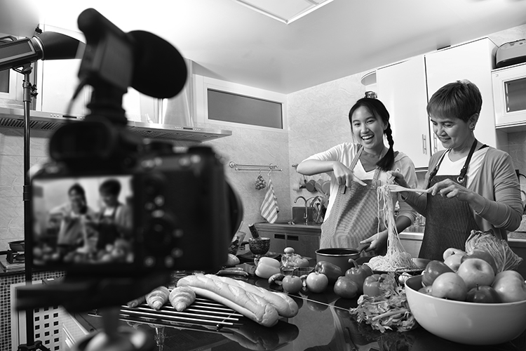
___ / 12

TOTAL: ___ / 20

