Part A • Grammar, Vocabulary and How to …
GRAMMAR
1 Choose the correct words to complete the sentences.
1 They put up a net in order / so as to play volleyball.
2 I bought some flour so that / to make pizza for dinner.
3 He went to the petrol station so that / in order to get some petrol for the car.
4 So as to / that we can arrive on time, we need to catch the 7.15 train.
5 We wrapped the glasses carefully in order to not /
not to break them.
6 I’ve been working late this week so as not to / not as to fall behind schedule.
7 I gave the plants plenty of water so that not to /
they don’t die when we’re on holiday.
/7

2 Complete the second version of the sentences using the words in brackets.
1 Bread costs a lot more than it did a few months ago.
Bread is _______________ than it was a few months ago. (much / expensive)
2 Your desk is tidier than mine.
My desk _______________ as yours. (isn’t)
3 She used to be less confident speaking English.
She speaks English _______________ she used to. (more)
4 You haven’t made ramen as tasty as this before.
The ramen you made is _______________ ever. (than)
5 I know few people more reliable than Neil.
Neil is _______________ people I know. (among)
6 His behaviour is becoming worse every day.
His behaviour is _______________ every day. (and)
7 If you practise the trumpet more, you will become better.
The more you practise the trumpet, _______________ become. (the)
/7

3 Put the words in the correct order to make sentences and questions.
1 farmer / delivered / has / by / vegetables / She / a
___________________________________________.
2 Saturdays / gets / usually / car / He / on / his / washed
___________________________________________.
3 by / I’m / dress / made / professional / having / my / a
___________________________________________.
4 tomorrow / more / some / getting / cut / They’re / keys
___________________________________________.
5 somebody / get / look / problem / the / to / at / Let’s
___________________________________________.
6 herself / design / posters / the / she / Did
___________________________________________?
/6
VOCABULARY
4 Complete the sentences with personality adjectives.
1 I spoke to a p _ _ _ _ _ _ t young man who was polite and smiled a lot.
2 She’s s _ _ _ _ _ _ e so she makes good decisions.
3 Don’t lose your temper and try to stay c _ _ m.
4 I know you’ve been waiting a long time, but you need to be p _ _ _ _ _ t.
5 When he argues, he often becomes a _ _ _ _ _ _ _ _ e. He looks angry and talks in loud voice.
6 She’s quite d _ _ _ _ t so she’s happy to give her opinion.
/6

5 Complete the sentences with the words and phrases in the box.
bargain hunter brand loyalty consumer
good deal influence on offer quality
1 There’s no doubt that social media can __________ users and change how they behave.
2 These trainers are really bad __________. They’ve broken already.
3 I bought this dishwasher because it was __________. It was much cheaper than usual.
4 My cousin is a real __________. He’s always looking for the best products at the cheapest prices.
5 You can get a __________ if you go on holiday in winter. It’s usually much cheaper.
6 I don’t think __________ is that important to me. I don’t buy things because of the name.
7 I used to be a big __________, but don’t buy so many things anymore.
/7

6 Choose the correct words to complete the sentences.
1 Most supermarkets make you pay a small charge / discount for plastic shopping bags.
2 We made a bargain / donation to an organisation which protects animals.
3 The company made a loss / profit last year so it had to close some shops.
4 The shop assistant gave me a discount / fee because the box was damaged.
5 This phone was supposed to be 350 euros, but it only cost me 210 euros. It was a bargain / receipt!
6 Every time I use my credit card when I’m on holiday, the bank makes me pay a fee / fare.
7 If you’re unhappy with the service, you should ask for a profit / refund.
/7
HOW TO …
7 Complete the conversations with the words and phrases in the box.
comes down from what impressive
just because matter
A: Are you still thinking about buying that newest smart phone?
B: I’m not sure. It’s a(n) ¹__________ phone, but it’s quite expensive.
A: I know, but ²__________ everyone says, it’s the best phone you can buy at the moment.
B: Well, ³__________ something’s expensive, it doesn’t mean it’s better.
A: I suppose it’s a(n) ⁴__________ of whether you’re prepared to pay for good quality.
B: I agree, but sometimes I think you’re just paying for the name.
A: Well, I suppose it all ⁵__________ to how much you trust what other people say.

according to in the end into account
only thing superb
A: Did you like the restaurant last night?
B: Taking everything ⁶__________, I was a bit disappointed.
A: Really? In what way?
B: Well, ⁷__________ the reviews, the food is amazing, which it was. The ⁸__________ is that the waiters were really slow.
A: I didn’t notice that. In fact, I thought the service was ⁹__________.
B: I guess you had a different waiter. Personally, I got fed up with waiting. ¹⁰__________, I didn’t even have a dessert.
/10

Total: /50
Part B • Listening, Reading and Writing
LISTENING
1 [Audio UT5.01] Listen to five people talking about complaints they have made. Match the speakers
(1–5) with the statements (A–E).
1 Sandra: ___
2 Patrick: ___
3 Amanda: ___
4 George: ___
5 Isabel: ___
A I probably sounded a bit aggressive.
B I made a complaint online.
C I handled the situation in a relaxed way.
D I didn’t speak my mind at the beginning.
E I was sure I would be successful.
/5

2 [Audio UT5.01] Listen again. Choose the correct answer (A, B or C).
1 Sandra managed to
A repair the denim jacket herself.
B get the damaged jacket replaced.
C get a refund on her purchase.

2 Patrick
A was able to change the brakes himself.
B felt that he had been treated unfairly.
C ended up paying for new brakes.

3 Amanda had planned to
A save some money on her flights.
B cancel her trip to Berlin.
C pay the full fare for her flights.

4 George was pleased because
A he was contacted by the bookseller.
B he didn’t have to pay for a genuine book.
C he had bought a genuine book.

5 Isabel was able to get
A a bigger car for her journey.
B a response on social media.
C a reduction in the price of the car.
/10

READING
3 Read an article about how the ways we consume are changing. Match the phrases (a–h) with the trends
(1–3) they are connected to.
1 Online shopping: __________
2 Customer attraction: __________
3 Eating out: __________
a some businesses have been losing money
b customers are comparing products before making purchases
c some businesses are trying to provide a faster service
d customers can choose from many different products
e customers are finding it easier to choose places to go out
f customers are less interested in always buying the same products
g some businesses have found new ways of making money
h customers are showing less satisfaction with their purchases
/8
Consumer Trends
Online shopping
For many consumers, online shopping makes complete sense because it’s by far the most convenient way to shop. It gives you access to a wide range of products and it’s easy to find a bargain. It’s not surprising that online purchases have grown by about 30 percent in recent years. However, some people are warning that the current model of online shopping will need to change. While most of us expect free delivery, the high costs are causing some companies to make a loss. This might be acceptable in the short-term, but will companies keep offering it in the longer-term? What’s more, many consumers are finding that the quality of the products is getting worse and worse. People are becoming increasingly disappointed with what they receive. While online shopping is here to stay, it’s unlikely to continue growing as quickly.
Customer attraction
For years, companies have focused on achieving brand loyalty. The idea is that even if their products are more expensive than the competition’s, consumers will continue to buy them. However, recent studies have shown that there’s less brand loyalty among the younger generation of consumers. That’s because they’d rather get the best deal than continue to buy the same things. They’re far more likely to use online reviews to compare prices, quality, and other people’s opinions before making a decision. At the same time, younger consumers are more worried about personal identity and less interested in owning the same things as everyone else. As a result, companies need to come up with new ways to sell their products and attract the younger generation of consumers. This means that new businesses with original products find it easier to compete with better-known brands.
Eating out
The internet also offers a more convenient way to choose restaurants, book tables and leave reviews. Apps also allow customers to access digital menus and pay without the need for cash or credit cards. Many restaurants have also been looking for ways to serve their customers more quickly. Their customers lead busy lives and they don’t want to be kept waiting. In the past, good quality restaurants were unlikely to be self-service. However, some of them now ask customers to serve themselves and even tidy up afterwards. Interestingly, a lot of customers are happy to do this if it means saving time. Restaurants have also been looking for new ways to increase their profits. The latest trend is to offer ingredients for customers to buy and take home with them. At the end of their meal, customers are able to buy the same products as the ones used in the restaurant, like olive oil and pasta, which provides extra income for restaurants.
4 Read the article again. Are the statements True (T) or False (F)?
1 There are more convenient ways to shop than online.
T / F
2 The quality of products bought online is not always better. T / F
3 Consumers will only buy products if they are cheaper than the competition. T / F
4 Brand loyalty is more important to older generations than younger ones. T / F
5 Younger people want to have the same things as the people around them. T / F
6 Most restaurants will only accept payment by cash or credit card. T / F
7 Many customers don’t mind changes to the way they are served in restaurants. T / F
/7

WRITING
5 Match the sentence beginnings (1–5) with the endings (a–e).
1 I am writing to complain
2 I was shocked to
3 Unfortunately, the problems
4 A passenger should never be
5 My experience was

a didn’t end there.
b put in this situation.
c about a flight I took with your airline.
d completely unacceptable.
e discover that my seat was taken.
/5

6 You have recently had a bad experience in a shop. Write a complaint email to the manager of the shop.
Write 100–140 words.
/15

Total: /50

Part C • Speaking
SPEAKING
1 Make questions and ask your partner.
1 What / best way / to deal / aggressive / people?
2 What things / normally / complain about?
3 How important / brand loyalty / you?
4 Have / ever asked / for / refund / in a shop?
5 When / the last time / had / eyes tested?
/5

2 Answer your partner’s questions.
/5

3 Describe the picture to your partner. Why is the man complaining?
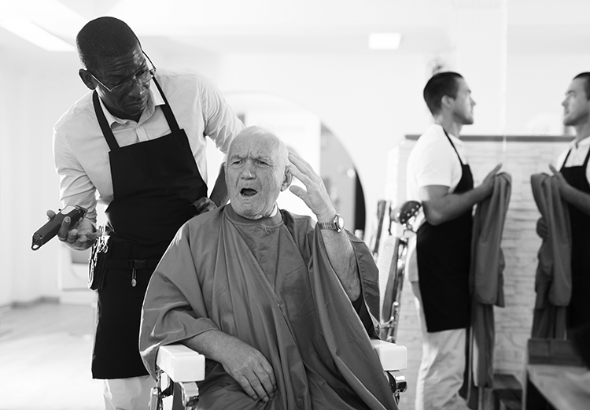
/10

Total: /20

