Part A • Grammar, Vocabulary and How to …
GRAMMAR
1 Choose the correct words to complete the sentences.
1 We put on some music so as to / that we could dance.
2 They were saving up money so as to / in order go travelling in the summer.
3 I turned some of the lights off so not as to / as not to waste electricity.
4 I brought a blanket so that / to sit on in the park.
5 I filled the car with petrol in order to not / not to run out on the motorway.
6 I blocked their number on my phone so they couldn’t / not to phone me anymore.
7 We discussed the options carefully in order / so that to make the right decision.
/7

2 Complete the second version of the sentences using the words in brackets.
1 Silvia is funnier than Juan.
Juan isn’t _______________ Silvia. (as)
2 My old computer didn’t work as well as my new one.
My new computer is _______________ my old one. (bit / reliable)
3 I’ve never heard a story as bad as that.
That is _______________ story I’ve ever heard. (far)
4 He used to be a less dangerous driver.
He drives _______________ he used to. (more)
5 There are few people at work less friendly than her.
She’s _______________ people at work. (one / least)
6 Recently, the city has become increasingly crowded.
Recently, the city has become _______________. (and)
7 If you sleep longer, it is harder to get up.
The longer you sleep, _______________ to get up. (the)
/7

3 Put the words in the correct order to make sentences and questions.
1 by / fixed / I / have / car / mechanic / my / a
___________________________________________.
2 sometimes / They / painted / nails / get / their
___________________________________________.
3 suit / having / for / I’m / my / wedding / cleaned / the
___________________________________________.
4 windows / cleaned / getting / on / my / Thursday / I’m
___________________________________________.
5 looked / children / get / a / The / after / by / neighbour
___________________________________________.
6 they / Did / themselves / the / bake / cake
___________________________________________?
/6
VOCABULARY
4 Complete the sentences with personality adjectives.
1 She needs some help preparing her presentation because she’s not very c _ _ _ _ _ _ _ t.
2 The man lost his temper and became quite
a _ _ _ _ _ _ _ _ e towards me.
3 He’s quite d _ _ _ _ t so he’ll tell you exactly what he thinks.
4 She finds it hard to talk to people because she’s s _ _ .
5 Thank you for waiting. You’ve been very p _ _ _ _ _ t.
6 I always trust Kiera to make the right decision because she’s very s _ _ _ _ _ _ e.
/6

5 Complete the sentences with the words and phrases in the box.
a purchase brand loyalty good deal influence limited availability on offer worth
1 It’s not __________ buying a phone for the house because we’ll never use it.
2 I bought this coffee maker because it was __________. It was half-price.
3 I always buy shoes from the same company so I suppose __________ is important to me.
4 You should book those cheap flights soon because there’s __________.
5 I got a(n) __________ on these socks because I got three pairs for the price of two.
6 Nowadays to make __________, I usually use a special app on my phone.
7 Advertisements must __________ people because companies spend a lot of money on them.
/7

6 Choose the correct words to complete the sentences.
1 They got a bargain / charge when they bought their car because it was much cheaper than the normal price.
2 A man was collecting money for the homeless so I made a small discount / donation.
3 I noticed that the bus fare / fee has gone up. It costs an extra fifty cents now.
4 The company has made a loss / refund this year, but they hope to make some money next year.
5 I asked for a profit / receipt in case I need to take it back to the shop.
6 The price of the hotel includes bed and breakfast, but there’s an extra charge / discount for dinner.
7 I can’t believe I was charged a fee / profit for using my credit card.
/7
HOW TO …
7 Complete the conversations with the words and phrases in the box.
according to comes down matter only thing stable
A: Have you decided what camping chair we should buy?
B: Well, I’m not sure because ¹__________ the reviews, they’re both pretty good.
A: I suppose it’s a ²__________ of what colour you want.
B: Yes, but not just that. The first one is supposed to be more ³__________.
A: That’s important. You don’t want the chair to break or fall over.
B: True. The ⁴__________ is that it’s more expensive.
A: So it all ⁵__________ to how much we want to spend.
B: Exactly.

from what impressive long story only thing the end
A: How’s your new tablet?
B: In ⁶__________, I didn’t buy it. ⁷__________ short, it wasn’t as good as I expected.
A: Really? ⁸__________everyone says, it’s a really ⁹__________ device.
A: It is in some ways. The ¹⁰__________ is that it doesn’t have much memory. If I’m going to pay that much money for a tablet, I want it to have plenty of memory.
/10

Total: /50
Part B • Listening, Reading and Writing
LISTENING
1 [Audio UT5.01] Listen to five people talking about complaints they have made. Match the speakers
(1–5) with the statements (A–E).
1 Sandra: ___
2 Patrick: ___
3 Amanda: ___
4 George: ___
5 Isabel: ___
A I didn’t speak my mind at the beginning.
B I probably sounded a bit aggressive.
C I was sure I would be successful.
D I handled the situation in a relaxed way.
E I made a complaint online.
/5

2 [Audio UT5.01] Listen again. Choose the correct answer (A, B or C).
1 Sandra
A was nervous about complaining.
B planned to have the jacket repaired at first.
C had realised in the shop that the jacket was damaged.

2 Patrick
A became very annoyed in the bike shop.
B had owned the bike for several years.
C made a complaint to a consumer organisation.

3 Amanda
A didn’t feel confident about flying.
B was unable to find a hotel room.
C paid the full price for her plane ticket.

4 George managed to
A get a genuine copy of the book.
B get a refund from the bookseller.
C make a photocopy of the book.

5 Isabel says the car was
A suitable for travelling with her family.
B not as big as she had expected.
C the most comfortable car she had driven.
/10

READING
3 Read an article about how the ways we consume are changing. Match the phrases (a–h) with the trends (1–3) they are connected to.
1 Shopping experiences: __________
2 Careful consumers: __________
3 Entertainment: __________

a consumers have less money to spend than in the past
b people working in some industries are treated unfairly
c consumers are buying more products on the internet
d businesses in some industries have been losing money
e some businesses are returning to town centres after a long time
f businesses are combining new technology with old ways of buying things
g consumers are taking more care when choosing things to buy
h consumers can have things brought to their homes quickly
/8
Consumer Trends
Shopping experiences
The shopping experience has changed a great deal for many of us. Shops which used to be located in town centres, have been moving to out-of-town shopping centres. Cheaper rent and more space are the main reason for that. At the same time, online shopping is becoming more and more popular. It’s easier than ever to buy things online and get them delivered to your door within hours. However, some people still like the experience of walking around the shop, as well as being able to check the quality of the products before buying them. As a result, the shopping industry has come up with the concept of ‘hybrid’ shopping, which uses digital technology to improve the traditional shopping experience. Shoppers download apps which suggest products, offer discounts, and allow them to pay automatically. All of this can be done without the need to join a queue.
Careful consumers
In recent years, many consumers have reduced the amount they spend for different reasons. For some people, this is because they have less money. What they earn hasn’t increased as fast as the cost of goods, so they’re constantly looking out for the best deals. At the same time, others are worried about the effects of consumer behaviour on the planet. One example is ‘fast fashion’ – cheap clothes which people only wear for a short time. Some people think fast fashion has little respect for the environment and that some workers are exploited. As a result, younger generations, who worry most about the future, would rather spend their money more carefully. They use their digital skills to find products which reflect their identity and show respect to people and the environment.
Entertainment
Digital technologies have also had an important influence on the way we consume entertainment. For decades, cinemas were one of the main leisure activities, but fewer and fewer people have been going in recent years. As a result, an increasing number of cinema companies have reported losses. The main reason is that more and more people are watching films on the internet. For a small monthly fee, streaming services allow viewers to watch as many films as they like, which are often the latest releases. However, there is evidence that some people are looking for a more genuine cinema experience. Fed up with watching films on tablets and TVs, they would rather see them on a big screen. Noticing an opportunity, smaller independent cinemas have started to appear. The traditional town-centre cinemas, which disappeared long ago, are becoming a feature of our towns once again.
4 Read the article again. Are the statements True (T) or False (F)?
1 Fewer shops are now found in town centres. T / F
2 It used to be easier to make purchases online. T / F
3 It’s not necessary for some shoppers to wait in queues. T / F
4 Consumers spend less time looking for the cheapest products. T / F
5 Older generations tend to be more careful about how they spend money. T / F
6 Going to the cinema is less popular than it was in the past. T / F
7 Some people are unhappy about new ways of viewing films. T / F
/7

WRITING
5 Match the sentence beginnings (1–5) with the endings (a–e).
1 I found it extremely
2 I was beginning
3 I’m afraid to say that
4 I was reasonable and
5 I am confident that we

a to regret choosing your airline.
b patient with your staff.
c they were very rude.
d can reach a sensible resolution.
e annoying that my seat was taken.
/5

6 You have recently had a bad experience in a shop. Write a complaint email to the manager of the shop.
Write 100–140 words.
/15

Total: /50

Part C • Speaking
SPEAKING
1 Make questions and ask your partner.
1 Who / most confident / person / know?
2 When / last time / made / complaint?
3 What / most expensive / purchase / ever made?
4 How often / make / donation / to charity?
5 Where / usually / get / hair cut?
/5

2 Answer your partner’s questions.
/5

3 Describe the picture to your partner. Why are the people enjoying themselves?
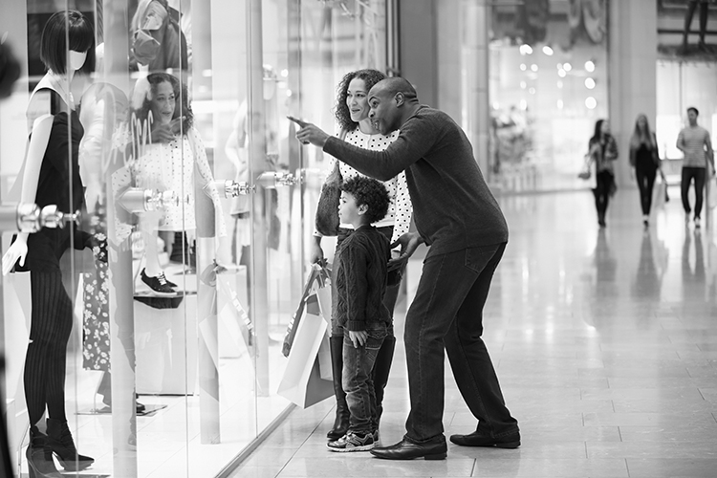
/10

Total: /20

