Part A • Grammar, Vocabulary and How to …
GRAMMAR

1 Circle the correct words.
0 They put up a net in order / so as to play volleyball.

1 He went to the petrol station so that / in order to get some petrol for the car.
2 So as to / that we can arrive on time, we need to catch the 7.15 train.
3 We wrapped the glasses carefully in order to not / not to break them.
4 I’ve been working late this week so as not to / not as to fall behind schedule.
5 I gave the plants plenty of water so that not to / they don’t die when we’re on holiday.
___ / 5

2 Complete the second version of the sentences. Use the word in brackets.
0 Bread costs a lot more than it did a few months ago.
- Bread is ___much more expensive__ than it was a few months ago. [MUCH / EXPENSIVE]
1 Your desk is tidier than mine.
- My desk ____________________ as yours. [ISN’T]
2 She used to be less confident speaking English.
- She speaks English ____________________ she used to. [MORE]
3 I know few people more reliable than Neil.
- Neil is ____________________ people I know. [AMONG]
4 His behaviour is becoming worse every day.
- His behaviour is ____________________ every day. [AND]
5 If you practise the trumpet more, you will become better.
- The more you practise the trumpet, ____________________ become. [THE]
___ / 5

3 Put the words in the correct order to make sentences and questions.
0 a farmer / delivered / has / by / vegetables / She
___She has vegetables delivered by a farmer__________.
1 Saturdays / gets / usually / car / He / on / his / washed
________________________________________________.
2 by / I’m / dress / made / a professional / having / my
________________________________________________.
3 tomorrow / more / some / getting / cut / They’re / keys
________________________________________________.
4 somebody / get / look / the problem / to / at / Let’s
________________________________________________.
5 herself / design / the posters / she / Did
________________________________________________?
___ / 5

VOCABULARY

4 Complete the sentences with personality adjectives.
0 I spoke to a p l e a s a n t young man who was polite and smiled a lot.
1 She’s s _ n _ _ b _ e so she makes good decisions.
2 I know you’ve been waiting a long time, but you need to be p _ t _ _ _ t.
3 When he argues, he often becomes a _ g r _ _ _ _ _ e. He looks angry and talks in loud voice.
4 She’s quite d _ r _ _ t so she’s happy to give her opinion.
___ / 4

5 Complete the sentences with the words and phrases (A–F).
0 There’s no doubt that social media can _E_ users and change how they behave.
A bargain hunter
B brand loyalty
C consumer
D good deal
E influence
F on offer
1 I bought this dishwasher because it was ___. It was much cheaper than usual.
2 My cousin is a real ___. He’s always looking for the best products at the cheapest prices.
3 You can get a ___ if you go on holiday in winter. It’s usually much cheaper.
4 I don’t think ___ is important to me. I don’t buy things because of the name.
5 I used to be a big ___, but don’t buy so many things
anymore.
___ / 5

6 Circle the correct words.

0 We made a bargain / donation to an organisation which protects animals.
1 The company made a loss / profit last year so it had to close some shops.
2 The shop assistant gave me a discount / fee because the box was damaged.
3 This phone was supposed to be 350 euros, but it only cost me 210 euros.
It was a bargain / receipt!
4 If you’re unhappy with the service, you should ask for a profit / refund.
___ / 4

HOW TO …

7 Complete the conversations with the words and phrases (A–G).
Conversation 1:
A: Are you still thinking about buying that new smartphone?
B: I’m not sure. It’s ⁰ _D_, but quite expensive.
A according to
B comes down
C from what
D impressive
E in the end
F only thing
G superb
A: I know, but ¹ ___ everyone says, it’s the best phone you can buy.
B: Well, I think sometimes you’re just paying for the name.
A: Mmm … I suppose it all ²___ to how much you trust what other people say.

Conversation 2:
A: Did you like the restaurant last night? I was a bit disappointed.
B: Really? In what way?
A: Well, ³___ the reviews, the food is amazing, which it was. The ⁴___ is that the waiters were really slow.
A: Oh, I thought the service was ⁵___.
B: I guess you had a different waiter. Personally, I got fed up with waiting. In fact, ⁶___, I didn’t even have a dessert.
___ / 12

TOTAL: ___ / 40
x 1.25 = ___ / 50

Part B • Listening, Reading and Writing
LISTENING

1 [Audio UT5.01] Listen to five people talking about complaints they have made. Match the speakers (1–4) with the statements (A–E).
0 Sandra _C_
A I probably sounded a bit aggressive.
B I made a complaint online.
C I handled the situation in a relaxed way.
D I didn’t speak my mind at the beginning.
E I was sure I would be successful.
1 Patrick ___
2 Amanda ___
3 George ___
4 Isabel ___

___ / 4

2 [Audio UT5.01] Listen again. Circle the correct answer, A or B.
0 Sandra managed to
^{A} get a refund on her purchase. | ^{B} get the damaged jacket replaced.

1 Patrick
^{A} was able to change the  brakes himself. | ^{B} felt that he had been  treated unfairly.

2 Amanda had planned to
^{A} save some money on her flights. | ^{B} pay the full fare for her flights.

3 George was pleased because
^{A} he didn’t have to pay for a genuine book. | ^{B} he was contacted by the bookseller.

4 Isabel was able to get
^{A} a bigger car for her journey. | ^{B} a reduction in the price of the car.
___ / 8

READING

3 Read the text about how the ways we consume are changing. Match the phrases (A–G) with the trends (1–3) they are connected to.
1 Online shopping:  __A________ | A some businesses have been losing money  B customers are comparing products before making purchases  C some businesses are trying to provide a faster service  D customers are finding it easier to choose places to go out  E customers are less interested in always buying the same products  F some businesses have found new ways of making money  G customers are showing less satisfaction with their purchases
2 Customer attraction:
___________
3 Eating out:
___________
___ / 6

Consumer trends
ONLINE SHOPPING
For many consumers, online shopping is by far the most convenient way to
shop. It gives you access to a wide range of products and it’s easy to
find a bargain. It’s not surprising that online purchases have grown in recent
years. However, while most of us expect free delivery, the high costs
are causing some companies to make a loss. This might be acceptable in
the short-term, but will companies keep offering it in the longer-term?
What’s more, people are becoming increasingly disappointed with the quality
of the products they receive. While online shopping is here to stay, it’s
unlikely to continue growing as quickly.
CUSTOMER ATTRACTION
For years, companies have focused on achieving brand loyalty. The idea is
that even if their products cost more than the competition’s, consumers will still buy them. However, recent studies have shown that the younger generation of consumers would rather get the best deal than continue to buy the same things. They’re far more likely to use online reviews to compare prices, quality, and other people’s opinions before
making a decision. At the same time, they’re more worried about personal
identity and less interested in owning the same things as everyone
else. As a result, companies need to come up with new ways to sell their
products and attract younger consumers. This means that new
businesses with original products now find it easier to compete with better-
known brands.

EATING OUT
The internet also offers a more convenient way to choose restaurants, book
tables and leave reviews. Apps also allow customers to access digital
menus and pay without the need for cash or credit cards. Many restaurants
have also been looking for quicker ways to serve their customers.
In the past, good quality restaurants were unlikely to be self-service. However,
some now ask customers to serve themselves and even tidy up
afterwards. Interestingly, a lot of customers are happy to do this if it means
saving time. Restaurants have also been looking for new ways to
increase their profits. The latest trend is to offer ingredients for customers to
buy and take home with them. At the end of their meal, customers are
able to buy the same products as the ones used in the restaurant, like olive oil
and pasta, which provides extra income for restaurants.

4 Read the text again. Are the statements True (T) or False (F)?
0 There are more convenient ways to shop than online. _F_
1 The quality of products bought online is not always better. ___
2 Consumers will only buy products if they’re cheaper than the competition. ___
3 Brand loyalty is more important to older generations than younger ones. ___
4 Younger people want the same things as the people around them. ___
5 Most restaurants will only accept payment by cash or credit card. ___
6 Many customers don’t mind changes to how they are served in
restaurants. ___
___ / 6

WRITING

5 Match (1–4) with (A–E) to make sentences.
0 I am writing to complain _C_
A didn’t end there.
B put in this situation.

C about a flight I took with your airline.
D completely unacceptable.
E discover that my seat was taken.

1 I was shocked to ___
2 Unfortunately, the problems ___
3 A passenger should never be ___
4 My experience was ___
___ / 4

6 You have recently had a bad experience in a shop.
Write a complaint email to the manager of the shop.

Write 100–140 words.
___ / 12

TOTAL: ___ / 40
x 1.25 = ___ / 50

Part C • Speaking
SPEAKING

1 Put the words in the correct order to make questions.
Ask your partner your questions.
0 the best / to / What / deal with / aggressive / is / way / people?
__What is the best way to deal with aggressive people?____
1 complain / you / normally / things / do / What / about?
___________________________________________________
2 loyalty / important / How / brand / is / to you?
___________________________________________________
3 asked / Have / a refund / you / for / ever / in a shop?
___________________________________________________
4 eyes / had / the last time / was / you / When / your / tested?
___________________________________________________
___ / 4

2 Answer your partner’s questions.
___ / 4
3 Describe the picture to your partner.
Why is the man complaining?
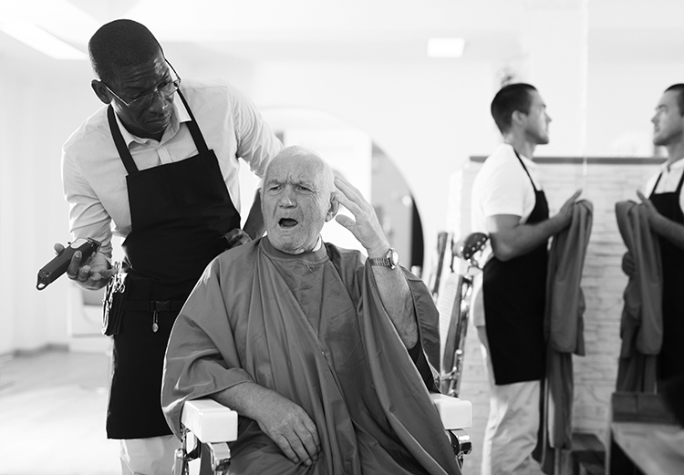
___ / 12

TOTAL: ___ / 20

