Part A • Grammar, Vocabulary and How to …
GRAMMAR
1 Complete the sentences with so, such or such a(n).
1 The children were __________ enthusiastic about going to the museum.
2 It was __________ nice day that we swam in the sea.
3 She’s __________ unfriendly that I’m afraid to speak to her.
4 There was __________ lot of traffic that I decided to take the metro.
5 It was __________ bad news that she didn’t want to tell anyone.
6 I really like Jin and Keiko. They’re __________ interesting.
7 It was __________ awful music that I asked him to turn it off.
8 The pyramids were __________ impressive sight. I’ll never forget them.
9 He was driving __________ dangerously that I wanted to get out of the car.
10 I’m really pleased with my new phone. It was __________ good deal.
/10

2 Choose the correct options (a, b or c) to complete the sentences.
1 I can’t ___ working at home. I miss being with my colleagues.
a be used to b get used to c used to
2 We ___ go on lots of holidays, but we can’t afford it now.
a used to b be used to c get used to
3 They ___ getting up at this time in the morning.
a not used to b not get used to c aren’t used to
4 I found it hard to stop drinking coffee, but I’m ___ it now.
a get used to b not used to c used to
5 She ___ read much, but she reads all the time these days.
a didn’t use to b isn’t used to c used to
6 They ___ driving on the right-hand side of the road.
a not used to b weren’t used to c didn’t use to
7 He ___ to the heat when he lived in Libya.
a never used b got never used c never got used
8 It was difficult to ___ having short hair after I got it cut.
a used to b get used to c be used to
9 He ___ to giving presentations at work.
a isn’t used b didn’t use c aren’t used
10 I’ve lived alone for a few years, so I ___ it now.
a used to b use to c ’m used to
/10

VOCABULARY
3 Complete the sentences with the words and phrases in the box.
colourful murals historic buildings ideal spot nightlife street market tree-lined avenue wealthy areas
1 You have to be rich to live in the __________ of town.
2 I live next to a busy __________ which is great for getting fresh vegetables.
3 With lots of cafés and discos, the __________ is lively.
4 It’s an ancient city with a lot of __________, such as the ninth-century castle.
5 This looks like a(n) __________ for having a picnic.
6 There’s a beautiful __________ which you can walk along from the palace to the main square.
7 I love the __________ which local artists have painted on the walls.
/7

4 Complete the sentences with words related to challenges.
1 He’s got a t _ _ _ h job because he has to solve difficult problems.
2 The emergency workers were working in difficult
c _ _ _ _ _ _ _ _ s.
3 The language was u _ _ _ _ _ _ _ _ r to me so it was hard to communicate.
4 Please drive safely. I don’t want you to r _ _ k having an accident.
5 They were able to e _ _ _ _ e from the house by climbing out of a window.
6 The race was c _ _ _ _ _ _ _ _ _ g because it was a very hot day.
7 She managed to swim to s _ _ _ _ y after her boat sank.
/7

5 Match the sentence beginnings (1–6) with the endings (a–f).
1 It’s much better to travel
2 We just need to weather
3 They were able to think
4 I’d rather break
5 I was living out of
6 We got into

a on their feet and find a way out.
b a suitcase for many months.
c light when you go backpacking.
d hot water when we lost our passports.
e the journey as we’re driving a long way.
f the storm for the moment.
/6
HOW TO …
6 Complete the sentences with the words and phrases in the box.
catch correctly cycle lanes don’t get
go through in advance let me other words speed limit unlimited travel
1 You need a special bus pass. In __________, you can’t travel without one.
2 Could you just __________ those options again, please?
3 This ticket will give you __________ on public transport for three days.
4 Can you say that again? I didn’t __________ what you said about the exhibition.
5 You should book __________ because the tickets normally sell out very quickly.
6 If I’ve understood __________, what you’re saying is I need to pay now.
7 So __________ just check what you said about the concert.
8 If you want to go by bike, there are plenty of __________.
9 I __________ what you’re saying. Can you tell me again?
10 Be careful not to go faster than the __________. The police are very strict about that.
/10

Total: /50
Part B • Listening, Reading and Writing
LISTENING
1 [Audio UT6.01] Listen to someone talking about the city of Bristol. Number the topics (A–G) in the order they are mentioned.
1 ___
2 ___
3 ___
4 ___
5 ___
6 ___
7 ___
A A well-known person
B Jobs in the city
C The attitude of the residents
D The location of the city
E Music in the city
F Places for visitors to see
G A title the city was given
/7

2 [Audio UT6.01] Listen again. Complete the notes with a word, number or short phrase.
1 Approximately __________ people live in Bristol.
2 Bristol was named Britain’s coolest city in __________.
3 There are fashionable restaurants which used to be __________.
4 No one knows the true __________ of a local artist.
5 There’s a __________ atmosphere in the city at night.
6 Some companies find it __________ to have their offices in Bristol.
7 Lizzie was __________ when people she didn’t know spoke to her.
8 Lizzie suggests watching __________ if you don’t want to listen to music in the evenings.
/8

READING
3 Read a story about a challenging journey. Tick the topics (1–5) which are mentioned.
1 where Burke and Wills were from ___
2 the things they took on their journey ___
3 the reason their journey was so slow ___
4 why Burke and Wills didn’t achieve their goal ___
5 how Landsborough was able to make the journey ___
/5
A challenging journey
In 1860, two men set out to cross Australia from the city of Melbourne in the south to Carpentaria on the northern coast. They were Robert Burke and William Wills and they hoped to be the first Europeans to complete the 3,250-kilometre journey. They knew it wouldn’t be easy, but it was far tougher than they expected. During their trip, they faced challenges from the weather, the land, and their own bad decisions.

Although Burke had little experience, he was the leader of the expedition. Wills was the navigator, in charge of choosing the route. They spent several years planning the journey, and organising the equipment they would need. They weren’t going to travel light, though. They took eight tonnes of food, a solid wood table and even a large bath! In total, there were 19 men, 23 horses and six wagons, which are vehicles pulled by horses. They also took camels in order to transport the equipment because they were used to hot, dry conditions.

In August 1860, the group left the Royal Park in Melbourne. However, they immediately had some difficulties when one of the wagons broke. It took more than a day to leave the city. After that, they made slow progress despite acceptable weather conditions. The problem was that they had so much equipment. They needed to break the journey on several occasions, each time leaving more and more equipment behind. When they arrived at a place called Cooper Creek, Burke, Wills and a few other men decided to try and complete the expedition on their own.

With little food and water, they struggled on towards the north coast. However, the land there was so wet that the camels couldn’t walk on it. Leaving them behind, Burke and Wills carried on, but they were unable to achieve their goal. Soon they had to turn around and go back to their team. However, when they got back to Cooper Creek, the rest of their team had gone. Although they had left only hours earlier, Burke and Wills were too tired to follow them.

The journey was a disaster for Burke and Wills, and many of the problems were their own fault. They were proud men who had rejected help at various stages of the journey. They had also stopped trusting each other and even attacked one of their men for taking food. However, their expedition did result in success for a man called William Landsborough, who led a team to rescue Burke and Wills. Although he couldn’t save them, he managed to complete the journey from Melbourne to Carpentaria. He was awarded £2,000 for his achievement!

4 Read the article again. Are the statements True (T) or False (F)?
1 In 1860, no Europeans had yet to complete the journey from Melbourne to Carpentaria. T / F
2 Burke and Wills expected the journey to be quite easy. T / F
3 Burke had not been in charge of many expeditions. T / F
4 The team didn’t take enough equipment for the journey. T / F
5 They started to have problems after they had left Melbourne. T / F
6 They needed to stop travelling several times before arriving at Cooper Creek. T / F
7 Burke and Wills were unable to take the camels for the last part of the journey. T / F
8 Burke and Wills had just missed their team when they got back to Cooper Creek. T / F
9 Burke and Wills were not responsible for the difficulties on the journey. T / F
10 A man called Landsborough was able to rescue the men. T / F
/10

WRITING
5 Match the sentence beginnings (1–5) with the endings (a–e).
1 The fastest way to get
2 The park is 600 metres down
3 The journey takes about
4 The supermarket is about a 10-minute
5 The central station is just

a half an hour.
b the road from the bookshop.
c opposite the town hall.
d walk from my house.
e to the station is to go on foot.
/5

6 A friend who lives abroad is going to visit you next weekend. Write them an email telling them:
- why you can’t meet them at the airport.
- the best way to get your house from the airport.
- what you plan to do with them.
Write 100–140 words.
/15

Total: /50

Part C • Speaking
SPEAKING
1 Make questions and ask your partner.
1 What / are / buildings / like / your town?
2 What / toughest / journey / ever / made?
3 What difficulties / young people / face / these days?
4 Have / ever / had / live out of / suitcase?
5 Are / used / staying up late / night?
/5

2 Answer your partner’s questions.
/5

3 Describe the picture to your partner. Why are the people enjoying themselves?
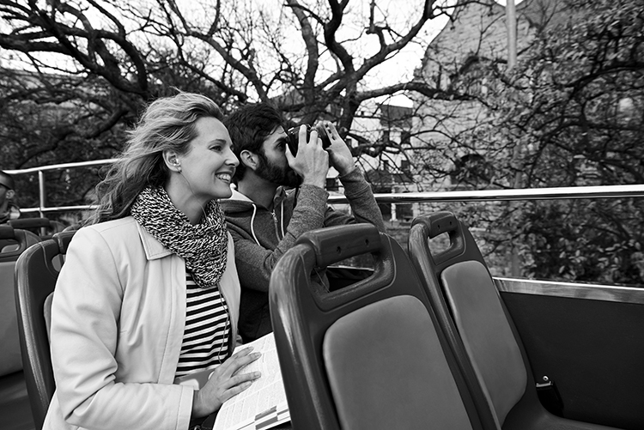
/10

Total: /20

