Part A • Grammar, Vocabulary and How to …
GRAMMAR
1 Complete the sentences with so, such or such a(n).
1 It was __________ big stadium that we could hardly see the pitch.
2 The children were playing __________ happily together.
3 He was __________ busy that he didn’t even say hello to me.
4 There was __________ heavy snow that we couldn’t leave the house.
5 That meal was __________ delicious. I could eat more!
6 He was __________ aggressive man. I was really scared of him.
7 I don’t know how you can drive __________ big car.
8 She talked __________ quickly, I didn’t understand a word she said.
9 I love this band. They play __________ good songs.
10 I can’t possibly afford that watch. It’s __________ expensive.
/10

2 Choose the correct options (a, b or c) to complete the sentences.
1 They ___ staying up this late. They’ll be tired tomorrow.
a not used to b not get used to c aren’t used to
2 She ___ work all the time, but she works less now.
a used to b be used to c get used to
3 I couldn’t ___ wearing glasses at first.
a used to b get used to c be used to
4 We ___ to all the traffic when we lived in the city.
a never used b got never used c never got used
5 He can’t ___ living alone. He was happier when he lived with his parents.
a be used to b get used to c used to
6 She’s been driving for a few months, so she ___ it now.
a used to b use to c ’s used to
7 We ___ buying food in a market because we’d always gone to the supermarket.
a not used to b weren’t used to c didn’t use to
8 I ___ watch much TV, but I watch a lot more these days.
a didn’t use to b isn’t used to c used to
9 She ___ to managing a large team of people.
a isn’t used b didn’t use c aren’t used
10 I’m ___ working nights now, but it was hard at first.
a get used to b not used to c used to
/10

VOCABULARY
3 Complete the sentences with the words and phrases in the box.
a sense of high-rise building nightlife
relaxed atmosphere run-down tourist spot tree-lined avenue
1 We live at the top of a __________ so we’ve got some great views of the city.
2 Everyone helps each other so there’s __________ community in my neighbourhood.
3 There’s a wide __________ which families walk along on Sunday afternoons.
4 The area’s __________ makes it feel friendly and calm.
5 It used to be a __________ part of the city, but it’s nicer these days.
6 The city park is a popular __________ so it’s usually full of people on holiday.
7 A lively __________ was important to me when I was younger, but not anymore!
/7

4 Complete the sentences with words related to challenges.
1 This place doesn’t look f _ _ _ _ _ _ r to me. I don’t recognise it at all.
2 The other team made it difficult for us today. We had a
t _ _ _ h match.
3 Your s _ _ _ _ y is important to us so we’ll make sure you don’t get hurt.
4 Be careful out there. The c _ _ _ _ _ _ _ _ s are awful.
5 We had a few d _ _ _ _ _ _ _ _ _ _ s during the holiday, but we managed to deal with them.
6 Make sure the cat stays indoors. Don’t let it e _ _ _ _ e.
7 We didn’t want to r_ _ k getting lost so we took a map.
/7

5 Match the sentence beginnings (1–6) with the endings (a–f).
1 You just need to weather
2 We got into
3 They were living out of
4 We should break
5 We managed to think
6 I’d rather travel

a a suitcase for a few months.
b the storm until things get better.
c on our feet and get some help.
d hot water when the police stopped us.
e light if I’m only going on a short trip.
f the journey so we don’t get too tired.
/6
HOW TO …
6 Complete the sentences with the words and phrases in the box.
catch fee go through got this right
in advance last bit mean rush hour
speed limit what you said
1 Can you say that __________ again?
2 I didn’t understand __________ about the exhibition.
3 I’d avoid the town centre in the __________. It’ll be really busy.
4 So what you __________ is that the show is cancelled.
5 So have I __________? Do I need to book the tickets again?
6 For a small __________, we will pick you up from the airport.
7 Could we __________ the options again, please?
8 A lot of people don’t respect the __________ around here. You need to drive less than 30 km/hour.
9 If you book __________, you won’t need to wait in a queue.
10 Can you repeat that? I didn’t __________ what you said.
/10

Total: /50
Part B • Listening, Reading and Writing
LISTENING
1 [Audio UT6.01] Listen to someone talking about the city of Bristol. Number the topics (A–G) in the order they are mentioned.
1 ___
2 ___
3 ___
4 ___
5 ___
6 ___
7 ___
A Music in the city
B A well-known person
C Places for visitors to see
D Jobs in the city
E A title the city was given
F The location of the city
G The attitude of the residents
/7

2 [Audio UT6.01] Listen again. Complete the notes with a word or short phrase.
1 Bristol became important because it is near the __________.
2 Lizzie thinks the city is cool because there are __________ with bright colours on the walls.
3 An artist called Banksy started creating __________ in the city.
4 You can see __________ music groups as well as DJs at night.
5 It’s cheaper for companies to have their __________ in Bristol than in London.
6 Companies in Bristol are responsible for making __________ as well as film and television.
7 Lizzie appreciates the feeling of being part of a __________ in Bristol.
8 Lizzie recommends some __________ including the Clifton Suspension Bridge.
/8

READING
3 Read a story about a challenging journey. Tick the topics (1–5) which are mentioned.
1 where Janet Moreland is from ___
2 why Janet decided to make the journey ___
3 where Janet bought her equipment ___
4 accidents that Janet had on her journey ___
5 what Janet did when she got to the sea ___
/5
A challenging journey
Janet Moreland grew up in California, where her hobbies included skiing and windsurfing. When she later moved to inland Missouri, she looked for another outdoor sport which didn’t involve the sea. The Missouri River passed through her town so she decided to take up kayaking. A kayak is a small boat for one or two people, which is ideal for travelling along rivers. One day, Janet met a travel writer who made her think about travelling the whole Missouri River in a kayak. The river is around 3,700 kilometres in length!

One reason Janet took up the challenge is that she wanted to be the first woman to kayak the whole River Missouri. It is the longest river in North America and the fourth longest in the world, so it would be tough. Another reason is that she wanted to set a positive example for young people. Janet was a teacher and she wanted to show her students that you can do anything if you try hard enough.

There isn’t much space in a kayak so Janet was planning to travel light. She took dry food, a tent to sleep in, and a new tablet in order to write her blog. Once she was ready, she set out on the 1,950-kilometre road trip to get to the starting point of her expedition. She knew she would face difficulties on the river, such as high winds, but she hadn’t expected any problems on the road trip. However, her car broke down on the way and she later had to sleep in it during a snowstorm.

In case the kayak trip wasn’t challenging enough, Janet had also planned a mini adventure before going out on the water. It involved skiing for 31 hours and then cycling 150 kilometres in order to get to the river. By the time she arrived, she’d already hurt her head while she was skiing! She didn’t give up, though, and she was soon ready to start her kayak trip. The first few days were tough because she got holes in her kayak and she hurt her wrist. However, she carried on and spent the next four months kayaking down the Missouri.

Although she got into hot water a few times, including camping out in an electrical storm, Janet enjoyed her journey. In fact, she enjoyed it so much that she decided to carry on – this time along the Mississippi River – until she reached the sea. After taking just a week off to get her boat repaired and take on more supplies, she set off again. In December 2013, she finally ran out of river and reached the sea in the Gulf of Mexico. Janet had kayaked more than 5,000 kilometres.

4 Read the article again. Are the statements True (T) or False (F)?
1 Janet had tried kayaking when she lived in California. T / F
2 Janet decided to make her journey after talking to someone. T / F
3 The Missouri River is longer than the other rivers in the United States. T / F
4 Janet wanted to encourage young people to try new things. T / F
5 Janet was able to take a lot of things on her kayak. T / F
6 Janet was unable to drive her car because of high winds. T / F
7 Janet injured her head while she was kayaking. T / F
8 There were several difficulties during the first few days on the river. T / F
9 Janet repaired her boat herself when she stopped before continuing down the Mississippi. T / F
10 The trip was much longer than Janet had planned. T / F
/10

WRITING
5 Match the sentence beginnings (1–5) with the endings (a–e).
1 Walk down Oxford Street
2 It’s about a 40-minute
3 Our house is just down
4 The cinema is on the
5 The easiest way to get

a the road from Peter’s.
b journey on the train.
c to the airport is to take a taxi.
d and take the second left.
e corner of West Street and South Parade.
/5

6 A friend who lives abroad is going to visit you next weekend. Write them an email telling them:
- why you can’t meet them at the airport.
- the best way to get your house from the airport.
- what you plan to do with them.
Write 100–140 words.
/15

Total: /50

Part C • Speaking
SPEAKING
1 Make questions and ask your partner.
1 What / nightlife / like / where / live?
2 Why / some people / like / taking risks?
3 Do / mind / being / with / unfamiliar people?
4 Is / better / travel light / when / go on / holiday?
5 Could / get used / living / another country?
/5

2 Answer your partner’s questions.
/5

3 Describe the picture to your partner. Why have the people chosen to do this activity?
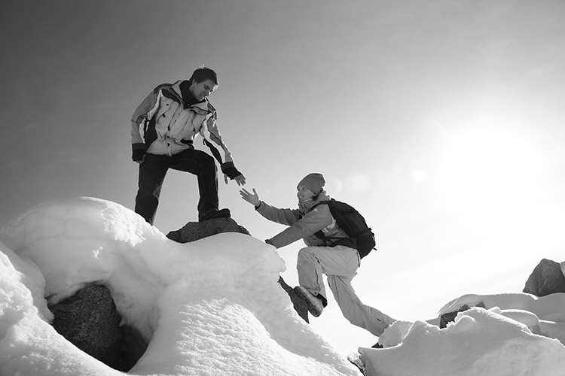
/10

Total: /20

