Part A • Grammar, Vocabulary and How to …
GRAMMAR

1 Complete the sentences with ‘so’, ‘such’ or ‘such a(n)’.
0 The children were ____so____ enthusiastic about going to the museum.
1 It was __________ nice day that we swam in the sea.
2 It was __________ bad news that she didn’t want to tell anyone.
3 I really like Jin and Keiko. They’re __________ interesting.
4 It was __________ awful music that I asked him to turn it off.
5 The pyramids were __________ impressive sight. I’ll never forget them.
6 He was driving __________ dangerously that I wanted to get out of the car.
7 I’m really pleased with my new phone. It was __________ good deal.
___ / 7

2 Circle the correct words.
0 I can’t get used to / be used to working at home. I miss my colleagues.

1 We be used to / used to go on lots of holidays, but we can’t afford it now.
2 They not get used to / aren’t used to getting up at this time in the morning.
3 I found it hard to stop drinking coffee, but I’m used to / get used to it now.
4 She didn’t use to / isn’t used to read much, but now she reads all the time.
5 They didn’t use to / weren’t used to driving on the right-hand side of the road.
6 He never got used / never used to the heat when he lived in Libya.
7 It was difficult to get used to / be used to having short hair after I got it cut.
8 He didn’t use / isn’t used to giving presentations at work.
___ / 8

VOCABULARY

3 Complete the sentences with the words and phrases (A–F).
0 You have to be rich to live in the _F_ of town.
A colourful murals
B ideal spot
C nightlife
D street market
E tree-lined avenue
F wealthy areas
1 I live next to a busy ___ which is great for getting fresh vegetables.
2 With lots of cafés and discos, the ___ is lively.
3 This looks like a(n) ___ for having a picnic.
4 There’s a beautiful ___ which you can walk along from the palace to the main square.
5 I love the ___ which local artists have painted on
the walls.
___ / 5

4 Complete the sentences with words related to challenges.
0 He’s got a t o u g h job because he has to solve difficult problems.
1 The emergency workers were working in difficult c _ _ d _ _ i _ _ s.
2 The language was u _ f _ _ _ l _ _ r to me so it was hard to communicate.
3 Please drive safely. I don’t want you to r _ _ k having an accident.
4 They were able to e _ _ a _ e from the house by climbing out of a window.
___ / 4

5 Match (1–4) with (A–E) to make sentences.
0 It’s much better to travel _C_
A on their feet and find a way out.
B a suitcase for many months.
C light when you go backpacking.
D hot water when we lost our passports.
E the storm for the moment.

1 We just need to weather ___
2 They were able to think ___
3 I was living out of ___
4 We got into ___

___ / 4

HOW TO …

6 Complete the sentences with the words and phrases (A–G).
0 Could you just _D_ those options again, please?
A catch
B correctly
C cycle lanes
D go through
E in advance
F speed limit
G unlimited travel
1 This ticket will give you ___ on public transport for
three days.
2 Can you say that again? I didn’t ___ what you said about the exhibition.
3 You should book ___ because the tickets normally sell out very quickly.
4 If I’ve understood ___, what you’re saying is I need to pay now.
5 If you want to go by bike, there are plenty of ___.
6 Be careful not to go faster than the ___. The police are very strict about that.
___ / 12

TOTAL: ___ / 40
x 1.25 = ___ / 50

Part B • Listening, Reading and Writing
LISTENING

1 [Audio UT6.01] Listen to someone talking about the city of Bristol. Number the topics (A–E) in the order they are mentioned.
0 _B_
A The attitude of the residents
B The location of the city
C Music in the city
D Places for visitors to see
E A title the city was given

1 ___
2 ___
3 ___
4 ___

___ / 4

2 [Audio UT6.01] Listen again. Complete the notes with A WORD, NUMBER or SHORT PHRASE.
0 Approximately __500,000__ people live in Bristol.
1 Bristol was named Britain’s coolest city in __________.
2 There are fashionable restaurants which used to be __________.
3 There’s a __________ atmosphere in the city at night.
4 Lizzie was __________ when people she didn’t know spoke to her.
___ / 8

READING

3 Read the text about the story of dance. Tick () the ideas that are mentioned. Put a dash (–) if they are not mentioned.
0 Where Burke and Wills were from. _–_
1 The things they took on their journey. ___
2 The reason their journey was so slow. ___
3 Why Burke and Wills didn’t achieve their goal. ___
4 How Landsborough was able to make the journey. ___
___ / 4

A challenging journey
In 1860, Robert Burke and William Wills set out to cross Australia from the
city of Melbourne in the south to Carpentaria on the northern coast.
They hoped to be the first Europeans to complete the 3,250-kilometre
journey. They knew it wouldn’t be easy and during their trip, they
faced challenges from the weather, the land, and their own bad decisions.

Although Burke had little experience, he was the leader of the
expedition while Wills was the navigator. They spent several years planning
the journey, and organising the equipment needed. They weren’t
going to travel light, though. They took eight tonnes of food, a solid wood
table and even a large bath! In total, there were 19 men, 23 horses
and six wagons. They also took camels to transport the equipment as they
were used to hot, dry conditions.

In August 1860, the group immediately had some difficulties when one of the
wagons broke after leaving Melbourne. After that, they made slow
progress despite acceptable weather conditions. The problem was that they
had so much equipment and needed to break the journey on several
occasions, each time leaving more and more equipment behind. When they
arrived at a place called Cooper Creek, Burke, Wills and a few other
men decided to try and complete the expedition on their own.

With little food and water, they struggled on towards the north coast.
However, the land there was so wet that the camels weren’t able to walk on
it. Leaving them behind, Burke and Wills carried on, but they were
unable to achieve their goal. They soon turned around and went back to
Cooper Creek only to find that the rest of their team had gone.
Although they had left only hours earlier, Burke and Wills were too tired to
follow them.

The journey was a disaster for Burke and Wills, and many of the problems
were their own fault. They were proud men who had rejected help at
various stages of the journey. They had also stopped trusting each other.
However, their expedition did result in success for a man called
William Landsborough, who led a team to rescue them. Although he couldn’t
save them, he did complete the journey from Melbourne.

4 Read the text again. Are the statements True (T) or False (F)?
0 In 1860, no Europeans had yet to complete the journey from
Melbourne to Carpentaria. _T_
1 Burke had not been in charge of many expeditions. ___
2 The team didn’t take enough equipment for the journey. ___
3 They started to have problems after they had left Melbourne. ___
4 They needed to stop several times before arriving at Cooper Creek. ___
5 Burke and Wills couldn’t take the camels for the last part of the journey. ___
6 Burke and Wills had just missed their team when they got back to
Cooper Creek. ___
7 Burke and Wills were not responsible for the difficulties on the journey. ___
8 A man called Landsborough was able to rescue the men. ___
___ / 8

WRITING

5 Match (1–4) with (A–E) to make sentences.
0 The fastest way to get _E_
A half an hour.
B the road from the bookshop.

C opposite the town hall.
D walk from my house.
E to the station is to go on foot.

1 The park is 600 metres down ___
2 The journey takes about ___
3 The supermarket is about a
10-minute ___
4 The central station is just ___
___ / 4

6 A friend who lives abroad is going to visit you next weekend.
Write them an email telling them:

- Why you can’t meet them at the airport.
- The best way to get your house from the airport.
- What you plan to do with them.

Write 100–140 words.
___ / 12

TOTAL: ___ / 40
x 1.25 = ___ / 50

Part C • Speaking
SPEAKING

1 Put the words in the correct order to make questions.
Ask your partner your questions.
0 in / are / What / like / your / the buildings / town?
____What are the buildings like in your town?____________
1 ever / journey / the toughest / you’ve / What’s / made?
___________________________________________________
2 difficulties / people / do / What / face / these / young / days?
___________________________________________________
3 live / you / Have / ever / out of / had to / a suitcase?
___________________________________________________
4 you / up / used to / at / Are / staying / late / night?
___________________________________________________
___ / 4

2 Answer your partner’s questions.
___ / 4
3 Describe the picture to your partner.
Why are the people enjoying themselves?
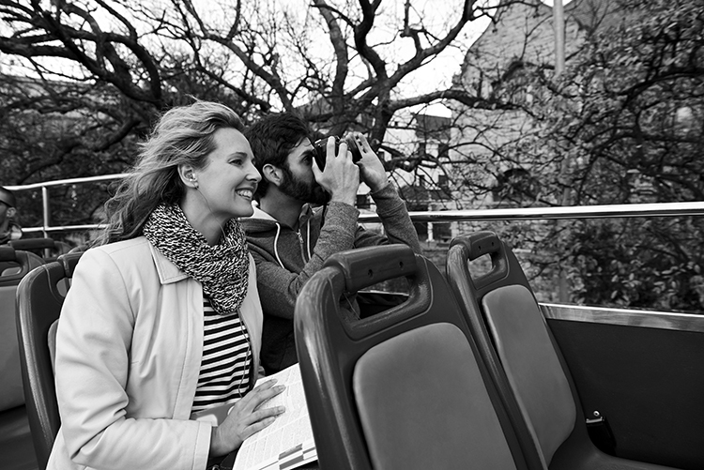
___ / 12

TOTAL: ___ / 20

