Part A • Grammar, Vocabulary and How to …
GRAMMAR
1 Choose the correct option (a, b or c) to complete the sentences.
1 She would have called us if she ___ lost.
a got b ’d get c ’d got
2 If you’d looked under the bed, you ___ the book.
a ’d have found b ’d found c found
3 If we hadn’t had to work, we ___ to the festival.
a will have gone b could have gone c have gone
4 They wouldn’t have been late if they ___ the fast train.
a ’d caught b haven’t caught c didn’t catch
5 If I’d known about the Picasso exhibition, I ___ to it.
a ’ll have gone b might have gone c might go
6 She ___ a successful gymnast if she hadn’t given up.
a ’d been b won’t have been c ’d have been
7 I ___ run so far yesterday. My legs really hurt today.
a should b should have c shouldn’t have
8 If the weather ___ so bad, we’d have gone to the beach.
a had been b hadn’t been c hasn’t been
9 I ___ bought some milk at the supermarket. I’ll have to go out again now to get some.
a should have b shouldn’t have c had
10 If you ___ all those sweets, you wouldn’t have been sick.
a wouldn’t eat b didn’t eat c hadn’t eaten
/10

2 Complete the sentences with would or used to and the words in brackets. Where both alternatives are possible use would.
1 She __________ (be) very friendly, but now she hardly talks to anyone.
2 My father __________ (tell) us fantastic stories which he’d invented.
3 I __________ (feel) lonely at school until I made friends with Kendrick.
4 My mother __________ (always / give) me a glass of milk before bedtime.
5 I __________ (know) the words to all the pop songs.
6 Katie __________ (love) spaghetti, but then she stopped eating it.
7 They __________ (sometimes / stay) with us during the school holidays.
8 Mila __________ (hardly ever / speak) to me in the mornings.
9 I __________ (never / like) swimming, but I enjoy it a lot nowadays.
10 My boss __________ (usually / complain) if I asked for a day off work.
/10

VOCABULARY
3 Complete the sentences with the words and phrases in the box.
be afraid to be ready to make the most
pay attention stop worrying take time
1 Always __________ take on more responsibility at work. In that way, you will learn new skills.
2 Try to __________ of what you’ve got. You never know when you might lose it.
3 Don’t __________ be honest with people. You should always say what you think.
4 Don’t __________ to what the others are saying. It doesn’t matter what they think.
5 __________ about tomorrow and concentrate on today.
6 You should __________ to think about the advantages and disadvantages. You don’t need to decide quickly.
/6

4 Complete the sentences with words related to learning.
1 My parents e _ _ _ _ _ _ _ _ d me to study French, but I decided to study German instead.
2 I was never m _ _ _ _ _ _ _ d to earn lots of money. I just wanted to lead a happy life.
3 We want to i _ _ _ _ _ e young people to become interested in science and engineering.
4 He had read a good book about economics which
d _ _ _ _ _ _ d his interest in the subject.
5 This course will help you m _ _ _ _ r some of the skills you need to be a good communicator.
6 She studied medicine, but she didn’t a _ _ _ _ _ e the title of doctor.
7 We’re making good p _ _ _ _ _ _ s this morning so let’s take a short break.
/7

5 Choose the correct words to complete the sentences.
1 We need to follow / take up on Brian’s plan and see if we can make it work.
2 I spent hours working on the problem, but I still couldn’t figure / understand out how to solve it.
3 There’s a lot of information to understand so why don’t we break / make it down?
4 You don’t need to make a decision now. Why don’t you know / think it through a bit?
5 Raj has dreamt / imagined up some crazy idea that I don’t like him.
6 Let’s get / meet together next week to discuss the idea.
7 If I have to remember something, it always helps me to read / write it down.
/7
HOW TO …
6 Complete the sentences with the words and phrases in the box.
a final point a show of hands an outline brings delivery engage facts and figures not sure to add to begin
1 You should create __________ to help you organise your presentation.
2 The report included lots of __________, but I couldn’t understand most of them.
3 I intend __________ with a short video I made in Kenya.
4 Before I finish, I’d just like __________ that you can follow our work on social media.
5 This __________ me to the first point on my list.
6 If you’re a comedian, __________ is important. You need to tell jokes in the right way.
7 The best way to __________ your audience is by sharing a personal experience.
8 I’m __________ I can answer that now, but I’ll get back to you later.
9 Can I just get __________ for everyone who’s heard of Ken Robinson?
10 As __________, I’d just like to say that you’ve been a lovely audience.
/10

Total: /50
Part B • Listening, Reading and Writing
LISTENING
1 [Audio UT8.01] Listen to a presentation about a scientist called Carl Sagan. Tick the topics that are mentioned.
1 His mother’s views on knowledge ___
2 What Sagan learnt about stars in a library ___
3 The school subjects he was good at ___
4 The number of scientific texts he wrote ___
5 What countries his series was shown in ___
/5

2 [Audio UT8.01] Listen again. Choose the correct option (a or b) to complete the sentences.
1 Carl Sagan’s parents were
a not scientists.
b born in New York.

2 His mother encouraged him to
a make scientific drawings.
b think carefully about things.

3 He went to a library to
a find out about stars.
b get away from his family.

4 He was interested in space
a for the rest of his life.
b because of a TV programme.

5 When he was at school, he
a found the subjects interesting.
b often achieved the best marks.

6 His parents were unable to
a help him with his science experiments.
b pay for him to go to a special school.

7 After his master’s degree, he
a wrote hundreds of scientific texts.
b left the field of science.

8 He dreamt about
a going on a trip to the moon.
b communicating with other planets.

9 He made a TV series which
a had more viewers than most other programmes.
b had viewers in more than sixty different countries.

10 He was able to
a name all the stars in the universe.
b attract viewers with his interest in space.
/10
READING
3 Read an article about people who are learning English and their advice for other learners.
Match the people (1–5) with the things they might say (A–E).
1 Aisha: ___
2 Ronnie: ___
3 Layla: ___
4 Yusuf: ___
5 Marion: ___

A This way of learning splits complicated ideas up into smaller pieces.
B English has been an interest of mine for as long as I can remember.
C Someone suggested that doing this would help me in my future profession.
D Another person’s English skills made me want to learn the language.
E I had hoped to learn more about the customs and traditions of a place.
/5
English lessons
We spoke to five language learners. They talked about their experience of learning English and gave us their advice for anyone struggling to learn English.

Aisha
I’m currently on a language exchange in London because I was motivated to experience the culture and practise my English. I’m staying with an English family, but, the truth is, they’re quite boring. We haven’t been on any excursions and they’re always watching TV. I’d have learnt more if I’d gone to a language school in my own country. I’d recommend taking the time to choose the right family if you’re planning on going on a language exchange. I should have thought it through more carefully myself.

Ronnie
I’ve been doing an online English course and it’s better than I expected. At school, we only used to study grammar, but this is more focused on communication. Each lesson has a video where an expert breaks the language down so that it’s easy to understand. The only disadvantage is not having a real teacher to deal with your questions. If you want to study online, you should be ready to think your problems through alone. If you need a teacher looking over your shoulder, it probably isn’t for you.

Layla
I’m studying English as an optional subject at university. I’m doing a degree in international relations and my tutor encouraged me to study English as well. She said it would be useful for my career, especially if I end up working abroad. It’s definitely deepened my interest in the language. The only thing is that I nearly failed the exam last term. It was my own fault, though, because I didn’t prepare for it. If you’re studying a language, be careful not to put off studying until the last moment!
Yusuf
A friend of mine speaks amazing English and she inspired me to improve. In fact, I hope to speak English as well as her one day. I’d intended to sign up for classes at a language school, but then I had the opportunity to do them at work. I was pleased because if I’d gone to a language school, it would have cost quite a lot. If you ever get the chance to have free classes, you should make the most of it because you can save a fortune.

Marion
English has been a lifelong passion of mine and I’ve been attending the same language school for the last nine years. The classes are very communicative, so, during activities, the teacher usually listens and writes down our mistakes. Then she follows up on them at the end of the activity and we try to figure out the corrections. If you’re new to learning English, don’t be afraid to speak in class. It can be tough at first, but the best way to master the language is by using it as much as possible.

4 Read the article again. Choose the correct answer (A, B, C or D).
1 Aisha
A has learnt more than if she had stayed at home.
B is enjoying her time staying with an English family.
C would like to be able to understand English TV better.
D didn’t consider the facts of the exchange properly.

2 Ronnie
A thinks that you need to investigate things alone in online courses.
B says that he would prefer to spend more time studying grammar.
C complains that the website he uses to study keeps breaking down.
D argues that most people need a teacher to help them study.

3 Layla
A failed her last exam because she didn’t prepare.
B has become more interested in English recently.
C thinks it can be helpful to delay studying sometimes.
D blames her tutor for mistakes she has made.

4 Yusuf
A wants to inspire other people to start studying English.
B plans to start studying English in a language school.
C hasn’t ever studied English in a language school before.
D doesn’t have to pay for the English classes he attends.

5 Marion
A has been working in a language school for several years.
B is sometimes afraid of making mistakes in her English lessons.
C is given the chance to solve language problems with the teacher.
D had expected the classes to focus more on communication.
/10

WRITING
5 Choose the correct words to complete the sentences.
1 We had lost our keys and because / result of this we couldn’t get back into the flat.
2 I was feeling nervous as / so I’d never had to speak in public before.
3 She had always loved animals and as / for this reason, she decided to become a vet.
4 Their parents frequently travelled for work and consequently / consequence they spent much of their childhood with their grandparents.
5 He hadn’t been able to prepare properly and as a result / so he lost the race.
/5

6 Write a short biography of a friend or a member of your family.
Write 100–140 words.
/15

Total: /50

Part C • Speaking
SPEAKING
1 Make questions and ask your partner.
1 If / hadn’t studied / English, / how / your life / been different?
2 What toys / would / play with / as / child?
3 Do / make the most / of / free time?
4 What / like to / achieve / in / next five years?
5 Do / know / anyone / with / lifelong passion?
/5

2 Answer your partner’s questions.
/5

3 Describe the picture to your partner. What advice is the coach giving?
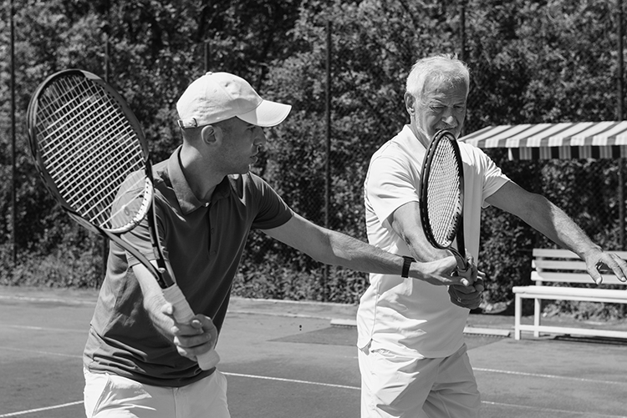
/10

Total: /20

