Part A • Grammar, Vocabulary and How to …
GRAMMAR

1 Circle the answer (A or B) that best completes each sentence.
0 If it ___, we’d have had a barbecue.
^{A} didn’t rain | ^{B} hadn’t rained

1 She ___ happier if you’d helped her with her project.
^{A} ’d been | ^{B} ’d have been

2 You ___ stayed at my place if you’d told me you were coming.
^{A} could have | ^{B} should have

3 If I had more money, I ___ bought that suit we saw.
^{A} might have | ^{B} ’ll have

4 If he ___ me about the traffic, I’d have caught the train.
^{A} ’d warned | ^{B} did warn

5 She ___ her job last month if she’d enjoyed working there.
^{A} wouldn’t leave | ^{B} wouldn’t have left

6 You ___ mentioned that you can’t consume milk products. I wouldn’t have bought all that cheese.
^{A} should have | ^{B} shouldn’t have

7 I can’t believe you told Jake about the surprise party. You ___ said a word.
^{A} should have | ^{B} shouldn’t have
___ / 7

2 Complete the sentences with ‘would’ or ‘used to’ and the words in brackets. Where both alternatives are possible use ‘would’.
0 As a child I ___would spend___ (SPEND) hours playing outside.
1 She _______________ (LOVE) playing chess, but she doesn’t play it anymore.
2 When I was a kid, I _______________ (BE) quite shy so I didn’t have many friends.
3 He _______________ (BRING) home insects that he’d found in the garden.
4 I _______________ (FEEL) lonely living on my own, but now I quite like it.
5 My parents _______________ (OFTEN / BUY) me an ice cream on Sunday afternoons.
6 They _______________ (NEVER / YELL) at me if I’d done something wrong.
7 My grandfather _______________ (SOMETIMES / FALL ASLEEP) in front of the TV.
___ / 7

VOCABULARY

3 Complete the sentences with the words and phrases (A–F).
A Be careful not
B Don’t take
C make the most
D pay attention
E stop worrying
F Take time to
0 You should _E_ about what other people think.
1 ___ consider all your options before making a decision.
2 ___ to spend too long thinking about what you can’t fix. Focus on what you can.
3 Promise me you’ll ___ of your time off to relax.
4 ___ John too seriously. He’s usually joking.
5 Please ___ to what I’m saying. It’s important.

___ / 5

4 Complete the sentences with words related to learning.
0 Gina’s learning karate because she’s m o t i v a t e d by being able to protect herself.
1 I hope this story will i _ s _ _ r e you to work hard at school as well.
2 She managed to a _ h _ e _ e good grades in maths and physics.
3 Mika has had a lifelong p _ _ s _ _ n for cars so I’m not surprised he wants to be a mechanic.
4 I saw a documentary about the ocean which d _ _ p _ n _ d my interest in the subject.
___ / 4

5 Circle the correct words.
0 Let’s make / try out David’s idea and see if it works.

1 I read / wrote her phone number down on a piece of paper, but now I can’t find it.
2 Do you want to get / put together this weekend and discuss some of our ideas?
3 Clara’s dreamt / slept up an unusual way of solving the problem.
4 How about we break / work this task down into stages?
5 If we work together, I’m sure we can get / figure out the answer.
___ / 5

HOW TO …

6 Complete the sentences with the words and phrases (A–G).
0 I liked his use of images to _E_ the point.
A a show of hands
B end
C engage
D get back
E illustrate
F joining
G recap
1 Thanks for ___ me for today’s workshop.
2 Can I just get ___ for how many are engineers?
3 Using stories is a good way to ___ your audience.
4 Just to ___, we can’t solve climate change if we don’t change our way of life.
5 I can’t answer that question right now, so I’ll ___ to you on that one.
6 I’d like to ___ with a personal anecdote.

___ / 12

TOTAL: ___ / 40
x 1.25 = ___ / 50

Part B • Listening, Reading and Writing
LISTENING

1 [Audio UT8.01] Listen to a presentation about a scientist called Carl Sagan. Tick the topics () that are mentioned. Put a dash (–) if they are not mentioned.
0 The work that Sagan’s parents did _–_
1 How Sagan became interested in space ___
2 Sagan’s educational achievements ___
3 Why Sagan wanted to work for NASA ___
4 How Sagan made science popular ___
___ / 4

2 [Audio UT8.01] Listen again. Circle the correct answer, A or B.
0 Carl Sagan used to
^{A} talk about his childhood on TV. | ^{B} make drawings about science.

1 His interest in the universe
^{A} lasted for a long time. | ^{B} changed when he grew up.

2 He didn’t always like school because
^{A} he didn’t get the best grades. | ^{B} it was too easy for him.

3 He had several jobs, including
^{A} advising NASA. | ^{B} working as a publisher.

4 His television series was watched
^{A} by more than 500 million people. | ^{B} in more than sixty countries.
___ / 8

READING

3 Read an article about people who are learning English and their advice for other learners. Match the speakers (1–4) with the things they might say (A–E).
A Getting to know the people who use a language is a motivating way to learn.
B It’s more convenient for me to study this way because I can’t always study at the same time.
C I needed to change my attitude to learning the language in order to make progress.
D I find it helpful if more complicated ideas are split up into smaller pieces.
E I’ve been interested in learning English for as long as I can remember.
0 Roman _B_
1 Sophia ___
2 Mohammed ___
3 Elsa ___
4 Luca ___

___ / 4

English lessons
We spoke to five language learners. They talked about their experience of learning English and gave us their advice for anyone struggling to learn English.

ROMAN
I’m studying online because I don’t have time for regular classes. The
advantage is that when I’ve got free time, I can log on and do some
work. If you’re thinking about doing an online course, be careful not to put off
doing grammar exercises. It’s easy to fall behind schedule. I should’ve
done classes in a school because I need a teacher looking over my
shoulder, encouraging me to work.

SOPHIA
I’ve been studying in a language school for about five years now. I used to
have one lesson a week, but now I do them twice a week and I’m
making much better progress. What I like most is that the teacher breaks
down the grammar so it’s easier to understand. Having said that, I’d
recommend paying attention to vocabulary as well. Everyone thinks
grammar is the most important thing, but if you don’t know much
vocabulary, it’s difficult to express yourself properly.

MOHAMMED
I’m staying with an Irish family for a month to improve my English.
I have to say, the experience has deepened my interest in Ireland and its
culture. If you’re planning to learn English abroad, you should make
the most of the opportunity to get to know the people. I’ve learnt much more
than if I’d just gone to classes. In fact, if I’d known it would be this
useful, I’d have stayed here longer.

ELSA
I’m doing a degree in English because it’s been a lifelong passion.
As a child, I used to love British rock bands, and they inspired me to learn
English. What I would say to other students is, don’t be afraid to ask
your classmates for help. I’ve started getting together with some of mine and
I think, if I’d done that in the first year, I might not have been so
stressed at exam time.

LUCA
I never got good English grades at school. I should’ve worked
harder, though, because my boss recently said I had to improve my English.
I told her I felt uncomfortable speaking it and hated making mistakes in
front of others. That’s why she agreed to pay for one-to-one classes. I’ve got
such a patient teacher, who’s taught me to lose my fear of making
mistakes. My advice to other learners is to stop worrying about getting things
wrong. If you can do that, everything else becomes easier.

4 Read the text again. Circle the correct answer, A or B.
0 Roman
^{A} doesn’t think it’s a good idea to delay studying. | ^{B} doesn’t think English classes help him at work.

1 Sophia
^{A} has recently started taking English lessons. | ^{B} has recently been getting better at learning English.

2 Mohammed
^{A} thinks he should have spent more time in Ireland. | ^{B} thinks more people should have the chance to study abroad.

3 Elsa
^{A} wants to inspire other young people to learn English. | ^{B} suggests working with other students to solve issues.

4 Luca
^{A} has been asked to become better at English. | ^{B} is afraid of making mistakes in his English lessons.

___ / 8

WRITING

5 Choose the correct words to complete the sentences.
0 Her family had never been wealthy as / so she worked hard to get a good job.
1 They didn’t enjoy living in a village and consequently / result they went to live in a city.
2 Our car was too small and for this reason / result we bought a bigger one.
3 She decided to go travelling as / for she wanted to have new experiences.
4 The aeroplane was unable to take off and as a because / result of this we had to stay another night.
___ / 4

6 Write a short biography of a friend or a member of your family.

Write 100–140 words.
___ / 12

TOTAL: ___ / 40
x 1.25 = ___ / 50

Part C • Speaking
SPEAKING

1 Put the words in the correct order to make questions.
Ask your partner your questions.
0 you’d / what / If / last weekend, / would you / had / more time / have done?
_If you’d had more time last weekend, what would you have done?__

1 do / holidays / would / as / What / in the / you / summer / a child? ___________________________________________________________
2 much / pay / Do / to / you / attention / usually / the news?
___________________________________________________________
3 you / a young / to learn / would / How / encourage / person / English?
___________________________________________________________
4 is / complicated / down / useful / it / How / to break / problems?
___________________________________________________________
___ / 4

2 Answer your partner’s questions.
___ / 4
3 Describe the picture to your partner.
Why is learning important in this situation?
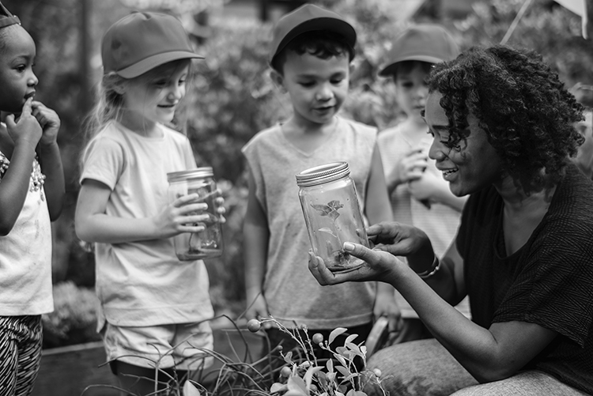
___ / 12

TOTAL: ___ / 20

