Part A • Grammar, Vocabulary and How to …
GRAMMAR
1 Choose the correct answer, A, B, C or D.
1 ___ any sports in your free time?
A Are you playing
B Do you play
C You’re playing
D You play

2 She ___ today because she’s sick.
A works
B doesn’t work
C ’s working
D isn’t working

3 I promise ___ you something nice for dinner.
A to cook
B cook
C cooking
D cooked

4 Before ___ on holiday, she gave the plants some water.
A to go
B go
C going
D went

5 I don’t work with Alan now, so I see him ___ less.
A a lot
B fairly
C quite
D relatively

6 She ___ for the bus when a woman asked her for help.
A waits
B waited
C was waiting
D had waited

7 We ___ eating our lunch and we were taking the plates out to the kitchen.
A finished
B were finishing
C ’ve finished
D ’d finished

8 I don’t know how to write a poem. I ___ one before.
A never write
B never wrote
C ’ve never written
D ’d never written

9 Ms Tranter left the office ___ two o’clock today.
A at
B during
C in
D on

10 He lived there ___ 2016 and then he moved house.
A after
B between
C on
D until

11 Who ___ the keys to the shop?
A you gave
B gave you
C did you give
D does you give

12 What website ___?
A you are looking
B are you looking
C you are looking at
D are you looking at

13 I ___ my parents this weekend, but I’m not sure yet.
A might visit
B ’ll visit
C ’m visiting
D ’m going to visit

14 She ___ dinner with her friends this evening. They organised it weeks ago.
A ’ll have
B won’t have
C ’s having
D has

15 Have they ___? They’re not in their seats yet.
A got on the plane
B got the plane on
C got up the plane
D got the plane up

16 I ___ wear a suit to work. I can decide what clothes to wear.
A have to
B don’t have to
C must
D mustn’t

17 They were late because they ___ look for a parking space.
A have to
B had to
C need to
D must
18 She was at ___ school when she hurt herself.
A a
B an
C the
D –

19 My birthday is on ___ 14th July.
A a
B an
C the
D –

20 It was ___ hotel I’ve ever stayed in.
A a beautiful
B a most beautiful
C the more beautiful
D the most beautiful

21 I’m sure that’s the street ___ they live.
A where
B which
C whose
D who

22 That was the time ___ I broke my glasses.
A who
B when
C where
D which

23 ‘I’ve written a letter to the manager,’ she said.
She said she ___ a letter to the manager.
A wrote
B ’s writing
C ’s written
D ’d written

24 ‘I’ll take the rubbish out when I leave,’ he said.
He said he ___ the rubbish out when he left.
A ’ll take
B ’d take
C ’d taken
D ’s taken

25 She ___ late today because it’s her birthday.
A ’ll work definitely
B won’t definitely work
C definitely won’t work
D ’ll definitely work

26 I ___ enjoy those long car journeys, but I don’t mind them now.
A did use to
B used to
C didn’t use to
D never used to
27 My new teacher is ___ than the last one.
A more patient
B more patiently
C the most patient
D as patient

28 Gabby doesn’t type ___ as Yannis.
A more quick
B more quickly
C the most quickly
D as quickly

29 He hasn’t finished cleaning his bedroom ___.
A for
B yet
C ever
D since

30 They’ve known each other ___ they were children.
A ever
B for
C since
D yet

31 If you don’t get up now, you ___ late for work.
A ’re late
B were late
C ’d be
D ’ll be

32 You’d be more relaxed if you ___ looking at your phone all the time.
A aren’t
B weren’t
C will not be
D would not be

33 We’ve got ___ potatoes, but we haven’t got any onions.
A a bit
B a few
C a little
D a lot

34 I didn’t get ___ sleep last night. I feel exhausted today.
A a lot
B a little
C enough
D plenty of

35 My wife goes running by ___.
A myself
B herself
C himself
D themselves

36 I ___ cook very well, but I’m pretty good at tortilla.
A couldn’t
B could
C can’t
D can

37 She ___ solve the problem when the teacher helped her.
A was able to
B wasn’t able to
C can
D couldn’t

38 The men ___ by the police at the moment.
A are interviewed
B are being interviewed
C were interviewed
D have been interviewed

39 The children ___ about the school trip yet.
A told
B have told
C weren’t told
D haven’t been told

40 I wouldn’t mind ___ at home this evening.
A stay
B to stay
C staying
D stayed
/40

VOCABULARY
2 Choose the correct answer, A, B, C or D.
41 I don’t ___ with Rosie. For some reason, she doesn’t seem to like me.
A friendly
B get on well
C look up
D take after

42 The man wasn’t very ___. He didn’t reply when I spoke to him.
A crazy
B funny
C polite
D rude

43 She gave me a lovely birthday present. It was very ___ of her.
A bossy
B easy-going
C generous
D serious

44 We’re looking for a ___ who can look after our plants and trees.
A gardener
B journalist
C plumber
D mechanic

45 I’m ___ at the moment so I’m looking for a new job.
A career
B full-time
C out of work
D profession

46 She was ___ with her present because she wanted something else.
A disappointed
B disappointing
C excited
D exciting

47 I’m a bit ___ because I’m waiting for the result of my driving test.
A angry
B calm
C exhausted
D nervous

48 Why are you ___ of your brother? We love both of you the same.
A in love
B jealous
C proud
D terrified

49This is one of my favourite ___. I watch it every week.
A characters
B fairytales
C storytellers
D TV shows

50 I dreamt about monsters after I watched that ___.
A action film
B drama
C horror film
D romantic comedy

51 My ___ was better when I was younger. I find it hard to remember new things these days.
A data
B memory
C revise
D score

52 Which ___ would you choose from the list?
A general knowledge
B mind
C multiple-choice
D option

53 I don’t ___ the question. Can you help me?
A know
B knowledge
C understand
D understanding

54 There isn’t much ___ on the menu. It’s either fish or meat.
A choice
B choose
C decision
D select

55 It makes ___ to stay at home because the weather’s terrible.
A a decision
B the right choice
C sense
D up your mind

56 I’m not ___ in this game so I’m probably going to lose.
A carrying on
B doing well
C giving up
D working hard

57 She doesn’t find it easy to accept ___. She wants to succeed in everything.
A bad loser
B failure
C success
D talented

58 He’s an amazing ___. He’s spent his whole life helping people learn.
A educator
B education
C inventor
D invention

59 Children can only ___ an account with their parents’ permission.
A create
B download
C launch
D send

60 Your video will only ___ if people find it interesting.
A download an app
B go live
C go viral
D share videos

61 People said the story was ___, but I think it was true.
A a blog post
B content
C fake news
D a headline

62 You won’t ___ the truth in the newspapers. They’ll never write about it.
A find out
B look up
C post
D publish

63 We’re worried about the high ___ around the factory.
A activists
B campaigns
C environment
D levels of pollution

64 We’ve asked local people to ___ money to the charity.
A collect
B donate
C raise
D waste

65 Do you mind taking the ___ out this morning?
A recycle
B resources
C rubbish
D smoke

66 Because of ___, the world is hotter than it was 100 years ago.
A climate change
B environment
C natural resources
D public transport

67 Earthquakes can be some of the world’s worst ___.
A campaigns
B natural disasters
C rainforests
D traffic jams

68 I love the colours that this ___ uses for his portraits.
A composer
B musician
C painter
D performer

69 You couldn’t see what was happening because the ___ wasn’t very clear.
A arts
B image
C recording
D works

70 Our hotel is the perfect ___ for weddings and other events.
A gallery
B show
C studio
D venue

71 This ___ has designed some of the world’s tallest buildings.
A architect
B artist
C dance
D photographer

72 I like art class because it allows me to use my ___.
A create
B creator
C creative
D creativity

73 How do you ___ your life will be in 2050?
A imagine
B imagined
C imagination
D imaginative

74 We couldn’t believe how good his ___ skills were.
A art
B arts
C artist
D artistic

75 My parents are planning a ___ to Buenos Aires.
A destination
B festival
C sightseeing
D trip

76 We’re going on a ___ for a few days in Glasgow.
A check-in
B city break
C nightlife
D resort

77 Why don’t we ___? We can ride them to the beach.
A book a tour
B go sightseeing
C plan a trip
D rent bicycles
78 What do you think the ___ will be like? Do you think it will be comfortable?
A accommodation
B backpacker
C exchange rate
D luggage

79 I haven’t ___ that shop there before. It must be new.
A accepted
B expected
C noticed
D surprised

80 We’d ___ the park by chance, but we spent a lovely afternoon there.
A come across
B explored
C realised
D never heard of

81 It was normally a wide river but now it was no bigger than a ___.
A rainforest
B stream
C valley
D waterfall

82 We trekked through the ___, which was hot and full of plants.
A coast
B countryside
C jungle
D mountain range

83 I don’t think we can ___ the computer. We need to get a new one.
A install
B repair
C replace
D upload

84 My neighbour has ___ an automatic system for watering his plants.
A arranged
B calculated
C designed
D turned into

85 They ___ a silly story about why they were late.
A got up
B made up
C picked up
D took up

86 Can you ___ how this clock works? I don’t know how to set the alarm.
A get on with
B looked after
C set up
D work out

87 My friend has a video ___ where he talks about computer games.
A comment
B like
C podcast
D share

88 Do you mind if I ___ your phone? I need to use this socket.
A charge
B restart
C switch
D unplug

89 I’m going to ___ the latest update. Your computer should work better then.
A install
B pay
C press
D shut down

90 Let’s see if the light works now. Can you ___?
A plug it out
B put it down
C switch it on
D undo it
/50

HOW TO …
3 Choose the correct answer, A, B, C or D.
91 A: How was your holiday?
B: Not bad. ___
A And you?
B Have fun.
C Not at all.
D Be my guest.

92 A: I apologise. I got the time wrong.
B: That’s ___.
A fine
B mind
C problem
D worry

93 ___ I can use the library on Sundays?
A Could you tell
B Can you explain
C Do you know if
D Can I ask

94 In cricket, players use a bat which ___ wood.
A consists of
B is made of
C is played on
D scores by

95 A: Bad news, I’m afraid. I’ve lost my job.
B: I’m ___ to hear that.
A afraid
B shame
C sorry
D terrible

96 A: I would say that’s the worst play I’ve ever seen.
B: What ___ you say that?
A do
B does
C make
D makes

97 ___ visiting the national museum in Copenhagen.
A Don’t leave without
B Make sure you
C It’s a great place to
D You absolutely must

98 This Victorian bridge has become ___ for its engineering design.
A ancient
B famous
C peaceful
D traditional

99 A: The coffee machine seems to be broken.
B: ___ clean it properly.
A Maybe you need to
B Have you tried
C It won’t
D Try

100 Your ___ is supposed to be secret. Thieves can take money from your account if they know it.
A charge
B credit card
C PIN
D USB
/10

Total: /100
Part B • Listening, Reading and Writing
LISTENING
1 [Audio ET.01] You will hear five people talking about learning. Match the speakers (1–5) with the statements (A–E).
1 Suzanne ___
2 Axel ___
3 Amelia ___
4 Rory ___
5 Lisa ___

A I don’t plan to carry on going to the classes.
B I made a change because I wasn’t learning.
C I’ll continue having lessons for the moment.
D I didn’t expect to enjoy it this much.
E I like the place where I have the lessons.
/5

2 [Audio ET.01] Listen again. For each speaker, choose the correct answer, A, B or C.
1 Why is Suzanne having tennis lessons?
A She used to play tennis and wants to play it again.
B She has recently been given a new tennis racquet.
C She wants to be able to play with her friend.

2 What does Axel say about his art classes?
A He does the classes in an artist’s workspace.
B His teacher gets annoyed with him sometimes.
C He’s preparing to show his pictures in a gallery.

3 What does Amelia like most about her teaching course?
A Learning about the language
B Being in a different country
C Spending time with her students

4 What does Rory say about learning the trumpet?
A He would like to do classes in a music school.
B He wanted to learn because of a famous person.
C He doesn’t practice as much as he should.

5 How does Lisa feel about the creative writing classes?
A She has problems learning some of the content.
B They’re similar to the classes she had at school.
C The teacher doesn’t try to make them interesting.
/10

READING
3 Read the text about a vlogger called Demi Skipper. Match the paragraphs (1–5) with the headings (A–E).
A Where did Demi get her inspiration?
B How did Demi reach her goal?
C Why has Demi been in the news?
D What difficulties did Demi face?
E What is ‘trading up’?
/5
Trading up
1___
Demi Skipper has recently been given the keys for her new home in Tennessee, USA. Getting a new house can be an exciting experience for anyone, but there’s nothing strange about it. So why has Demi’s achievement been in the headlines? It’s because it didn’t cost her a cent. Instead, she “traded up” her possessions.

2___
If you exchange something you have for something better, then you have traded up. Demi started with an ordinary hair pin, which you use to keep your hair in place, and traded it up for a pair of earrings. After that, she traded them for a set of glasses and she carried on until she was finally able to trade a caravan for a house. She only used her own money to pay for the delivery of the items.

3___
Demi came up with the idea after hearing about Kyle MacDonald who’d done something similar back in 2006. Kyle had become famous for his “One Red Paperclip” blog. He’d written it while trying to trade up to a house from a red paperclip. Kyle succeeded in just over a year and with only fourteen trades. While Kyle wrote about his experiences in a blog, Demi recorded her experiences on videos and uploaded them to her vlog. Her videos soon went viral and, apart from her fans, she had TV reporters following her as well. They were all keen to see her achieve her dream of getting a house.

4___
There were some unusual exchanges during Demi’s “journey”. For example, there were the three tractors which she exchanged for a year’s worth of free food in a Mexican restaurant. However, some of her trades didn’t go as well as expected. For example, she received a diamond necklace which was worth less than she thought. There was also a car that didn’t work, but she didn’t give up. She just carried on trading!

5___
It took just over a year and twenty-eight trades for Demi to reach her goal. She was driving home with her caravan when she started to arrange her next trade. But before she’d got home, Demi managed to achieve her dream. One of Demi’s social media followers had agreed to exchange their two-bedroom house for her caravan! In her final vlog, Demi is given the keys to her new home, before reminding her followers that anything is possible if you try hard enough.
4 Read the text again. Are the statements True (T) or False (F)?
1 Getting a new house is an unusual experience for most people. T / F
2 Demi had to pay one cent to the owners of her new home. T / F
3 If you trade up, you hope to get something more valuable. T / F
4 Demi was expected to pay to get the items delivered.
T / F
5 Demi was inspired by a man who had done something similar. T / F
6 Kyle MacDonald wasn’t able to achieve his goal. T / F
7 Demi became popular very quickly on the internet. T / F
8 Demi decided to stop trading after a car broke down.
T / F
9 It took a long time to find someone who wanted Demi’s caravan. T / F
10 Demi’s last video shows her receiving the keys to her house. T / F
/10

WRITING
5 Choose the correct words to complete the sentences.
1 She studied medicine at university because / so she wanted to be a doctor.
2 They thought they’d take the train, but by the time /
in the end they took the bus.
3 If you want to meet new people, make sure you /
why not try joining a club or gym?
4 Although / Unless we can’t visit you this weekend, we’d love to see you soon.
5 These days / At first, I couldn’t understand any Spanish, but now I understand it much better.
/5

6 Read part of an email from a friend.
I’d like to go on holiday in your country. I’d like to hear your suggestions about accommodation, sightseeing and interesting festivals.
Write an email to your friend with your suggestions. Write your email in about 100 words.
/15

Total: /50

Part C • Speaking
SPEAKING
1 Make questions and ask your partner.
1 What / first thing / do / in the morning?
2 Have / ever / eaten / anything unusual?
3 What jobs / need / do / at home?
4 What / nicest thing / anyone / told / you?
5 What / would / do / if / you / a millionaire?
/5

2 Answer your partner’s questions.
/5

3 Describe the picture to your partner.
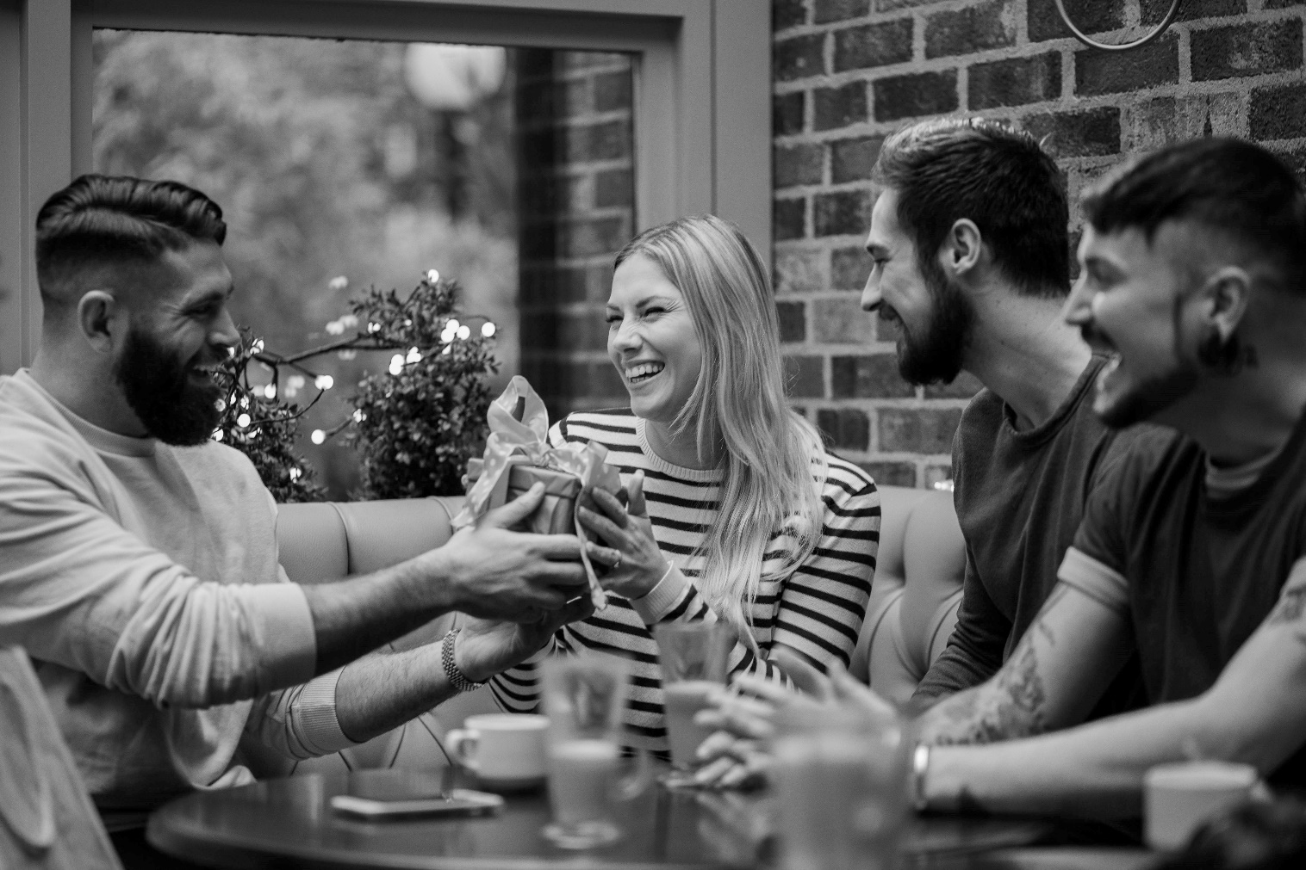
/10

Total: /20

