Part A • Grammar, Vocabulary and How to …
GRAMMAR
1 Circle the correct option (A, B or C).
0 ___ any sports in your free time?
^{A} Are you playing | ^{B} Do you play | ^{C} You play

1 I promise ___ you something nice for dinner.
^{A} to cook | ^{B} cooking | ^{C} cook

2 I don’t work with Alan now, so I see him ___ less.
^{A} a lot | ^{B} fairly | ^{C} relatively

3 She ___ for the bus when a woman asked her for help.
^{A} waited | ^{B} had waited | ^{C} was waiting

4 He lived there ___ 2016 and then he moved house.
^{A} after | ^{B} between | ^{C} until

5 Who ___ the keys to the shop?
^{A} you gave | ^{B} gave you | ^{C} did you give

6 I ___ my parents this weekend, but I’m not sure yet.
^{A} might visit | ^{B} ’ll visit | ^{C} ’m going to visit

7 She ___ dinner with her friends this evening. They organised it weeks ago.
^{A} ’ll have | ^{B} ’s having | ^{C} has

8 Have they ___? They’re not in their seats yet.
^{A} got on the plane | ^{B} got the plane on | ^{C} got up the plane

9 They were late because they ___ look for a parking space.
^{A} have to | ^{B} had to | ^{C} must

10 She was at ___ school when she hurt herself.
^{A} an | ^{B} a | ^{C} –

11 It was ___ hotel I’ve ever stayed in.
^{A} a beautiful | ^{B} the more beautiful | ^{C} the most beautiful

12 I’m sure that’s the street ___ they live.
^{A} where | ^{B} which | ^{C} who

13 ‘I’ve written a letter to the manager,’ she said.
- She said she ___ a letter to the manager.
^{A} wrote | ^{B} ’s written | ^{C} ’d written

14 ‘I’ll take the rubbish out when I leave,’ he said.
- He said he ___ the rubbish out when he left.
^{A} ’ll take | ^{B} ’d take | ^{C} ’d taken

15 She ___ late today because it’s her birthday.
^{A} ’ll work definitely | ^{B} won’t definitely work | ^{C} definitely won’t work

16 I ___ enjoy those long car journeys, but I don’t mind them now.
^{A} used to | ^{B} didn’t use to | ^{C} never used to

17 Gabby doesn’t type ___ as Yannis.
^{A} the most quickly | ^{B} more quickly | ^{C} as quickly

18 He hasn’t finished cleaning his bedroom ___.
^{A} since | ^{B} yet | ^{C} ever

19 If you don’t get up now, you ___ late for work.
^{A} ’re late | ^{B} ’d be | ^{C} ’ll be

20 You’d be more relaxed if you ___ looking at your phone all the time.
^{A} aren’t | ^{B} weren’t | ^{C} will not be

21 I didn’t get ___ sleep last night. I feel exhausted today.
^{A} a lot | ^{B} enough | ^{C} plenty of

22 My wife goes running by ___.
^{A} myself | ^{B} herself | ^{C} himself

23 She ___ solve the problem when the teacher helped her.
^{A} was able to | ^{B} can | ^{C} couldn’t

24 The men ___ interviewed by the police at the moment.
^{A} are | ^{B} are being | ^{C} have been

25 The children ___ about the school trip yet.
^{A} have told | ^{B} weren’t told | ^{C} haven’t been told

26 I wouldn’t mind ___ at home this evening.
^{A} stay | ^{B} to stay | ^{C} staying
___ / 26

VOCABULARY
2 Circle the correct option (A, B or C).
0 l don’t ___ with Rosie. For some reason, she doesn’t seem to like me.
^{A} look up | ^{B} get on well | ^{C} take after

1 She gave me a lovely birthday present. It was very ___ of her.
^{A} easy-going | ^{B} generous | ^{C} serious

2 I’m looking for a new job because I’m ___ at the moment.
^{A} out of work | ^{B} career | ^{C} profession

3 This is one of my favourite ___. I watch it every week.
^{A} storytellers | ^{B} characters | ^{C} TV shows

4 I find it hard to remember new things these days. My ___ was better when I was younger.
^{A} score | ^{B} revise | ^{C} memory

5 There isn’t much ___ on the menu. It’s either fish or meat.
^{A} choice | ^{B} decision | ^{C} select

6 It makes ___ to stay at home because the weather’s terrible.
^{A} the right choice | ^{B} sense | ^{C} up your mind

7 I’m not ___ in this game so I’m probably going to lose.
^{A} carrying on | ^{B} doing well | ^{C} giving up

8 He’s spent his whole life helping people learn. He’s an amazing ___.
^{A} educator | ^{B} education | ^{C} inventor

9 Children can only ___ an account with their parents’ permission.
^{A} create | ^{B} download | ^{C} launch

10 Your video will only ___ if people find it interesting.
^{A} go live | ^{B} go viral | ^{C} share videos

11 You won’t ___ the truth in the newspapers. They’ll never write about it.
^{A} find out | ^{B} look up | ^{C} publish

12 We’re worried about the high ___ around the factory.
^{A} activists | ^{B} environment | ^{C} levels of pollution

13 We’ve asked local people to ___ money to the charity.
^{A} collect | ^{B} donate | ^{C} raise

14 Because of ___, the world is hotter than it was 100 years ago.
^{A} climate change | ^{B} natural resources | ^{C} environment

15 You couldn’t see what was happening because the ___ wasn’t very clear.
^{A} recording | ^{B} image | ^{C} works

16 Our hotel is the perfect ___ for weddings and other events.
^{A} show | ^{B} studio | ^{C} venue

17 This ___ has designed some of the world’s tallest buildings.
^{A} architect | ^{B} artist | ^{C} photographer

18 I like art class because it allows me to use my ___.
^{A} creator | ^{B} creative | ^{C} creativity

19 My parents are planning a ___ to Buenos Aires.
^{A} destination | ^{B} sightseeing | ^{C} trip

20 I haven’t ___ that shop there before. It must be new.
^{A} accepted | ^{B} expected | ^{C} noticed

21 We’d ___ the park by chance, but we spent a lovely afternoon there.
^{A} came across | ^{B} explored | ^{C} realised

22 We trekked through the ___, which was hot and full of plants.
^{A} coast | ^{B} jungle | ^{C} mountain range

23 I don’t think we can ___ the computer. We need to get a new one.
^{A} install | ^{B} repair | ^{C} replace

24 Can you ___ how this clock works? I don’t know how to set the alarm.
^{A} get on with | ^{B} set up | ^{C} work out

25 Do you mind if I ___ your phone? I need to use this socket.
^{A} charge | ^{B} switch | ^{C} unplug

26 Let’s see if the light works now. Can you ___?
^{A} plug it in | ^{B} switch it on | ^{C} undo it
___ / 26

HOW TO …
3 Circle the correct option (A, B or C).
0 A: How was your holiday?
B: Not bad. ___
^{A} Have fun. | ^{B} And you? | ^{C} Not at all.

1 A: I apologise. I got the time wrong.
B: That’s ___.
^{A} fine | ^{B} mind | ^{C} worry

2 ___ I can use the library on Sundays?
^{A} Could you tell | ^{B} Do you know if | ^{C} Can I ask

3 In cricket, players use a bat which ___ wood.
^{A} consists of | ^{B} is made of | ^{C} is played on

4 A: Bad news, I’m afraid. I’ve lost my job.
B: I’m ___ to hear that.
^{A} shame | ^{B} afraid | ^{C} sorry

5 A: I would say that’s the worst play I’ve ever seen.
B: What ___ you say that?
^{A} does | ^{B} make | ^{C} makes

6 ___ visiting the national museum in Copenhagen.
^{A} Don’t leave without | ^{B} Make sure you | ^{C} You absolutely must

7 A: The coffee machine seems to be broken.
B: ___ clean it properly.
^{A} Have you tried | ^{B} Maybe you need to | ^{C} It won’t

8 Your ___ is supposed to be secret. Thieves can take money from your account if they know it.
^{A} charge | ^{B} PIN | ^{C} USB
___ / 8

TOTAL: ___ / 60
x 1.66 = ___ / 100

Part B • Listening, Reading and Writing
LISTENING

1 [Audio ET.01] Listen to five people talking about learning. Match the speakers (1–5) with the statements (A–E).
0 Suzanne _C_
A I don’t plan to carry on going to classes.
B I made a change because I wasn’t learning.
C I’ll continue having lessons for the moment.
D I didn’t expect to enjoy it this much.
E I like the place where I have the lessons.
1 Axel ___
2 Amelia ___
3 Rory ___
4 Lisa ___
___ / 4

2 [Audio ET.01] Listen again. Circle the correct answer (A or B).
0 Why is Suzanne having tennis lessons?
^{A} She wants to be able to play with her friend. | ^{B} She used to play tennis and wants to play it again.

1 What does Axel say about his art classes?
^{A} He does the classes in an artist’s workspace. | ^{B} He’s preparing to show his pictures in a gallery.

2 What does Amelia like most about her teaching course?
^{A} Being in a different country. | ^{B} Spending time with her students.

3 What does Rory say about learning the trumpet?
^{A} He would like to do classes in a music school. | ^{B} He wanted to learn because of a famous person.

4 How does Lisa feel about the creative writing classes?
^{A} She has problems learning some of the content. | ^{B} They’re similar to the classes she had at school.
___ / 8

READING

3 Read the text about a vlogger called Demi Skipper. Match the headings (1–4) with the paragraphs (A–E).
0 Where did Demi get her inspiration? _C_
1 How did Demi reach her goal? ___
2 Why has Demi been in the news? ___
3 What difficulties did Demi face? ___
4 What is ‘trading up’? ___
___ / 4

Trading up
A
Demi Skipper has recently been given the keys for her new home in
Tennessee, USA. But there’s nothing strange about getting a new
house so why has Demi’s achievement been in the headlines? It’s because
it didn’t cost her a cent. Instead, she “traded up” her possessions.

B
If you exchange something you have for something better, then you have
traded up. Demi started with an ordinary hair pin and traded it up for a
pair of earrings. After that, she traded them for a set of glasses and she
carried on until she was finally able to trade a caravan for a house.
She only used her own money to pay for the delivery of the items.

C
Demi came up with the idea after hearing about Kyle MacDonald
who’d done something similar back in 2006 and become famous for trying to
trade up to a house from a red paperclip. While Kyle wrote about his
experiences in a blog, Demi recorded her experiences on videos and
uploaded them to her vlog. Her videos soon went viral and, apart from
her fans, she had TV reporters following her as well. They were all keen to
see her achieve her dream of getting a house.

D
There were some unusual exchanges during Demi’s “journey” and some of
her trades didn’t go as well as expected. For example, she received a
diamond necklace which was worth less than she thought. There was also a
car that didn’t work, but she didn’t give up. She just carried on trading!

E
It took just over a year and twenty-eight trades for Demi to reach her goal.
She was driving home with her caravan when she started to arrange
her next trade. But before she’d got home, Demi managed to achieve her
dream. One of Demi’s social media followers had agreed to exchange
their two-bedroom house for her caravan! In her final vlog, Demi is given the
keys to her new home, before reminding her followers that anything is
possible if you try hard enough.

4 Read the text again. Are the statements True (T) or False (F)?
0 Demi had to pay one cent to the owners of her new home. _F_
1 Demi was expected to pay to get the items delivered. ___
2 Kyle MacDonald wasn’t able to achieve his goal. ___
3 Demi became popular very quickly on the internet. ___
4 Demi’s last video shows her receiving the keys to her house. ___
___ / 8

WRITING

5 Circle the correct words.
0 She studied medicine at university because / so she wanted to be a doctor.

1 They thought they’d take the train, but by the time / in the end they took the bus.
2 If you want to meet new people, make sure you / why not try joining a club or gym?
3 Although / Unless we can’t visit you this weekend, we’d love to see you soon.
4 These days / At first, I couldn’t understand any Spanish, but now I understand it much better.
___ / 4

6 Read part of an email from a friend.
I’d like to go on holiday in your country. I’d like to hear your suggestions about accommodation, sightseeing and interesting festivals.
Write an email to your friend with your suggestions. Write about 100 words.
___ / 12

TOTAL: ___ / 40
x 1.25 = ___ / 50
Part C • Speaking
SPEAKING

1 Put the words in the correct order to make questions.
Ask your partner your questions.
0 What’s / in / thing / you / the morning / do / the first
____What’s the first thing you do in the morning__________?

1 Have / you / eaten / unusual / anything / ever
___________________________________________________?
2 you / jobs / What / at home / need / to do / do
___________________________________________________?
3 What’s / thing / anyone / the nicest / told / has / you ___________________________________________________?
4 a millionaire / if you / would / What / you / were / do
___________________________________________________?
___ / 4

2 Answer your partner’s questions.
___ / 4
3 Describe the picture to your partner.
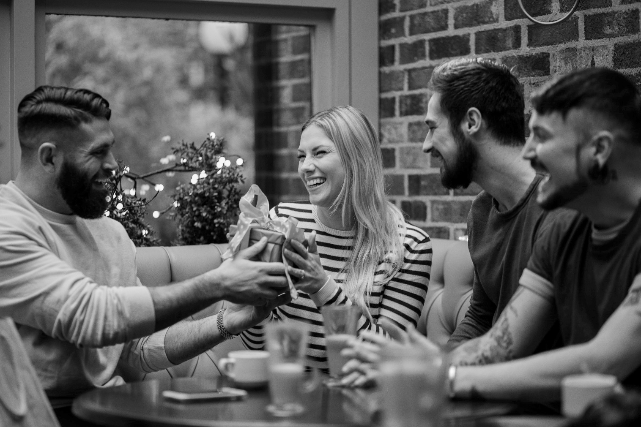
___ / 12

TOTAL: ___ / 20

