Part A • Grammar, Vocabulary and How to …
GRAMMAR
1 Put the words in the correct order to make sentences and questions.
1 Austria / a / sister / holiday / My / in / planning / is
________________________________________.
2 you / know / Kate / where / lives / Do
________________________________________?
3 I / the / go / usually / running / in / morning
________________________________________.
4 your / Are / keys / for / you / looking
________________________________________?
5 Jonah / a / while / Once / see / in / comes / us / to
________________________________________.
6 They / not / are / for / long / staying / here
________________________________________.
7 day / cleans / his / bedroom / every / He
________________________________________.
/7

2 Complete the sentences with the correct -ing or
to + infinitive form of the verbs in brackets.
1 We agreed __________ (meet) at six o’clock.
2 Before __________ (leave), we must close all the windows.
3 Can you imagine __________ (live) in a house next to the sea?
4 They expect __________ (arrive) early in the morning.
5 __________ (drink) a lot of coffee gives me a headache.
6 I’d like __________ (watch) a film this evening.
7 She doesn’t mind __________ (lend) me her car.
/7

3 Choose the correct option (a, b or c).
1 The restaurant was nice, but it was ___ expensive.
a quite an b bit c fairly
2 I spend ___ less time worrying nowadays.
a quite b a lot c pretty
3 It was ___ surprise to see Andrew yesterday.
a quite a b relatively c a bit
4 She’s ___ happy with her new motorbike.
a a bit b pretty c a quite
5 I’m tired so I need to sleep ___ more.
a fairly b lot c a bit
6 The actors were ___ good in the play.
a quite a b reasonably c a lot
/6

VOCABULARY
4 Complete the sentences with personality adjectives.
1 James is very h _ _ _ _ _ _ sometimes. Yesterday, he did my shopping for me.
2 Silvia is quite s _ _ _ _ _ _. She’s quite quiet and she rarely makes jokes.
3 My mum is very p _ _ _ _ _ _. She always stays calm and she doesn’t get angry.
4 Mikel’s a g _ _ _ _ _ _ _ guy. He paid for my dinner.
5 My cousin is quite b _ _ _ _. He always tells other people what to do.
/5

5 Complete the sentences with the words and phrases in the box.
friendly with gets on in touch looks up
take after
1 I use a messenger app to stay __________ with my friends.
2 Paula __________ well with everyone she meets.
3 People say I __________ my grandfather because we’ve got similar personalities.
4 I’m very __________ my neighbours. I talk to them every day.
5 Mia __________ to her big brother. She respects him a lot.
/5

6 Complete the sentences with jobs.
1 I’m a f _ _ _ _ _ _ _ l c _ _ _ _ _ _ _ _ t so I give people advice about their money.
2 I’m a m _ _ _ _ _ _ c so I repair cars and other vehicles.
3 I’m a j _ _ _ _ _ _ _ _ t so I write articles for magazines and newspapers.
4 I’m a s _ _ p a _ _ _ _ _ _ _ t so I serve customers in a shop.
5 I’m a c _ _ f and I prepare food in a Greek restaurant.
/5

7 Choose the correct alternative.
1 I hope to have a career / profession as a nurse in the future.
2 My mother runs / responsible for an online fashion company.
3 Hassan works part-time / full-time so he only works on Saturday mornings.
4 I was out of work / volunteer for a few months, but I’ve got a job now.
5 You need the right qualifications / wages if you want to be a lawyer.
/5
HOW TO …
8 Complete the conversations with the expressions in the box.
Conversation 1
by the way excuse me help yourself
how about you nice to meet you
A: ¹__________, is anyone using this computer?
B: No. ²__________.
A: Thanks.
B: Is it your first time in this library?
A: Yes. ³__________?
B: No, I’ve been a member for a long time.
A: Great. I’m Katrina, ⁴__________.
B: ⁵__________. I’m Sakura.

Conversation 2
anything nice have fun lovely morning
see you what about you
A: It’s a(n) ⁶__________, isn’t it?
B: Yes. Beautiful weather.
A: Are you doing ⁷__________ at the weekend?
A: Not really. ⁸__________?
B: If the weather stays like this, I’ll probably go to the beach.
A: Lovely. Well, ⁹__________!
B: Thanks! ¹⁰__________ later.
/10

Total: /50

Part B • Listening, Reading and Writing
LISTENING
1 [Audio UT1.01] Listen to five people talking about how they relax. Match the speakers (1–5) with the things they do to relax (A–E).
1 Alyssa ___
2 Felix ___
3 Julia ___
4 Jake ___
5 Sarah ___

A Playing computer games
B Reading
C Hanging out with friends
D Watching television
E Cooking
/5

2 [Audio UT1.01] Listen again. Choose the correct answer, A, B or C.
1 Why is it important for Alyssa to relax?
A She has a lot of work at university.
B She’s starting a new job soon.
C She does a lot of exercise.

2 What does Felix say about his hobby?
A It helps him stay in touch with people.
B It helps him learn new things.
C It helps him spend less time in his bedroom.

3 What does Julia say about her job?
A It’s hard work, but fun.
B It takes a lot of her time.
C It makes her stressed out.

4 Why does Jake prefer preparing food at home than in the restaurant?
A There is better food.
B There are cookery books.
C There is less noise.

5 What does Sarah say about her lifestyle?
A She has more free time nowadays.
B She still has a lot to do.
C She finds it hard to relax.
/10

READING
3 Read the text about volunteer firefighters. Match the paragraphs (1–5) with the topics (A–E).
A What the volunteers do
B Meeting a firefighter
C Informing other people
D Ingrid’s full-time job
E How Ingrid became a volunteer
/5
The volunteer fire service
1 ___
Ingrid Karlsson is a veterinary nurse. After completing her training in Sweden, she found a job with a vet in Somerset, England. She usually does medical tests and provides treatments for pets and farm animals but, occasionally, she does operations. Today, she’s treating a sick cow and tomorrow she’s helping the vet with an operation on a cat. But this isn’t Ingrid’s only job. In her spare time, she’s also a volunteer firefighter.

2 ______
One day a firefighter brought a dog to the vet’s office. It had been injured in a fire. The dog had some burns, but they weren’t very serious. While she was treating the dog, she began talking to the firefighter about his job. Ingrid found out that the firefighter, called Patrick, was actually a volunteer. Most of the time, he worked as a mechanic in the local garage. This was a surprise for Ingrid because she thought all firefighters worked full-time. Patrick saw that Ingrid was interested in his job and offered to show her around the fire station.

3 ___
The following Saturday, she went to the fire station and met the other firefighters. The team were easy-going and happy to show her around. She found out that most of them had other jobs, but they worked 10–15 hours a week as firefighters. They spent most of their time looking after the equipment and practising putting out fires. However, in an emergency, they had to stop what they were doing and go quickly to the fire station. Sometimes they even had to leave their other jobs to go and put out a fire.

4 ___
After meeting the firefighters and seeing the fire station, Ingrid decided to become a volunteer. She thought it was a great way to help her community. However, before being allowed to respond to emergency calls, she had to attend different training courses. The courses included learning how to use the equipment, emergency care and giving advice to the public. When she completed her training, Ingrid was allowed to ride in the fire engine and attend emergencies.

5 ___
Ingrid also visits local schools and businesses to talk about the volunteer fire service. A lot of people don’t realise that many places don’t have full-time firefighters. Ingrid explains how much work the firefighters do for their community without getting a salary. She also tells them the story about Patrick and the dog and why she joined the volunteer fire service. By telling her story, Ingrid hopes that other people will give up their time as well.
4 Read the text again. Choose the correct answer, A, B, C or D.
1 What do we learn about Ingrid in the first paragraph?
A She often does operations on pets and farm animals.
B She studied to be a veterinary nurse in Sweden.
C She would like to find a job in England one day.
D She is unhappy working as a veterinary nurse.

2 How did Ingrid meet Patrick?
A Patrick brought his pet to the vet’s office.
B Ingrid had a problem with her car.
C Ingrid was visiting the fire station.
D Patrick wanted to help an injured animal.

3 What did Ingrid learn about the firefighters?
A They all worked part-time for the fire service.
B They didn’t like people visiting the fire station.
C They spent most of their time on emergency calls.
D They all wanted to find new jobs.

4 Why did Ingrid become a volunteer firefighter?
A She wanted to ride in a fire engine.
B She wanted to find a better job.
C She wanted to do something useful.
D She wanted to meet new people.

5 Why does Ingrid visit schools and businesses?
A To ask people to volunteer for the fire service.
B To inform them about the dangers of fire.
C To make sure their buildings are safe.
D To ask them to give money to the fire service.
/10

WRITING
5 Choose the correct words to complete the sentences.
1 Marcos speaks good Italian and he also / as well as speaks a little German.
2 Everyone likes him for example / because he’s friendly and easy-going.
3 He plays tennis in his free time and a little chess,
as well as / too.
4 He helps me in different ways – because / for example, he helps me practise Italian.
5 He’s lived in Rome and Paris as well as / too London.
/5

6 You have seen this advertisement in a magazine:
A good friend
We want readers to write a description of a good friend. Talk about:
- their personality.
- their lifestyle.
- why you get on well.
We will include the best descriptions in our next magazine!
Write your description in about 100 words.
/15

Total: /50

Part C • Speaking
SPEAKING
1 Make questions and ask your partner.
1 What / usually / do / the evening?
2 What / sports / play?
3 Who / look up to / your family?
4 How / travel / work or college?
5 Do / have / a relaxing lifestyle?
/5

2 Answer your partner’s questions.
/5

3 Describe the picture to your partner.
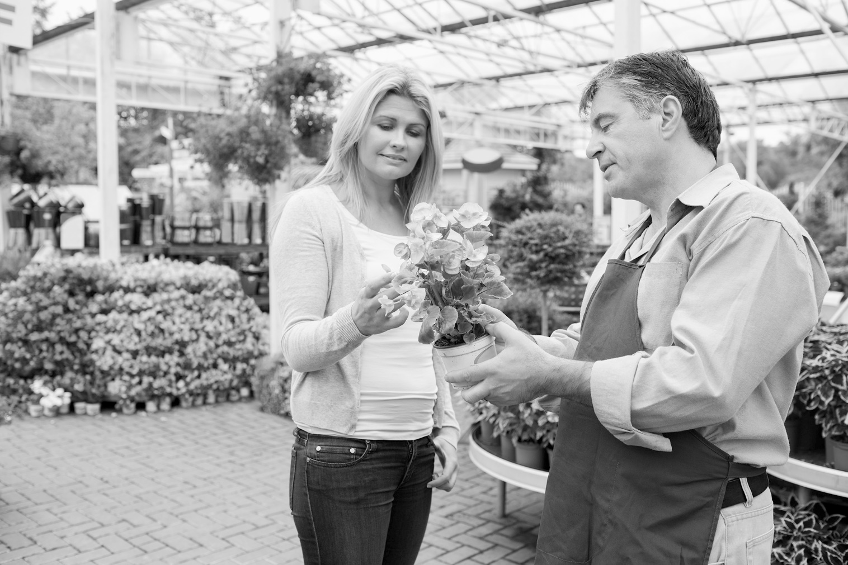
/10

Total: /20

