Part A • Grammar, Vocabulary and How to …
GRAMMAR

1 Put the words in the correct order to make sentences and questions.
0 My / Austria / sister / holiday / a / planning / is / in
____My sister is planning a holiday in Austria____________.

1 Do / you / know / Kate / where / lives
___________________________________________________?
2 I / the / go / usually / running / in / morning
___________________________________________________.
3 Are / your / keys / for / you / looking
___________________________________________________?
4 They / not / are / for / long. / staying / here
___________________________________________________.
5 He / day / cleans / his / bedroom / every
___________________________________________________.
___ / 5

2 Circle the correct verb forms.
0 We agreed to meet / meeting at six o’clock.

1 Can you imagine to live / living in a house next to the sea?
2 They expect to arrive / arriving early in the morning.
3 To drink / Drinking a lot of coffee gives me a headache.
4 I’d like to watch / watching a film this evening.
5 She doesn’t mind to lend / lending me her car.
___ / 5

3 Circle the answer (A or B) that best completes each sentence.
0 The restaurant was nice, but it was ___ expensive.
^{A} fairly | ^{B} bit

1 I spend ___ less time worrying nowadays.
^{A} quite | ^{B} a lot

2 It was ___ surprise to see Andrew yesterday.
^{A} quite a | ^{B} a bit

3 She’s ___ happy with her new motorbike.
^{A} a quite | ^{B} pretty

4 The actors were ___ good in the play.
^{A} reasonably | ^{B} a lot
___ / 4

VOCABULARY

4 Circle the correct words.
0 James is very helpful / serious sometimes. Yesterday, he did my shopping for me.
1 Silvia is quite patient / serious. She’s quite quiet and she rarely makes jokes.
2 My mum is very generous / patient. She always stays calm and she doesn’t get angry.
3 My cousin is quite bossy / generous. He always tells other people what to do.
___ / 3

5 Complete the sentences with the words (A–H).
A chef
B friendly with
C gets on
D in touch
E journalist
F looks up
G mechanic
H take after
0 I use a messenger app to stay _D_ with my friends.
1 Paula ___ well with everyone she meets.
2 People say I ___ my grandfather because we have
similar personalities.
3 I’m very ___ my neighbours. I talk to them every day.
4 Mia ___ to her big brother. She respects him a lot.
5 I’m a ___ so I repair cars and other vehicles.
6 I’m a ___. I write articles for magazines and newspapers.
7 I’m a ___ and I prepare food in a Greek restaurant.

___ / 7

6 Circle the answer (A or B) that best completes each sentence.
0 I hope to have a ___ as a nurse in the future.
^{A} career | ^{B} profession

1 My mother ___ an online fashion company.
^{A} runs | ^{B} responsible for

2 Hassan works ___ so he only works on Saturday mornings.
^{A} full-time | ^{B} part-time

3 I was ___ for a few months, but I’ve got a job now.
^{A} volunteer | ^{B} out of work

4 You need the right ___ if you want to be a lawyer.
^{A} qualifications | ^{B} wages
___ / 4

HOW TO …

7 Circle the correct words.
Conversation 1:
A: ⁰ Nice to meet you / Excuse me, is anyone using this computer?
B: No, ¹ nice to meet you / help yourself.
A: Thanks.
B: Is it your first time in this library?
A: Yes. ² Excuse me / How about you?
B: No, I’ve been a member for a long time.
A: Great. I’m Karina, ³ how about you / by the way.
B: Nice to meet you. I’m Sakura.

Conversation 2:
A: It’s a lovely morning, isn’t it?
B: Yes, beautiful weather.
A: Are you doing ⁴ have fun / anything nice at the weekend?
B: Not really. What about you?
A: If the weather stays like this, I’ll probably go to the beach.
B: Lovely. Well, ⁵ have fun / what about you!
A: Thanks! ⁶ See you / Anything nice later.
___ / 12

TOTAL: ___ / 40
x 1.25 = ___ / 50

Part B • Listening, Reading and Writing
LISTENING

1 [Audio UT1.01] Listen to five people talking about how they relax. Match the speakers (1–4) with the things they do to relax (A–E).
0 Alyssa _C_
A Playing computer games
B Reading
C Hanging out with friends
D Watching television
E Cooking
1 Felix ___
2 Julia ___
3 Jake ___
4 Sarah ___
___ / 8

2 [Audio UT1.01] Listen again. Circle the correct answer, A or B.
0 Why is it important for Alyssa to relax?
^{A} She’s starting a new job soon. | ^{B} She does a lot of exercise.

1 What does Felix say about his hobby?
^{A} It helps him stay in touch with people. | ^{B} It helps him to learn new things.

2 What does Julia say about her job?
^{A} It makes her stressed out. | ^{B} It takes a lot of her time.

3 Why does Jake prefer preparing food at home than in the restaurant?
^{A} There is better food. | ^{B} There is less noise.

4 What does Sarah say about her lifestyle?
^{A} She still has a lot to do. | ^{B} She finds it hard to relax.

___ / 4

READING

3 Read the text about volunteer firefighters. Match the headings (1–4) with the paragraphs (A–E).
0 What the volunteers do. _C_
1 Meeting a firefighter. ___
2 Informing other people. ___
3 Ingrid’s full-time job. ___
4 How Ingrid became a volunteer. ___
___ / 4

The volunteer fire service
A
Ingrid Karlsson is a veterinary nurse. After completing her training in
Sweden, she found a job with a vet in England. She usually provides
treatments for pets and farm animals but, occasionally, she does
operations. Today, she’s treating a sick cow. But this isn’t Ingrid’s
only job. In her spare time, she’s also a volunteer firefighter.

B
One day a firefighter brought a dog to the vet’s office. It had been
injured in a fire. The dog had some burns, but they weren’t very serious.
While she was treating the dog, she found out that the firefighter, called
Patrick, was actually a volunteer. Most of the time, he worked as a mechanic
in the local garage. This was a surprise for Ingrid because she thought
all firefighters worked full-time. Patrick saw that Ingrid was interested and
offered to show her around the fire station.

C
The following Saturday, she went to the fire station. The other firefighters
were easy-going and happy to show her around. She found out that
most of them had other jobs, but they worked 10–15 hours a week as
firefighters. In an emergency, they had to stop what they were doing
and go quickly to the fire station. Sometimes they even had to leave their
other jobs to go and put out a fire.

D
After meeting the firefighters and seeing the fire station, Ingrid decided to
become a volunteer. She thought it was a great way to help her
community. However, before being allowed to respond to emergency calls,
she had to attend different training courses. When she completed
these, Ingrid was allowed to ride in the fire engine and attend emergencies.

E
Ingrid also visits local schools and businesses to talk about the volunteer
fire service. A lot of people don’t realise that many places don’t have
full-time firefighters. Ingrid explains how much work the firefighters do for
their community without getting a salary. She also tells them the story
about Patrick and the dog. By telling her story, Ingrid hopes that other
people will give up their time as well.

4 Read the text again. Circle the correct answer (A or B).
0 What do we learn about Ingrid in the first paragraph?
^{A} She often does operations on pets and farm animals. | ^{B} She studied to be a veterinary nurse in Sweden.

1 How did Ingrid meet Patrick?
^{A} Ingrid was visiting the fire station. | ^{B} Patrick wanted to help an injured animal.

2 What did Ingrid learn about the firefighters?
^{A} They all worked part-time for the fire service. | ^{B} They spent most of their time on emergency calls.

3 Why did Ingrid become a volunteer firefighter?
^{A} She wanted to find a better job. | ^{B} She wanted to do something useful.

4 Why does Ingrid visit schools and businesses?
^{A} To ask people to volunteer for the fire service. | ^{B} To inform them about the dangers of fire.
___ / 8

WRITING

5 Circle the correct words.

0 Marcos speaks good Italian and he also / as well as speaks a little German.
1 Everyone likes him for example / because he’s friendly and easy-going.
2 He plays tennis in his free time and a little chess, as well as / too.
3 He helps me in different ways – because / for example, he helps me practise Italian.
4 He’s lived in Rome and Paris as well as / too London.
___ / 4

6 You see this advertisement in a magazine.
A GOOD FRIEND
We want readers to write a description of a good friend. Talk about:
- Their personality.
- Their lifestyle.
- Why you get on well.
Write your description in about 100 words.
___ / 12

TOTAL: ___ / 40
x 1.25 = ___ / 50

Part C • Speaking
SPEAKING

1 Put the words in the correct order to make questions.
Ask your partner your questions.
0 What / you / do / usually / in / evening / the / do
____What do you usually do in the evening______________?

1 do / play / What / you / sports
___________________________________________________?
2 you / Who / your / look up to / do / family / in
___________________________________________________?
3 How / travel / do / to / work or college / you
___________________________________________________?
4 a / Do / lifestyle / you / relaxing / have
___________________________________________________?
___ / 4

2 Answer your partner’s questions.
___ / 4
3 Describe the picture to your partner.
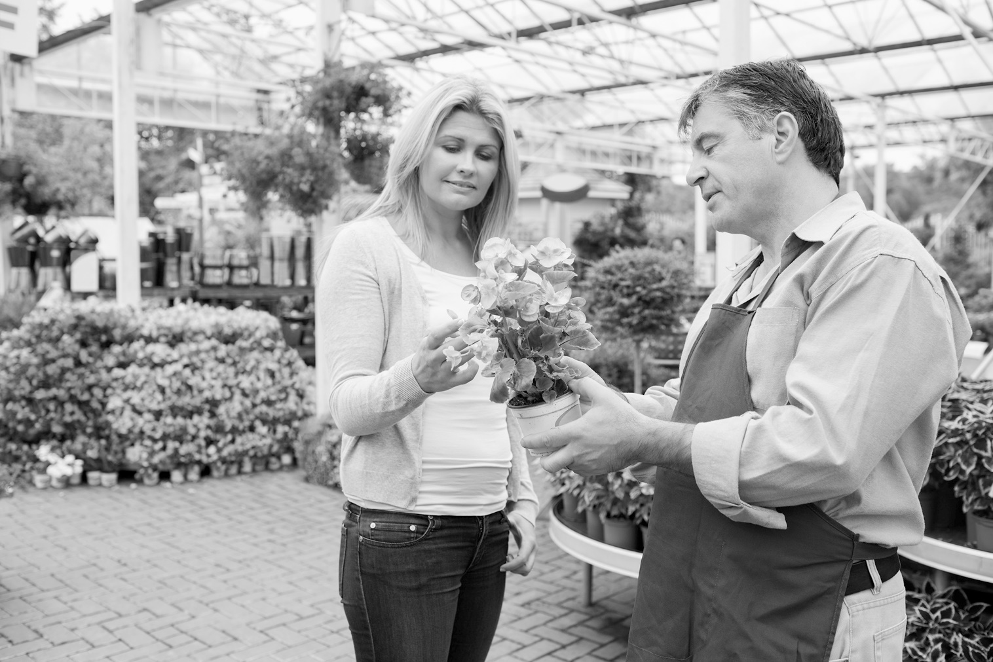
___ / 12

TOTAL: ___ / 20

