Part A • Grammar, Vocabulary and How to …
GRAMMAR
1 Choose the correct words to complete the sentences.
1 We drove / were driving to work when the accident happened.
2 There was a new woman at work today who I
didn’t meet / hadn’t met before.
3 I was trying to repair my bike when a man
was stopping / stopped to help me.
4 The parcel had arrived / arrived just after I got home.
5 When I tried to use my phone, I realised it
hadn’t worked / wasn’t working.
6 He ate / had eaten already so he was cooking just for the children.
/6

2 Complete the sentences with the past simple or present perfect form of the verbs in brackets.
1 She __________ (never / study) Turkish before. This is her first class.
2 I __________ (see) Lucas when I was on the bus this morning.
3 He __________ (finish) cleaning the bedroom and now he’s going to start the lounge.
4 They __________ (open) their first shop in 2020.
5 I __________ (drive) more than 1,000 kilometres already this week.
6 A: Have you ever been up a mountain?
B: Yes, I __________ (climb) Ben Nevis last summer.
7 A: __________ (ride) a motorbike before?
B: I don’t think so. This is her first time.
/7

3 Choose the correct words to complete the sentences.
1 During / Until the journey, we decided to visit the science museum.
2 Come and sit down. The match starts at / in five minutes.
3 The concert is at the arts centre of / on 17 November.
4 The city centre is usually quite busy at / after night.
5 They hope to arrive between / during four and five o’clock.
6 We’re allowed to finish work early at / on Fridays.
7 Let’s wait in the library between / until it stops raining.
/7

VOCABULARY
4 Choose the correct option (a, b or c).
1 My brother was ___ of my new tablet because his tablet is really old.
a angry b jealous c worried
2 The children look pretty ___. It must be time for bed.
a kind b silly c sleepy
3 Please stay ___. There’s nothing to worry about.
a calm b nervous c upset
4 He’s ___ of the dark so he sleeps with a light on.
a exhausted b sleepy c terrified
5 I think they’re ___. They look so happy together.
a in love b jealous c upset
6 Kevin wasn’t very ___. He didn’t say hello to me.
a bossy b polite c rude
7 I can’t hear you because the children are too ___.
a easy-going b helpful c noisy
/7

5 Complete the sentences with the words in the box.
characters ending fairytales hero performances plot storyteller TV shows
1 There are lots of __________ about cooking. They’re on all the channels.
2 I prefer films that finish with a happy __________.
3 Children love __________ because of the magic and unusual animals.
4 In most action films, the __________ stops something terrible from happening.
5 The __________ of the book was hard to follow because too many things were happening.
6 My uncle was a brilliant __________. I loved it when he read to me.
7 There are two main __________ in the book and they’re called Jimmy and Jan.
8 There will be music and dance __________ every day at the music festival.
/8

6 Complete the sentences with types of films.
1 Most h _ _ _ _ r films are too frightening for me.
2 This b _ _ _ _ c tells the story of the most famous guitar player in the world.
3 I’m watching a d _ _ _ _ _ _ _ _ _ y about oceans. It’s great because I’ve learnt a lot.
4 Modern a _ _ _ _ _ _ _ n films are usually made with computers so the pictures are amazing.
5 The jokes in some old c _ _ _ _ y films are really funny.
/5

HOW TO …
7 Complete the conversations with the words and phrases in the box.
fault got keep made mind problem really sorry terrible worry
1 A: Sorry to ¹__________ you waiting.
B: Don’t ²__________.
A: I ³__________ lost and I had to ask for directions.

2 A: I ⁴__________ a mistake. I’ve given you the wrong address.
B: Never ⁵__________. Can you tell me the correct one?

3 A: ⁶__________ I’m late. The traffic was ⁷__________.
B: No ⁸__________. I’ve only just got here.

4 A: Hey Monika, I can’t see my name on the list.
B: I’m ⁹__________ sorry. It was my ¹⁰__________.
/10

Total: /50

Part B • Listening, Reading and Writing
LISTENING
1 [Audio UT2.01] Listen to Liam telling a story about travelling in Senegal. Number the events (A–F) in the order you hear them.
1 ___
2 ___
3 ___
4 ___
5 ___
6 ___

A Liam and Mark flew with a pilot.
B Liam went to university.
C Liam and Mark couldn’t fly home.
D Liam and Mark got help from their families.
E Liam and Mark decided to go travelling.
F Mark needed to see a doctor.
/6

2 [Audio UT2.01] Listen again. Complete the notes with a word or number.
Liam’s flight to Senegal was ¹__________ because he worked at the airport.
Liam and Mark wanted to experience the ²__________ and ³__________ in Senegal.
At the airport, they added their names to a ⁴__________ for the flight.
They had good ⁵__________ of the places below them from the aeroplane.
Someone took them to stay in the ⁶__________ where his grandfather lived.
Only two flights a ⁷__________ returned to Gatwick airport.
The pilot didn’t let Mark fly because he was ⁸__________.
Liam and Mark had to wait for ⁹__________ days for the next flight home.
/9

READING
3 Read the article about the story of dance. Tick the ideas that are mentioned.
1 People have always performed difficult dances. ___
2 Dance is important for different social events. ___
3 Learning to dance is a popular activity in Britain. ___
4 Flamenco is practised all over the world. ___
5 Dance is as good as other forms of exercise. ___
/5
The story of dance
No one knows for sure when people first started to dance, but the earliest example is from about 9,000 years ago. Indian cave paintings from that time show large groups of people doing difficult dance movements. Some of the paintings show up to a hundred people dancing so whole villages probably participated. We also know it was important to the ancient Egyptians who used it during religious ceremonies, as well as the Greeks and the Romans. Almost every culture since then has practised some form of dance.

Dance is an important activity in many societies and often the main event at festivals, such as weddings and birthdays. In some cultures, they even dance at funerals. It is also a popular form of entertainment and people all over the world go to nightclubs at weekends in order to dance. Some people dance with a partner and follow their moves, but others prefer to dance alone and invent their own moves. Dance is a way of expressing yourself, relaxing and having a good time with your family and friends.

More formal types of dance are enjoyed by both young and old. People often attend classes to learn special dance moves and enter competitions to show off their skills. In Britain, for example, a lot of children go to ballet classes, while ballroom dancing is popular with older people. Breakdancing has also become very fashionable in recent years. Looking like a mixture of gymnastics and karate, some people would like it to be an Olympic event.

Neither ballet nor breakdancing are traditional British dances, but in other countries, popular dance forms are sometimes connected to their culture and traditions. In Spain, for example, flamenco has been practised for hundreds of years and is associated with the region of Andalusia. Flamenco music is played on the guitar with musicians singing and clapping as well. Flamenco’s particular style is seen as an art form and, in 2010, it was recognised by UNESCO for its contribution to humanity and culture.

Nowadays, people also recognise the benefits of dancing for your health. It’s good for you in the same way as other forms of exercise like running or swimming. It helps with breathing, makes your heart stronger and improves control of your body. It is also good for your mind because it requires discipline, communication and working with others. Most importantly, it’s one of the most natural forms of exercise – one which people have done for thousands of years.
4 Read the text again. Choose the correct answer, A, B, C or D.
1 What do the Indian cave paintings show?
A Ancient religious ceremonies
B People dancing together
C Life in an Indian village
D Instructions for dance movements

2 What does the author say about social occasions?
A People should not dance at funerals.
B Dancing is a good way to meet a new partner.
C It is not necessary to dance with someone else.
D Nightclubs are the best places for dancing.

3 According to the text, which type of dancing is like
a sport?
A Flamenco
B Ballet
C Ballroom dancing
D Breakdancing

4 What does the author say about flamenco?
A It’s a type of creative art as well as a type of dance.
B It’s more popular than ballet and breakdancing.
C It’s only practised in one region of Spain
D It’s not the traditional dance of Spain.

5 How does the author feel about dancing?
A It’s not clear that there are health benefits.
B It’s good for you in a number of different ways.
C It’s easier if you have good control of your body.
D It’s better for you than swimming or running.
/10

WRITING
5 Correct the mistake in the linking phrase in the sentences below.
1 A day I was working on my computer at home.
2 At the time they arrived, we had already eaten.
3 As soon that I woke up, I jumped out of bed.
4 By the end, everyone was happy with the plan.
5 After then, we were really exhausted.
/5

6 You have seen this advertisement on a website:
Short story competition
We want you to write a short personal story. Your story must begin with this sentence:

I was walking along the street when I saw an old friend.

We will publish the best stories on our website.
Write your story in about 100 words.
/15

Total: /50

Part C • Speaking
SPEAKING
1 Make questions and ask your partner.
1 Where / come from?
2 How / the place where you live / changed?
3 What / do / last weekend?
4 What / doing / five o’clock yesterday?
5 Have / seen / a good film / recently?
/5

2 Answer your partner’s questions.
/5

3 Describe the picture to your partner.
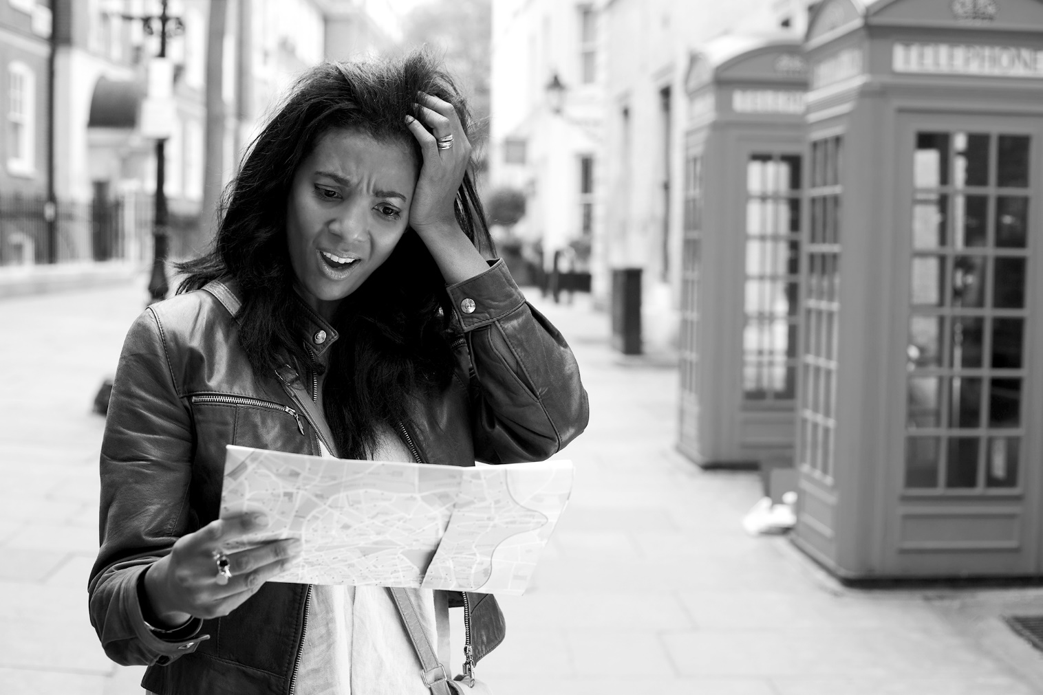
/10

Total: /20

