Part A • Grammar, Vocabulary and How to …
GRAMMAR
1 Put the words in the correct order to make questions.
1 Do / out / go / to / want / you
___________________________________________?
2 reading / he / Is / book / that
___________________________________________?
3 Where / your / work / does / wife
___________________________________________?
4 the / at / they / are / doing / moment / What
___________________________________________?
5 stay / to / you / home / Who / told / at
___________________________________________?
6 you / Where / have / all / been / morning
___________________________________________?
7 usually / Who / out / go / with / you / do
___________________________________________?
/7

2 Choose the correct words to complete the sentences.
1 A: What are your plans for the weekend?
B: I ’ll / ’m going to stay at home and study.
2 A: This box is very heavy.
B: Don’t worry. I ’m helping / ’ll help you carry it.
3 A: Are you going to watch the rugby match?
B: I’m not sure. I might / will watch it.
4 A: Have you bought the plane tickets yet?
B: Yes. We ’re flying / ’ll fly next Monday.
5 A: Do you want to meet next Tuesday?
B: I ’ll check / ’m checking my diary later.
6 A: Why isn’t Chuck coming out?
B: He ’ll start / ’s starting a new job tomorrow and he doesn’t want to be tired.
/6

3 Choose the correct option (a or b).
1 I can’t ___ because I can’t remember my password.
a log the computer onto b log onto the computer
2 Jeff is going to ___ so we can go to the theatre.
a look the children after b look after the children
3 You don’t need a hat on in here. Why don’t you ___?
a take it off b take off it
4 My alarm ___ last night.
a went off at 3 a.m. b went at 3 a.m. off
5 I usually fall asleep when ___.
a takes the plane off b the plane takes off
6 I’ve got the shopping so I’m going to ___.
a put it away b put away it
7 Let’s ___ before it leaves.
a get the bus on b get on the bus
/7
VOCABULARY
4 Complete the sentences with the words in the box. There are three words you do not need.
data guess knowledge memory mind note option revise score solve
1 Don’t just __________! Think about the answer before you write it.
2 Rita got a low __________ in the test. I think she had a bad day.
3 I’ve got a bad __________. I’m always forgetting things.
4 Our exam is next week so we need to __________.
5 We used a special program to organise the __________ for the report.
6 I need a pen so I can __________ down his phone number.
7 It’s important to look after your __________ as well as your body.
/7

5 Complete the sentences with the correct form of the words in brackets.
1 Dottie showed a lot of __________ (understand) when I explained the problem.
2 My daughter is trying to __________ (memory) all the words of her favourite song.
3 She’s got a good __________ (know) of French. She knows lots of unusual words.
4 We need more __________ (inform) before we decide.
5 I don’t know what the __________ (solve) is. Do you have any idea?
6 I did a lot of __________ (revise) for the exam so I’m surprised about the result.
7 She didn’t do much __________ (prepare) for her job interview.
/7

6 Match the sentence halves.
1 There are a lot of advantages
2 The book’s ending didn’t make
3 It’s important to consider all
4 I hope she makes the
5 I don’t want to choose
6 Let’s try to focus

a the options before deciding.
b on the exercise.
c right choice this time.
d and disadvantages to think about.
e between two options.
f sense to me.
/6
HOW TO …
7 Complete the indirect questions. Use the direct questions to help you.
1 Where is the science museum?
Could you tell _______________________________?
2 Who do you live with?
I’d like to know _______________________________.
3 What time does the film start?
Can you tell _________________________________?
4 Where is the petrol station?
I’d like to know _______________________________.
5 What do you want for dinner?
Do you know ________________________________?
6 How long have you lived here?
Could you tell ________________________________?
7 How do I buy a ticket online?
Could you explain ____________________________?
8 Do you work here?
Can I ask ___________________________________?
9 Can I speak to the manager?
Do you know ________________________________?
10 When is the next coach to Manchester?
I’d like to know _______________________________.
/10

Total: /50

Part B • Listening, Reading and Writing
LISTENING
1 [Audio UT3.01] Listen to Josh and Melanie planning a holiday. Are the statements True (T) or False (F)?
1 Josh and Melanie haven’t been to another country recently. T / F
2 Josh is worried about the weather in Morocco. T / F
3 Melanie is starting a new job in June. T / F
4 Josh and Melanie have never visited France. T / F
5 Josh thinks the children would like to visit a city. T / F
6 Melanie says people go swimming in French lakes. T / F
7 Melanie would like to visit Mont Blanc. T / F
8 Josh agrees to ask Paul about France. T / F
/8

2 [Audio UT3.01] Listen again. Complete the notes with one word in each space.
Josh and Melanie haven’t been abroad on holiday for ¹__________ years
Melanie says the holiday in Mexico was ²__________.
The children start their school ³__________ in July.
According to Josh, France is a ⁴__________ country.
The children like swimming and playing in the ⁵__________ on the beach when they’re on holiday.
Melanie says most French towns have ⁶__________.
Melanie doesn’t like staying at ⁷__________.
/7

READING
3 Read the article about learning. Match the paragraphs (1–5) with the headings (A–E).
A How do we learn?
B How can I become a better learner?
C What is learning?
D What is informal learning?
E What is formal learning?
/5
Learning
Nowadays, people say it’s important to be a lifelong learner. In this article, we’ll talk about the different ways we learn and show you how to become a better learner.

1 ___
Learning is the way we get new knowledge and skills and change our behaviour. When children learn how to say “please” and “thank you”, they are changing their behaviour. When you learn how to repair a car, you are getting a new skill. And when you study the planets, you are getting new knowledge. It’s hard to imagine a world without learning.

2 ___
Scientists have different opinions about the way we learn. Some of them think it’s by copying behaviour and then repeating it. An example would be a child learning to say words by copying their parents. Others think it’s by talking to people and doing things with them. This is the way most of us get new knowledge at school. No one knows exactly how we learn, but both of these opinions make sense.

3 ___
Nowadays, most people go to school to get new skills and knowledge, like maths or languages. This is an example of formal learning, where teachers organise the learning experience. Some people go to university to increase their knowledge and get qualifications. Many companies also organise training for their staff, with subjects like how to use computer programs or how to get on with colleagues.

4 ___
This is learning which doesn’t happen in a formal context. There’s no teacher to help you and there aren’t any qualifications. But you can select the time, the place and the subject. If you think about it, we do this all the time. For example, if you don’t know how to boil an egg, you can look in a cookery book. There are many ways of learning informally, but one of the most useful is the internet.

5 ___
Firstly, take responsibility for your learning. These days, we can use the internet to find the information we’re looking for. Videos, blogs and articles can all help us learn so there’s no excuse. But don’t forget that we can learn a lot from other people. It’s surprising what you can learn by just talking and listening. Lastly, you need to be a lifelong learner; it can increase your work opportunities and it might even be good for your health.
4 Read the text again. Choose the correct answer, A, B, C or D.
1 What does the writer say in paragraph A?
A Knowledge is more useful than skills.
B Children need to be more polite.
C Learning is very important in our world.
D Studying the planets is not a good way to learn.

2 How does the writer feel about learning?
A We only learn by copying behaviour.
B We probably learn in different ways.
C Scientists are wrong about how we learn.
D Scientists are the best at learning new knowledge.

3 According to the writer, formal learning …
A is something new.
B is a school subject.
C only happens at school.
D happens in different places.

4 According to the writer, informal learning …
A is worse than formal learning.
B is not very common.
C happens without a teacher.
D only happens on the internet.

5 What is the writer’s opinion about learning?
A It’s important to continue learning during your life.
B People create excuses to avoid learning new things.
C Learning is definitely good for your health.
D The best way to learn is by talking and listening.
/10

WRITING
5 Correct the underlined words in the formal email.
¹Hello Sir / Madam,

²I’m writing to express my interest in the job at the sports centre. Before I apply, I would like to ask some questions.

Could you tell me how many hours a week the job is?
I ³also want to know what days of the week I would have to work.

⁴Thanks for your attention and I hope to hear from you soon.

⁵See you soon,

Jade Roberts
/5

6 Read the task below.
You want to buy a new computer and you would like some information. You decide to write an email to the shop.

Information you need:
- How big is the screen?
- Colour?
- Price?
- Will you deliver it?
Write your formal email in about 100 words.
/15

Total: /50

Part C • Speaking
SPEAKING
1 Make questions and ask your partner.
1 What / doing / after this lesson?
2 What plans / have got / for the weekend?
3 Have / a good memory?
4 How / learn / new things?
5 What activities / important / to you?
/5

2 Answer your partner’s questions.
/5

3 Describe the picture to your partner.
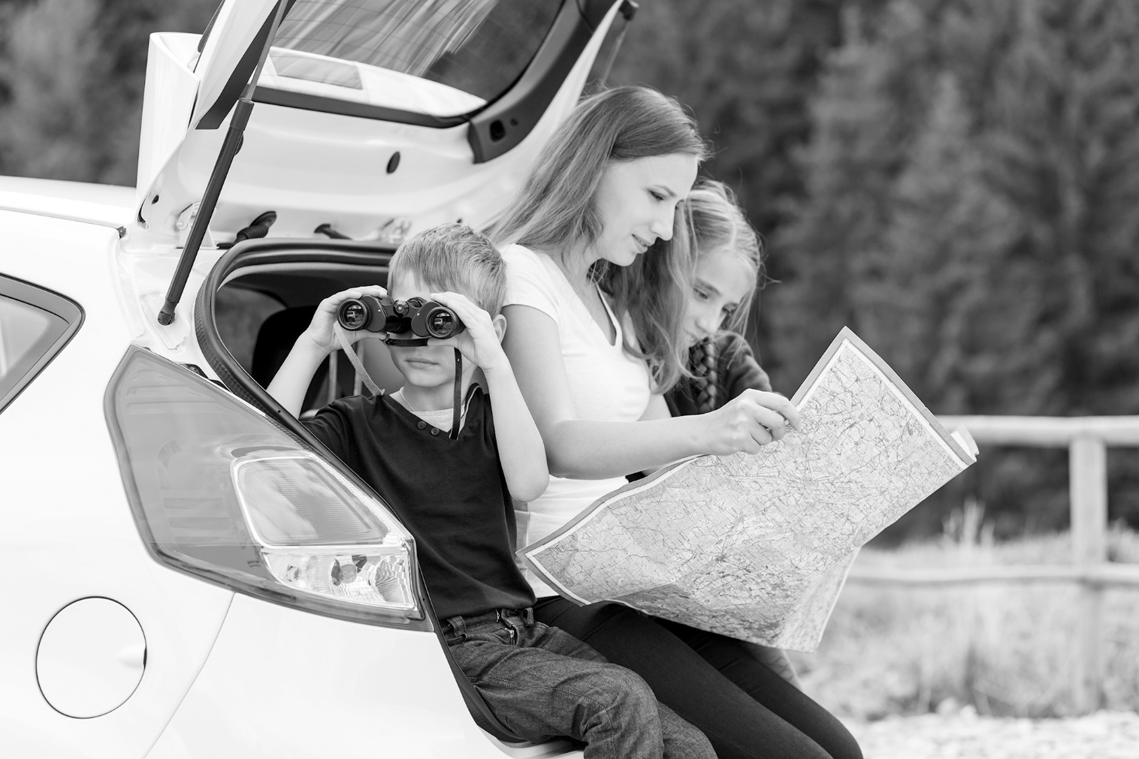
/10

Total: /20

