Part A • Grammar, Vocabulary and How to …
GRAMMAR
1 Choose the correct words to complete the sentences.
1 You have to / mustn’t have a ticket when you travel by bus.
2 We must / mustn’t make a decision soon or it’ll be too late.
3 The children shouldn’t / should spend less time playing computer games and more time reading.
4 You needn’t / need to bring sandwiches because we’ll give you lunch.
5 You don’t have to / mustn’t go to bed early because you don’t have school tomorrow.
6 You shouldn’t / don’t have to walk in the road because there’s a lot of traffic.
7 We had to / must take off our shoes when we went in the house.
/7

2 Complete the sentences with an article (a, an, the
or –).
1 I can’t see __________ moon tonight.
2 He’s __________ receptionist in a hotel.
3 I’m not very good at __________ football.
4 We’d like to go to __________ Vietnam on holiday.
5 He’s reading __________ book, but I don’t know which one.
6 Raquel is __________ cleverest person I know.
7 Do you have __________ interesting job?
/7

3 Complete the sentences with the correct form of the words in brackets.
1 It’s the best bread we __________ (ever / eat).
2 Pedro is __________ (kind) person she’s ever met.
3 It’s __________ (interesting) article I’ve ever read.
4 She’s the happiest she __________ (ever / be) at the moment.
5 He sings __________ (sad) songs I’ve ever heard.
6 That’s probably the most uncomfortable bed they __________ (ever / sleep) in.
/6

VOCABULARY
4 Complete the sentences with the words and phrases in the box. There are three words you do not need.
bad loser carry on competitive do well failure give up hard strict success talented
1 The children are working very __________ at the moment.
2 You shouldn’t be so __________. It’s not important who finishes first.
3 It can be difficult to accept __________ , but we can also learn from it.
4 Umberto’s a __________ artist. He’s got a natural ability for painting.
5 My grandfather was __________ so he had rules for everything.
6 The book was so hard I wanted to __________, but I finished it in the end.
7 Oana is such a __________. She always gets annoyed when other people win.
/7

5 Complete the sentences with the correct form of the words in the box.
download find go launch make send take
1 Can you __________ a picture of me with my camera?
2 She needed help so she __________ a call to her old manager.
3 The company is __________ its website to the public today.
4 I’m sure their pop video will __________ viral on the internet.
5 I __________ you a message, but you didn’t reply.
6 I only __________ the app because I didn’t have to pay for it.
7 This is a great website if you need to __________ information about transport.
/7
6 Complete the sentences with the correct form of the words in brackets.
1 I think every child should have access to good __________ (educate).
2 Julia is taking a course so she can be a video game __________ (develop).
3 He’s going on a course to learn __________ (leader) skills.
4 The only way to be __________ (success) is by working hard.
5 You need to be able to accept failure if you want to be an __________ (invent).
6 I don’t usually read the __________ (introduce) at the beginning of books.
/6

HOW TO …
7 Choose the correct option (a, b or c).
1 The ___ is to win more money than the other players.
a goal b rules c score
2 I don’t ___ any football teams, but I sometimes watch England matches.
a lose b support c take part
3 We had an amazing view of the ___ at the tennis match.
a court b field c pitch
4 A baseball bat is usually ___ of wood or metal.
a consists b lasts c made
5 Thousands of ___ were at the stadium to watch the World Cup finals.
a champions b fans c supports
6 We like playing ___ in the house so we’re not looking at screens.
a board games b team sports c video games
7 The aim of football is to ___ the ball into the goal.
a bat b pass c shoot
8 The first player to ___ ten points is the winner.
a goal b score c succeed
9 You ___ kick the ball in a game of volleyball. You can only hit it with your hands.
a can b have to c mustn’t
10 A game of ice hockey normally ___ about 60 minutes.
a lasts b plays c stages
/10

Total: /50

Part B • Listening, Reading and Writing
LISTENING
1 [Audio UT4.01] Listen to a podcast about screen time. Number the points (A–H) in the order you hear them.
1 ___
2 ___
3 ___
4 ___
5 ___
6 ___
7 ___
8 ___

A Having different apps open at the same time
B Number of hours spent on devices
C Apps for controlling time spent on devices
D Turning off devices more frequently
E Talking to children about screen time
F Problems caused by too much screen time
G Time spent on devices by children
H Turning off the sound on your device
/8

2 [Audio UT4.01] Listen again. Are the statements True (T) or False (F)?
1 Ava is surprised about the time people spend on devices. T / F
2 The presenters agree that devices are bad for your eyes. T / F
3 Ava agrees that you should turn apps off when you’re not using them. T / F
4 Joshua thinks people should leave their phones on at night. T / F
5 Joshua thinks children should decide how long to spend on devices. T / F
6 Ava finds it easy to control her children’s screen time.
T / F
7 Joshua recommends an app to control children’s screen time. T / F
/7

READING
3 Read the webpage about success stories. Complete the sentences with a date or number.
1 Josef Koeberl took an ice bath in __________.
2 Felix Baumgartner did a parachute jump in __________.
3 Chloe McCardel swam __________ miles between two islands in 2014.
4 Dean Karnazes ran 350 miles in __________.
5 Roger Bannister ran the first ever “sub-four-minute mile” in __________.
/5

Success Stories
What are your favourite success stories?

Handy_35:
Some people take short ice baths for their health, but never for more than a few minutes. In fact, doctors say it’s dangerous to spend more than fifteen minutes in one. But that hasn’t stopped people trying! Wim Hof tried on different occasions between 2009 and 2013. Then Josef Koeberl spent 2 hours 30 minutes in an ice bath. That was in September 2020, but in December 2020, Romain Vandendorpe lasted 2 hours 35 minutes.

Flowerpower:
Felix Baumgartner jumped from a balloon nearly 39 kilometres up in the sky. He started to plan the jump in 2010 with a team of scientists and finally made it in 2012. Cameras recorded the event and millions watched it on the internet. Baumgartner jumped further and faster than anyone before him. He reached a speed of 1,357 kilometres per hour, faster than the speed of sound. Two years later, in 2014, Alan Eustace jumped even further, with a distance of 41 kilometres.

R2D4:
Chloë McCardel is a swimmer who has swum from England to France 44 times. In 2013, she tried to swim the 110 miles from Cuba to Florida, but she had to stop after getting hurt in an accident. However, she didn’t give up and she tried another difficult swim in 2014. This time she swam 74 miles from one Caribbean island to another. This was further than anyone else had ever swum with only the simplest equipment.

MetalMike:
Ultra-runner Dean Karnazes runs really long distances. He ran for his school in 1976 before stopping for fifteen years. Then, in 2005, he ran about 350 miles without a break. He wasn’t fast, but he ran a long way without sleeping or eating! He completed it in 80 hours 44 minutes. For a few years this was the longest anyone had run for. However, in 2013, Kim Allan from New Zealand ran around a park for 86 hours 11 minutes with no sleep.

Penny_159:
Roger Bannister was an athlete famous for running the “four-minute mile”. In the 1950s, nobody thought it was possible to run a mile in four minutes. In 1952, Bannister competed in the Olympics in the men’s 1,500 metre race and he came fourth. Bannister was disappointed and he almost gave up running, but he carried on. His goal was to run a mile in less than four minutes and he achieved it in 1954. Nowadays, it’s common for athletes to run a mile in that time.
4 Read the webpage again. Choose the correct answer, A, B, C or D.
1 What is the longest you should normally spend in an ice bath?
A A few minutes
B 15 minutes
C 2 hours 30 minutes
D 2 hours 35 minutes

2 How did Felix Baumgartner prepare for his jump?
A He watched videos on the internet.
B He had help from a group of experts.
C He practised with a special balloon.
D He used photographs to plan it.

3 Why did Chloë McCardel give up swimming from Cuba to Florida?
A She was in too much pain.
B She was too tired to finish.
C She had the wrong equipment.
D It was too far for her to swim.

4 What do we find out about Dean Karnazes?
A He can run faster than anyone else.
B He ran around New Zealand in 2013.
C Another person ran for longer than him.
D Another person ran further than him.

5 What was special about the four-minute mile?
A It was a new race in the Olympics.
B It was Roger Bannister’s last race.
C No one else wanted to do it.
D Everyone believed it was impossible.
/10

WRITING
5 Correct the sentences.
1 You need to deciding what sports you want to learn.
2 How about speak to your art teacher?
3 Why not trying looking for a music school?
4 Don’t to worry about being new to the sport.
5 It’s easy find information on the internet.
/5

6 Your friend has written to you and asked for some advice.
I want to do something in my free time, but I don’t know what to do. Have you got any suggestions?
Write an informal email giving your advice. Write your email in about 100 words.
/15

Total: /50

Part C • Speaking
SPEAKING
1 Make questions and ask your partner.
1 What / most talented at?
2 How often / download / an app?
3 When / last / make a call?
4 Are / fan / any sports teams?
5 What / best / holiday / ever had?
/5

2 Answer your partner’s questions.
/5

3 Describe the picture to your partner.
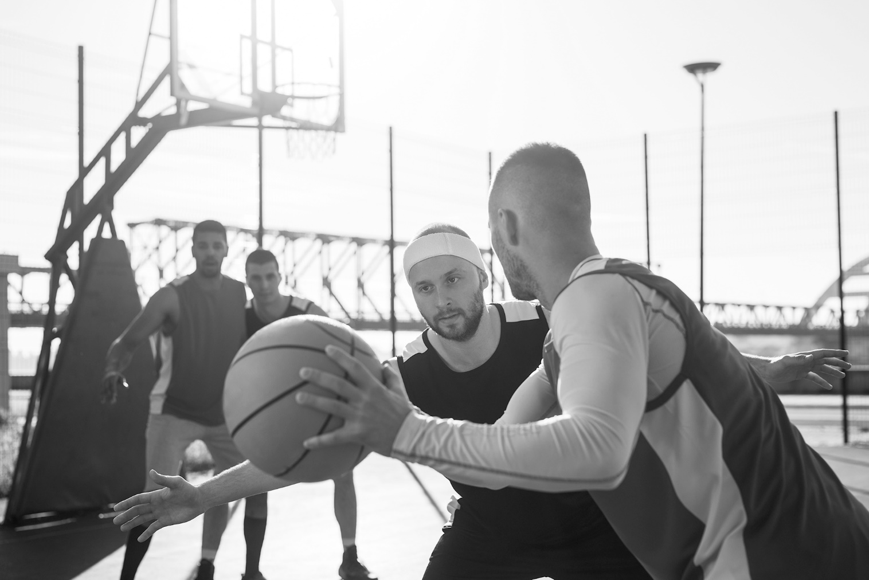
/10

Total: /20

